**Problem Statement:**

ABC Infotech wants you to develop a React based "Contacts" application for them. Below are their requirements for the application.

**Feature 1:** Application should make a API call to their back-end json server, which returns the details of their clients.

**Feature 2:**The details should be displayed in card format on the screen with the default image provided by them. You have to display the ***name***, ***mail id***, ***company name*** and ***a button*** for contacting them with their numbers on it. Below is the image for the same:

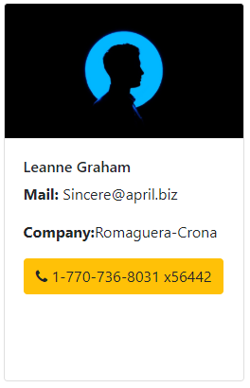

**Feature 3:**If the user clicks on button, an alert box should be displayed with the appropriate message on it, below is the sample image for the same:

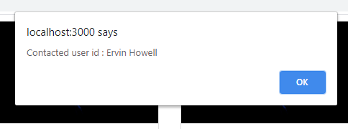

**Feature 4:** It should display the "Recently Contacted" people, with the time they are contacted on the screen to the user. Below are the screenshots for the two possible scenarios:

When no one has been contacted yet:

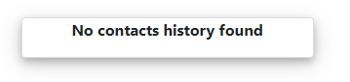

When users are contacted: It should follow a first in last out practice, that means if the 4th client is contacted Clementine will be out of the array and the client contacted will become on top of the list.

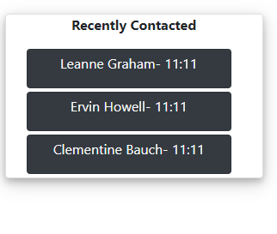

Here, Clementine was contacted first, then Ervin and Leanne Graham was contacted last.