Exp No: 3 | HELLO WORLD IN SERVLET

AIM:
To write a servlet program that prints “Hello World !” when accessed through a browser.

PROGRAM:

<%@ page language="java" contentType="text/html; charset=ISO-8859-1"
pageEncoding="ISO-8859-1"%>
<!DOCTYPE html>
<html>
<head>
<meta charset="ISO-8859-1">
<title>hello</title>
</head>
<body>
<h1>Hello World</h1>
</body>
</html>

OUTPUT:

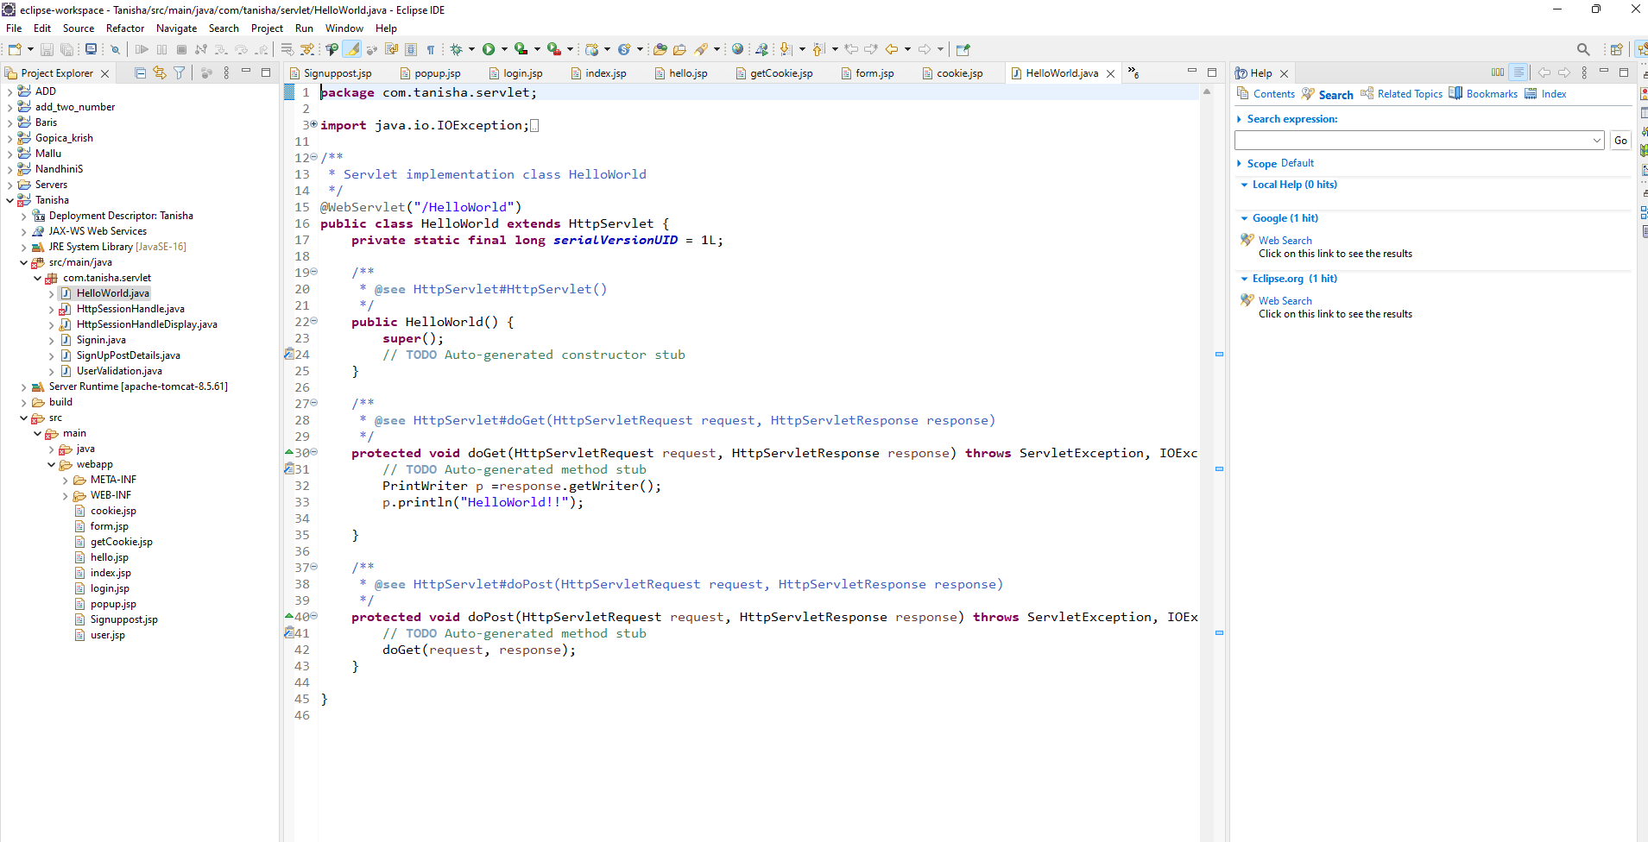

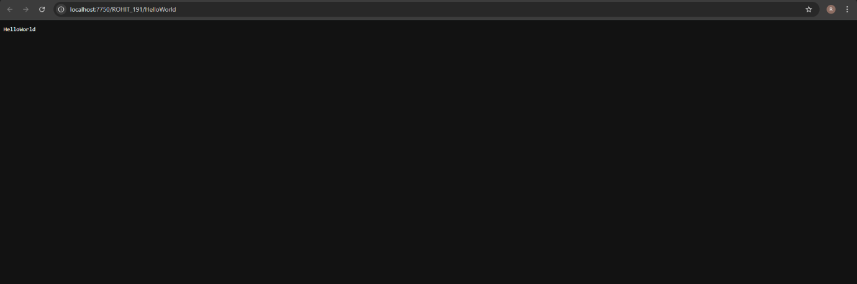

RESULT :
Thus the experiment to print “Hello world “ using servlet when accessed through a browser has been implemented and verified successfully

