

Aim

RAJALAKSHMI ENGINEERING COLLEGE,
CHENNAI

Department of Artificial Intelligence & Data Science

CS23633 – Cloud Computing Laboratory

Experiment 2: Setting up Public Cloud

To develop and deploy a simple web application using Render, a Platform as a Service (PaaS), and understand how cloud platforms host applications without requiring users to manage servers.

What is PaaS?
PaaS (Platform as a Service) is a cloud computing service that provides a ready-made platform for developing, running, and managing applications.

Everyday Example
Imagine you want to open a bakery.

Without PaaS
You need to:
- Rent a building
- Buy ovens
- Install electricity
- Arrange internet
- Hire maintenance staff Only then can you bake cakes. With PaaS
Someone gives you a fully equipped bakery. You simply bring your cake recipe and start baking.
Similarly,
- You write the application.
- The cloud provider manages the server, operating system, software installation, networking, and maintenance.
This is called Platform as a Service (PaaS).

Why Render?
Render is a cloud platform that allows you to deploy web applications easily. It automatically:
- Creates servers
- Installs Python
- Installs required software
- Runs the application
- Provides a public website
- Restarts the application if needed

Requirements
- Computer with internet connection
- Python 3.10 or later
- Git installed
- GitHub account
- Render account (you can sign up with your GitHub account)

Step 1: Sign in GitHub Account
- Open https://github.com
- Click Signin
GitHub stores your application code online.
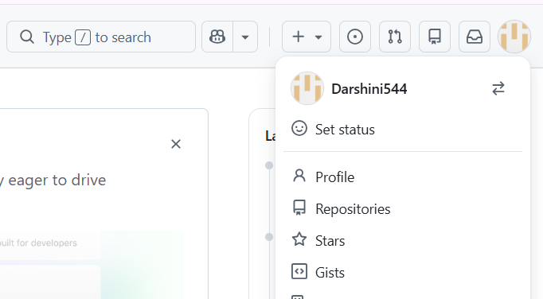

Step 2: Create a Project Folder

- Create a folder named RenderHelloApp in your local computer

- Inside it create two files. RenderHelloApp
├── app.py
├── requirements.txt

- Paste the following content in app.py
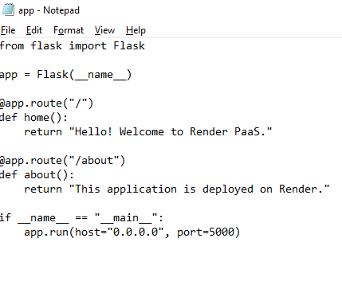
- Paste the following content in requirements.txt
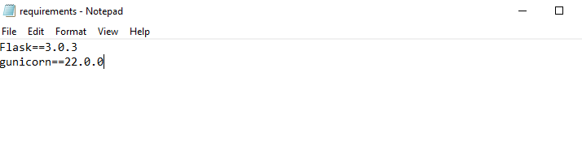

Step 3: Upload the Folder in GitHub

Create a Repository

- Click New Repository.
- Repository name: cloudexp1
- Choose Public.
- Click Create Repository.(cloudexp1)

Upload Your Files

- On the new repository page:
- On this page, there is usually a link that says:

uploading an existing file
- Click uploading an existing file. This opens the upload page where you can drag and drop app.py
and requirements.txt.
- You will see a page that says:
Drag files here to add them to your repository
- Click the green Commit changes button.

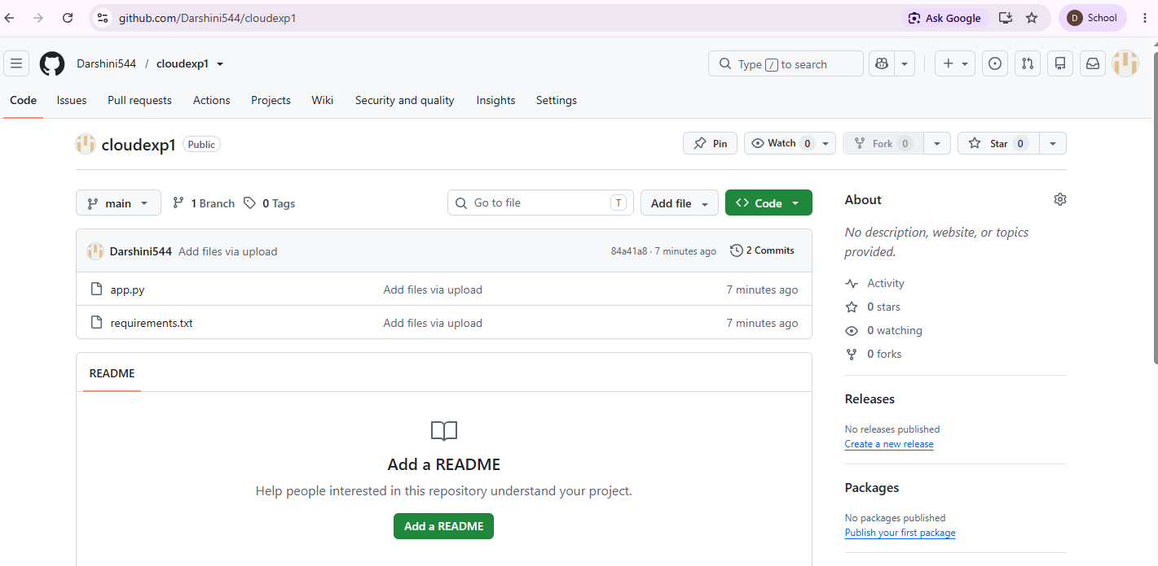
This last step is essential. Until you click Commit changes, the files are not actually saved in the repository.

Step 4: Create a Render Account
- Open https://render.com
- Click Get Started.
- After you log in to Render, it asks you to choose what type of service you want to create. For your Flask PaaS experiment, choose:

✅ Web Service
This is the correct option for hosting a Python web application.

Steps
- Log in to Render.
- On the "Choose a service" page, select Web Service.
- If prompted, connect your GitHub account.
- Select the GitHub repository that contains your Flask application.

- Configure it as follows:

Setting | Value
Name | renderhelloapp (or any unique name)
Language/Environment | Python
Branch | main
Root Directory | Leave blank
Build Command | pip install -r requirements.txt
Start Command | gunicorn app:app
Instance Type | Free (if available)
- Click Deploy Web Service.
- After successful deployment you will see the following screen.
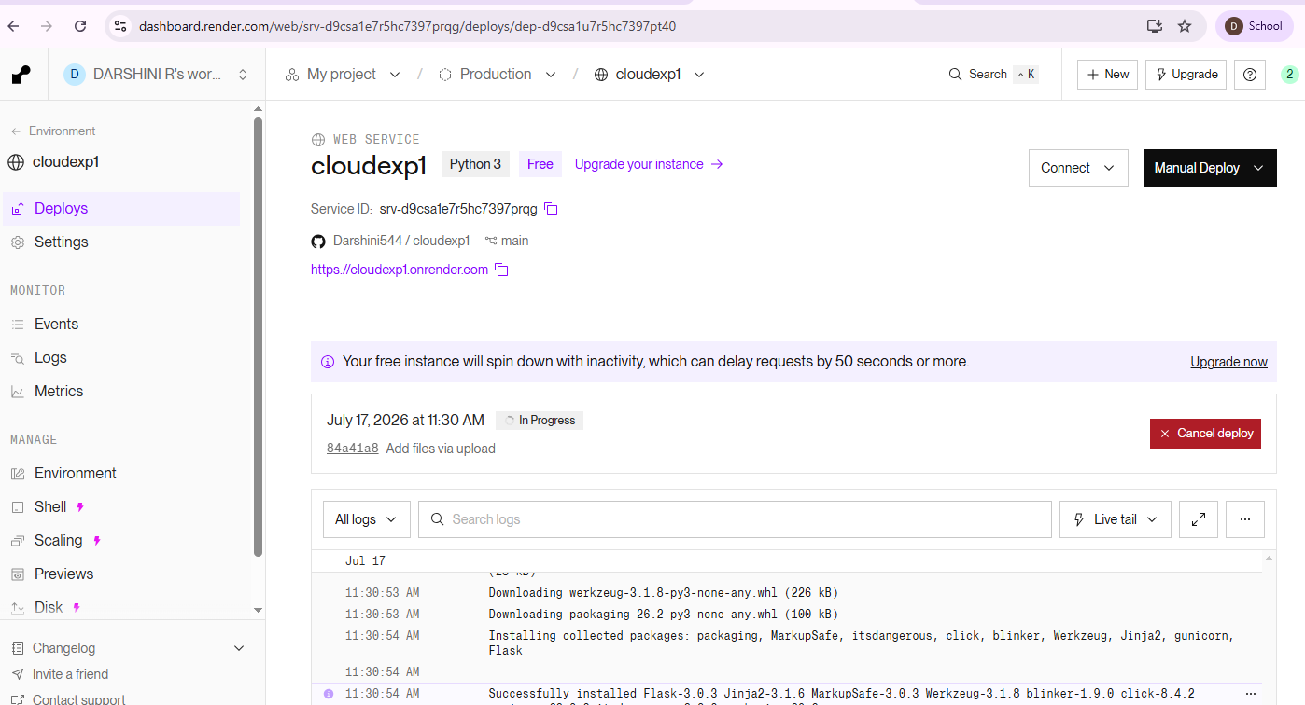

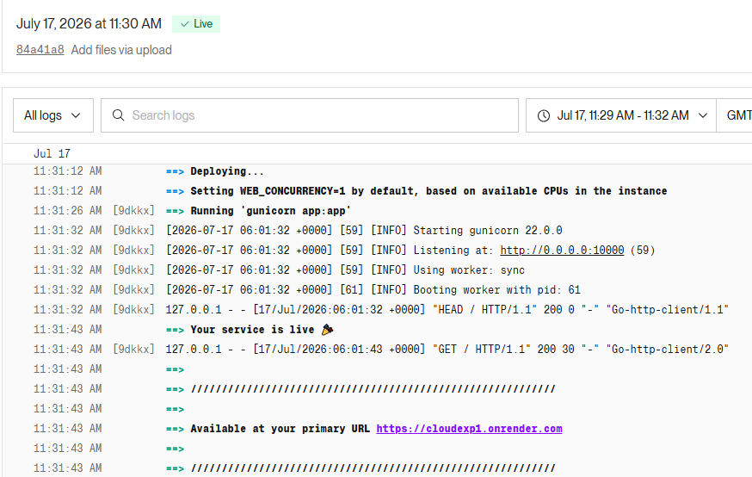

Step 5: Open Your Application
At the top of your screenshot, you can see the URL:
https://cloudepx1.onrender.com
Click that link (or copy and paste it into your browser).

Expected Output
If everything is working correctly, you should see:

Hello! Welcome to Render PaaS.
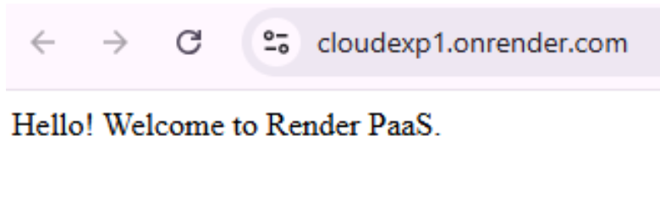

Then try visiting: https://renderhelloapp.onrender.com/about You should see:

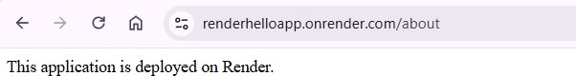
This application is deployed on Render.

Step 6: Verification
Take screenshots of:
- Render Dashboard (showing "Deploy live") ✅
- Home page (https://renderhelloapp.onrender.com)
- About page (https://renderhelloapp.onrender.com/about) These screenshots are useful for your experiment report.

Step 7: Test the Application

Test Case 1: Home Page
Open: https://renderhelloapp.onrender.com Expected Output:
Hello! Welcome to Render PaaS.
✅ Result: Pass

Test Case 2: About Page
Open: https://renderhelloapp.onrender.com/about Expected Output:
This application is deployed on Render.
✅ Result: Pass

