Two participants
1. Manager
2.Participants

Participants will send ethers on contract’s address
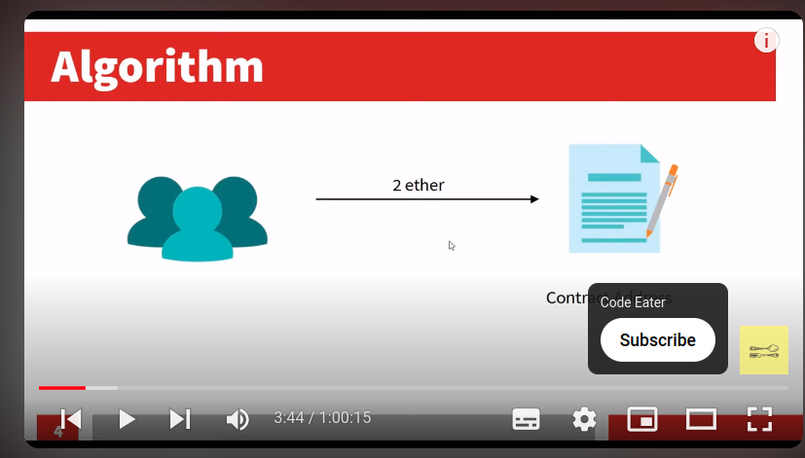

- Participants should be >= 3 and then only lottery will be valid.Managre will make sure this.

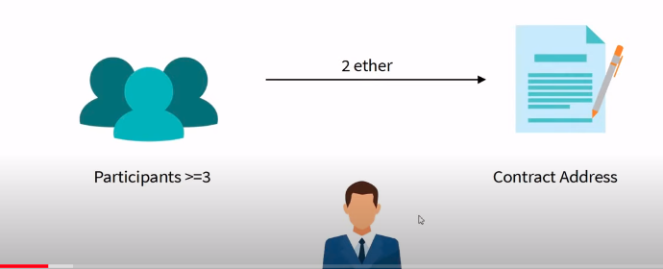

Whatever ethes gets collected/contract balance like 3 parrticipants means 6 ethers that ethers will be rewarded to one random winner as lottery.

