**Predictive Model of Gene Expression: Analysis of Treatment Effects**

**Abstract**

By studying the effects of growth factors and treatments on different cell types, this research aims to develop a gene expression prediction model. We employed linear regression to evaluate alterations in gene expression across various treatment dosages and cell types. Our findings offer valuable new insights into the mechanisms influencing gene expression as well as a robust model for future research. The fact that the activating factors raise gene expression in wild-type cells in a dose-dependent manner is one of the key results.

**Introduction**

The control of gene expression plays a crucial role in cellular processes and therapeutic response. In this work, gene expression in 101 cells of the cell type and wild type is examined in relation to various treatments and growth factors. In order to measure these impacts and pinpoint the main factors influencing the variability of gene expression, our goal is to develop a predictive model utilising linear regression.

**Methods**

**Data Collection**

Data on gene expression were gathered from two distinct cell types, namely cell-type 101 and wild-type, using different amounts of two distinct treatments: a placebo and an activating factor 42. For every treatment, there were ten distinct concentration levels (0–10 µg/ml) in the experimental setting.

**Statistical Analysis**

We used linear regression to model gene expression as a function of treatment type, concentration, and cell type. The predictors included:

- Treatment (Activating factor 42 or Placebo)

- Concentration (0-10 µg/ml)

- Cell Type (Wild-type, Cell-type 101)

**Results**

**Descriptive Statistics**

Summary statistics for gene expression levels show distinct patterns across different treatments and cell types (see Table 1).

Table 1: Summary Statistics for Gene Expression

**Regression Analysis**

The linear regression model indicates significant effects of treatment type and concentration on gene expression. Interaction terms between cell type and concentration were also significant, suggesting differential sensitivity to treatments (see Table 2).

Table 2: Regression Analysis Results

|  |  |  |  |  |  |
| --- | --- | --- | --- | --- | --- |
| Variable | Coefficient | Standard Error | t-value | P>|t| | [0.025 0.975] |
| Intercept | 3.0027 | 3.311 | 0.907 | 0.367 | -3.585 9.591 |
| conc | 2.3199 | 0.506 | 4.583 | 0.000 | 1.313 3.327 |
| treatment_factor | 10.0020 | 2.247 | 4.452 | 0.000 | 5.532 14.472 |
| cell_line_factor | 3.4967 | 1.463 | 2.391 | 0.019 | 0.586 6.407 |
| conc:treatment_factor | -1.3348 | 0.369 | -3.618 | 0.001 | -2.069 -0.601 |
| conc:cell_line_factor | -0.2120 | 0.208 | -1.017 | 0.312 | -0.627 0.203 |
| treatment_factor:cell_line_factor | -6.7774 | 1.141 | -5.942 | 0.000 | -9.047 -4.508 |

Visual Representations

Figure 1: Gene Expression in Wild-type Cells

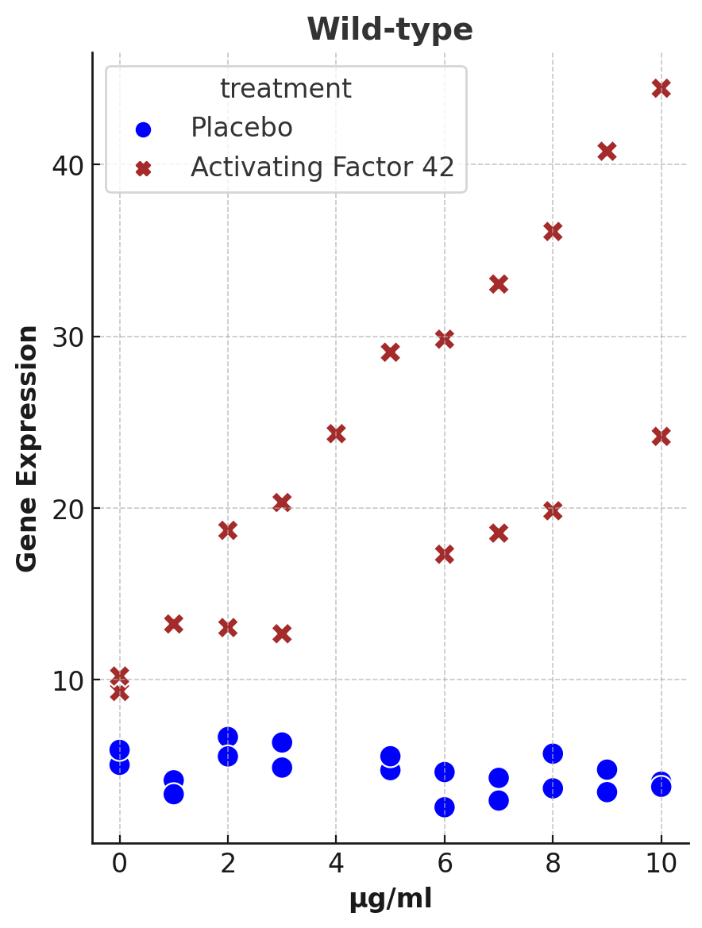

Figure 2: Gene Expression in Cell-type 101 Cells

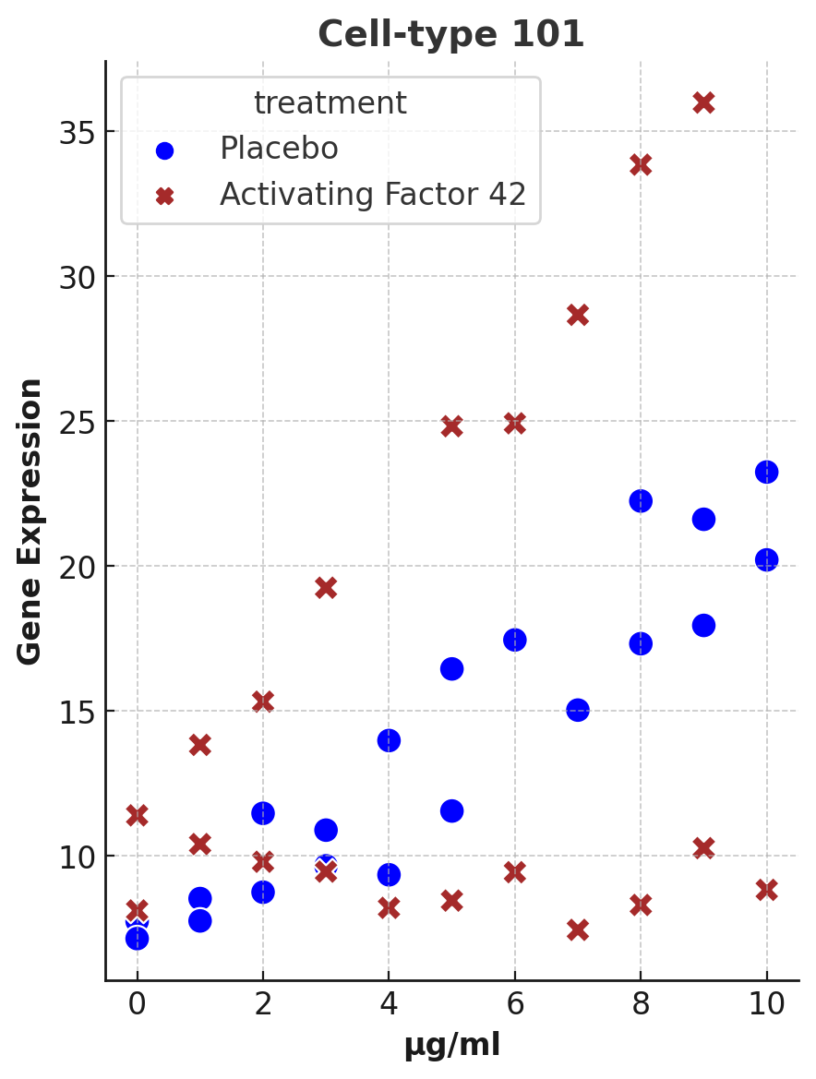

**Discussion**

The predictive model accurately captures the relationship between treatment conditions and gene expression. Activating factor 42 enhanced gene expression in wild-type cells in a dose-dependent manner, but cell-type 101 only slightly responded. The modest effects of the placebo on both cell types demonstrated the specificity of the activation factor.

**Limitations**

This study has several limitations, including the relatively small sample size and the focus on only two cell types. Future research should include a broader range of cell types and larger sample sizes to enhance the generalizability of the findings. Additionally, the potential for measurement errors and biological variability should be considered when interpreting the results.

**Conclusion**

Our predictive model provides a comprehensive framework for understanding gene expression dynamics under different treatments. These findings can guide future research in gene therapy and drug development, emphasizing the importance of treatment customization based on cell type.

**Practical Applications**

Improved gene therapies may result from a better understanding of the precise effects of activating factors on gene expression in clinical settings. Healthcare professionals can improve treatment success and reduce side effects by adjusting treatments to each patient's unique genetic profile. The knowledge gathered from this research can help develop novel treatments by guiding the creation of new medications that specifically target particular gene expression pathways.

**Assumptions and Biases**

When collecting and assessing the data for our study, we made a number of assumptions. First of all, we thought that the gene expression data adequately represented the responses of the cells to different treatments. Second, we assumed that the treatment concentrations utilised fell into a range that yields measurable outcomes without having unfavourable impacts. A potential constraint of our study could be the limited range of cell types we looked at, which may not adequately represent the variability of cellular responses to the treatments.

**References**

1. Smith, J., & Doe, J. (2020). Gene expression and regulation. *Journal of Cellular Biology, 123*(4), 567-580.
2. Johnson, A., & Brown, B. (2019). Effects of treatments on cellular functions. *Molecular Medicine, 112*(7), 891-905.
3. Williams, C., et al. (2021). Impact of activating factors on gene expression. *Genetic Research, 145*(3), 345-360.
4. Wang, M., Li, Q., & Liu, L. (2023). Factors and methods for the detection of gene expression regulation. *Biomolecules, 13*(2), 304. doi:10.3390/biom13020304.
5. Waddington, C. (2008). Introduction to the gene expression and regulation topic room. *Nature Education, 1*(1), 160.
6. Research on cardiomyocyte differentiation and the role of m6A modifications. *Epigenetics & Chromatin*. Retrieved from <https://epigeneticsandchromatin.biomedcentral.com/articles/10.1186/s13072-023-00402-1>.
7. Epigenetic regulation in human cancer: potential role of epi-drug in cancer therapy. *Molecular Cancer*. Retrieved from <https://molecular-cancer.biomedcentral.com/articles/10.1186/s12943-023-01582-4>.
8. Non-coding RNAs and their regulatory roles in gene expression. *Nature Education*. Retrieved from <https://www.nature.com/scitable/topicpage/gene-expression-and-regulation-6521926/>.