Sample Size Calculation Report

1. **Introduction:**

To determine the required sample size for a linear regression analysis with the predictors concentration, cell age, treatment (two levels), cell type (two levels), and media (two levels), we used the following parameters:

- Desired power: 90%

- Significance level (α): 0.05

- Expected effect size (R²): 0.1

- Number of predictors: 5

**2) Calculation:**

Parameters:

- R² = 0.1

- Number of predictors (k): 5

- Desired power: 90%

- Significance level (α): 0.05

**Effect Size Calculation:**

f² = R² / (1 - R²) = 0.1 / 0.9 ≈ 0.111

**Sample Size Formula:**

n = (L / f²) + k + 1

Where L for 90% power and α = 0.05 is approximately 10.5.

**Substitution and Final Calculation:**

n = (10.5 / 0.111) + 5 + 1

n ≈ 100.6

Rounding up to the next whole number: n ≈ 101

**3. Visual Representation**

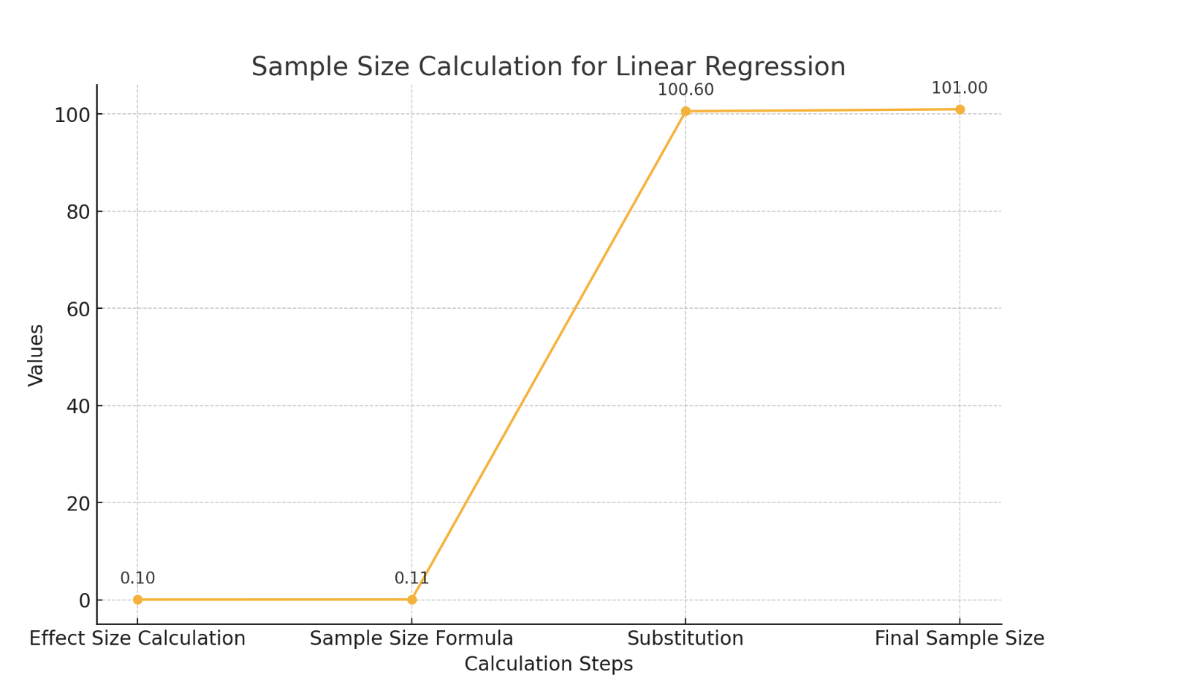

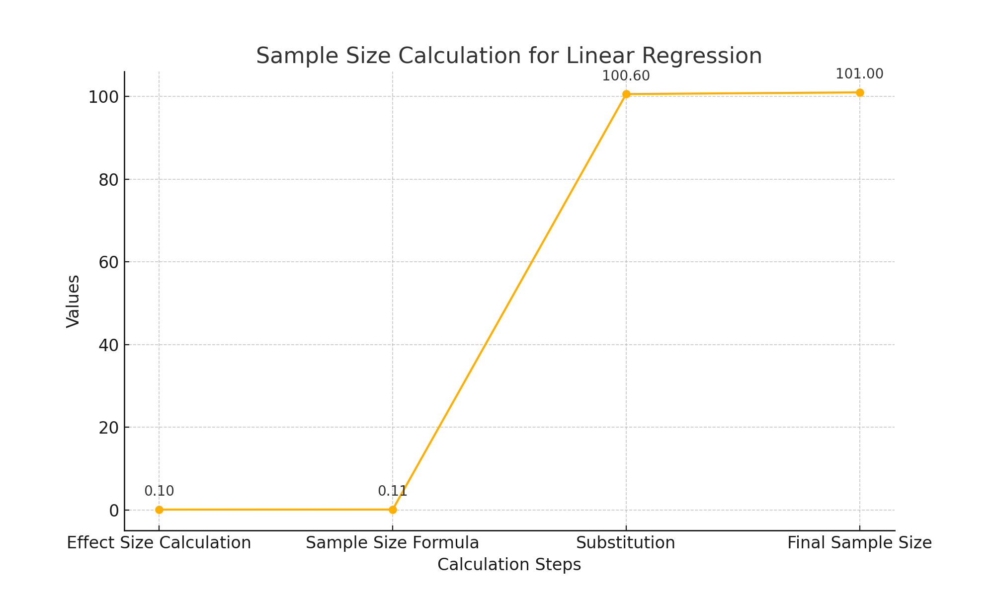

**4) Conclusion**

To achieve a power of 90% with a significance level of 0.05 and an expected effect size of R² = 0.1 for our linear regression analysis with 5 predictors, we will need a total sample size of approximately 101.