1. UML CLASS DIAGRAM (System Architecture)
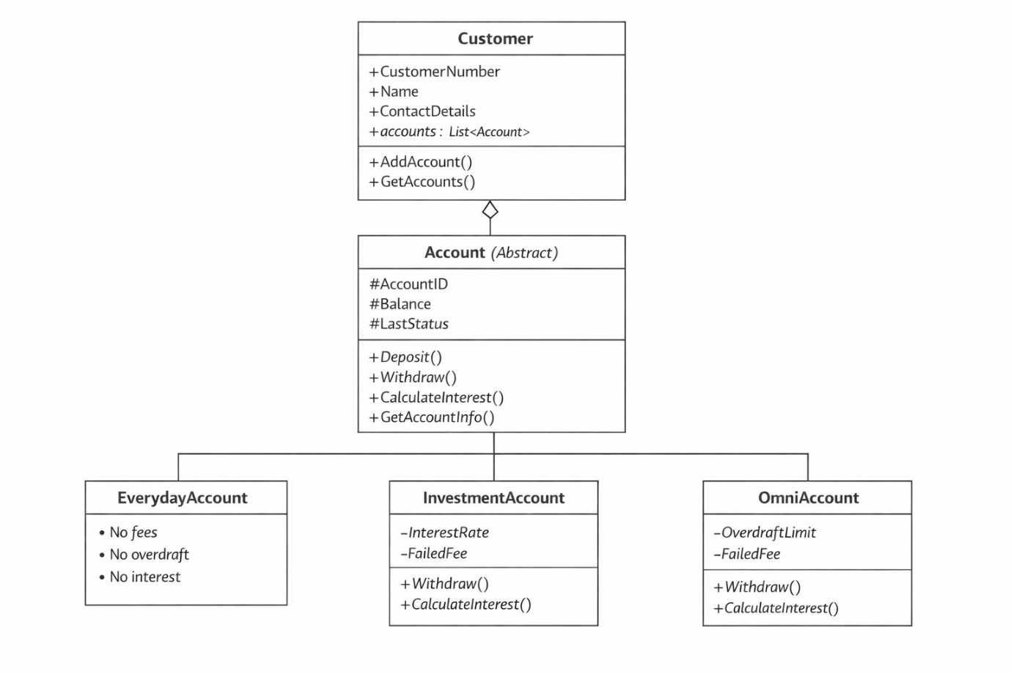

2. TECHNICAL JUSTIFICATION
System Architecture Justification
Object-oriented principles were used to design the banking system such that it could be maintained, scaled and be highly modular. The key principle of the system is the abstract class Account that reflects the general functionality of all the types of accounts. The important aspects about this class are AccountID, Balance, and LastTransactionStatus are stored and the important banking functions like Deposit, Withdraw and CalculateInterest are defined. The design will prevent direct instantiation of an Account by making the Account class abstract and only specialised types of accounts can be instantiated.
The base class has three concrete account types which are EverydayAccount, InvestmentAccount, and OmniAccount. The inheritance enables these classes to share the common functionality of the base class and realise specialised behaviour. As an example, the EverydayAccount lacks interest, transaction charges or overdraft, thus being the easiest type of account. Conversely, the InvestmentAccount replaces the CalculateInterest method with the use of a variable rate of interest and has a fixed charge of failed transactions. The OmniAccount includes a more sophisticated service feature including an overdraft service and the use of interest on the account balance after it goes past 1,000 dollars.
A Customer is also a class that is added to describe actual banking relationships. At this class, there is a list of accounts which is represented by List<Account> where there is an element of composition since accounts exist within the framework of a customer. Every customer records the personal data such as Customer Number, Name and Contact Details that meet the business data requirement.
Encapsulation is also carried out by the use of public properties and private fields to safeguard internal data and provide controlled access. The base keyword used in constructions chaining will guarantee proper initialisation of shared properties in the base class by all types of accounts.
This design assists the banking business requirements and ensures an effective division of the domain logic and the user interface making it easier to expand on the existing development sprint.
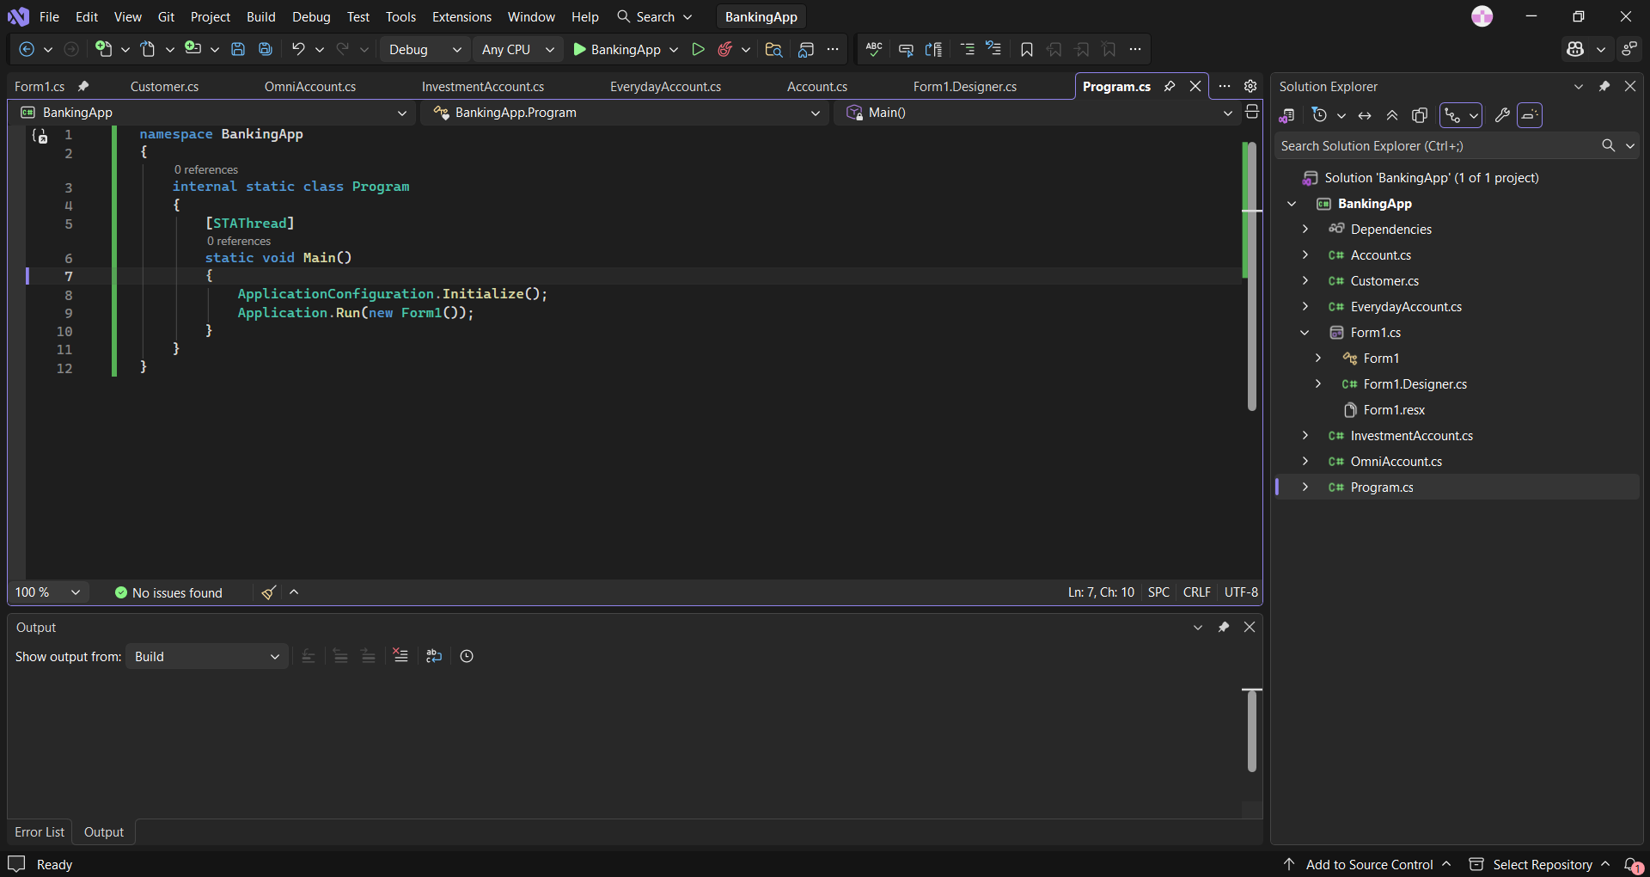
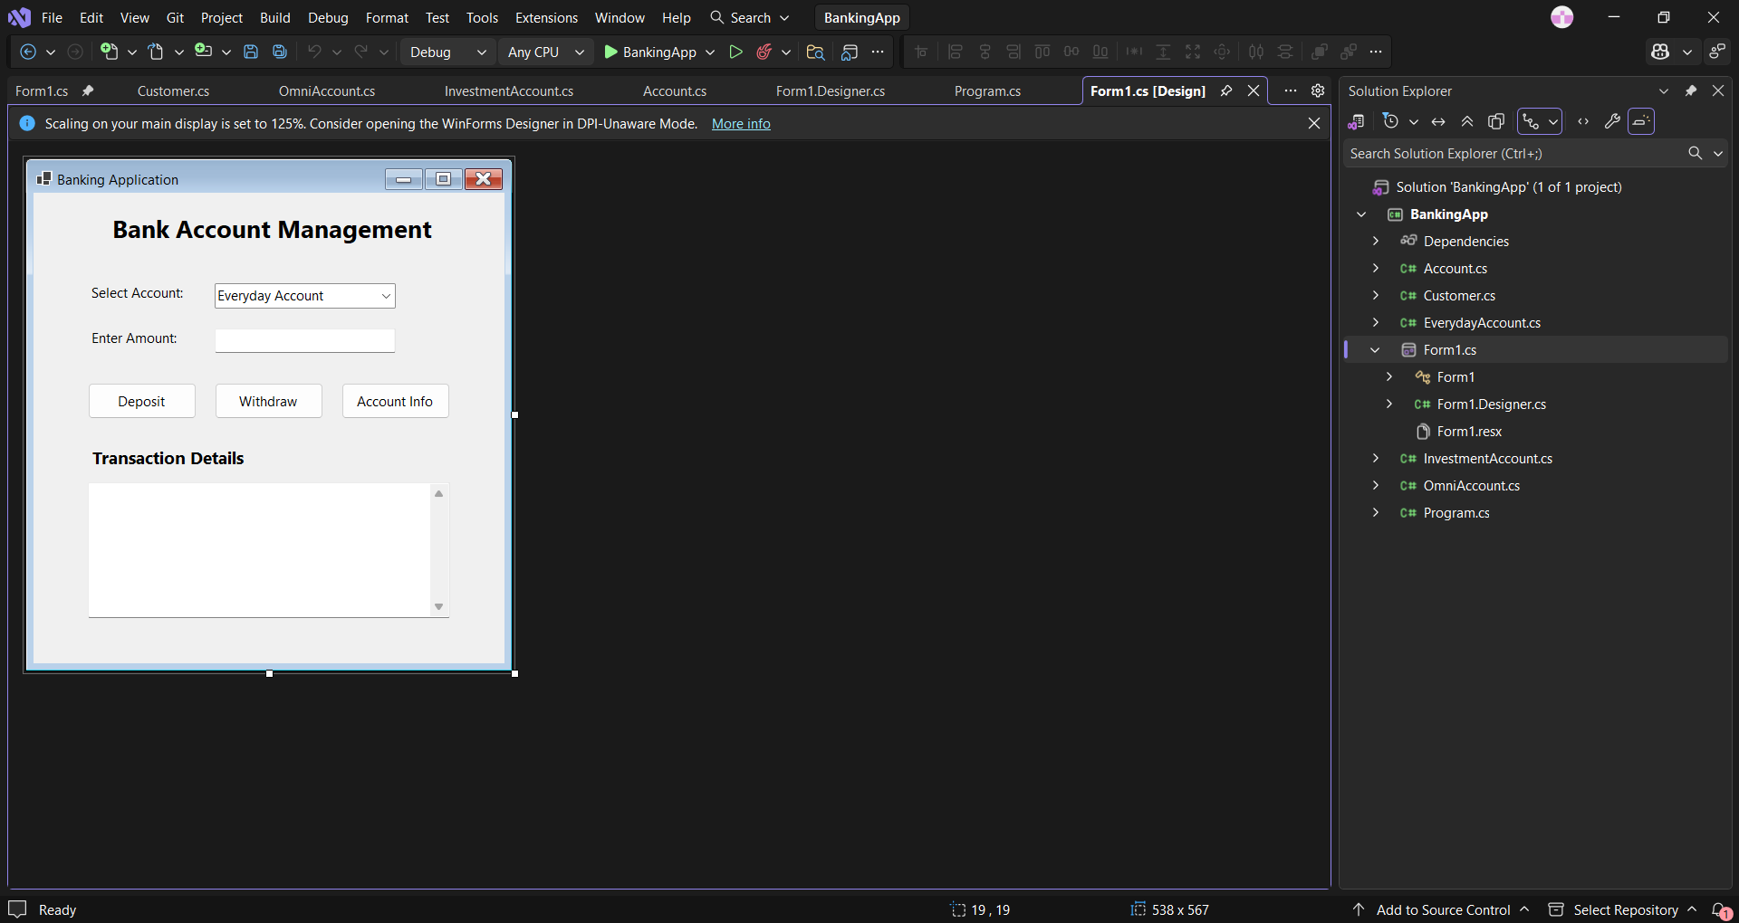

3. UI WIREFRAME
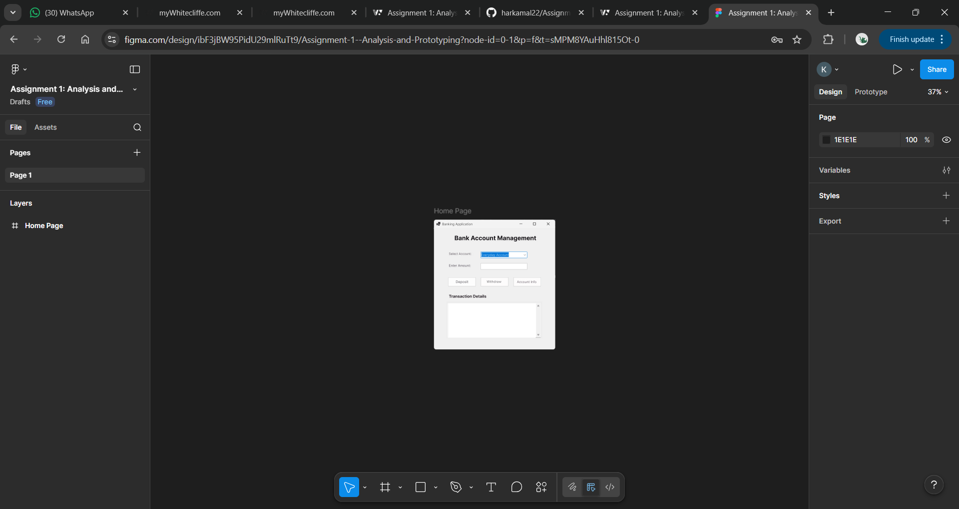
https://www.figma.com/design/ibF3jBW95PidU29mlRuTt9/Assignment-1--Analysis-and-Prototyping?node-id=0-1&t=sMPM8YAuHhl815Ot-1

4.Github Link
https://github.com/harkamal22/Assignment-1-Analysis-and-Prototyping.git

