**It can be good to have worms: Benthic marine ecosystem recovery by benthic invertebrates after a massive hypoxia and eutrophication events**

Jón Einar Jónsson 1, Róbert A. Stefánsson 2, Valtýr Sigurðsson 3,4, Menja von Schmalensee 2, Árni Ásgeirsson 1 and Jörundur Svavarsson 5.

1 University of Iceland’s Research Center at Snæfellsnes, Hafnargata 3, 340 Stykkishólmur, Iceland

2 West Iceland Nature Research Centre, Hafnargata 3, 340 Stykkishólmur, Iceland

3,4 Biopol Biotechnology, Einbúastíg 2, 545 Skagaströnd, Iceland; and Northwest Iceland Nature Research Centre, Aðalgötu 2, 550 Sauðárkrókur, Iceland

5 University of Iceland, Faculty of Life and Environmental Sciences, Sturlugata 7, 102 Reykjavík, Iceland.

**Möguleg target rit:**

Marine Biology

Estuaries and Coasts

**Lykil orð (leitarorð):**

hypoxia (benthic invertebrates) “permanent hypoxia”, “coastal hypoxia”

bæta “sediment” við leitirnar. mældur umhverfisparameter með gögnunum.

Organic pollution (benthic invertebrates)

Marine, benthos, secondary succession

**Introduction**

Oxygen concentrations vary within ecosystems, but hypoxic conditions are a growing problem worldwide, and such events can occur at seasonal, local, and even at global and geological scales (Rabalais et al. 2001, 2010, Diaz & Rosenberg 2008, Levin et al. 2009, Zhang et al. 2010, Caswell & Frid 2017, Alosairi et al. 2021). Hypoxic conditions in aquatic systems commonly arise because of anthropogenic eutrophication (Malone and Newton 2020), where an ecosystem becomes overflowed with nutrient stressors (sewage, waste, fertilizer, or other organic material). The subsequent usage of nutrients such as nitrogen and phosphorus by macrophytes, phytoplankton and bacteria in biological processes may require more oxygen than the system can supply, leading to hypoxic (or anoxic) conditions which are lethal or sub-lethal to pelagic and benthic organisms and other metazoans. Ecosystem recovery can take years, even decades or longer (Ærtebjerg et al. 2003, Diaz & Rosenberg 2008, Jones & Schmitz 2009, Borja et al. 2010, Malone and Newton 2020, Le Moal, Gascuel-Odoux et al. 2019).

There are three main types of hypoxic conditions: seasonal, episodic (“following flooding”) and permanent (Levin et al. 2009). Hypoxic conditions commonly occur when water columns become stratified, which prevents oxygenated surface waters from mixing with lower-oxygen water near the bottom. Various taxa display differing thresholds for tolerance of low oxygen conditions (Vaquer-Sunyer & Duarte 2008, Belley et al. 2010) but such responses also depend on size of the affected area and duration of exposure (Levin et al. 2009). Wijnhoven et al. 2010 defined hypoxia (low oxygen) as O2<3 mg/l but anoxia (no oxygen) at O2<0.5 mg/l, whereas Rabalais et al. (2010) defined hypoxic conditions as O2<2 mg/l. Vaquer-Sunyer & Duarte (2008) found that the common definition of 2 mg O2/l as hypoxic was below empirical sub-lethal and lethal O2thresholds for 50% the species tested, which implied that past, present and future distribution of hypoxic impacts on marine life generally have been underestimated.

Hypoxic conditions can be permanent, which makes it difficult for benthic animals to re-establish (Wijnhoven et al. 2010, Belley et al. 2010, Raman et al. 2015) but can also occur seasonally in water bodies which are largely land-locked or have relatively narrow outlets relative to their volume. Examples include estuaries, fjords, lagoons, or even land-locked oceans (e.g. Baltic and Black seas) which have relatively limited water exchange with sources of oxygenated water and relatively long residence times (Levin et al. 2009). To date, many of the fjord-like hypoxic ecosystems studied so far with respect to benthic fauna are estuaries with seasonal hypoxia, i.e. transition zones where freshwater from land and seawater mix with the occasional hyper abundance of fresh or saline conditions leading to stratifications (with seasonal nutrient or salinity overflows) and subsequent oxygen depletion, but also periods of recovery in between the seasonal stress (Leon-Morales & Vargas 1998, Como & Magni 2009, Yoshino et al. 2010, Díaz-Asencio et al. 2015). Studies of one-time hypoxic events (one-time hypoxic conditions with subsequent recovery for years without repeated hypoxic stressors), are relatively rare for marine/saline fjords, especially in the Northern Hemisphere (Micaroni et al. 2021). They are commonly associated with anthropogenic eutrophication although such events might also arise due to natural phases of seasonal cycles (Josefson & Widbom 1988, Fallesen et al. 2000, Nilsson & Rosenberg 2000, Hansen et al. 2002).

In the winter 2012-2013, a massive hypoxic event of catastrophic proportions occurred in Kolgrafarfjörður fjord, West-Iceland (Fig.1). Approximately 300 thousand tonnes (~70% of the Icelandic spawning stock) of herring (*Clupea harengus*) entered the semi-enclosed 6 km long fjord as part of their natural overwintering behaviour (Óskarsson et al. 2018, Jónsson et al. 2009). A combination of oxygen consumption by the colossal quantity of herring in the 0.2 km3 fjord (this amount of herring in the fjord might lower the oxygen concentrations to hypoxic levels in a few hours (Óskarsson et al. 2018)), unusually calm and cold weather and surface ice formation limiting oxygen exchange with the air, along with the semi-enclosed nature of the fjord caused a mass hypoxic fish kill of a cumulative total 55 thousand tonnes of herring in two separate occasions six weeks apart (hereafter herring event). The full volume of dead herring in Kolgrafarfjörður in winter 2012-2013, equating to 180 million individuals, was of similar magnitude as Iceland’s entire allowable herring catch in the 2012-2013 fishing season (Óskarsson et al. 2018, Jónsson et al. 2019). Measurements of oxygen saturation in the fjord in the days following the mass fish kill incidents clearly showed hypoxic environmental conditions with as low oxygen levels as 1.1 ml/L near the bottom (Óskarsson et al. 2018).

The magnitude of the fish death was clearly visible, as approximately 7 thousand tons of herring washed ashore during the later incident (Fig. 2). The immediate consequences for the benthic fauna were less clear, although numerous dead invertebrates of diverse taxa also washed ashore along with the dead herring (Stefánsson & von Schmalensee 2013). Given the low oxygen levels near the bottom of the fjord during the hypoxic events that led to the fish kills (Óskarsson et al. 2018), it is likely that the benthic fauna was also influenced at that time. In the weeks and months that followed, the benthic ecosystem experienced additional environmental stress, as thousands of tons of decomposing herring caused eutrophication and probably further hypoxia in the fjord, at least near the bottom.

The hypoxia event and following eutrophication in Kolgrafarfjörður in winter 2012-2013 was a one-time incident, as no further fish kills has occurred there since. The herring death thus presented a unique opportunity to follow the recovery of the benthic ecosystem in the years after the event. Mass fish kills are increasing worldwide, with numerous negative consequences (La & Cooke 2011, Alosairi et al. 2021). Understanding the effects such events can have on other species is therefore of the utmost importance.

This project began in the summer immediately after the herring deaths and sampling ran six years from 2013-2017. The project goal was twofold: 1) Estimate the effects of the hypoxia and eutrophication event on the benthos of Kolgrafarfjörður, by comparing our data from 2013-2017 to a dataset using the same sampling stations from 1999 (Ingólfsson 1999); 2) Quantify how species composition and number of individual macrofauna recover after the environmental shock event and estimate the time period needed until full recovery. Specifically, we looked at the emergence of species capable of decomposing the herring mass under eutrophic and hypoxic conditions and subsequently how they were replaced by pioneer species that normally live in undisturbed conditions. Species sensitive to low oxygen levels were also given special attention.

**Study area**

Kolgrafarfjörður is a semi-enclosed fjord which opens north to the Breiðafjörður bay in West Iceland (Fig. 1). It has a surface area of ~10 km2, volume 0.2 km3, and maximum depth of 42 m (Óskarsson et al. 2018). A 230 m long bridge with a 150 m effective opening and a causeway was built in 2004 at the mouth of the fjord. That narrowed the opening of the fjord, but the design allowed for an approximately the same exchange of water under the bridge as before the construction. Measurements after the construction confirmed that the amplitude and timing of the tides are similar inside and outside of the bridge (Mannvit 2011), with the tide inside of Kolgrafarfjörður delayed by 18 minutes relative to the outside waters of Urthvalafjörður. The exchange of seawater in Kolgrafarfjörður is almost exclusively driven by the tides, with minor effects of e.g. wind and air pressure (Jónsson et al. 2019). There is a strong tidal current of up to at least 7 knots (3.6 m/s) under the bridge between low and high tide (Óskarsson et al. 2018). The main direction of the current inside Kolgrafarfjörður is south along the west side of the fjord and out towards the bridge along the middle and east coast. Estimated flushing time of the fjord is 2.6 days at spring tide and 6.7 days at neap tide. Freshwater inflow to the fjord is at least two orders of magnitude smaller than the flow under the bridge. Generally, stratification in Kolgrafarfjörður is not expected to be common or important, although during calm and cold weather conditions, the freshwater runoff to Kolgrafarfjörður can create a less dense and colder surface layer, which may facilitate the formation of a thin layer of sea ice and hence limit the ocean-atmosphere exchange of oxygen (Jónsson et al. 2019). Anthropogenic influence on nutrients in the fjord are considered insignificant, as this is a rural area and only two small farms are situated at the fjord, although the fjord is occasionally entered by smaller fishing vessels. The fjord is saline despite freshwater input from nearby mountains.

Following the mass herring death in the winter 2012/2013, considerable effort was put into research to try to understand the role of different physical parameters in the events, including measurements of currents, wind, sea-level, temperature, salinity and oxygen at various positions and depths (see Óskarsson et al. 2018 and Jónsson et al. 2019).

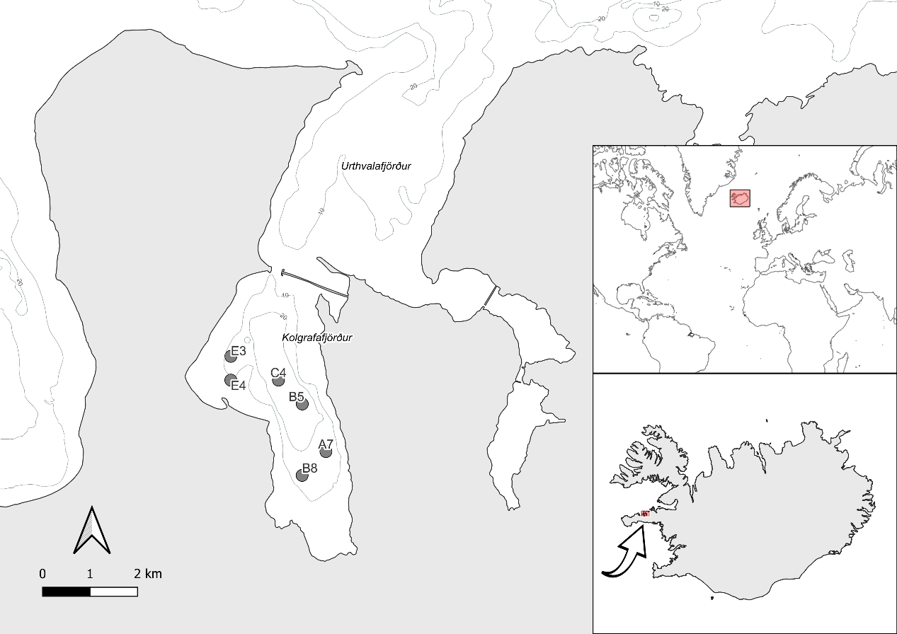

Figure 1. Map of Kolgrafarfjörður fjord in Iceland, showing sampling stations with depth contours. Insets provide geographic context: the larger inset (top) highlights Iceland’s location within the North Atlantic; the smaller inset focuses on Iceland, showing the fjord’s position.

Figure 2. Photos of the aftermath of the herring event in Kolgrafarfjörður, West Iceland in December 2012 and February 2013. Photos by RAS and MvS.

**2 Materials and methods**

This study investigates the long-term changes in benthic polychaete communities and sediment characteristics in Kolgrafarfjörður, Iceland, from 2013 to 2017, with a comparative reference to a 1999 baseline survey. Our methodology encompasses four main components: (1) a sampling design that aligns with selected stations from a previous 1999 environmental assessment, allowing for potential long-term comparisons; (2) detailed protocols for invertebrate sampling, processing, and identification; (3) sediment analysis for grain size and organic matter content; and (4) comprehensive data processing and statistical analyses. We used field sampling, laboratory analyses, and statistical methods to examine spatial and temporal patterns in polychaete communities and sediment characteristics. This approach allowed us to investigate ecosystem dynamics (2013-2017) while also providing context for potential long-term changes since 1999.

**2.1 Sampling design**

2.1.1 Baseline sampling in 1999

In the year 1999 an environmental impact assessment was done by Ingólfsson (1999) with an extensive sampling campaign of soft bottom fauna in the fjord. A single sample was collected from multiple stations in a grid-like pattern over the fjord with a small Ekman grab (0.0225 m2).

2.1.2 Sampling effort 2013-2017

Six of the stations used by Ingólfsson (1999) were selected for this study in 2013, the reason being their homogenous species composition, relative high diversity, and their similar sediment characteristics, allowing for fair comparison with later sampling. Research expeditions were in June/July each year.

**2.2 Invertebrate sampling strategy and analyses**

2.2.1 Field sampling

Sediment samples for benthic fauna were collected at each station using a Shipek© grab (0.04 m² sampling surface; three replicates). The samples were sieved with seawater onboard through a 0.5 mm mesh to retain macrozoobenthic organisms. The retained organisms were immediately preserved in a formaldehyde solution (5% v/v, neutralized with borax). Within a week, the samples were transferred to 70% ethanol. An additional sample was collected at each station for sediment analysis and preserved in 70% ethanol.

2.2.2 Laboratory processing

In the laboratory, the benthic macrofauna was sorted and identified. Each sample was dyed with Bengal Rose to facilitate sorting. Sub-sampling was employed to manage the collected samples effectively. After removing the largest organisms visible under a magnifying glass, the samples were divided using an Endecott's sample divider, splitting each sample into two parts, repeated three times, to ensure a representative subset for detailed analysis. The macrofauna was identified to species, when possible, otherwise to lowest possible taxonomic levels.

2.2.3 Species identification and quality assurance

For quality assurance, the same person, our colleague the late Guðmundur Víðir Helgason verified all annelid identifications in both this study and Ingólfsson (1999), apart from 2016 where VS and JS handled identifications following Helgason’s passing in May 2020.

**2.3. Sediment characteristics**

2.3.1. Sediment sampling and grain-size analysis

Sediment grain-size and organic matter content were assessed at each station. Sediments were sampled using the Shipek grab sampler and used for grain-size analysis. Small pebbles and shell fragments were separated from the sand and mud fractions by hand. Samples were dried at 60°C for 24 hours and sieved. To prevent clotting, the samples were stirred 2-3 times during the drying process and gently tapped with a spoon during sieving. The dried samples were sieved using a series of mesh sizes (4000, 2000, 1000, 250, 125, and 63 µm). Each size fraction was then weighed to determine the proportion of sediment in each particle size group.

2.3.2. Organic matter content analysis

The organic matter content of sediment samples was estimated by using loss on ignition (Heiri et al. 2001). Triplicate of subsamples of (2±0.05 g) were weighed directly in porcelain melting pots and burned at 475 °C for 2 hours. Only the fraction <63 µm was used for the analysis of organic content.

**2.4 Data processing and analysis**

2.4.1 Data processing

Raw count data were imported and adjusted for sub-sampling and sampling area. Counts were scaled to individuals per square meter based on the bottom grab size (0.04 m² for 2013-2017, 0.0225 m² for 1999). Species names and taxonomic classifications were standardized using the World Register of Marine Species (WoRMS) database via the 'worrms' R package (Chamberlain, 2023). Data cleaning involved removing entries related to newly settled individuals, juveniles, and specific taxa to focus on established adult populations.

Prior to multivariate analyses, a taxonomic harmonization process was performed to ensure consistency across samples and minimize artificial inflation of diversity. This involved standardizing taxonomic classifications and merging some lower taxonomic groups into higher taxa when inconsistencies were found. Data were summarized to year, station and species and merged with the environmental variables such as depth, percentage organic material in sediment, and grain size proportion in sediment. This integration allows for the exploration of how environmental factors influence species distribution, abundance, and community structure.

2.4.2 Assessment of Benthic Ecological Quality

To assess the ecological quality of benthic communities, we employed a normalized version of the Norwegian Quality Index (nNQI1) which combines AMBI with Shannon-Wiener diversity index. and was calculated using the BBI package (Cordier et al., 2021) in R (R Core Team, 2023). The rNQI1 index is commonly used by the Icelandic Marine Research Institute when working in Icelandic waters (Woods et al. 2021).

The Norwegian Quality Index (NQI1) is a composite index that combines the AMBI index with diversity measures, providing sensitivity to both disturbance and biodiversity changes (Rygg, 2006). The AZTI Marine Biotic Index (AMBI) classifies species into ecological groups based on their sensitivity to pollution stress (Borja et al., 2000). The Shannon diversity index accounts for both abundance and evenness of species in the community (Shannon, 1948).

The index was normalized to Ecological Quality Ratios (EQRs) ranging from 0 to 1, following the procedure outlined in Borja et al. (2007). This normalization allows for standardized comparison across indices and ecosystems.

2.4.3 Multivariate analysis

We analysed benthic community composition data using standardized, untransformed count data across 126 harmonized taxonomic categories. Using the vegan package in R (Oksanen et al. 2024) we employed three complementary multivariate techniques: Permutational Multivariate Analysis of Variance (PERMANOVA), Non-metric Multidimensional Scaling (NMDS), and Similarity Percentage analysis (SIMPER).

PERMANOVA tested for significant differences in community composition across space and time using the 'adonis2' function with 999 permutations and Bray-Curtis dissimilarity. The model included station and year as factors. NMDS visualized community composition patterns using the 'metaMDS' function with Bray-Curtis dissimilarities. Species contributing >1% to total abundance were included in the analysis. Environmental vectors were fitted to the ordination using the 'envfit' function, and only vectors with p < 0.05 were retained. Station trajectories were visualized using arrows connecting consecutive years, with arrow length representing magnitude of community change.

SIMPER analysis identified species contributing most to dissimilarity between early (2013-2014) and late (2016-2017) periods using the 'simper' function. These analyses collectively assess spatial and temporal variability in benthic community composition, identify key species driving changes, and visualize community change trajectories at each sampling station.

2.4.4 Sediment statistical analysis

2.4.4.1 Grain size

To analyse the temporal and spatial patterns in sediment grain size distribution, we employed beta regression models using the betareg package in R (Cribari-Neto & Zeileis, 2010). Beta regression is appropriate for analysing proportional data that are bounded between 0 and 1. Separate models were fitted for each grain size category (20 μm, 63 μm, 125 μm, 250 μm, and 1000 μm), with sampling year and station as predictors.

2.4.4.2 Organic Matter

Due to non-normal distribution of organic content data, we employed the non-parametric Kruskal-Wallis test to examine temporal differences across the five-year study period. This approach is robust against violations of normality and appropriate for comparing multiple independent groups with continuous response variables. Following significant Kruskal-Wallis results, Dunn's test with Bonferroni correction was used for post-hoc pairwise comparisons between years and stations.

**3. Results**

A total of 149 taxa of were found at 6 stations over the 5 year period. The number of taxa per station-year ranged from 2 (station A7, 2013) to 49 (station E3, 2017). Total organism density varied from 500 individuals/m² (station A7, 2013) to 27,392 individuals/m² (station E3, 2013). The proportion of organic content in the sediment declined significantly after the initial samples in 2013 and remained relatively steady for the rest of the study period, aligning with the expected decomposition and dispersal of organic matter from the herring die-off. The number of individuals per m² dropped drastically in the first two years, then increased and seemed to stabilize by the last year of the study. The number of species indicates a gradual recovery over the study period, starting at a low level in 2013 and reaching a threefold count by 2017.

Ættum við að sundurliða eftir Polychaeta, Crustacea og Bivalvia? Gefa % hlutdeild helstu hópa eftir árum?

Þurfum við ekki species accumulation curves?

**3.1 Temporal Changes in Benthic Biotic Indices**

Normalized biotic indices pooled across all stations in Kolgrafarfjörður revealed clear temporal patterns during 1999-2017 (Table 1). The pre-mortality period (1999) showed good ecological status with relatively low variance between stations (nAMBI: 0.67 ± 0.05, nNQI1: 0.54 ± 0.04, nShannon: 0.68 ± 0.02). The 2013 mass mortality event resulted in severe community degradation, with indices dropping to their lowest values (nAMBI: 0.08 ± 0.11, nNQI1: 0.21 ± 0.09, nShannon: 0.09 ± 0.13). Recovery began in 2014, marked by high variability between stations (nAMBI: 0.40 ± 0.22), reflecting asynchronous recovery patterns, particularly evident in station C4 which showed minimal recovery (nAMBI = 0.00) while stations E4 and B8 approached pre-mortality conditions. By 2015, the community had largely recovered to good status with reduced between-station variability (nAMBI: 0.66 ± 0.02, nNQI1: 0.52 ± 0.04, nShannon: 0.65 ± 0.04), maintaining similar conditions in 2017.

Table 1: Mean normalized benthic indices (± SD) across all stations showing temporal changes in Kolgrafarfjörður fjord from 1999 to 2017.

| **Year** | **nAMBI** | **nNQI1** | **nShannon** | **Ecological Status** |
| --- | --- | --- | --- | --- |
| 1999 | 0.67 ± 0.05 | 0.54 ± 0.04 | 0.68 ± 0.03 | Good |
| 2013 | 0.08 ± 0.11 | 0.21 ± 0.09 | 0.09 ± 0.13 | Bad |
| 2014 | 0.4 ± 0.22 | 0.39 ± 0.12 | 0.44 ± 0.25 | Moderate |
| 2015 | 0.66 ± 0.02 | 0.51 ± 0.04 | 0.65 ± 0.04 | Good |
| 2016 | 0.64 ± 0.02 | 0.52 ± 0.03 | 0.65 ± 0.04 | Good |
| 2,017 | 0.63 ± 0.04 | 0.51 ± 0.05 | 0.66 ± 0.07 | Good |

**3.2 Multivariate Analysis Results**

3.2.1 NMDS Ordination and Environmental Correlations

Non-metric multidimensional scaling (NMDS) ordination revealed clear temporal patterns in benthic community composition from 2013 to 2017 (stress = 0.138). The analysis, based on Bray-Curtis dissimilarities of 104 taxa across 36 samples (6 stations × 6 years), showed distinct recovery trajectories for different stations. Environmental fitting identified significant correlations with sediment characteristics (p < 0.05): organic content (r² = 0.640), fine mud <63μm (r² = 0.536), very fine particles <20μm (r² = 0.469), and medium-fine particles <125μm (r² = 0.334).

The NDMS analysis showed the years 2013 and 2014 each aggregating into ellipses by year rather than grouping the data by stations (Figure 3). The reference year 1999 was farthest away from 2013 and 2014, but 2015, 2016 and 2017 were intermediates which overlapped somewhat with one another but were more similar to 1999 than 2013 and 2014. The data grouped somewhat more by station than by year for data from 2015, 2016 and 2017, with stations E3 and E4 grouping away from the other 4 stations (lower position on the graph).

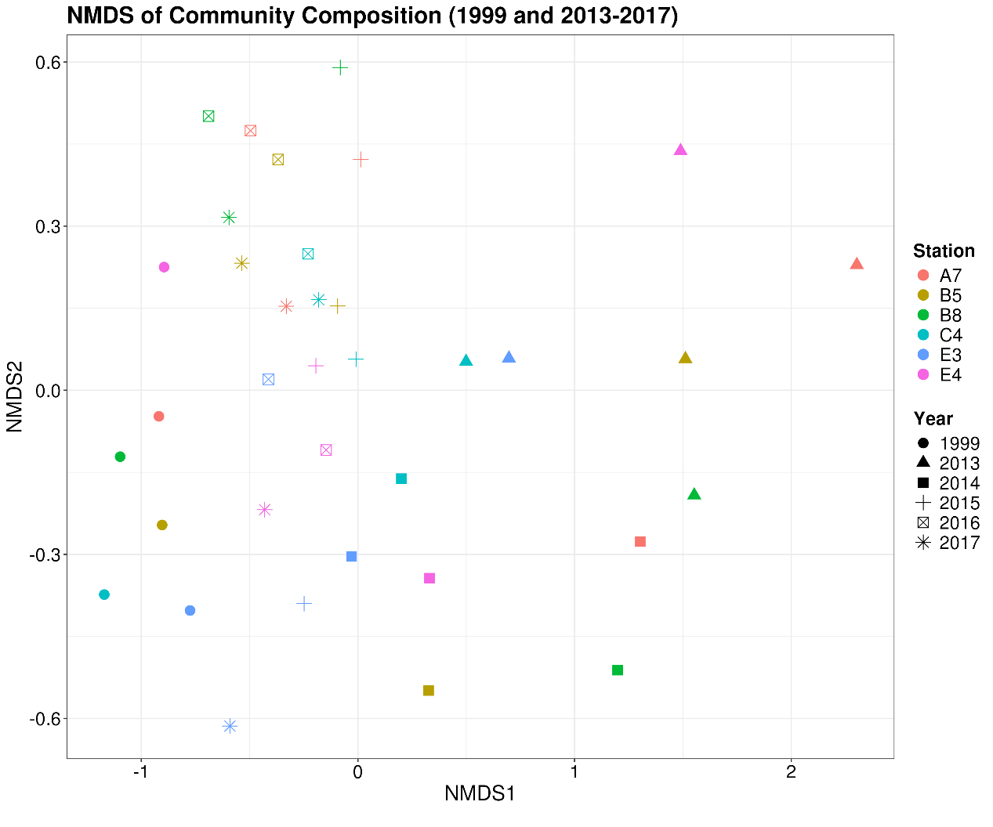Figure 3. Non-metric multidimensional scaling (NMDS) ordination of benthic community composition in Kolgrafarfjörður comparing baseline data from 1999 with post-disturbance recovery period (2013-2017). Points represent sampling stations in different years, with color indicating station and shape indicating sampling year. The ordination is based on Bray-Curtis dissimilarities of 104 taxa across 36 samples (stress = 0.138).3.2.2 Community Succession Patterns.

Temporal analysis revealed a clear succession pattern across the five-year period. The opportunistic species *Capitella capitata* strongly dominated the early recovery phase (2013: 66,225 ind. m⁻²), showing a dramatic decline over subsequent years (2014: 12,842 ind. m⁻²; 2015: 33 ind. m⁻²; 2016: 333 ind. m⁻²) until complete absence in 2017. Despite this temporal decline, *C. capitata* remained the most abundant species overall (35.9% of total abundance, 79,433 ind. m⁻²). The succession was characterized by a shift from *C. capitata* dominance to a more diverse community, with *Polydora sp.* (8.56%, 18,975 ind. m⁻²) and *Ophelina acuminata* (8.09%, 17,912 ind. m⁻²) becoming prominent in later years. By 2017, the community was dominated by Polydora (11,908 ind. m⁻²) and *Scalibregma inflatum* (5,133 ind. m⁻²), with increased abundances of equilibrium species such as *Macoma calcarea* (4,312 ind. m⁻²) and *Scoloplos armiger* (3,700 ind. m⁻²).

3.2.3 Spatial Organization in NMDS Space

The NMDS ordination showed clear spatial segregation of dominant species. *C. capitata*, the most abundant species (27.0% of total abundance), was strongly isolated in positive NMDS1 space (NMDS1 = 1.91), distinctly separated from all other species. A group of five species/taxa, including *Polydora sp.* (10.4%) and *Spio sp.* (7.1%), occupied neutral positions in the ordination space, suggesting their generalist distribution patterns. Species associated with positive NMDS2 scores included *O. acuminata* (6.5%) and *Macoma calcarea* (5.4%), while a distinct cluster of species including *Tubificoides benedii* (3.3%) and *S. inflatum* (3.3%) showed strong negative NMDS1 scores, suggesting their association with later recovery stages of the community succession.

3.2.4 - Station Recovery Trajectories

Station trajectories varied markedly in both total length (range: 2.78-6.69 units) and net displacement (range: 0.280-1.13 units), with station A7 showing the longest recovery path (6.69 units) and station C4 the shortest (2.78 units). All stations exhibited similar initial movement directions (18.9° to 36.2°), with stations E3 and E4 showing slightly higher angles (~29°) compared to other stations. The initial post-impact community (2013) showed substantial movement magnitude (0.917 ± 0.436 units), with movement decreasing consistently through subsequent years (2014: 0.861 ± 0.600; 2015: 0.401 ± 0.161; 2016: 0.314 ± 0.191 units).

3.2.5 - Temporal Consistency and Environmental Relationships

This recovery process showed remarkable spatial and temporal consistency across Kolgrafarfjörður, with community composition changing predictably over time during the recovery period (NMDS temporal gradient: r² = 0.702, p = 0.001). Tests of multivariate dispersion revealed no significant differences in community variability either between years (F = 0.719, p = 0.587) or between stations (F = 0.569, p = 0.723), indicating an orderly, fjord-wide recovery rather than patchy recolonization. This structured succession was strongly linked to the processing or dispersion of organic matter (r² = 0.549, p = 0.001), suggesting that the decomposition of herring biomass drove a coordinated ecosystem recovery.

3.2.6 - Long-term Change and Baseline Comparison

The 1999 baseline data, while collected using different sampling techniques, provides important historical context for the post-disturbance community development. The distance between the 2017 communities and the 1999 baseline state (0.657 ± 0.271 units in NMDS space) exceeded the final year-to-year changes during recovery (0.314 ± 0.191 units), indicating that while the community had stabilized by 2017, it had shifted to a different configuration than its pre-disturbance state. This transformation suggests that the hypoxic event may have triggered a transition to an alternative stable state in the fjord's benthic community structure.

**3.3 PCA Analysis**

3.3.1 PCA analysis of species density by station

The PCA analysis explained between 69.2% and 99.9% of the total variance in the species density data, with particularly high explanation (99.9%) in 2013 when the community was dominated by *Capitella capitata*.

The PCA plots align the arrows, representing the sampling stations, together when they show similar densities of species, with highest densities shown by those furthest away from the center of the graphs, pointing towards species that are highest in density.

According to PCA plots, the E3 and E4 stations (to the west of the fjord) aligned together in a different direction from other stations, in 1999 (Figure 4A); conversely, the stations do not differ from one another in 2013, 2014, and 2015 (Figure 4b, 4c and 4d). In 2016 and 2017, the alignment of E3 and E4 away from other stations seems to have returned (Figure 4e, 4f) but that is mostly due to high densities of *Spio* sp. and *Polydora* sp.

3.3.1.1 Baseline Year - 1999

According to PCA plots, stations E3 and E4 (to the west of the fjord) aligned together (Figure 4A). E3 and E4 both had high densities of two annelids, i.e. the polychaete *Polydora* sp. (absent from all other stations) and the oligochaete *Tubificoides benedii* (low densities at B8 and C4, absent from A7 and B5).

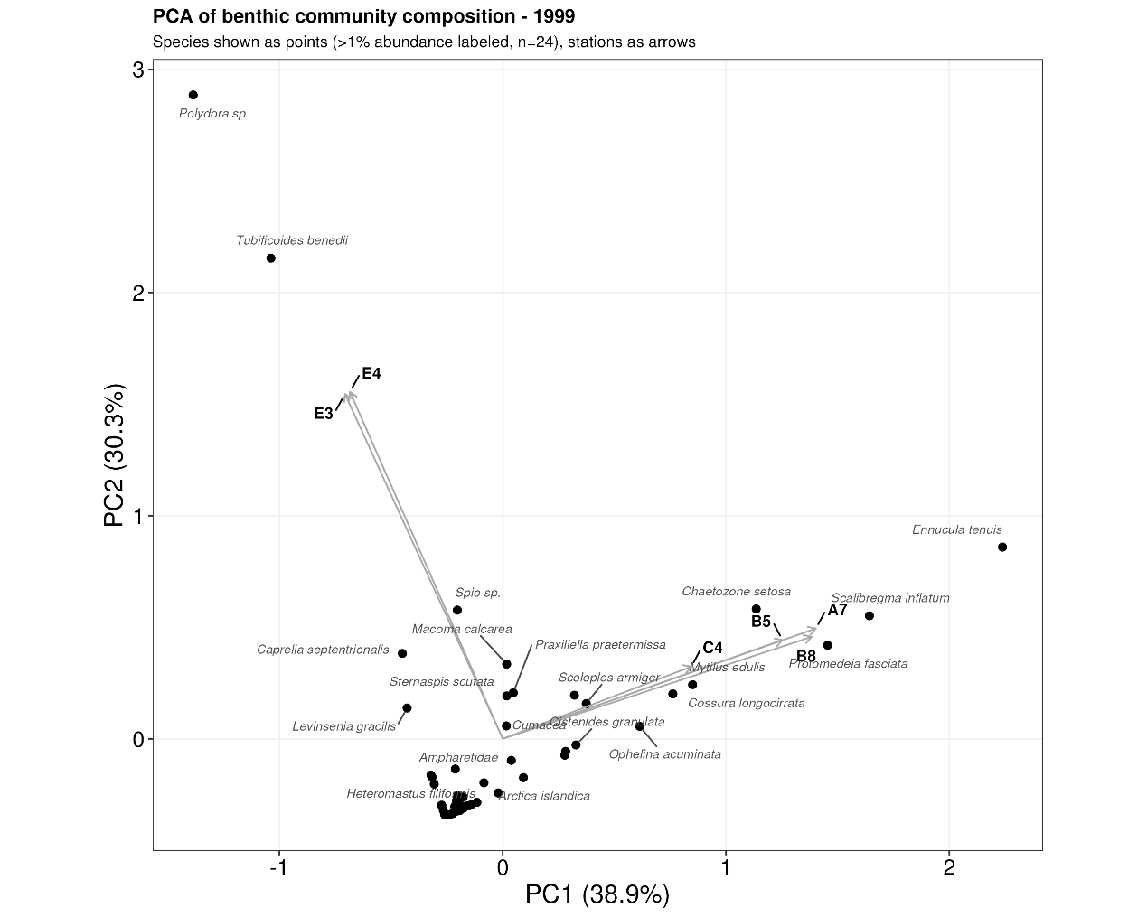

The other stations (A7, B5, B8, and C4), located to the east, aligned together away from E3 and E4 (Figure 4A). These were characterized by the bivalve *Ennucula tenuis*, two polychaetes *Scalibregma inflatum* and *Chaetozone setosa*, and the amphipod *Protomedeia fasciata*.

3.3.1.2 Impact Years - 2013 and 2014

The year at the organic enrichment (2013) was characterized by aberrantly high densities of the deposit-feeding polychaete *Capitella capitata* (Figure 4b and 4c), which is an enrichment opportunist. The extremely high variance explanation (98.9% on PC1 alone) quantitatively demonstrates *C. capitata*'s dominance of the community structure. *Spio* sp. was also prominent in 2013 but at lower densities than *C. capitata* and mostly occurring at stations C4 and E3. Additional species of note included the polychaete *Chaetozone setosa* (1.77% relative abundance) and the oligochaete *Tubificoides kozloffi* (<1%). The polychaetes *Harmothoe extenuata* and *Eteone longa* were present but at very low densities (<1% relative abundance.

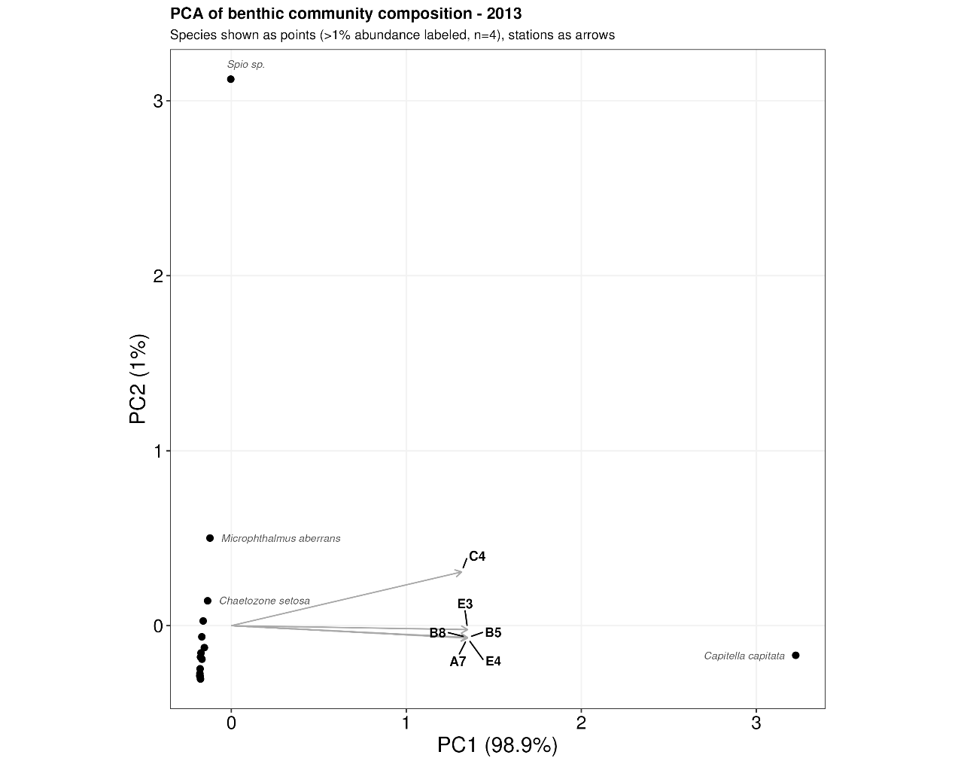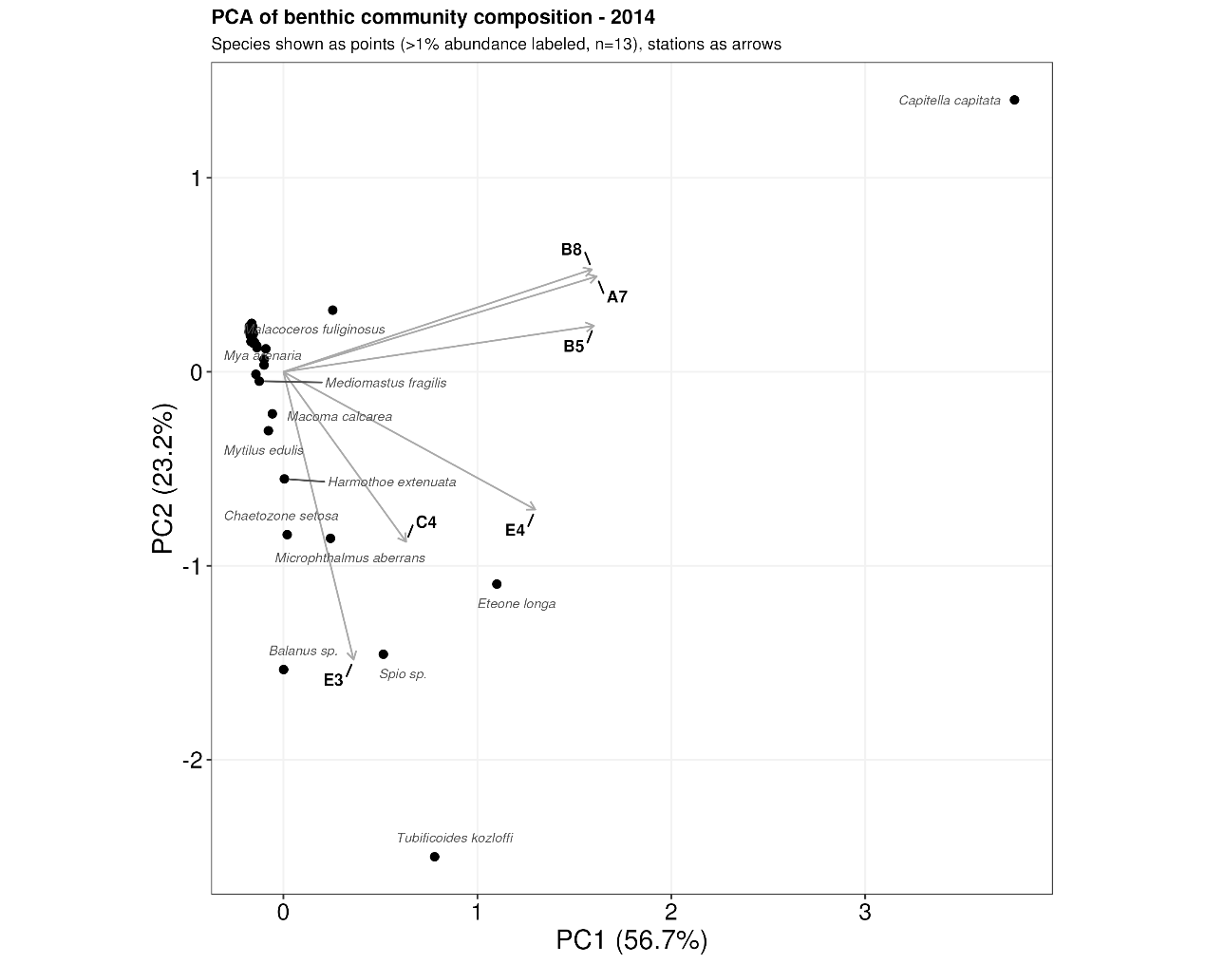

In 2014, the PCA explained 79.9% of the variance, with PC1 accounting for 56.7% and PC2 for 23.2%. This lower total variance (compared to 2013) reflects the increased complexity in species composition. The same species were the most common ones, but the number of species had increased substantially at stations B5, C4, E3 and E4. E3 aligned with the neighbouring C4 station but away from B5, A7 and B8, with E4 in between the two groups (Figure 4c). Station A7 and B8 were highest in *C. capitata* densities, followed by B5 and E4 but only low densities at stations C4 and E3. At stations E3 and E4, *Tubificoides kozloffi* reached high densities in 2014 at two stations (E3 and E4) (Figure 4c). Other notable species in 2014 included the surface-dwelling polychaete predator *Eteone longa* at all stations, the polychaete *Microphthalmus aberrans* at stations C4, E3 and E4, and four species at station E3; the barnacle *Balanus* sp., the polychaetes *Chaetozone setosa* and *Harmothoe extenuate* and the bivalve *Mytilus edulis*. Notably, Polydora sp. returned to stations E3 and E4 (same as 1999) in very low densities, after not being found at all in 2013.

3.3.1.3 Transition year - 2015

The PCA explained most of the variation in the community data, with the first two axes capturing 87.4% of total variance. The community was characterized by several key species: the bivalve *Macoma calcarea*, the polychaetes *Ophelina acuminata*, and *Mediomastus fragilis*, together accounting for over 40% of total abundance.

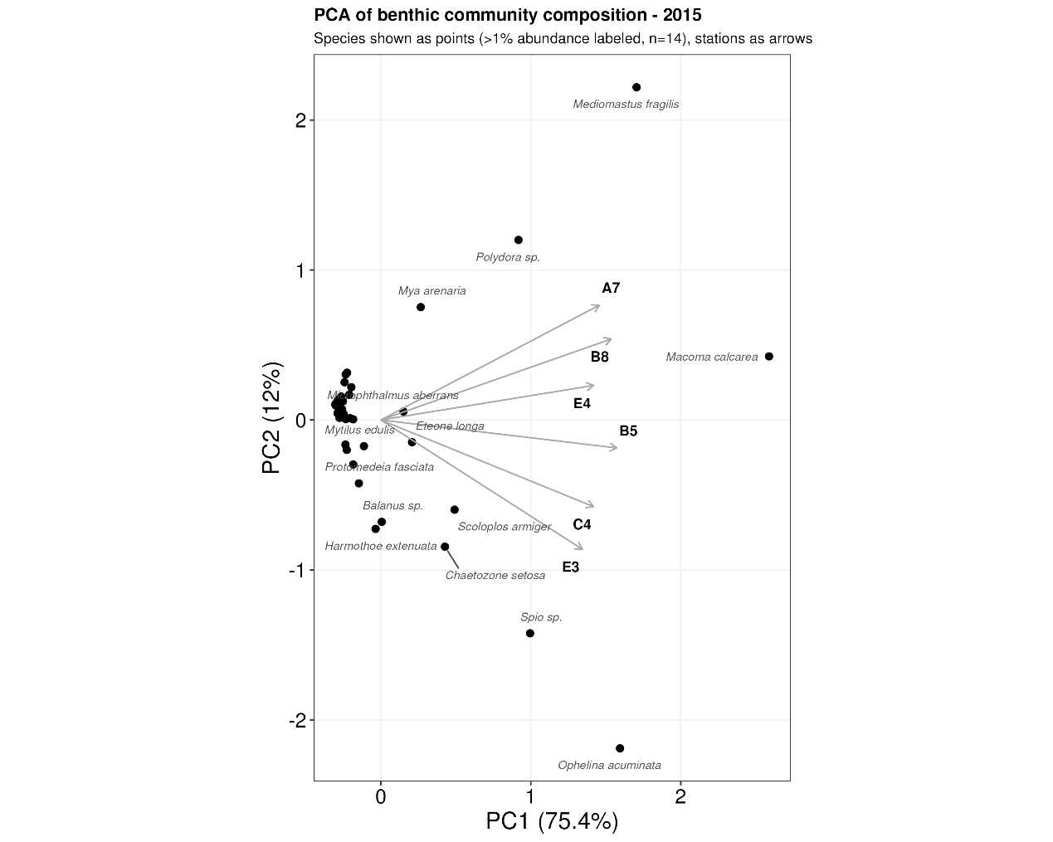

*C. capitata*, which had dominated the community in 2013 and 2014, was now found only at a single station in low density. *O. acuminata* showed strong associations with stations C4 and E3 based on the PCA. *Scoloplos armiger* was present at five of six stations but at highest densities at stations C4, and the polychaete *Mediomastus fragilis* was found at all stations (Figure 4d). Of those, *S. armiger* was found in lower densities in 1999, 2013 (C4 station only), and 2014. *O. acuminata* was found in 1999 but not in 2013 or 2014 and conversely, *M. fragilis* was not found in 1999 but in low densities in 2013 and 2014.

*Chaetozona setosa* and *Spio* sp. remained conspicuous as they did in 2013 and 2014, and Polydora sp. were found at all stations for the first time (found at E3 and E4 in 1999 and 2014 but none recorded in 2013). The bivalve *Mya arenaria* was found at all stations after being first found at stations E3 and E4 in 2014.

3.3.1.4 Recovery years - 2016 and 2017

These two years show E3 and E4 aligning towards each other, like that observed in 1999 but not in 2013, 2014 and 2015 (Figure 4). Many of the species from previous years were found in higher densities, most notably: 1) in 2016, *Spio* sp., *O. acuminata (*dominating with 22.8% abundance), *Polydora* sp., and *S. armiger*; and 2) in 2017, *Polydora* sp. (becoming dominant at 25% abundance), *S. armiger,* *Mediomastus fragilis*, *O. acuminata*, *Chaetozone setosa*, and *Mya arenaria*. We also note *Praxillella praetermissa,* found at all stations in 2016 and 2017, common in 1999 but occasionally found in 2013, 2014, and 2015. Species emerging in high densities in 2016 included: 1) the polychaete *Heteromastus filiformis*, which interestingly was found at stations E3 and E4 in 1999, not recorded in 2013-2015 and almost gone in 2017! 2) the bivalve *Macoma calcarea*, found at all stations in 1999 and 2015-2017 but not documented in 2013 and only found at C4 and E3 in 2014.

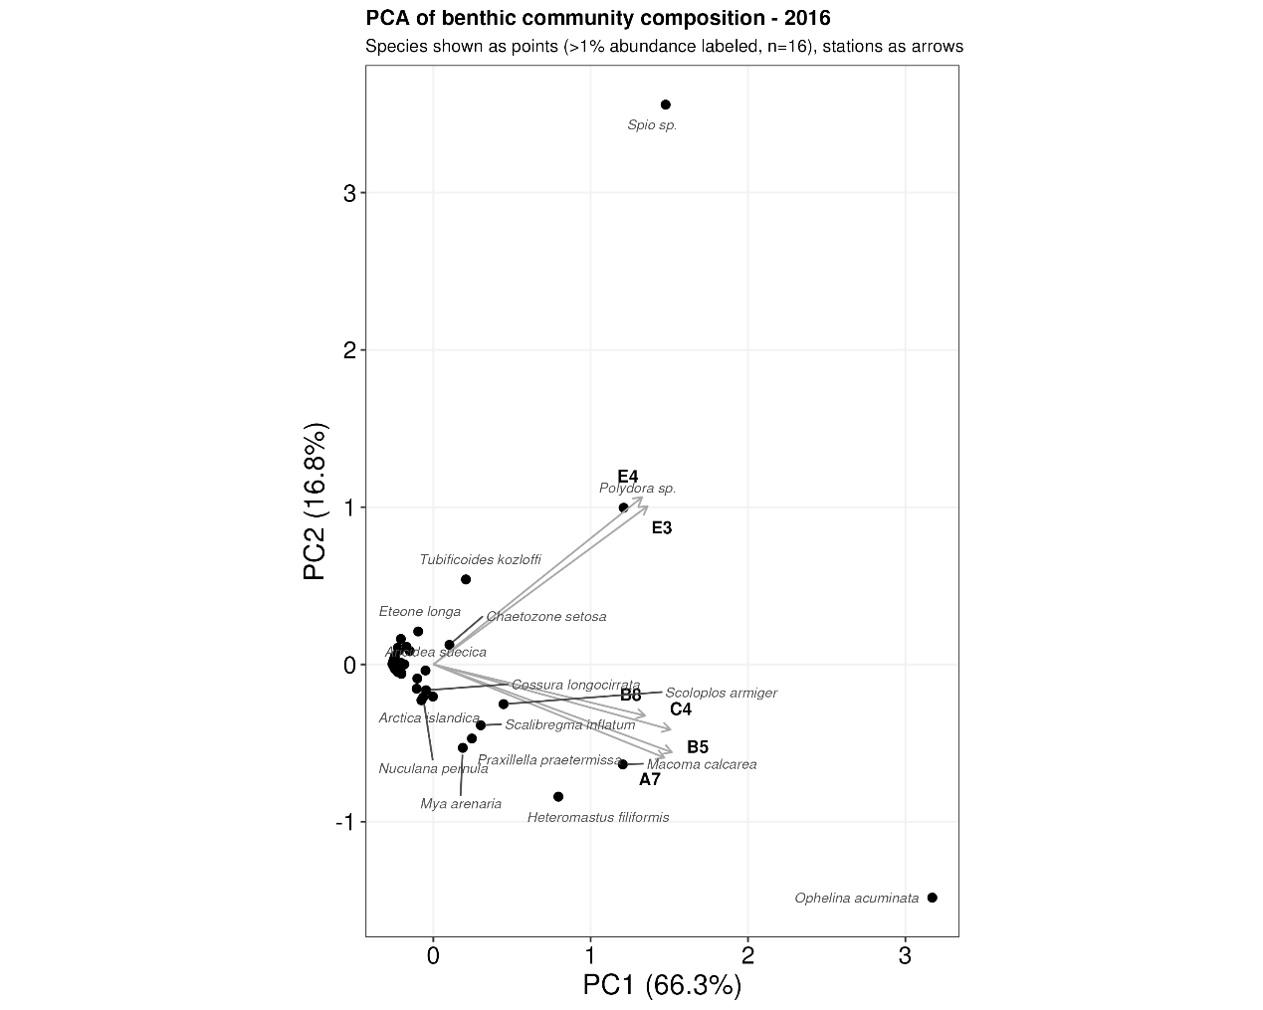

Species emerging in high densities in 2017 included: 1) the polychaete *Scalibregma inflatum,* which was common in 1999, not documented in 2013 or 2015, found in low densities 2015, common in 2016 and 2017 but reached high densities at stations A7 and B8 in 2017. and 2) the bivalve *Abra nitida*, found in low densities at 4 stations in 1999, not found in 2013, 2014 and 2015, but found in low densities at three stations in 2016 and increased densities at 5 stations in 2017 (absent from station E3).

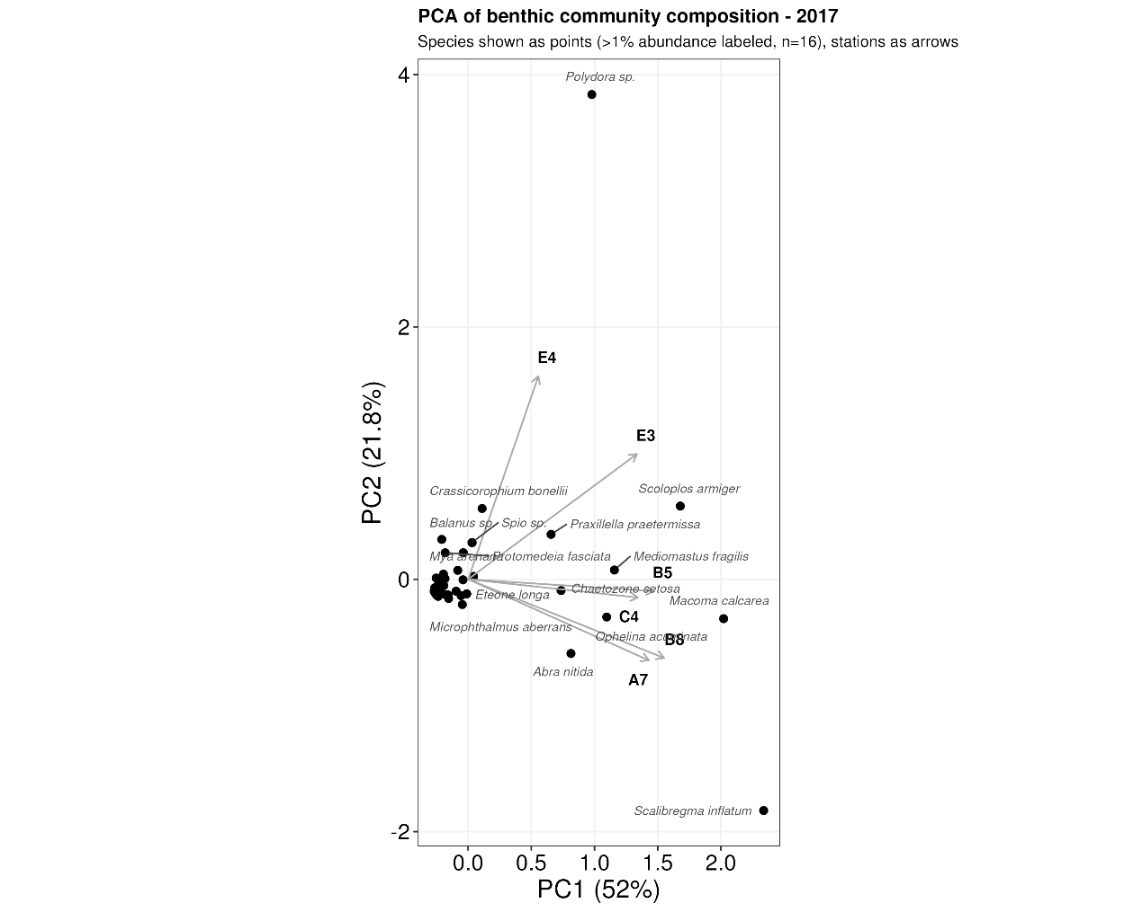

**3.4 Sediment analysis 3.4**

3.4.1 Particle size

We have no particle size data from 1999 but present a comparison of stations in 2013 and annual variation across stations that showed such variation 2013-2017. After the herring event in 2013, sediment structure was similar among the three stations to the south, A7, B5 and B8, with over 70% 63 microns or coarser (Fig. 5). Conversely, stations C5, E3 and E4 were richer in finer sediments (125 microns or finer), with E3 and E4 the only stations rich in sediment of 1000 microns.

Nefna variance (rauðu línuna í myndinna). Variance af hverju? Milli sýna innan stöðvar?

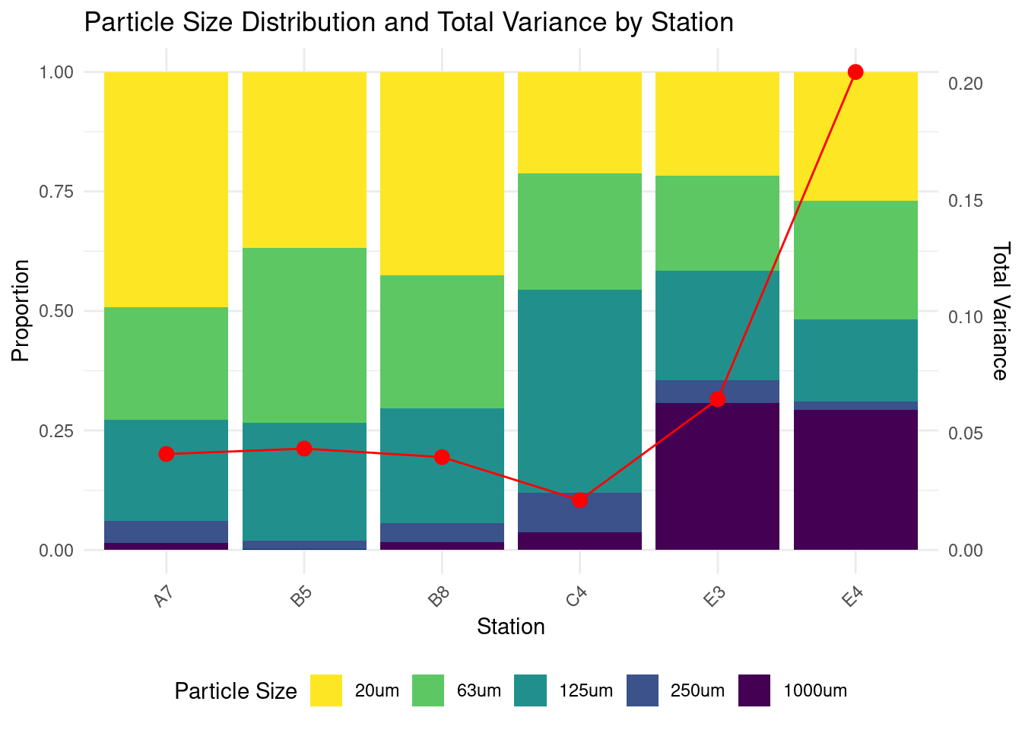

Figure 5. Proportions of dry weight of particle size groups in Kolgrafarfjörður grab sample stations from 2013 (left y-axis). Red line shows total variance of xxxx (right y-axis).

There was no annual variation in sediment particle sizes at 4 of 6 stations. The only stations to show annual variation were stations E3 and E4 (Fig. 6). The proportion of 1000 micron particles was lowest in 2013 and peaked at station E4 in 2016. The proportions of 20 micron and 63 micron particles were highest in 2013, remained high at station E4 in 2014 but declined at both stations to a low in 2016 but returned to higher values in 2017.

Þúsund micron normaldreifð í kringum 2015 nema með útgildi E4 2016, svipað með 250 micron nema útgildin 2016 þar er E3.

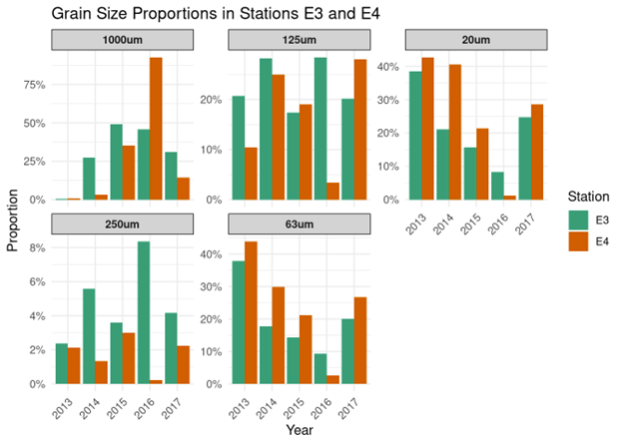

Figure 6. Annual variation in grain size distribution of the sampling stations E3 and E4 in Kolgrafarfjörður 2013-2015. The other 4 sampling stations showed no annual variation in particle sizes.

3.3.2 Organic content

While organic content showed some variation among stations (ranging from 11.2% to 13.4%), post-hoc analysis (Dunn's test with Bonferroni correction) revealed no significant differences between any station pairs (all p > 0.05). This suggests that organic content was relatively homogeneous across the study area, despite the slight tendency for higher values at station A7 (13.4% ±3.0 SD) compared to other stations.

The proportion of organic content in the sediment declined significally after the initial samples in 2013 and remained steady for the rest of the study period, aligning with the expected decomposition and dispersal of organic matter from the herring death. The number of individuals per m2 dropped drastically in the first two years, then increased and seemed to stabilize by the last year. The number of species indicates a gradual recovery over the study period, starting at a low level in 2013 and reaching a threefold count by 2017.

**4.1 Sediment**

4.1.1. Carbon content of sediment

Organic matter content differed significantly among years (Kruskal-Wallis: χ² = 16.83, p = 0.002), but not among stations (χ² = 6.14, p = 0.293). Dunn's test revealed significantly higher content in 2013 compared to 2016 (p = 0.0005) and 2017 (p = 0.0128). Median values decreased notably after 2013 (2013: 0.1763; 2014-2017 range: 0.1011-0.1184), remaining relatively stable from 2014 onwards. Station medians ranged from 0.0904 to 0.1191. Boxplots corroborated these findings, showing clear temporal differences but less pronounced spatial variations.

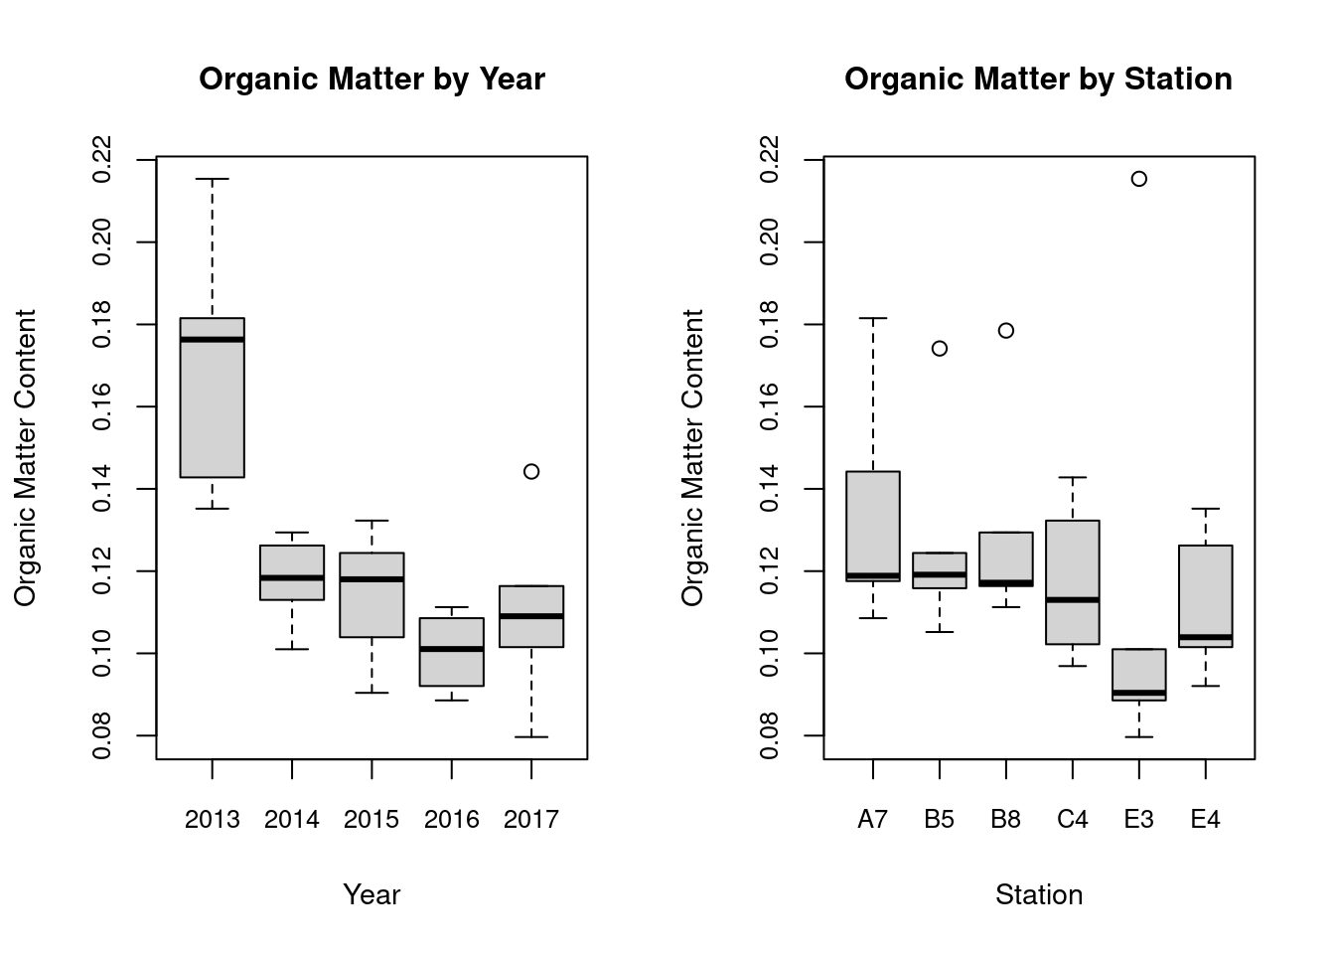

Figure 7. Organic matter content distribution in Kolgrafarfjörður. (A) Variation by year (2013-2017), showing significant decrease after 2013 (Kruskal-Wallis, p = 0.002) , with levels remaining relatively stable from 2014 to 2017. (B) Distribution across sampling stations, with no significant differences (p = 0.293).

These results indicate a significant shift in organic matter content between 2013 and subsequent years, particularly 2016 and 2017, while spatial differences were not statistically significant. This pattern suggests a potential environmental change or event occurring between 2013 and 2014 that influenced organic matter levels across the entire study area.

**Discussion**

Immediately following the herring event in 2013, biplots for the stations all pointed towards a high density of a single species, *Capitella capitata*, a specialist in anorexic benthos, and this continues as a dominant feature of the ecosystem into 2014 when *C. capitata remained* in high numbers for 4 of 6 stations. After 2014, C. capitata was only found in low densities (33 in 2015, 200 in 2016) until it vanished from the samples in 2017. After the herring event in 2013, then number of species was reduced to an all-time low of 21 total, but 4 species were conspicuous in density (200 or higher), i.e. *Microphthalmus aberrans*, *Capitella capitata*, *Harmothoe extenuate* and *Aricidea suecic*a., with *C. capitata* by far the most numerous species. These changes are reported by each year’s ecological status, which was bad for 2013, intermediate for 2014, and then good for 2015-2017 and the reference year 1999.

An important distinction between 1999 and 2013 was the separation of stations into two axes in 1999, the two westernmost stations E4 + E3 pointing vertically towards *Polydora* sp. and *Tubificoides benededi* but the remaining stations (C4 + B5 + A7 + B8) pointing towards *Chaetozone setosa*, *Ennucula tenuis*, *Scalibregma inflatum* and *Protomedeia fasciata.* The recovery of the ecosystem in 2015-2017 approaches a similar pattern to that in 1999, with 2013 and 2014 the two standout years in community structure. While we use 1999 as a reference year in this study, we acknowledge that communities could have differed between 1999 and 2012 due to naturally occurring changes in weather or sediment changes driven by storms or tidal activity (see Komendić et al. 2024).

**A summary of annual changes**

The herring event took place between December 2012 and February 2013.

**1999**: This year can be considered representative of a natural state, or even a “control” relative to later years, which were all post-herring event. However, there were species found in 1999 not recorded later, and vice versa. The dominant species found at E3 and E4 suggest muddy bottom whereas the other four stations have species that generally use a mixture of muddy, sandy and even more gravelly benthos.

**2013-2014**: These years showed strong signs of the herring event, most notably the scarcity of species and low densities but most importantly dominance by *C. capitata*, a specialist in anorexic benthos (Silva et al. 2017, Ghanavati Asl et al. 2023). The year 2013 was completely dominated by C. capitata, but 2014 is less clear, with other species haven risen to prominent densities compared to 2013. Number of species recovered to 1999-like levels by 2014.

**2015**: was an intermediate year between the herring death years 2013 and 2014 but also is different from 2016 and 2017 in many, cryptically interesting ways.

**2016-2017**: Similar years in many aspects and seem to be approaching 1999 in community structure and have more in common with 1999 than 2013-2014. However, the community structure of 2015-2017 was rather defined by stations than by year, although stations E3 and E3 were segregating away from the other stations during these years.

*C. capitata* are eutrophication specialists and are dominant in samples from areas high in organic matter (Ghanavati Asl et al. 2023). In our study, the species dominated in 2013 and 2014, for two years after the hypoxic herring event but quickly receded 2015-2016 and vanished from our samples in 2017. The disappearance of *C. Capitata* in 2017 is probably a huge step towards ecosystem restoration, with their ecosystem role of breaking down the herring mass and converting conditions into oxygenated again largely completed (Silva et al. 2017, Liu et al. 2024). The emergence of many predator species in 2014 or 2015 suggests that the Capitella were also a food source for other invertebrates.

*Capitellidae* indet. belongs to the Polychaeta Sedentaria group (POSE) and is a subsurface deposit feeder (SS-De). It is discretely motile (D), meaning it can move but does not require movement for feeding, and it is free-living (F). It is omnivorous (Om), feeding on a variety of food sizes including sediment, particulate organic matter, and benthic microfauna (sed/pom/mic).

**Temporal variation and sediment structure**

Benthic community structure can change vastly over two decades, without catastrophic events but changes in sediment structure, possibly driven by storm events (Komendić et al. 2024). We have no sediment or organic matter data for 1999, but sediment structure was constant at 4 of 6 stations 2013-2017, with some annual changes occurring at stations E3 and E4, which also showed different species compositions in 1999, and 2015- 2017. The herring event disrupted this structure in 2013 and 2014 but there was tendency to return to a similar community structure in 2015-2017. Kolgrafarfjörður is sheltered from storms but probably affected by them occasionally. However, a constant factor is the tidal activity, which may have greater effects on sediment and community structure at stations E3 and E4, which also is the location where the dead herring mass was swept towards in the wake of the herring event. The species that were prominent at E3 and E4 are pure mud specialists, whereas the prominent species at A7, B5, B8 and C4 correspond to species that utilize coarser sediments, i.e. mixtures of mud, sand and even gravel.

Importantly, Kolgrafarfjörður is a fjord with a narrow outflow and not exposed to much human activity (for example, ship traffic or aquaculture) but still faces its share of storms and tidal activity and combinations of those, including the one that lead to the herring event. This system is more pristine than most studied for organic pollutions, where influx of nutrients generally is related to human activity. However, changes in sediment structure occur at varying rates among our sampling stations, and we attribute the annual variation at stations E3 and E4 (to a lesser extent C4?) to tidal activity, which is greater in the eastern part of the fjord relative to that to the east or to the narrow infjord in the south (stations B5, A7 and B8).

**Changes in feeding groups (Guild analysis)**

Predators, scavengers, filter feeders, slík umfjöllun og það sem tengist.

**Acknowledgements**

This manuscript is dedicated to our late colleagues Guðmundur Víðir Helgason and Agnar Ingólfsson. The former was responsible for identifying most of the invertebrates to taxa in this study, and the latter inspired us to action with his earlier work in Kolgrafarfjörður.

We thank the crews of our three research vessels 2013-2017 for their invaluable help: Ásmundur Skeggjason and Skeggi Gunnarsson of Álfur, Símon Sturluson of Ronja, and Álfgeir Marínósson and Páll Aðalsteinsson of Anna Karín. We thank Hreiðar Þór Valtýsson at Akureyri University for loan of the Shipek grab sampler. We thank Rakel Dawn Hanson, Sara Róbertsdóttir, Ísól Róbertsdóttir and Aron A. Þorvarðarson for their support with sample processing and various assistance. This project was supported by the University of Iceland, the Icelandic Road and Coastal Administration’s research fund.

**References**

Aloisairi, Y., Al-Ragum, A., & Al-Houti, D. (2021) Environmental mechanisms associated with fish kill in a semi-enclosed water body: An integrated numerical modeling approach. Ecotoxicology and Environmental Safety 217: 112238.

Belley, R., Archambault, P., Sundby, B., Gilbert, F., & Gagnon, J.-M. l. (2010) Effects of hypoxia on benthic macrofauna and bioturbation in the Estuary and Gulf of St. Lawrence, Canada. Continental Shelf Research 30: 1302–1313.

Borja, Á., Dauer, D. M., Elliott, M., & Simenstad, C. A. (2010). Medium-and long-term recovery of estuarine and coastal ecosystems: patterns, rates and restoration effectiveness. Estuaries and Coasts, 33(6), 1249-1260.

Borja, A., Franco, J., & Pérez, V. (2000). A marine biotic index to establish the ecological quality of soft-bottom benthos within European estuarine and coastal environments. Marine Pollution Bulletin, 40(12), 1100-1114.

Borja, Á., Josefson, A. B., Miles, A., Muxika, I., Olsgard, F., Phillips, G., ... & Rygg, B. (2007). An approach to the intercalibration of benthic ecological status assessment in the North Atlantic ecoregion, according to the European Water Framework Directive. Marine Pollution Bulletin, 55(1-6), 42-52.

Caswell, B.A., & Frid, C. L. J. (2017) Marine ecosystem resilience during extreme deoxygenation: the Early Jurassic oceanic anoxic event. Oecologia 183: 275–290. DOI 10.1007/s00442-016-3747-6

Chamberlain S, Vanhoorne. B (2023). _worrms: World Register of Marine Species (WoRMS) Client_. <https://docs.ropensci.org/worrms/>, <https://github.com/ropensci/worrms> (devel), <https://taxize.dev> (user manual).

Como, S., & Magni, P. (2009) Temporal changes of a macrobenthic assemblage in harsh lagoon sediments. Estuarine, Coastal and Shelf Science 83: 638–646.

Cordier, T., Barrenechea, I., Apothéloz-Perret-Gentil, L., & Pawlowski, J. (2021). BBI: an R package for the computation of Benthic Biotic Indices from composition data. Metabarcoding and Metagenomics, 5, e58738.

Cribari-Neto F, Zeileis A (2010). “Beta Regression in R.” _Journal of Statistical Software_, *34*(2), 1-24. doi:10.18637/jss.v034.i02 <https://doi.org/10.18637/jss.v034.i02>.

Diaz, R. J., & Rosenberg, R. (2008). Spreading dead zones and consequences for marine ecosystems. Science, 321(5891), 926-929.

Diaz, R. J., & Rosenberg, R. (2011). Introduction to environmental and economic consequences of hypoxia. Water Resources Development, 27, 71-82.

Díaz-Asencio, L., Helguera, Y., Fernández-Garcés, R., Gómez-Batista, M., Rosell, G., Hernández, Y, Pulido, A., & Armenteros, A. (2015). Revista Biología Tropical 64: 177-188.

Direktoratsgruppen vanndirektivet. (2018). Veileder 02:2018 Klassifisering av miljøtilstand i vann.

Fallesen, G., Andersen, F., & Larsen, B. (2000). Life, death and revival of the hypertrophic Mariager Fjord, Denmark. Journal of Marine Systems 25: 313-321.

Gamenick, I., Vismann, B., Griehaber, M. K., & Giere, O. (1998). Ecophysiological differentiation of Capitella capitata (Polychaeta). Sibling species from different sulfidic habitats. Mar. Ecol. Prog. Ser., 175, 155-166.

Ghanavati Asl, A. ., Bagher Nabavi, S. M. ., Mohammadi Rouzbahani, M., Sabz Alipour, S. ., & Masood Monavari, S. . (2022). Ecological quality status of stressed coastal benthic ecosystems in Nayband Bay from the northern Persian Gulf, Iran using AMBI, M-AMBI, Bentix, and H´ indices. *Journal of Wildlife and Biodiversity*, *8*(1), 279–297. <https://doi.org/10.5281/zenodo.7076047>

Hansen, B. W., Stenalt, E., Petersen, J. K., & Ellegaard, C. (2002) Invertebrate re-colonization in Mariager Fjord (Denmark) after severe hypoxia. I. Zooplankton and settlement. Ophelia 56: 197-213.

Heiri, O., Lotter, A. F., & Lemcke, G. (2001) Loss on ignition as a method for estimating organic and carbonate content in sediments: reproducibility and comparability of results. Journal of Paleolimnology 25: 101-110.

Ingólfsson, A. 1999. Rannsóknir á lífríki í Kolgrafafirði. Fuglar, fjörur, og sjávarbotn. [Research of biota in Kolgrafarfjörður. Birds, beaches and benthos] Institute of Biology, University of Iceland, report nr. 47 (In Icelandic).

Jones HP, Schmitz OJ (2009) Rapid Recovery of Damaged Ecosystems. PLoS ONE 4(5): e5653. <https://doi.org/10.1371/journal.pone.0005653>

Jónsson, S., et al. (2019). Water exchange, circulation and oxygen in a small fjord in Iceland in relation to events of massive herring mortality. Regional Studies in Marine Science **32**.

Josefson, A. B., & Widbom, B. (1988) Differential response of benthic macrofauna and meiofauna to hypoxia in the Gullmar Fjord basin. Marine Biology 100, 31-40.

Komendić, I., de Moura Neves, B., Ramey‑Balci, P.A. 2024. What has Changed in 20 Years? Structure and Function of Soft-sediment Macrofauna in a Subarctic Embayment, Newfoundland (Canada). Estuaries and Coasts 47:1598–1616.

<https://doi.org/10.1007/s12237-024-01377-0>

La, V. T. and S. J. Cooke (2011). "Advancing the Science and Practice of Fish Kill Investigations." Reviews in Fisheries Science **19**(1): 21-33.

Le Moal, M., et al. (2019). "Eutrophication: A new wine in an old bottle?" Science of the Total Environment **651**: 1-11.

Leon-Morales, R., & Vargas, J. A. (1998) Macroinfauna of a tropical fjord-like embayment: Golfo Dulce, Costa Rica. Revista Biología Tropical 46 Suppl 6: 81-90.

Levin, L. A., Ekau, W., Gooday, A. J., Jorissen, F., Middelburg, J. J., Naqvi, S. W. A., Neira, C., Rabalais, N. N., & Zhang, J. (2009) Effects of natural and human-induced hypoxia on coastal benthos. Biogeosciences, 6, 2063–2098.

Liu K, Gao W, Yu Z, Hu Y, Zuo M, Sun C, Zou X and Wang L (2024) The effect of Sesuvium portulacastrum for reducing inorganic nitrogen pollution in coastal mariculture wetland. Front. Mar. Sci. 11:1460272. doi: 10.3389/fmars.2024.1460272

Malone, T. C. and A. Newton (2020). "The Globalization of Cultural Eutrophication in the Coastal Ocean: Causes and Consequences." Frontiers in Marine Science **7**.

Mannvit 2011. Sjávarfallamælingar í Kolgrafafirði og Dýrafirði. A report for The Icelandic Road and Coastal Administration (IRCA). 7 pp. [In Icelandic].

Micaroni, V., McAllen, R., Turner, J., Strano, F., Morrow, C., Picton, B., Harman, L., Bell, J.J. (2021). Vulnerability of Temperate Mesophotic Ecosystems (TMEs) to environmental impacts: Rapid ecosystemchanges at Lough HyneMarine Nature Reserve, Ireland. Science of the total environment 789: 147708

Nilsson, H. C., & Rosenberg, R. (2000) Succession in marine benthic habitats and fauna in response to oxygen deficiency: analysed by sediment profile-imaging and by grab samples. Marine Ecology Progress Series 197: 139-149.

Oksanen J, Simpson G, Blanchet F, Kindt R, Legendre P, Minchin P, O'Hara R, Solymos P, Stevens M, Szoecs E, Wagner H, Barbour M, Bedward M, Bolker B, Borcard D, Carvalho G, Chirico M, De Caceres M, Durand S, Evangelista H, FitzJohn R, Friendly M, Furneaux B, Hannigan G, Hill M, Lahti L, McGlinn D, Ouellette M, Ribeiro Cunha E, Smith T, Stier A, Ter Braak C, Weedon J (2024). _vegan: Community Ecology Package_. R package version 2.6-8, <https://github.com/vegandevs/vegan>.

Oug, E., Lein, T. E., Küfner, R. og Falk-Petersen, I. B. (1991) Environmental effects of a herring mass mortality in northern Norway. Impact on and recovery of rockyshore and soft-bottom biotas. Sarsia, 76(3):195-207.

Óskarsson, G. J., Guðmundsdóttir, Á., & Sigurðsson, T. (2009) Variation in spatial distribution and migration of Icelandic summer-spawning herring. ICES Journal of Marine Science: Journal du Conseil, 66(8):1762-1767.

Óskarsson, G. J., Ólafsdóttir, S. R., Sigurðsson Þ., & Valdimarsson, H. (2018) Observation and quantification of two incidents of mass fish kill of Icelandic summer spawning herring Clupea harengus) in the winter 2012/2013 Fisheries Oceanography, 27: 302–311.

Pétursson, GS, Sveinn Óli Pálmarsson, Helgi Gunnar Gunnarsson (2015). Kolgrafarfjörður. Rannsókn á umhverfisaðstæðum og súrefnisbúskap við síldargöngur. Skýrsla nr. 15.11 unnin fyrir Vegagerðina. Verkfræðistofan Vatnaskil. 276 bls. (In Icelandic)

Raman, A. V., Damodaran, R., Levin, L. A., Ganesh, T., Rao, Y. K. V., Nanduri, S. & Madhusoodhanan, S. (2015) Macrobenthos relative to the oxygen minimum zone on the East Indian margin, Bay of Bengal. Marine Ecology 36 (2015) 679–700.

Rabalais,N.N.,Turner,R.E.(Eds.), 2001 Coastal hypoxia: consequences for Living Resources and Ecosystems. American Geophysical Union,Washington,pp.211–240.

Rabalais, N. N., Diaz, R. J., Levin, L. A., Turner, R. E., Gilbert, D., & Zhang, J. (2010). Dynamics and distribution of natural and human-caused hypoxia. Biogeosciences, 7, 585-619.

R Core Team (2023). R: A language and environment for statistical computing. R Foundation for Statistical Computing, Vienna, Austria.

Rygg, B. (2006). Developing indices for quality-status classification of marine soft-bottom fauna in Norway. NIVA report, 5208, 32.

Shannon, C. E. (1948). A mathematical theory of communication. The Bell System Technical Journal, 27(3), 379-423.

Silva CF, Seixas VC, Barroso R, Di Domenico M, Amaral ACZ, Paiva PC (2017) Demystifying the Capitella capitata complex (Annelida, Capitellidae) diversity by morphological and molecular data along the Brazilian coast. PLoS ONE 12(5): e0177760. <https://doi.org/10.1371/journal.pone.0177760>

Stefánsson, R.A., & von Schmalensee, M. (2013). Síld og fuglar í Kolgrafafirði. [Herring and birdlife in Kolgrafarfjörður] Fuglar 9: 36-43. (In Icelandic)

Sigurðsson, V. (2015). Áhrif lífrænnar mengunar á lífríki sjávarbotns í Breiðafirði. M.S. ritgerð við Líf- og umhverfisvísindadeild Háskóla Íslands. 63 bls. <http://hdl.handle.net/1946/21894>.

Wijnhoven, S., Escarvage, V., Daemen, E., & Hummel, H. (2010) The Decline and Restoration of a Coastal Lagoon (Lake Veere) in the Dutch Delta. Estuaries and Coasts (2010) 33: 1261–1278.

Woods, P, Ólafsdóttir, S.H., Guðmundsdóttir R. 2021. Exploration of Benthic Invertebrate Diversity Indices and Ecological Quality Ratios for defining ecological status of coastal marine waters according to the Water Framework Directive (2000/60/EC) HV 2021-05, ISSN 2298-9137

Vaquer-Sunyer, R., & Duarte, C. M. (2008) Thresholds of hypoxia for marine biodiversity. PNAS 105: 15452–15457.

Zhang, J., Gilbert, D., Gooday, A. J., Levin, L. A., Naqvi, S. W. A., Middelburg, J. J., Scranton, M., Ekau, W., Peña, A., Dewitte, B., Oguz, T., Monteiro, P. M. S., Urban, E. R., Rabalais, N. N., Ittekkot, V., Kemp, W. M., Ulloa, O., Elmgren, R., Escobar-Briones, E., & Van der Plas, A. K. (2010). Natural and human induced hypoxia and consequences for coastal areas: synthesis and future development. Biogeosciences, 7, 1443-1467.

Ærtebjerg, G., Andersen, J. H., & Hansen, O. S. (2003). Nutrients and eutrophication in Danish marine waters. Report, Danish Environmental Protection Agency & National Environmental Research Institute. 66 pages

Yoshino, K., Hamada, T., Yamamoto, K., Hayami, Y., Yamaguch, S., & Ohgushi, K. (2010) Effects of hypoxia and organic enrichment on estuarine macrofauna in the inner part of Ariake Bay. Hydrobiologia (2010) 652:23–38.

**List of tables**

Table 1: Organic indeces of biootic health.

**List of figures**

Figure 1: Map of the study area.

Figure 2: myndir af herring event.

Figure 3: NMDSI myndin.

Figure 4: PCA myndirnar (sex panelar).

Figure 5: Kornastærð 2013 by stations

Figure 6: Kornastærð E3 and E4 by year

Figure 7: Lífrænt efni