**Effects of rise in population, increase in GDP and increased CO2 emissions**

In this report, for the purpose of this analysis I have selected 11 countries to compare the GDP rise, Co2 emissions and Population growth, I have also tried discovering patterns, trends, relationships between the indicators. (Please find link to my code and Repositor)

https://github.com/harkaran009/statistics-and-trends.git

My breakdown found that there is correlation between, and I have further tried finding the causes and factors.

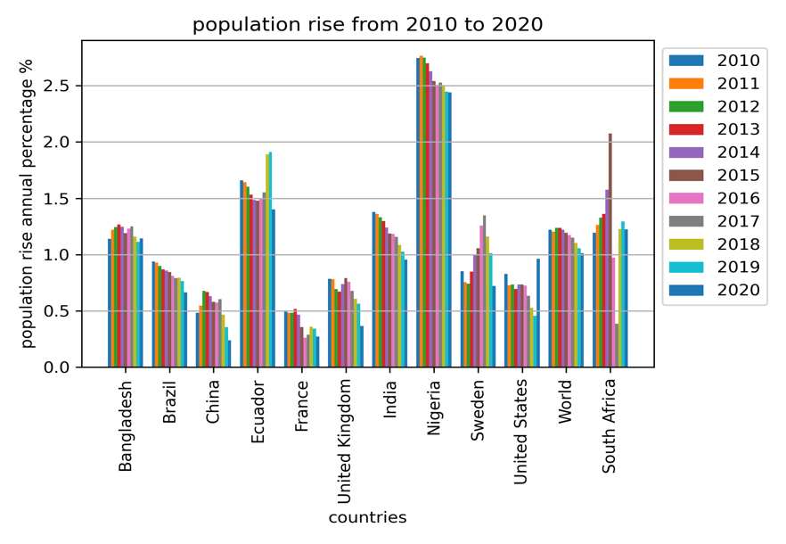

The Bar graph on the left shows rise in population in percentage for last 10 years Nigeria, South Africa and Ecuador has the highest rise percentage 2.8%, 2.1% and 2.4% respectively. but the trend that I have analysed here is that over time the population rise is being decreasing for all countries.

The information about popultion rise and the decreasing pattern can be confirmed by the heatmap on the right. I have mentioned exact population rise but more accurately can be confirmed by the heatmap. The fading of the cells and the precise percentage values shows the decreaseing trend.

The bar graph represents CO2 emissions and China is the highest producer, total worlds CO2 emission is approximately 3.4 kilotons and China alone produces 1.3 kilotons, which is significantly high comparing to the world.

The heatmap on the left represents C02 emissions and it is visible that China is producing more and more CO2 emissions and shows an increasing g trend. **Note- that after 2019 the data is missing therefore there is no darkening of the cells, but the trend is upwards.**

The bar graph on the right shows GDP representation I have analysed that Sweden has the highest GDP per million dollars along with United states, France and United Kingdom also has upward trend with the year increasing.

The heatmap shows correlation for the co2 emissions and shows precisely in which year co2 emissions where high or low.

Finally on the left there is vertical bar chart where I have performed a correlation between CO2 emissions and GDP for each country.

Finally, I have come to this conclusion that higher the population rise the more CO2 emissions are produced and more revenue is being generated but at the same time there is a contradiction to this too, Nigeria has shown that even though they had high population rise there was low GDP and low CO2 emissions but this is due to the low overall population of the country, even though there is rise but overall it has less total population compared to the other countries.