# COE528 (Fall 2019)

# Lab3

**General Lab Rule**

* **Lab attendance is mandatory and will be recorded weekly**. You lose 10% of the lab mark if you do not attend the lab sessions. (For a lab with two sessions, it means that if you do not attend both sessions and for a lab with one session, it means that if you do not attend the only one session).
* **Due date: 11:59pm, the day before you scheduled lab 4 session.**
  + The penalty for up to 8 hours delay in submission is 20% of your mark
  + No acceptance after 8 hours delay
* All the necessary files of this lab should be in lab3 directory. Please zip lab3 directory before submission
* You must include the duly filled and signed standard cover page with your submission. The cover page can be found on the departmental web site: [Standard Assignment/Lab Cover Page](http://www.ee.ryerson.ca/guides/Standard_Cover_Page_Assignments.pdf)

All the java files in this lab should have the following package declaration:

package coe528.lab3;

**Duration: one week.**

## Objectives

* Use Java interface
* Use abstract class

In this lab, you will design and implement few classes that model an odometer. An odometer is a counter with a specified number of digits. There is no a priori limit on the number of digits an odometer can have. The count can be incremented or decremented by one. If all digits are 9, incrementing will cause all digits to become 0. If all digits are 0, decrementing will cause all digits to become 9. The commands an odometer must support are increment, decrement, and reset. A query count provides the current value.

### Design:

Since there is no limit on the number of digits, we cannot use a simple integer counter. In fact, we cannot return the value of the odometer as an int. We will return the value of the odometer as a String.

The odometer is designed as a sequence of digits, each with a value in the range 0 through 9. When the odometer is incremented, if the right-most digit is less than 9, it is incremented by 1. If that digit is 9, it is set to zero and process repeated for the next digit.

For any given digit, the increment algorithm will be:

void increment () {

if (value < 9)

value = value + 1;

else {

value = 0;

increment digit to the left

}

}

Decrement is similar:

void decrement () {

if (value > 0)

value = value - 1;

else {

value = 9;

decrement digit to the left

}

}

Two questions need to be addressed:

* how is a digit represented?
* what happens with the left-most digit?

A digit can be represented as a counter that counts from zero to nine, and has essentially the same operations as an odometer: commands reset, increment, and decrement, and a String-returning query count. We name the class representing digits LinkedDigitCounter.

The left-most digit behaves just as the others, except that it never references the "digit to the left." We need a class to model this kind of digit: that is, a digit with no left neighbour. We call it DigitCounter.

How do we put the digits together to form an odometer? The answer to this will simply be based on what a LinkedDigitCounter should know:

* it must know its current value;
* it must know its left neighbour.

A LinkedDigitCounter will look like this:

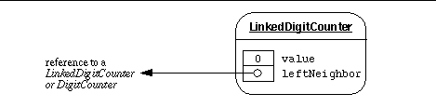

A DigitCounter, on the other hand, need only know its current value.

A four-digit odometer, for example, will consist of three LinkedDigitCounter instances, and one DigitCounter:

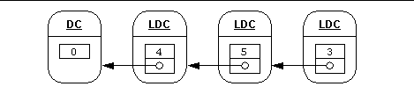

The above grouping represents the value 0453.

DigitCounter, LinkedDigitCounter, and Odometer have the same functionality. We can specify the functionality using an interface.

/* A basic up-down counter. */

public interface Counter {

//The current value of this Counter as a String of digits.

String count();

//Increment this Counter.

void increment();

//Decrement this Counter.

void decrement();

//Reset this Counter.

void reset();

}

### Implementing the classes:

A common structural pattern is to define an abstract class that implements an interface, defines data common to all interface implementations, and provides some default method implementations. Concrete classes can then extend the abstract class.

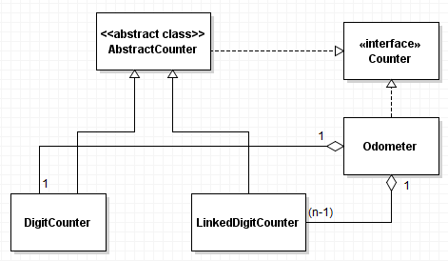

The figure above shows the class diagram. As shown in the class diagram, we will define an abstract class AbstractCounter that implements the abstract methods of the interface Counter and defines an int component variable to contain the value of the counter. The abstract class also defines a constructor that initializes the value to 0. The classes DigitCounter and LinkedDigitCounter will both extend this abstract class. The letter *n* in the class diagram represents the number of digits in the odometer.

In the Netbeans program, click on Project > New Project and save it as "Ex1" on your lab3 directory.

In this lab, you **must** have one interface (*Counter* interface) and five classes (*AbstractCounter*, *DigitCounter*, *LinkedDigitCounter*, *Odometer*, OdometerDriver).

* Implement the class AbstractCounter. Be aware that the data will be shared by its subclasses, and those subclasses should be able to modify it.
* Implement the classes DigitCounter and LinkedDigitCounter. The class LinkedDigitCounter adds a new attribute, leftNeighbor. The value of leftNeighbor might reference a LinkedDigitCounter or a DigitCounter. Its type should be Counter, and the LinkedDigitCounter constructor should require a Counter as an argument.
* Implement the class *Odometer*. An *n*-digit odometer contains (*n*-1) LinkedDigitCounter instances, and one DigitCounter instance. We should be able to specify *n* while creating an *Odometer* instance. The value of *n* should be at least 1. The *Odometer* constructor **must** throw IllegalArgumentException whenever a value of *n* that is less than 1 is specified.
* Compile and test your implementation. A test driver, OdometerDriver class that contains the main method is provided in the Appendix-1. You **must** copy this OdometerDriver class and its *main* method as given. You **must not modify** this *main* method. Your console output **must** match the output given in Appendix-2 for a 0-digit, 4-digit, 5-digit, 6-digit odometer.

### Appendix-1: The test driver class OdometerDriver

import java.util.Scanner;

public class OdometerDriver {

public static void main(String[] args){

try{

//read number of digits for odometer from console

System.out.print("Enter number of digits for odometer: ");

Scanner s = new Scanner( System.in);

int numOfDigits = s.nextInt();

Odometer odometer = new Odometer(numOfDigits);

//increment 130 times and print the count.

for ( int i = 0; i < 130; ++i ) {

odometer.increment();

}

System.out.println(odometer.count());

//decrement 31 times and print the count.

for ( int i = 0; i < 31; ++i ){

odometer.decrement();

}

System.out.println(odometer.count());

//increment 1001 times and print the count.

for ( int i = 0; i < 1001; ++i ){

odometer.increment();

}

System.out.println(odometer.count());

// decrement 1101 times and print the count.

for ( int i = 0; i < 1101; ++i ){

odometer.decrement();

}

System.out.println(odometer.count());

//reset the odometer and print the count.

odometer.reset();

System.out.println(odometer.count());

//decrement once and print the count.

odometer.decrement();

System.out.println(odometer.count());

//increment once and print the count.

odometer.increment();

System.out.println(odometer.count());

}

catch(IllegalArgumentException ex){

System.out.println("Number of digits in odometer must be at least 1");

}

}

}

### Appendix-2: The Output

**Console output for 0-digit odometer**

Enter number of digits for odometer: 0

Number of digits in odometer must be at least 1

**Console output for 4-digit odometer**

Enter number of digits for odometer: 4

0130

0099

1100

9999

0000

9999

0000

**Console output for 5-digit odometer**

Enter number of digits for odometer: 5

00130

00099

01100

99999

00000

99999

00000

**Console output for 6-digit odometer**

Enter number of digits for odometer: 6

000130

000099

001100

999999

000000

999999

000000