# Table content

1. **Project Goal**
2. **Project Objectives**
3. **Project Scope**

* **Project in Scope**
* **Target Language Platform**
* **Target Audience**
* **Out of Scope**

1. **Project Deliverable**

* **Analysis Document**
* **Design Documents**
* **User Documentation**
* **Quality Plan**
* **Project Executive**

1. **Resources**
2. **Project Milestone**
3. **Project Schedule**

# Project Proposal

# Project Introduction and Overview

Sam wans to create a website for his move store he wants to keep track of all the movies. He wants a website that can add, update and delete a movie.

|  |  |
| --- | --- |
| **NAME** | Sam |
| **CONTACT** | 02283746463 |
| **ADDRESS** | 7 A MERI STREET AUCKLAND |
| **E-MAIL** | john@gmail.com |

# Project Description

## Project Need

* Need a page that can add a movie
* Need a page that can delete a movie
* Need a page that can update the movie
* Need a page that has a web Api which can search most of the movie that’s exist

## Goals and Objectives

The main goal of the website is to add, delete and update a movie on website and create a web api

The website allows following features: -

* Can add a movie and add the details of it
* Move Api that allows you to sech any movie .

## Languages used: -

* .Net framework
* C Sharp
* ASP.net
* Bootstrap
* MYSQL

## Target Audience

The main target audience is: -

* Client: - the main target audience is the client and his employees that will use this website to manage the movie store.

## Out of Scope: -

* Can put a function that plays the movies
* Can add a contact us and about us page

## Project Deliverable: -

## Analysis Document: -

**Wireframe of About**

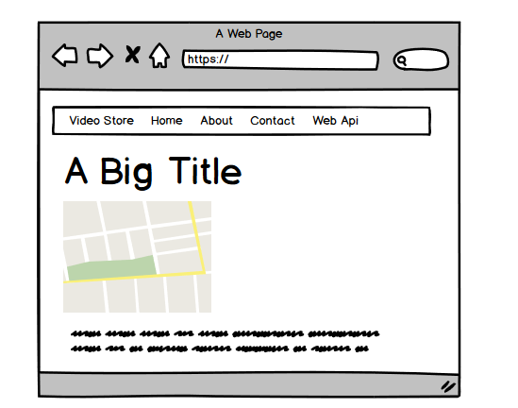

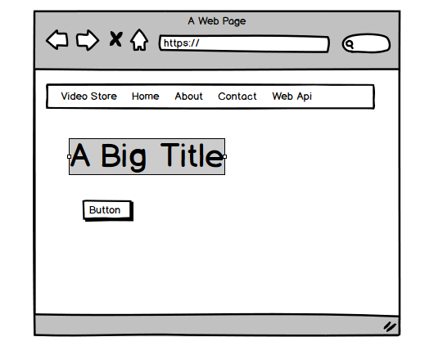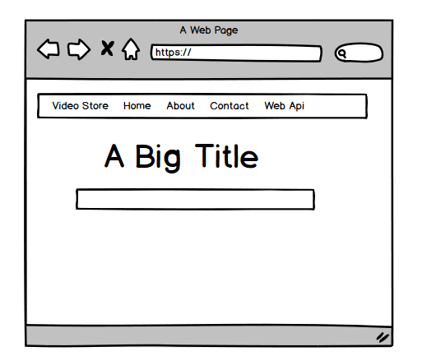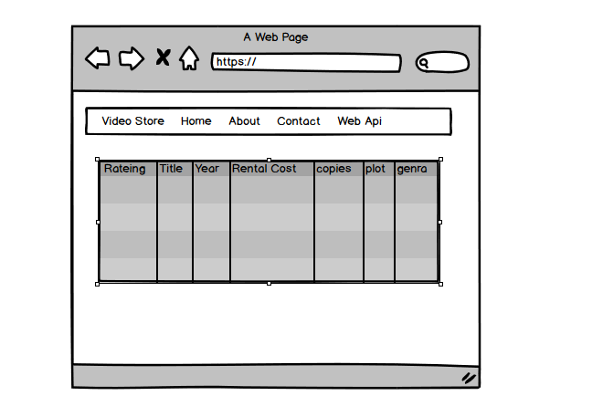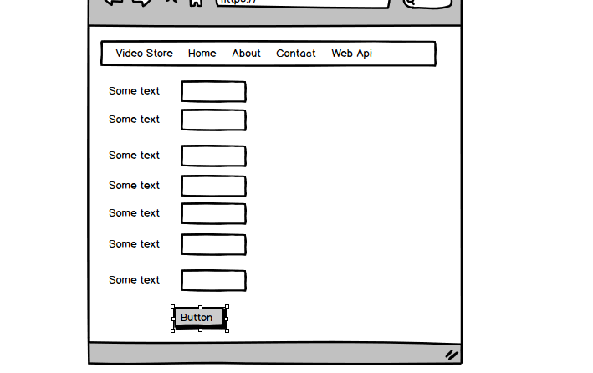

## Design Document: -

**Below are the mock-ups of given project**

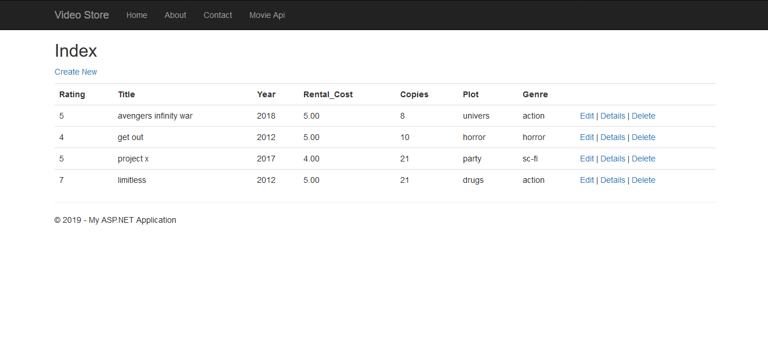

**Main Table Page**

This is the table page this holds all the information and data grid this data grid update when u add or delete a movie u can add a movie by clicking on the create new button .you can delete a movie by clicking on the delete button

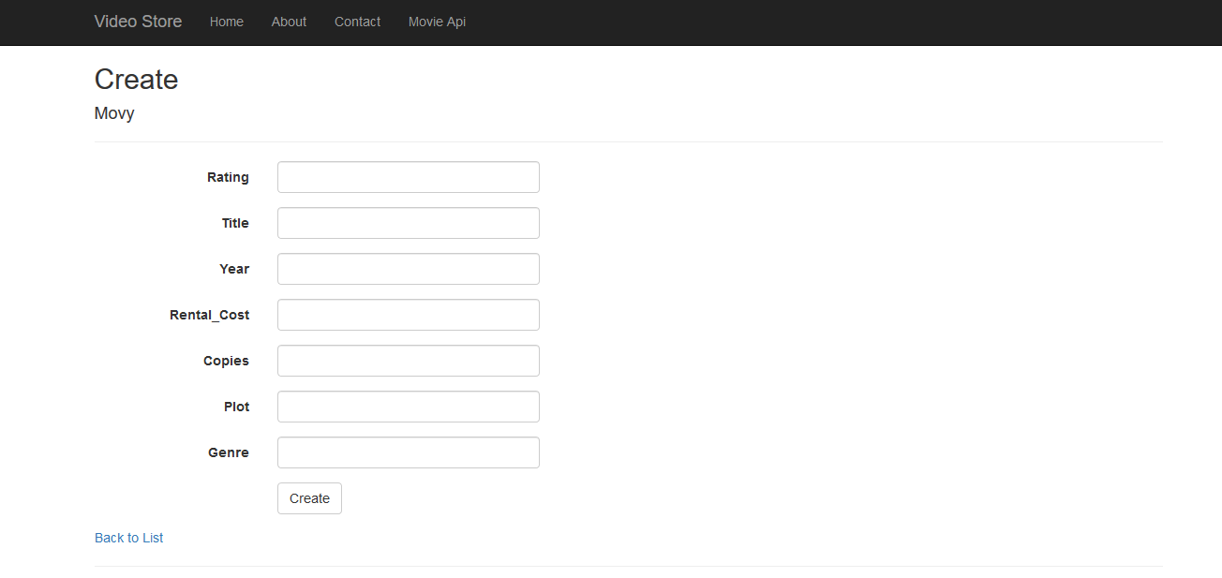

**This the movie add page**

This Page is to add the movie to the database .to add the movie just fill out all the text box and then click on add button this will add the movies to the database and the it will be shown on DataGrid page

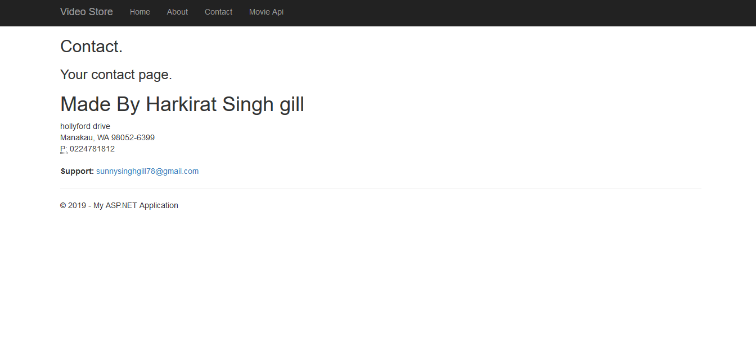

**Contact page**

This is a simple contact page it show the personal information from which the person that is using the website can contact if he/she has any problem

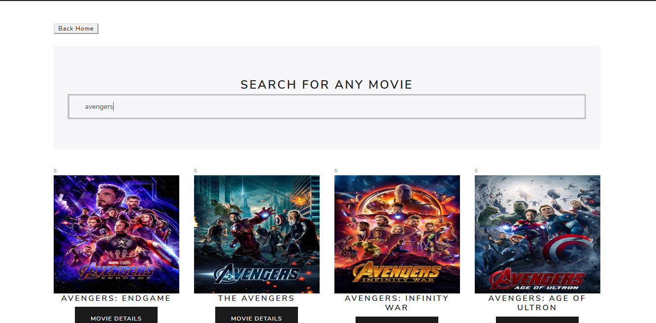

**Web api**

This page has the web api u can search any movie by just typing its name and its keep on adding new movie when they come so it’s a great way to know if a movie exist

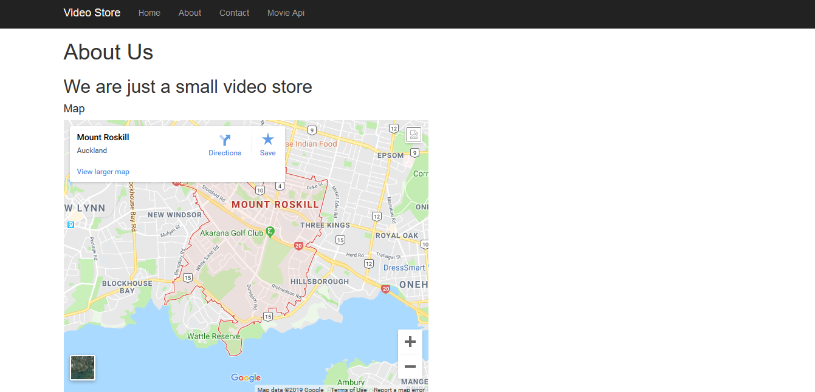

**About Us**

It’s a simple about us page that show the map from which u can find the shop

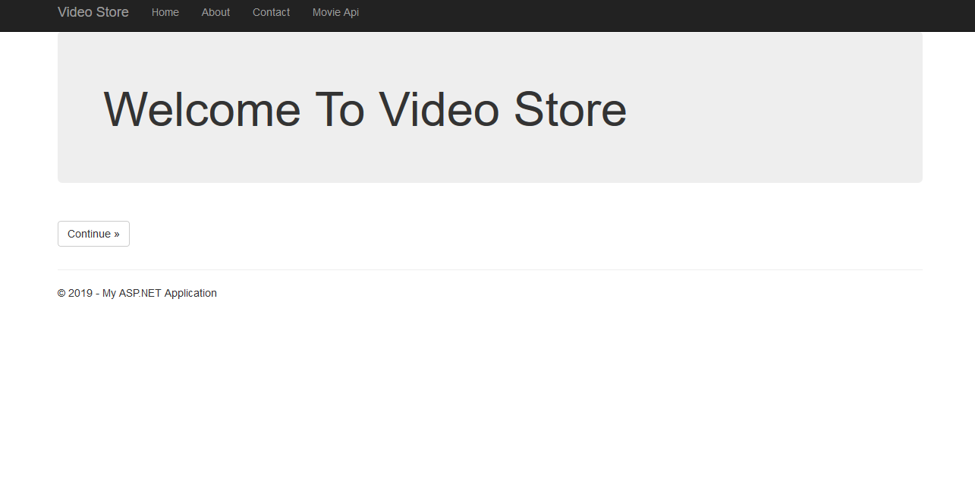

**Welcome page**

This is the page you see when u open the website

## Quality Plan: -

|  |  |  |  |  |  |
| --- | --- | --- | --- | --- | --- |
| Step NO | Test Step | Input Data | Expected Result | Actual Result | Test Step Result |
| 1 | Create New movie | avengers | All Details Should Appear on The Screen | As Expected | Pass |
| 2 | Edit Button | Change avenger to end game | The name of the movie will be changed | As Expected | Pass |
| 3 | Delete button |  | It should delete the movie | As Expected | Pass |
| 4 | Search api button | limitless | This show display the movie | As Expected | Pass |

## Project executive summary: -

**Hardware: -**

* Windows 10
* Intel core processor i7
* 12GB RAM

**Software: -**

* Visual Studio 2017
* Microsoft SQL

**Languages: -**

* C Sharp
* jQuery
* ASP.Net
* SQL

## Resources: -

Requirements Required to complete this project are as follow:

* PC must have RAM of 8GB.
* Windows used should be Windows 10.
* At least Intel i5 Processor should be used.
* Visual Studio 2017 is Required for the coding.
* Microsoft SQL is required for establishing the database and for the connection between visual studio and database.
* C#, jQuery, bootstrap, HTML, NETFramwork, ASP, all of them should be used.

## Project Milestone: -

|  |  |
| --- | --- |
| **WORK** | **DAY** |
| Database | 8 April to 10 April |
| Controller | 10 April to 16 April |
| Front End | 16 April to 21 April |
| Back End Coding | 21 April to 26 April |
| Documentation | 26 April to 28 April |

## Project Schedule: -

|  |  |
| --- | --- |
| **WORK** | **HOURS** |
| **Database** | **4 hours** |
| **Controller** | **11 hours** |
| **Front End** | **8 hours** |
| **Back End Coding** | **18 hours** |
| **Documentation** | **4 hours** |