**OSCP NOTES**

[Nmap Scanning - OSCP Playbook (gitbook.io)](https://fareedfauzi.gitbook.io/oscp-playbook/port-scanning/nmap-scanning)

AUTORECON:

INSTALLATION:

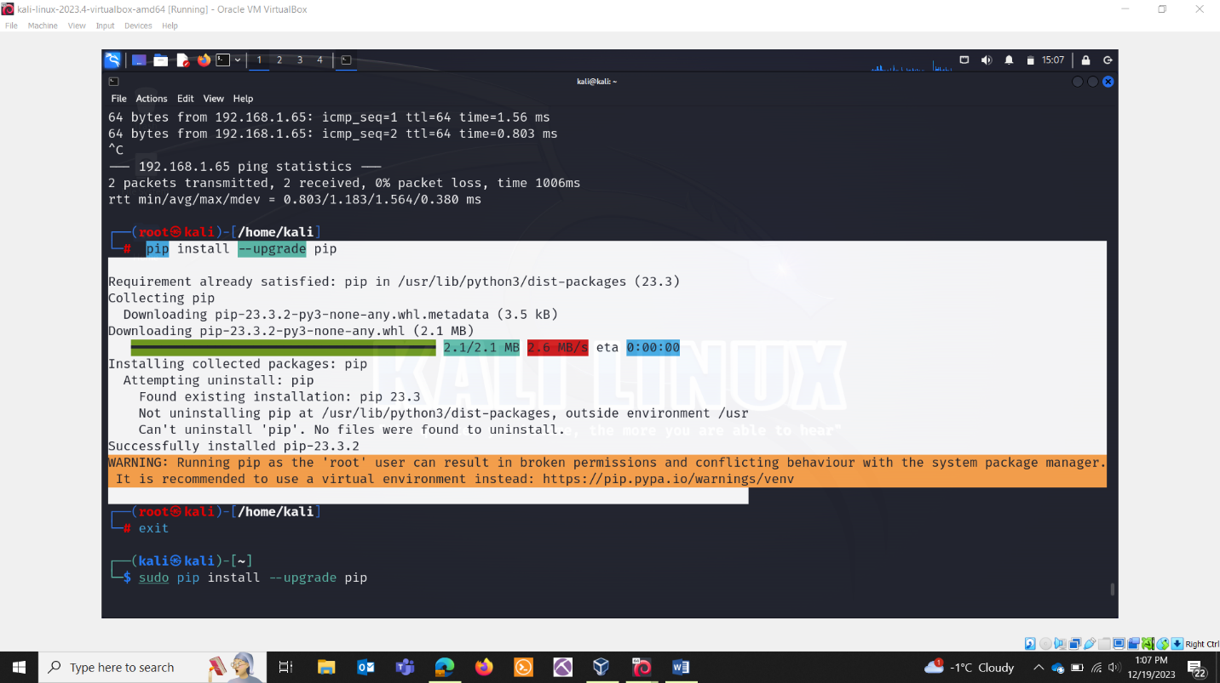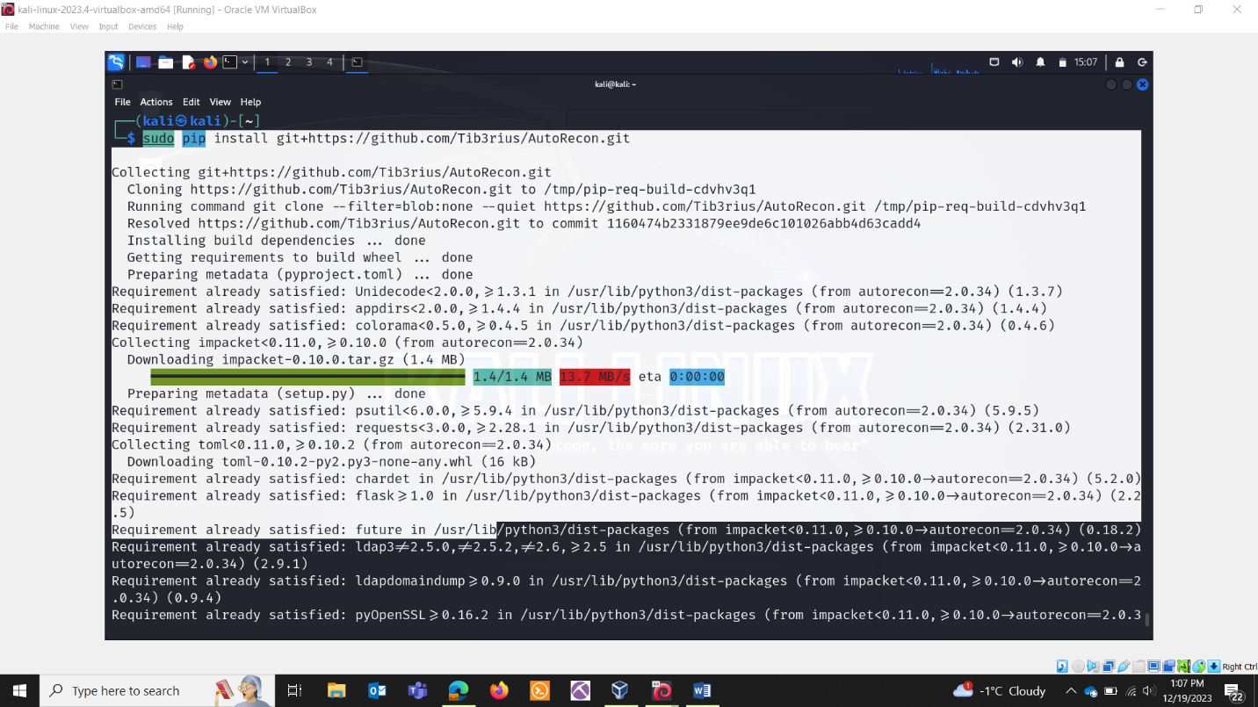

COMMANDS:

autorecon 10.10.10.3 (Single machine)

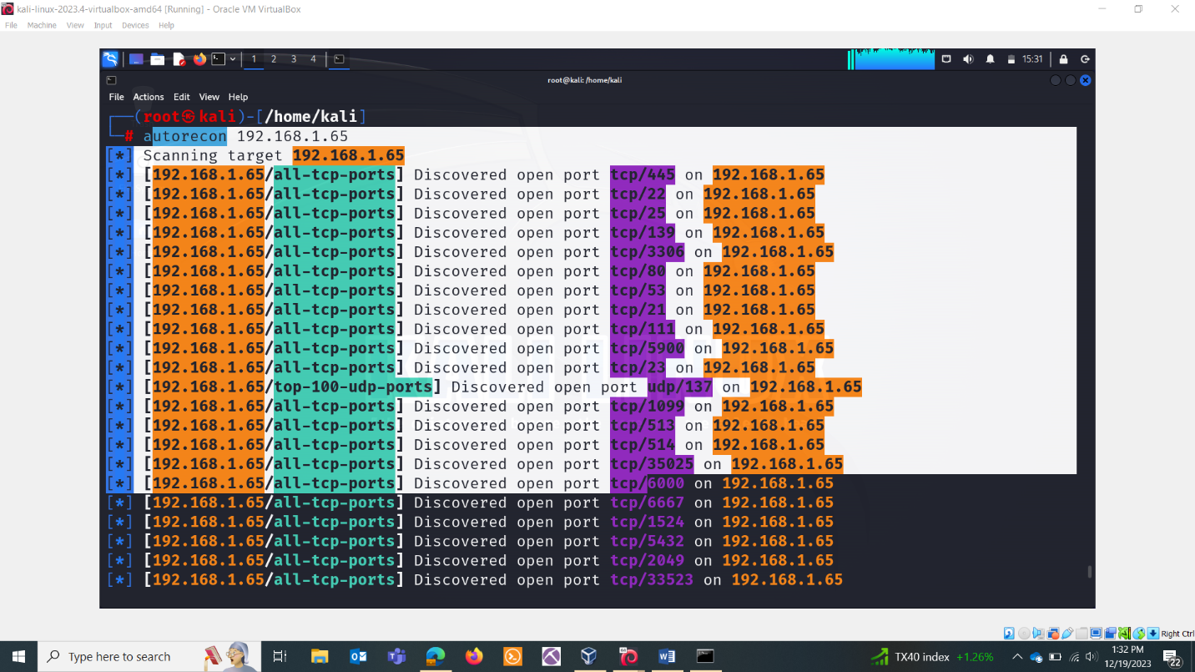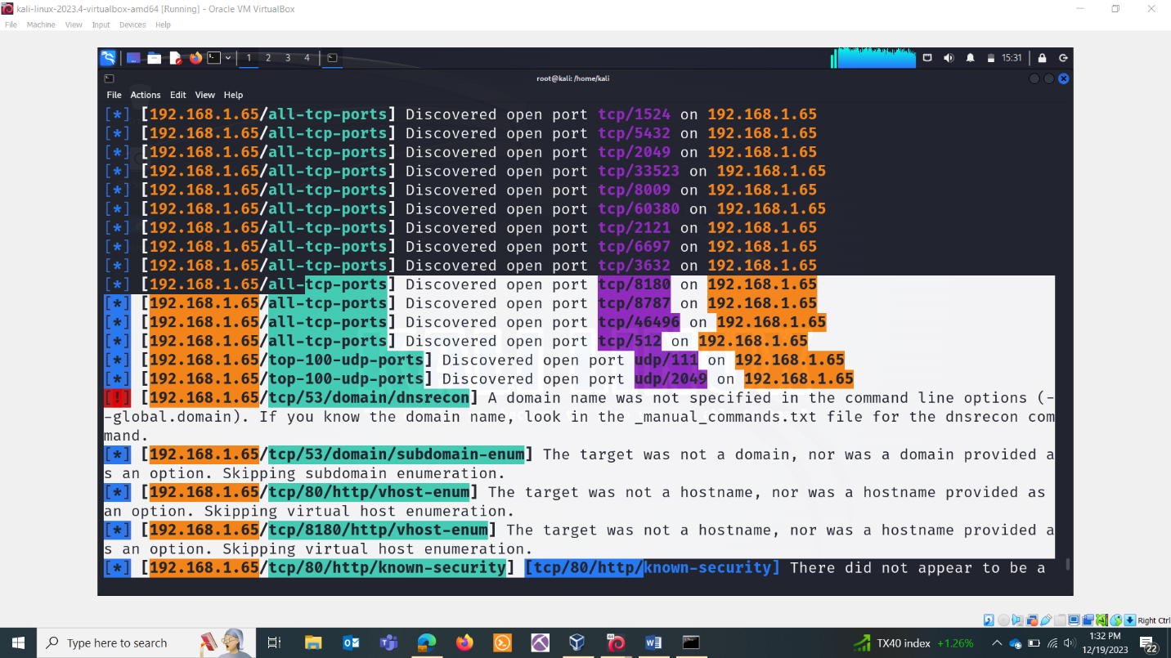

autorecon -t targets.txt (multiple targets included in targets.txt)

