**NFS**

Network File System is a distributed file system protocol that allows a user on a client computer to access files over a network as if they were on the local machine. The showmount command is used to display information about the NFS server’s exported file systems.

The command is used to display the NFS exports on a specific server identified by its IP address.

Showmount -e 192.168.1.100

192.168.1.100 is the actual NFS server, show a list of directories that the NFS server has exported and list of clients.

|  |
| --- |
| Export list for 192.168.1.100:  /var/nfs/share1 client1,client2  /home/user client3 |

NMAP :

* Nmap -v -p 111 192.168.1.0-254
* Nmap -sV -p 111 –script=rpcinfo 192.168.1.0-254

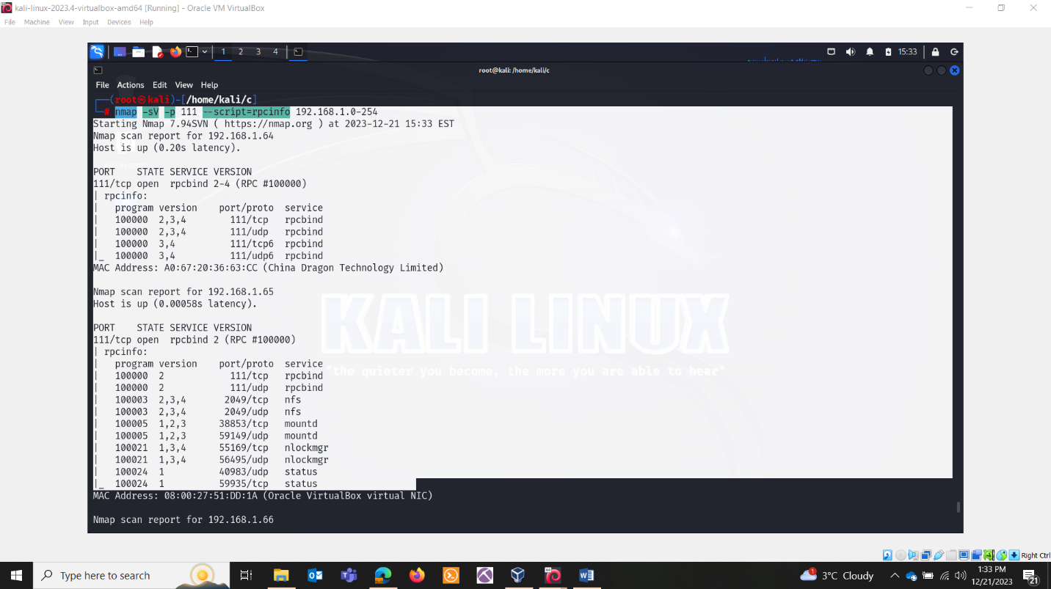

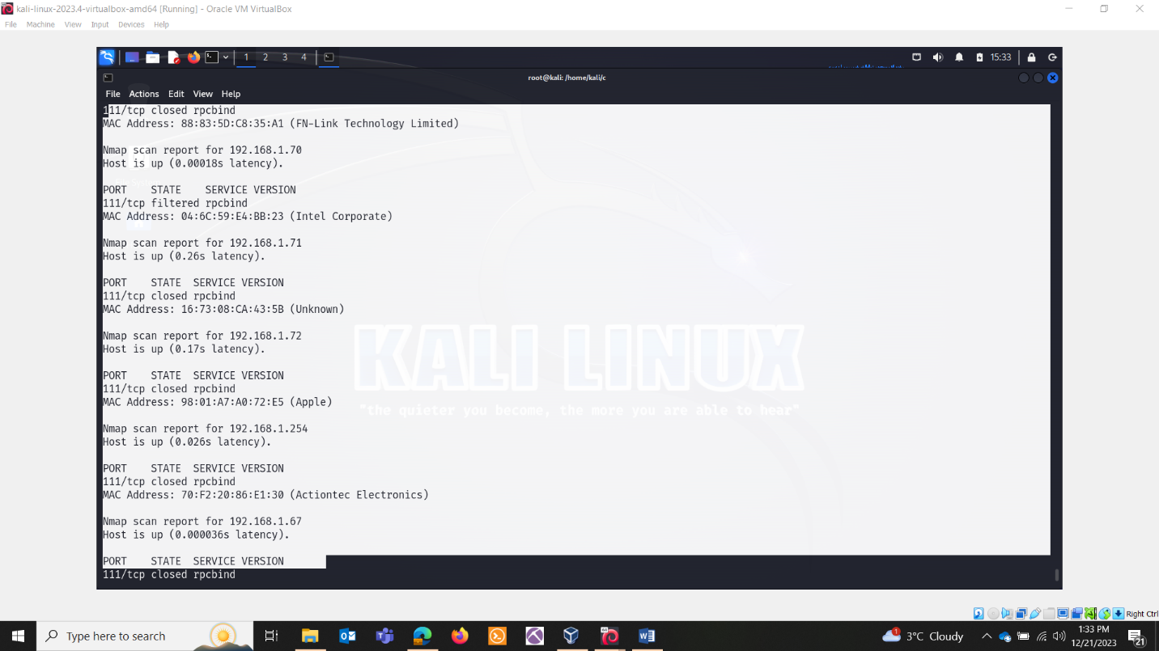

* Nmap -sV -p 111 –script=rpcinfo 192.168.1.65

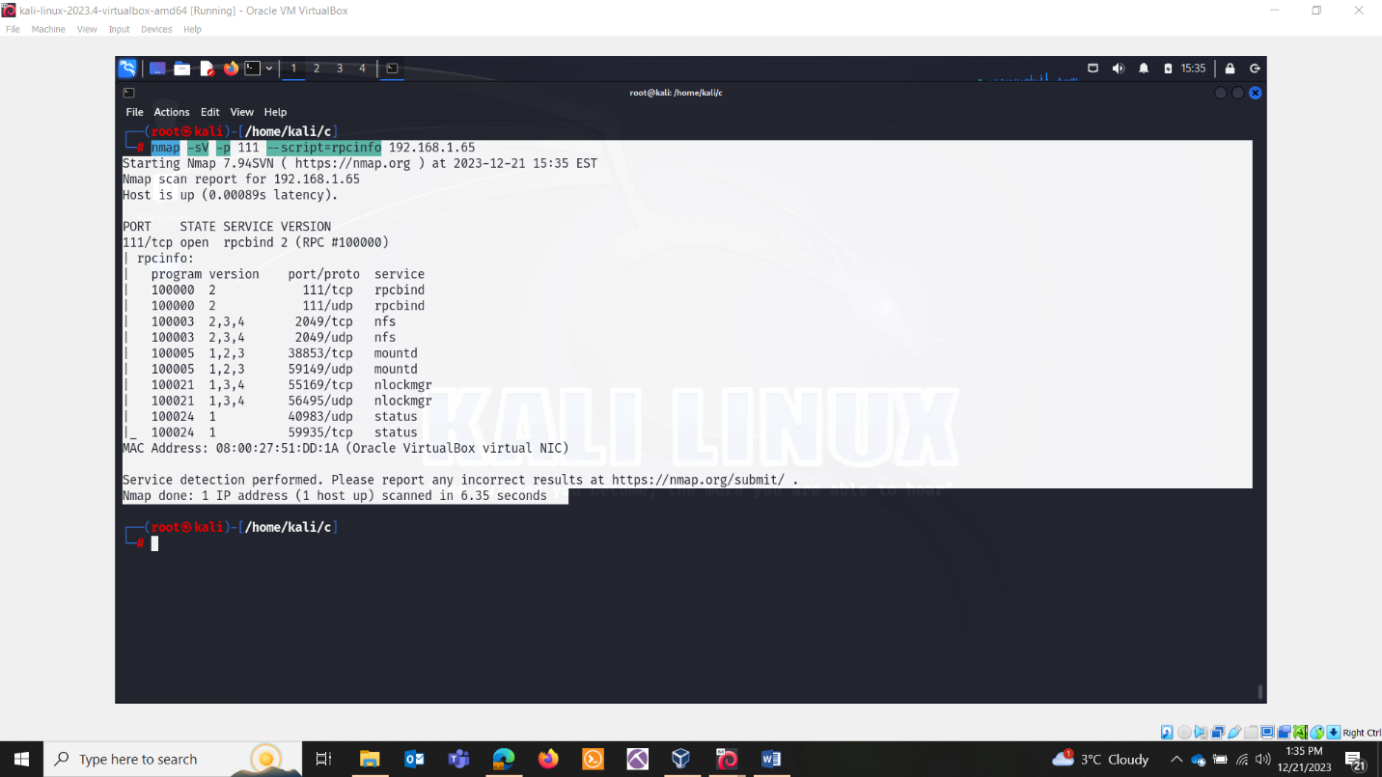

* Nmap -p 111 –script nfs* 192.168.1.65

