**ORACLE**

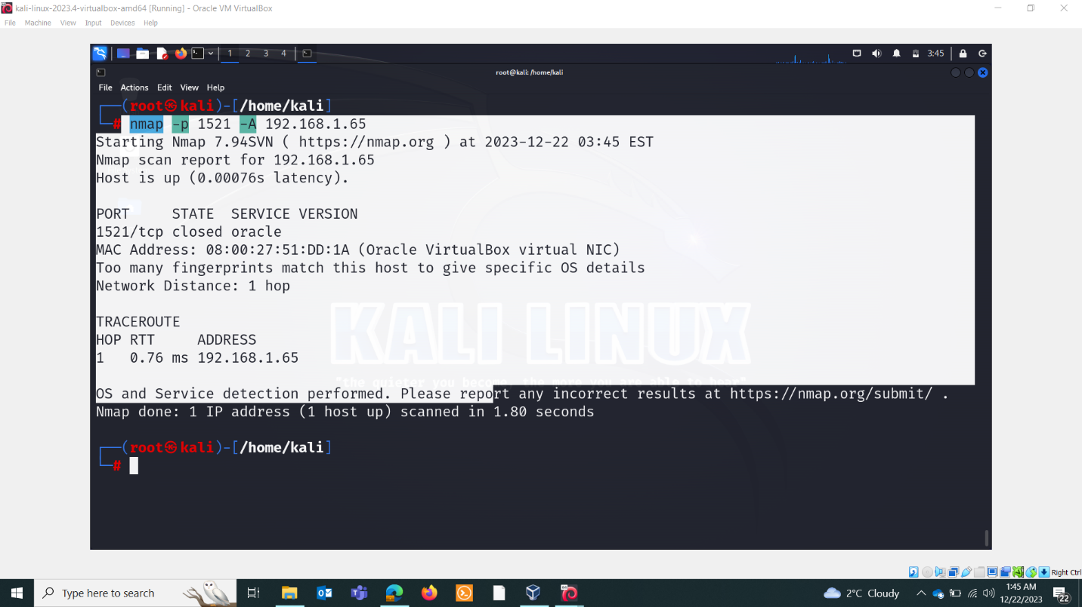

SCRIPTS:

Nmap -n -v -sV -Pn -p 1521 –script=oracle-enum-users –script-args sid=ORCL userdb=users.txt ip

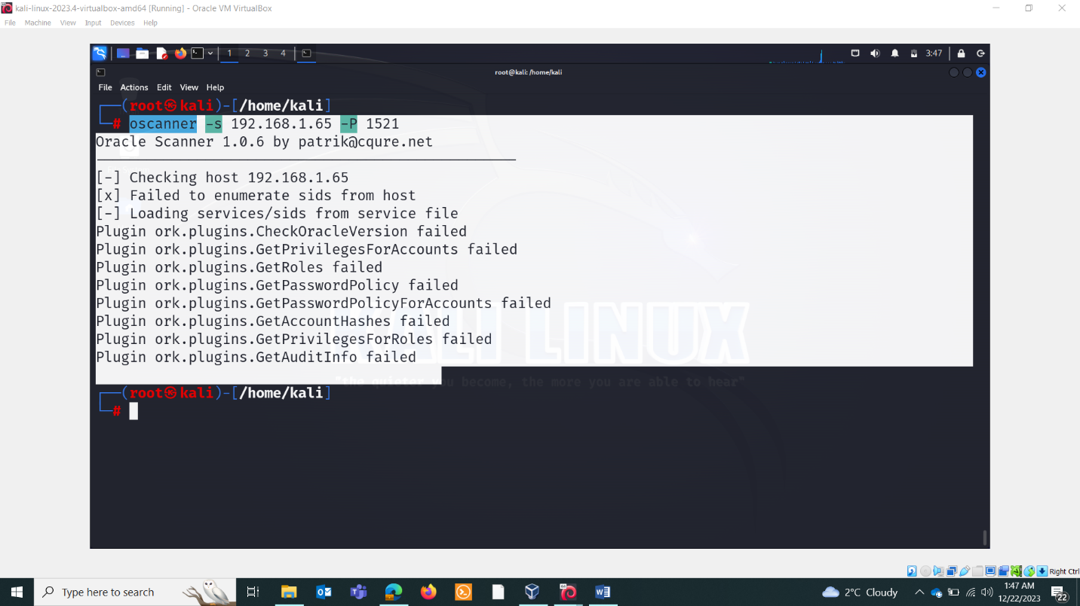

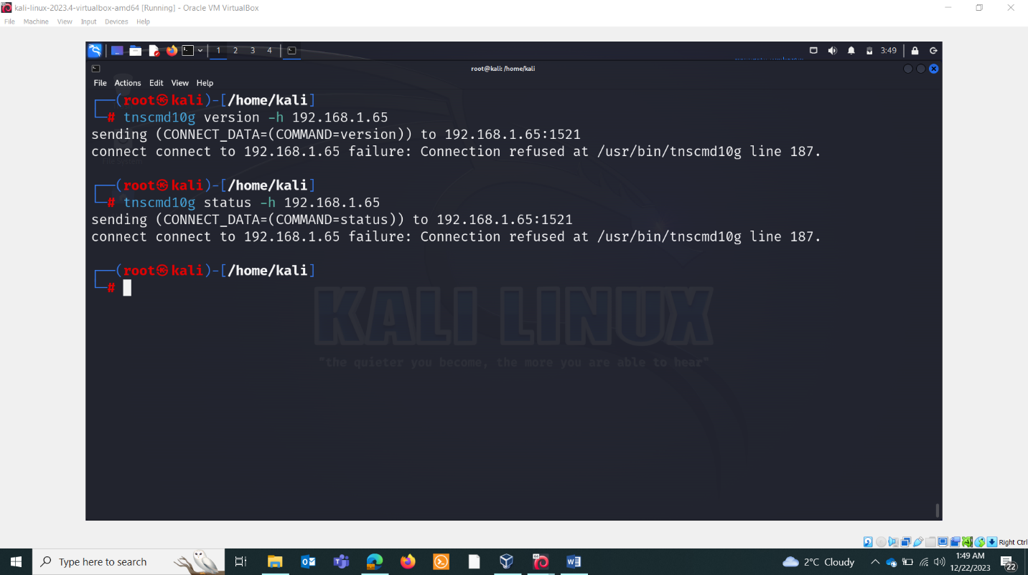

Nmap –script=oracle-sid-brute ip

Nmap -n -v -sV -Pn -p 1521 –script=oracle-brute ip