**SQLMAP**

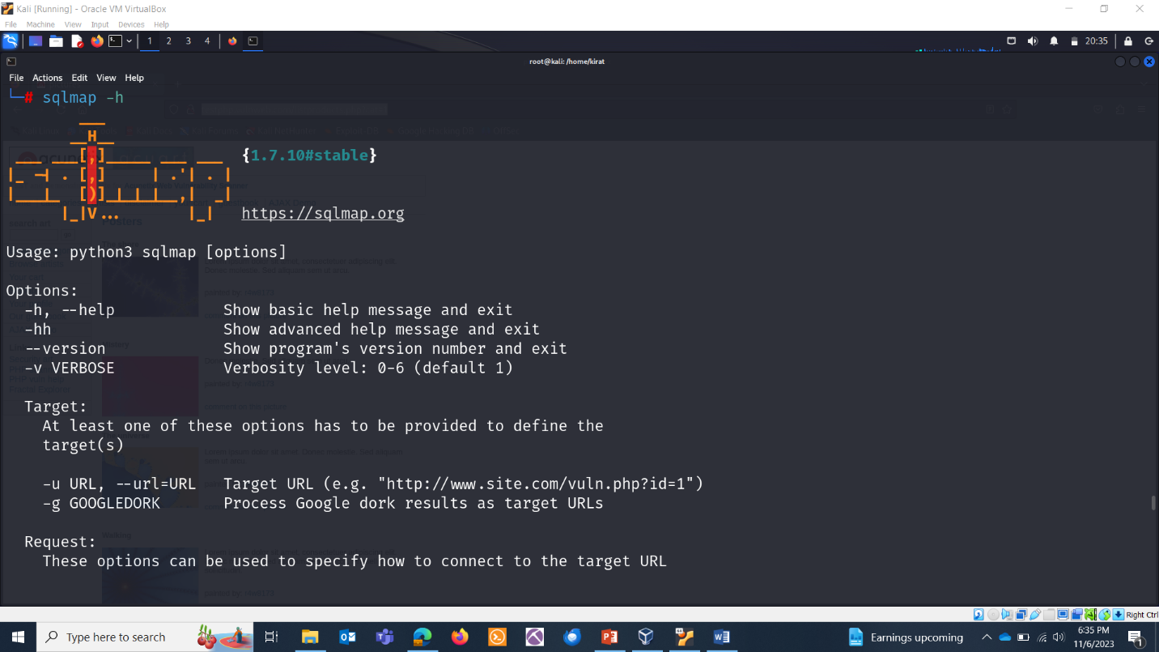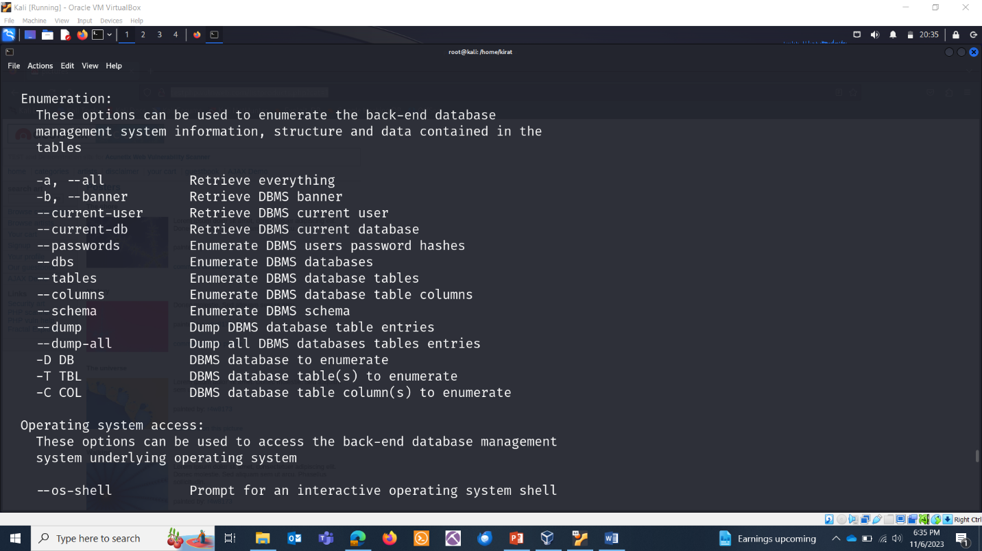

**SCANNING DATABASES:**

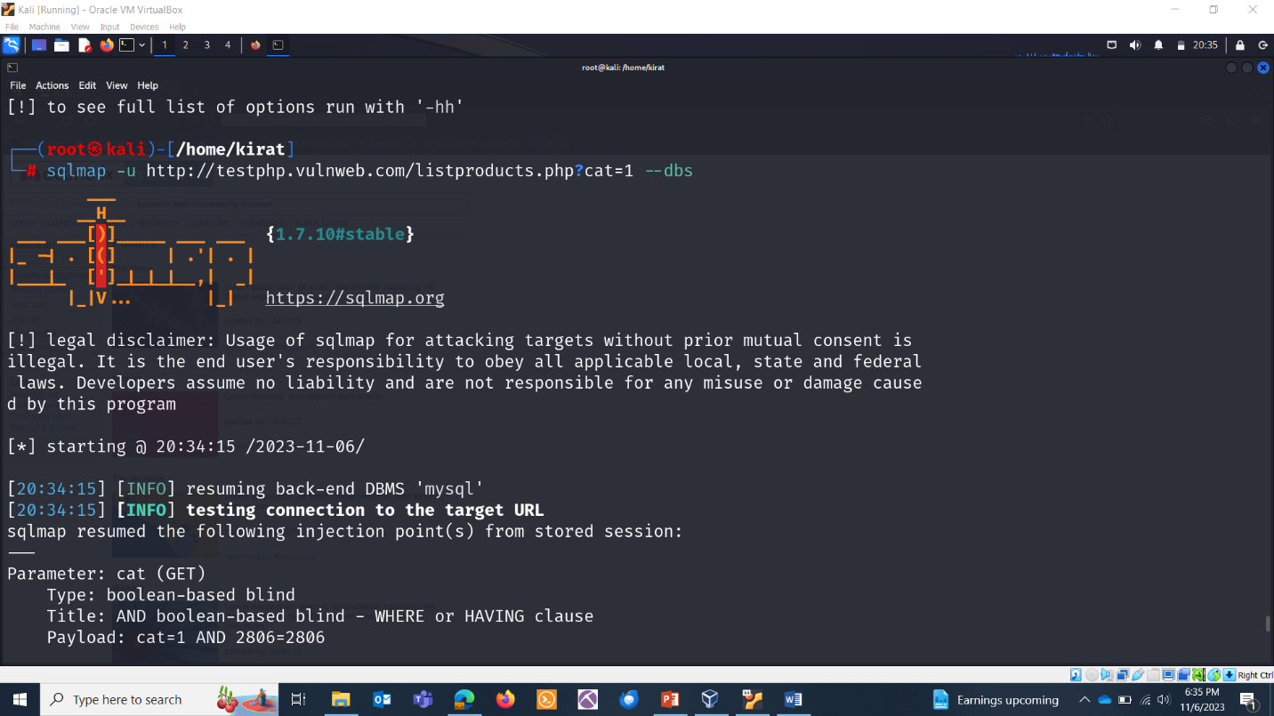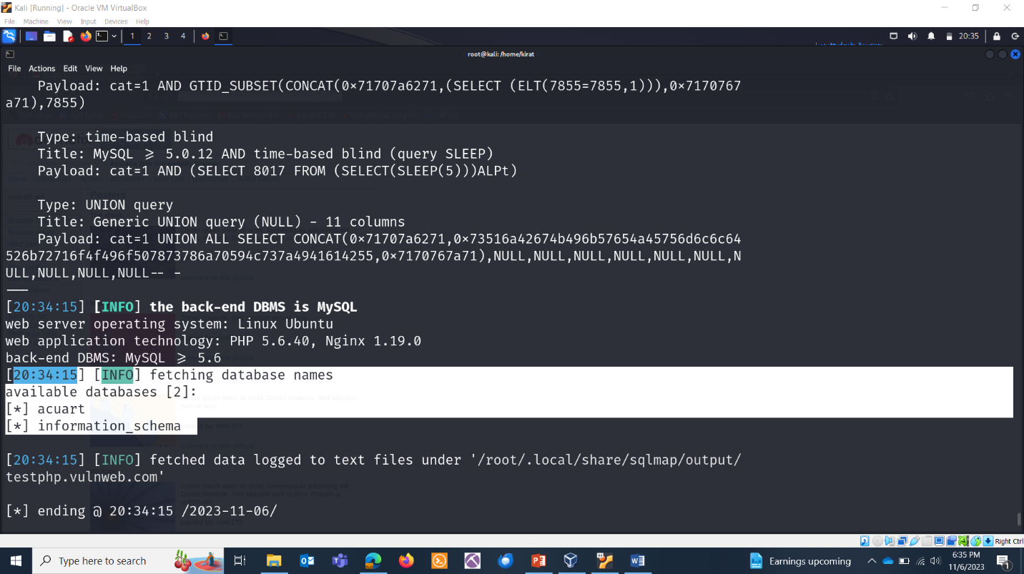

**TABLES:**

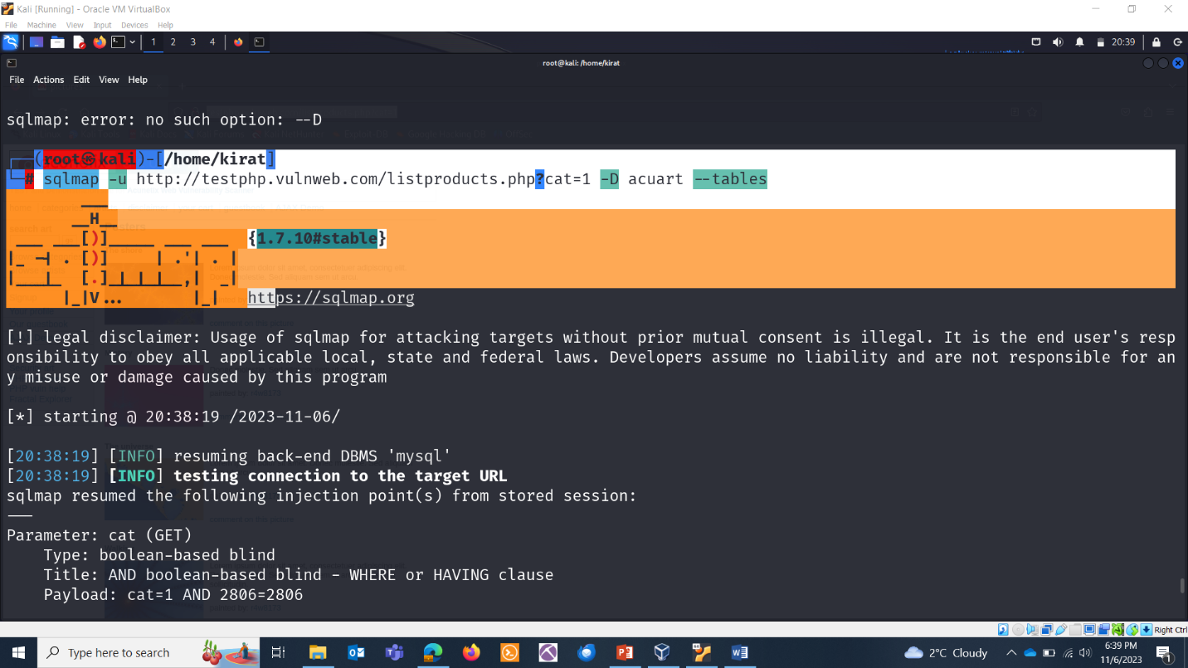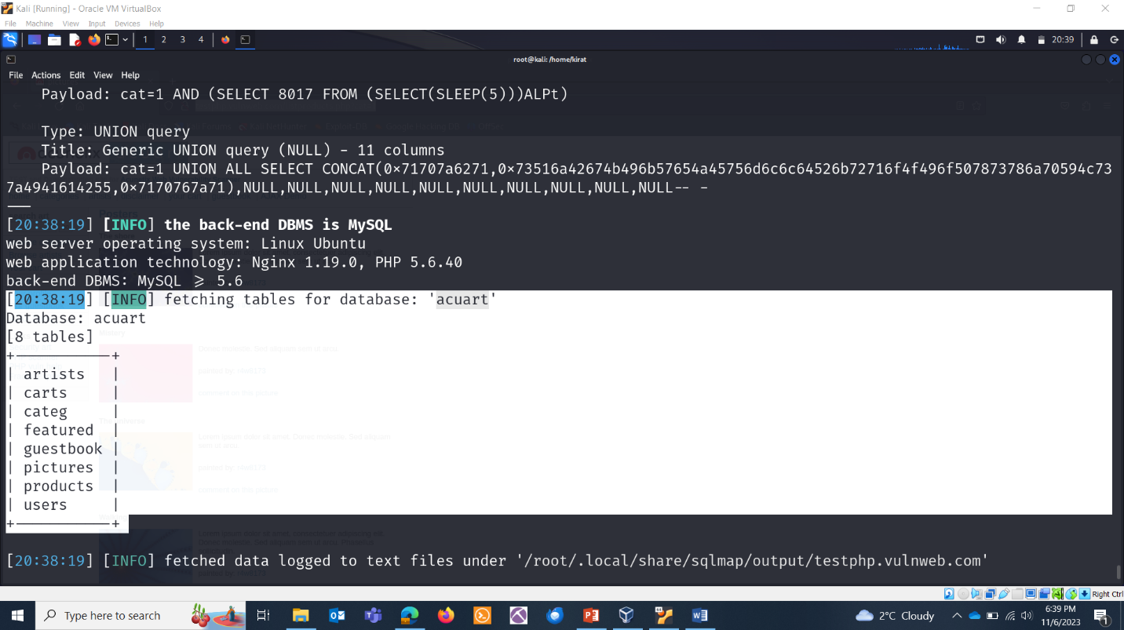

**COLUMNS OF TABLES:**

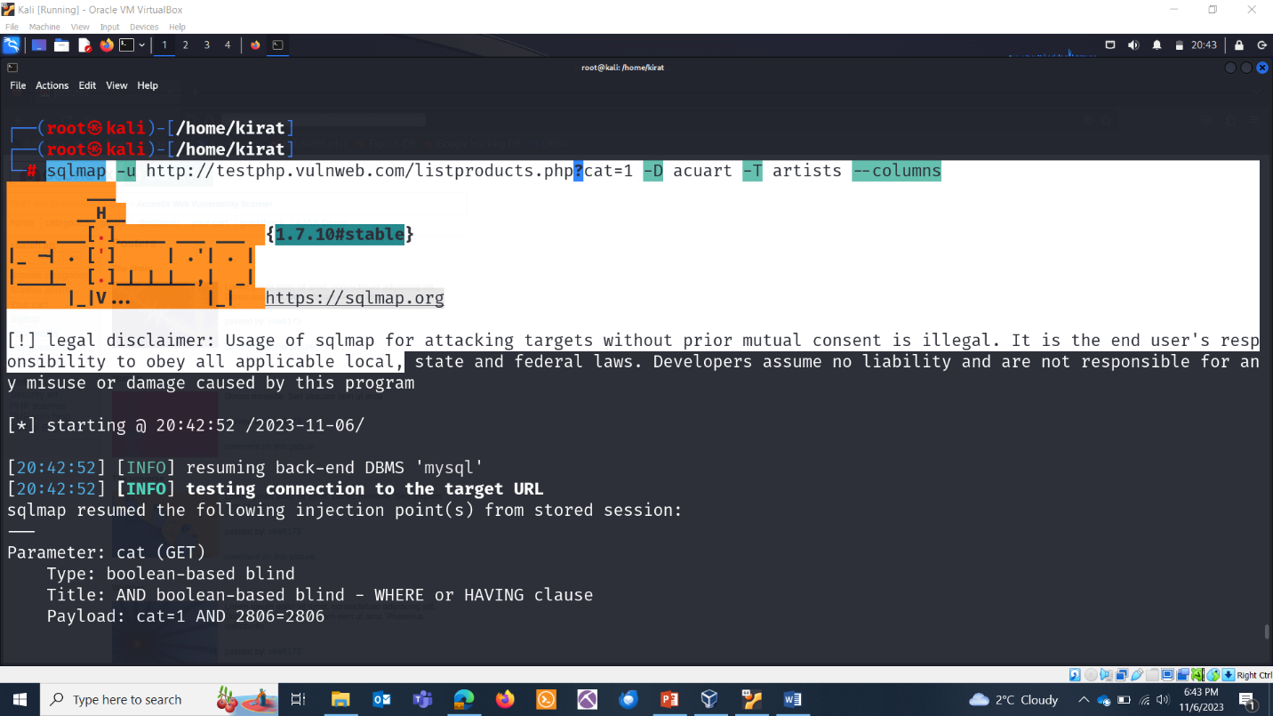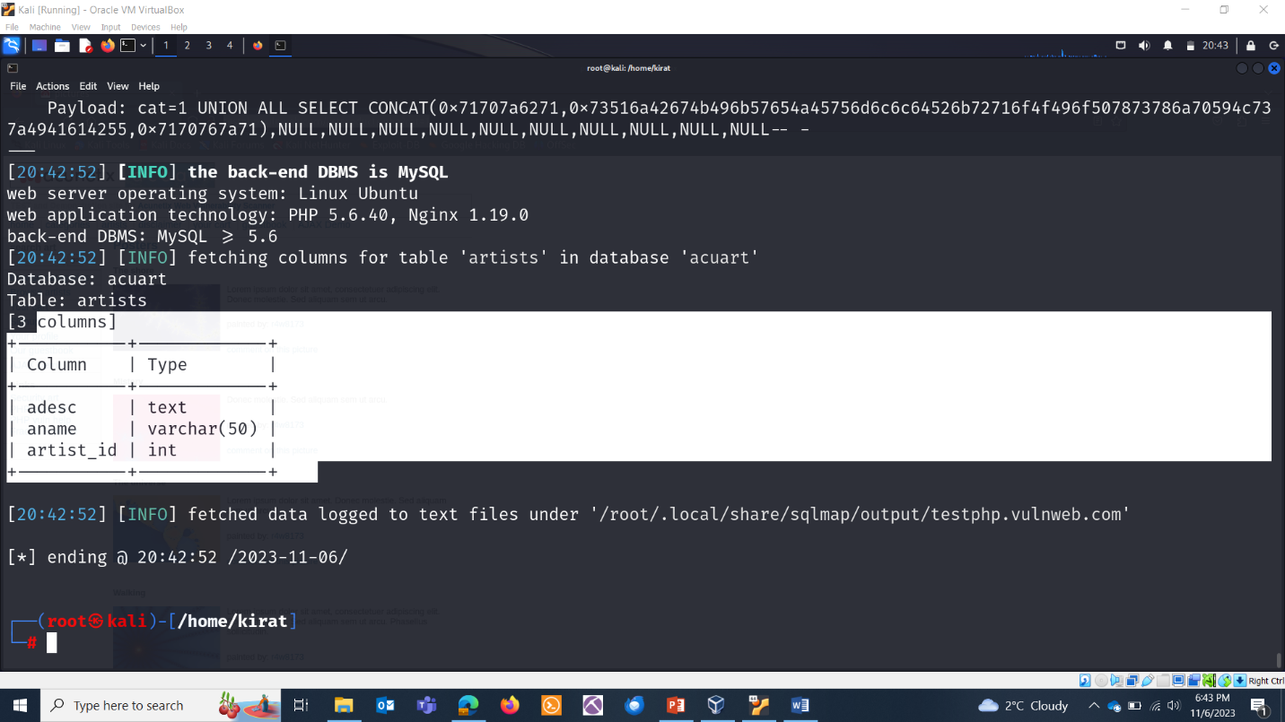

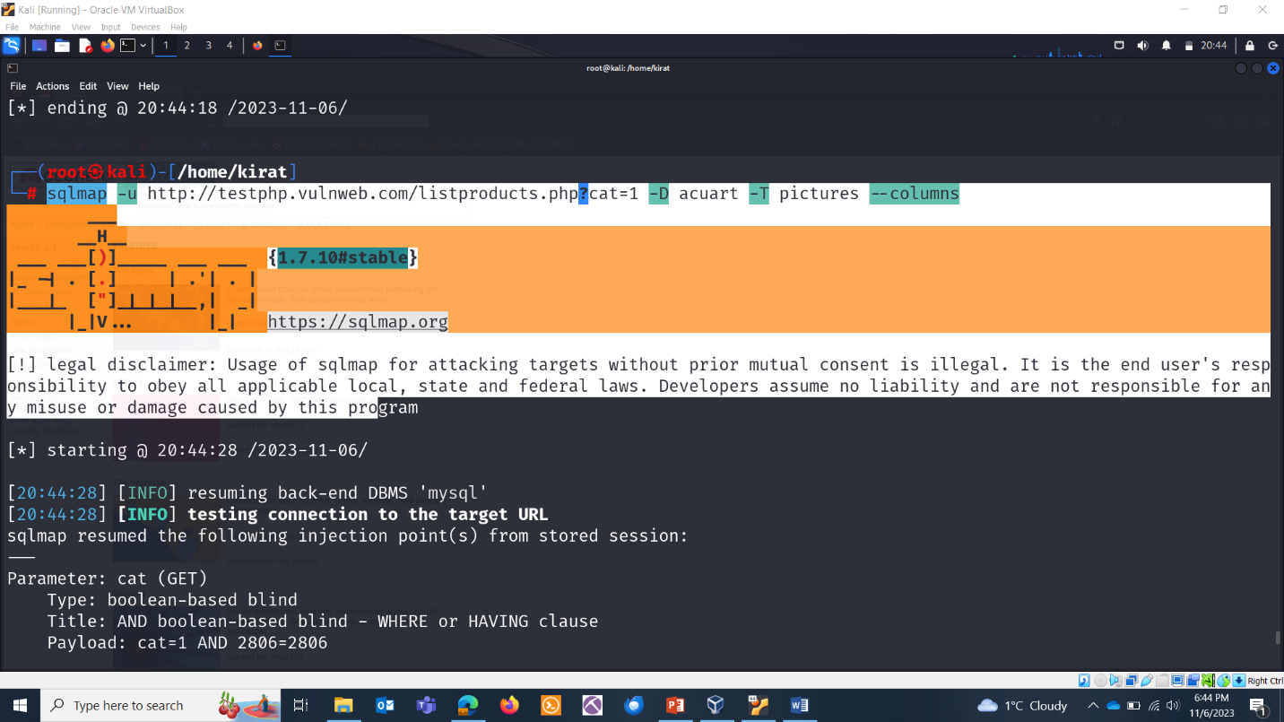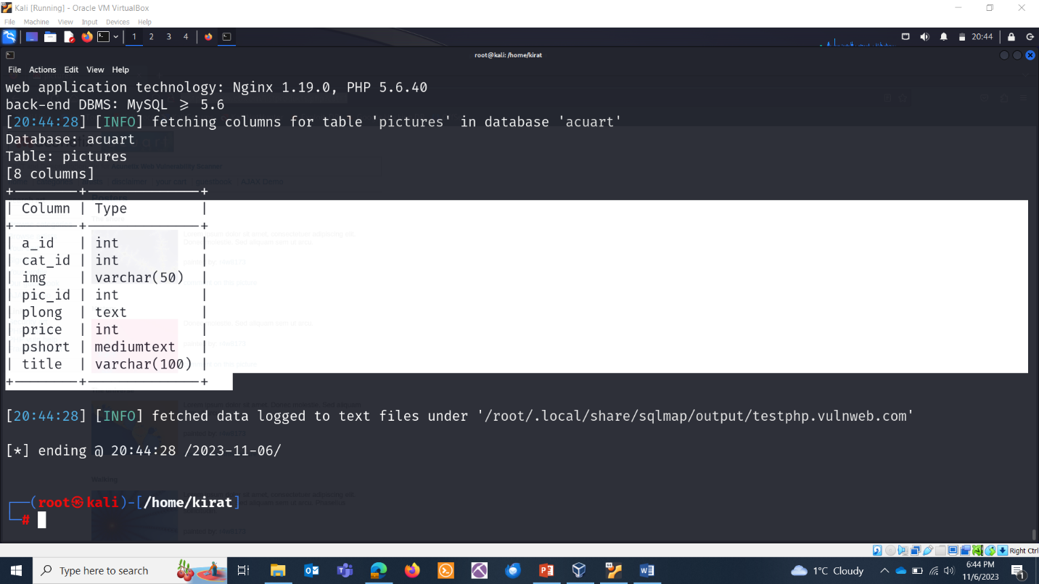

**ADVANCED USAGE:**

**Modifying HTTP headers and cookies:**

To modify HTTP headers and cookies during a SQLmap scan, you can use the --headers and --cookie options respectively. Here's an overview of how to use them:

* --headers: This option allows you to add or modify HTTP headers for the requests sent during the scan. You can use it to modify headers such as User-Agent, Referer, Cookie, etc.For example, to modify the User-Agent header to "Mozilla/5.0" during a SQLmap scan, you would use the following command:
  + sqlmap -u TARGET --headers="User-Agent: Mozilla/5.0"
* --cookie: This option allows you to set or modify cookies for the requests sent during the scan. You can use it to modify cookies such as PHPSESSID, JSESSIONID, etc.For example, to modify the PHPSESSID cookie to "12345" during a SQLmap scan, you would use the following command:
  + sqlmap -u TARGET --cookie="PHPSESSID=12345"