1. What do you plan to do after high school?

Job, entrepreneurship, college

2. If you were given $5,000 what would you do with it?

3.What do you think is the importance of having a credit card?

4. Do you know your FICO score?

5. You plan to take out a loan in order to buy a car. Given these 3 loan options, which one would you choose?

* Monthly payment: $172.04; Interest rate: 5.9%; Term: 12 Months; Total Paid: $2064.48
* Monthly payment: $88.55; Interest rate: 5.9%; Term: 24 Months; Total Paid:

$2125.20

* Monthly payment: $116.37; Interest rate: 5.9%; Term: 18 Months Total Paid: $2094.66

6. What is the deadline to file your income tax?

7.If you would be willing to participate in the playtest(ing) /interested in helping Carnegie Mellon University (CMU) graduate students design a web-based game that teaches money skills (banking, investing, saving, budgeting, earning) ?” If yes, can you provide your name and email address?

Information:

* Credit card: payment deadline, grace period
* Credit cards are evil | credit system is essential
* Tax knowledge(fill forms)
* Art style
* Loan

"What's your relationship with money?"

"Is money discussed at home or how do you learn about money?"

"How do you receive/earn money"

"What do you know about banks or the stock market?"

"What do you do with your money/what do you spend it on?"

if you were given $500/1,000 what would you do with it?More like $2,500 or $5,000 because they will spend the other amount on sneakers and video games lol. Need to make them think about answer with hopefully their future in mind”

How much they think they'll make in their first full-time job after high school; and How they earn money and in the case I spoke about earlier, how do they acquire or what's the source of their money?”

if they would be willing to participate in the playtest(ing) [interested in helping Carnegie Mellon University (CMU) graduate students design a web-based game that teaches money skills (banking, investing, saving, budgeting, earning) ?”

The importance of financial management, making money or saving money?

The role of banks in the world, the function of banks

The connection between financial management and banks

How to manage money, how to make money

If you want to run a bodega, what are your favorite decoration styles?

List the games that you played the most

What art style do you prefer?(Pokemon, 3d, realistic)(new york)



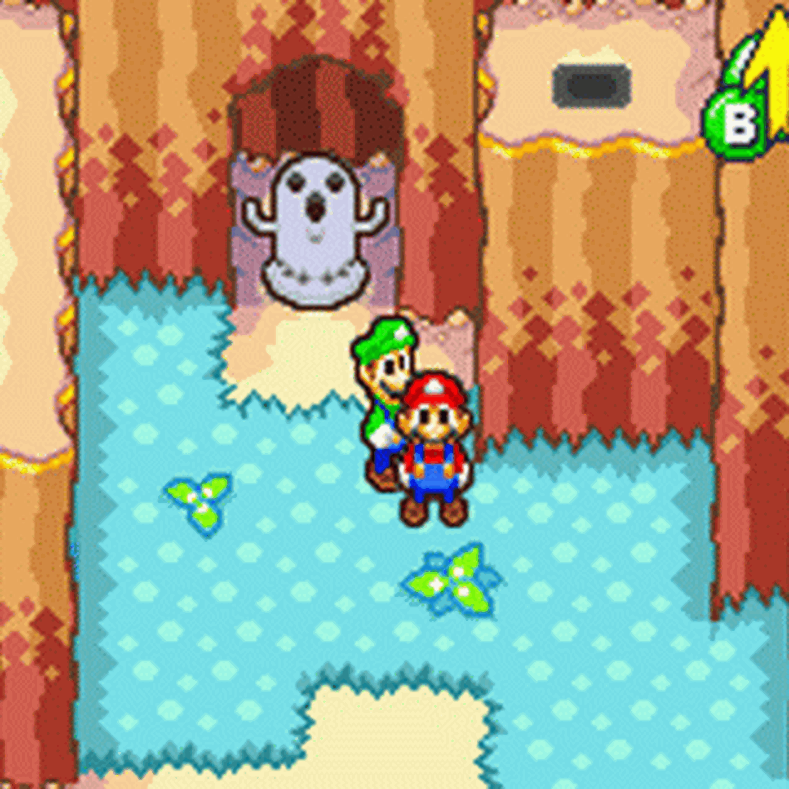

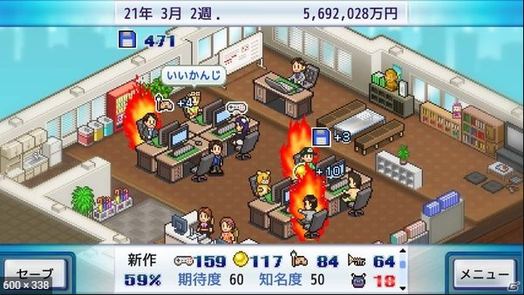

Kairosoft