Quiz 1

# Basic Statistics Quiz.

There are different types of data. Data can be classified using a number of similar groupings. For example, here are some ways of grouping.

*Set Theory*

* Natural Numbers
* Integers
* Rational Numbers
* Real Numbers
* Complex Numbers (the Real numbers extended with the square root of negative 1)

*Types of Data*

* Categorical
* Numerical
  + Continuous (or interval)
  + Discrete
    - Binomial

*Flavors*

* Quantitative
  + Continuous Data
  + Discrete
* Qualitative
  + Binomial Data
  + Nominal Data
  + Ordinal Data

*Common R atomic data types*

* Logical
* Integer
* double
* Character

1. Look at the plot below, What is the classification for the field gender_first

*Set Theory*

1. Natural Numbers
2. Integers
3. Rational Numbers
4. Real Numbers
5. Complex Numbers (the Real numbers extended with the square root of negative 1)
6. None of these.

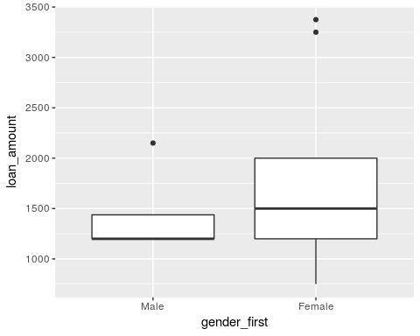

1. How about *Types of Data*
2. Categorical
3. Continuous
4. Discrete, not Binomial
5. Binomial

1. How about *Flavors*
2. Continuous Data
3. Discrete
4. Binomial Data
5. Nominal Data
6. Ordinal Data

1. What R data type would be used?
2. Logical
3. Integer
4. double
5. Character

Consider now, the field counting the number of females receiving the loan. 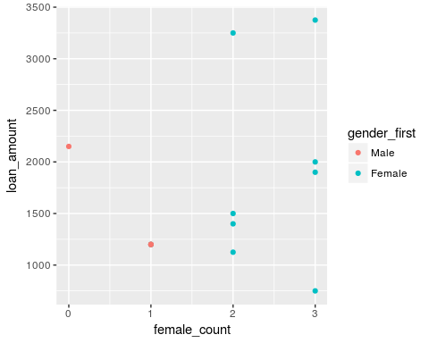

1. *Set Theory*
2. Natural Numbers
3. Integers
4. Rational Numbers
5. Real Numbers
6. Complex Numbers (the Real numbers extended with the square root of negative 1)
7. None of these.

1. How about *Types of Data*
2. Categorical
3. Continuous
4. Discrete, not Binomial
5. Binomial

1. How about *Flavors*
2. Continuous Data
3. Discrete
4. Binomial Data
5. Nominal Data
6. Ordinal Data

1. What R data type would be used?
2. Logical
3. Integer
4. double
5. Character

1. What appears to be the recommendation of this study:
2. Recommend Immunotherapy for the treatment of cancer patients to reduce immune-related adverse events.
3. Recommend against Immunotherapy because is causes immune-related adverse events.

Medical studies try to learn about patient populations by sampling known patients. Here is a study on immune-related adverse events.

Incidence of immune-related adverse events and its association with treatment outcomes: the MD Anderson Cancer Center experience.

Background Immunotherapy is emerging as the cornerstone for treatment of patients with advanced cancer, but significant toxicity (immune-related adverse events [irAEs]) associated with unbridled T cell activity remains a concern.

Patients and methods.

A retrospective review of the electronic medical records of 290 patients with advanced cancer treated on an immunotherapy-based clinical trial in the Department of Investigational Cancer Therapeutics at The University of Texas MD Anderson Cancer Center between February 2010 and September 2015 was performed. Clinical and laboratory parameters were collected to determine the incidence of irAEs, risk factors, and their association with treatment outcomes. Results Ninety eight of 290 patients (34%) experienced any grade irAEs. Among the 15 (5.2%) patients with grade ≥ 3 irAEs, the most common irAEs were dermatitis and enterocolitis. Although 80% of the patients with grade ≥ 3 irAEs required systemic corticosteroids, all the 15 patients recovered from the irAEs. On re-challenge, 4 of the 5 patients who had received systemic corticosteroids for irAE continued to respond. There were no irAE-related deaths. Importantly, patients with grade ≥ 3 irAEs had improved overall response rate (25 vs. 6%; p = 0.039) and longer median time to progression (30 weeks vs. 10 weeks; p = 0.0040) when compared to those without grade ≥ 3 irAEs. Conclusion Incidence of irAEs with immunotherapeutic agents indicates an active immune status, suggestive of potential clinical benefit to the patient. Further validation of this association in a large prospective study is warranted.

1. A study is conducted. A group of 20 people are matched and 10 are put on an exercise regimen, the other 20 are put on a low calorie diet. Everybody is matched to one other similar person (weight, age,sex). The difference in weight loss between the each pair is used. The paired value for weight loss for those on the exercise regimen is subtracted from the weight loss for those on the low calorie diet.  
   The appropriate statistic is calculated as well as the standard error of that statistic. The central limit theorem applies and it is accepted that the statistic follows a student t distribution with a standard deviation equal to the calculated standard error.  
   The significance level for the test is set at 5%. The group with the low calorie diet lost more weight. When the distribution of the test statistic was plotted, the area under the curve to the right was 0.05. Does the study show that diet is better than exercise at the significance level of 0.05%?

