Quiz 1

# Basic Statistics Quiz.

*Question 1.*

Gender is coded as 1 = Female and 0=Male. What is the classification for this field using set theory?

1. Natural Numbers
2. Integers
3. Rational Numbers
4. Real Numbers
5. Complex Numbers (the Real numbers extended with the square root of negative 1)

*Question 2.*

Gender is coded as “Female” and “Male,” what is the type of data?

1. Categorical
2. Continuous
3. Discrete, not Binomial
4. Binomial

*Question 3.*

Regions are ranked based on total loan amounts. What type of data are these rankings?

1. Continuous Data
2. Discrete Binomial Data
3. Discrete Nominal Data
4. Discrete Ordinal Data

*Question 4.*

Currency is recorded for each loan amount. What R type would be used for currency?

1. Logical
2. Integer
3. double
4. Character

*Question 5.*

A probability space is divided up into three mutually exclusive sets. One set has the probability of .97. The other two set have equal probability. What is the probability of each?

1. .03
2. .015
3. 1
4. 0

*Question 6.*

If two continuous variables x and y are independence, then the slope of the regression line that models y as a function of x, will have what slope?

1. Positive slope
2. Negative slope
3. Zero Slope (a flat line)
4. Cannot be know unless the correlation is known.

*Question 7.*

If events A and B are mutually exclusive then their intersection will be:

1. P(A)*P(B)
2. P(A)
3. P(B)
4. zero.

*Question 8.*

If two continuous variables x and y are linearly dependent and a regression line $\overset{^}{y}$ is fit predicting y from x, and the sum of squared errors is calculated, with the error measuring the distance between the predicted value and the actual value, and the total sum of squares is measured where each distance from the actual value to the mean of the actual values is squared and summed, and the sum of squares of the model is calculated where the distance from the predicted value to the mean of the actual values is squared and summed, then:

1. The proportion of sum of squared errors to total sum of squares will be between -1 and 1.
2. The proportion of sum of squared errors to total sum of squares is call R^2.
3. The proportion of the Model sum of squares to the total sum of squares is the portion of variance in y explained by x.
4. The sum of squares or the errors will always be greater than the sum of squares of the model.

1. A study is conducted. A group of 20 people are matched and 10 are put on an exercise regimen, the other 20 are put on a low calorie diet. Everybody is matched to one other similar person (weight, age,sex). The difference in weight loss between the each pair is used. The paired value for weight loss for those on the exercise regimen is subtracted from the weight loss for those on the low calorie diet.  
   The appropriate statistic is calculated as well as the standard error of that statistic. The central limit theorem applies and it is accepted that the statistic follows a student t distribution with a standard deviation equal to the calculated standard error.  
   The significance level for the test is set at 5%. The group with the low calorie diet lost more weight. When the distribution of the test statistic was plotted, the area under the curve to the right was 0.05. Does the study show that diet is better than exercise at the significance level of 0.05%?
2. Yes
3. No

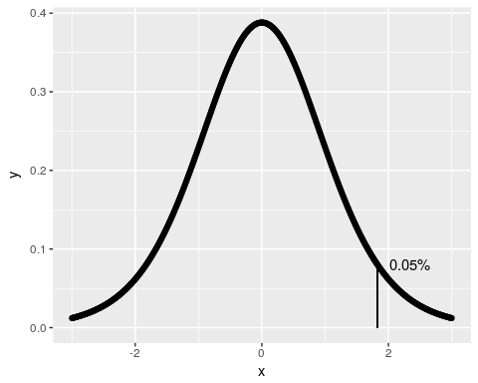 *Question 10.*

If there are two events A and B. The what is equal to the probability of A

$P(A∩B)/P(A)$

$P(A∩B)+P(A∩\overline{B})$

$P(A)*P(B)+P(A)*P(\overline{B})$

$P(A∪B)−P(B|A)$

## Answers

1. (a.) It includes 0, so choose the Integers not the natural numbers.
2. (a.) Gender as coded is categorical.
3. (d.) Ordinal
4. (c.) double
5. (b.) 0.015. 2*(0.015) = 0.03
6. (c.)
7. (d.) zero
8. (c.) This is R^2
9. (a.) Yes. This is a one tailed test with a significance level of 0.05
10. (b.) The addition of two mutually exclusive sets.