Installing the StartCom Free Certification Authority

Start by pointing your browser to the root CA certificate link below and follow the directions for your browser.

http://cert.startcom.org/ca.crt

Safari / Internet Explorer (IE skip step 1)

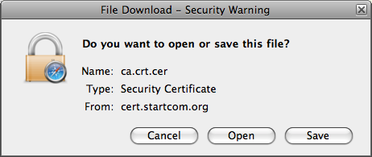
Click Open

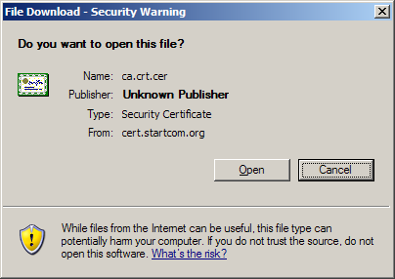
Click Open. There will be an extra “Save” button in IE. Click Open.

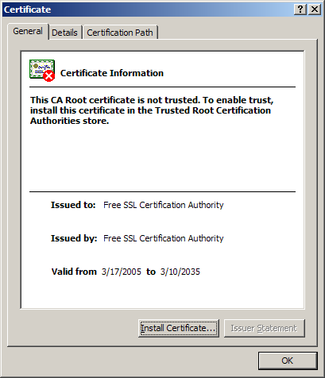
Click Install Certificate

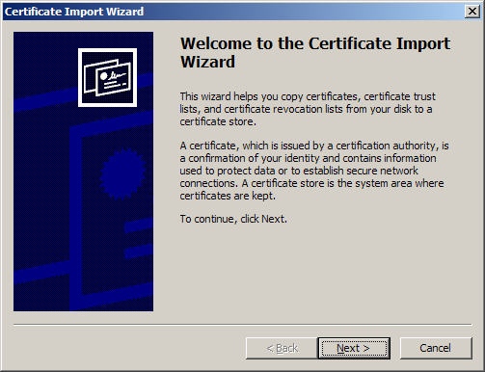
Click Next

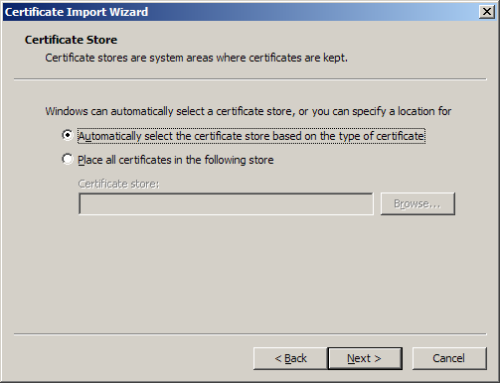
Ensure “Automatically select the certificate store...” is selected and click Next

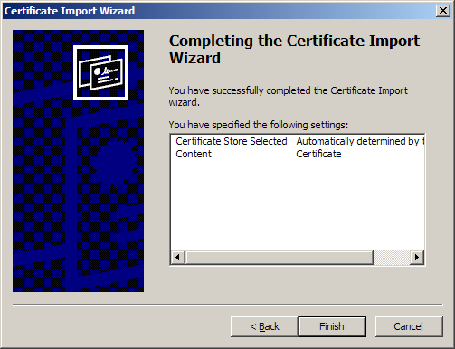
Click Finish

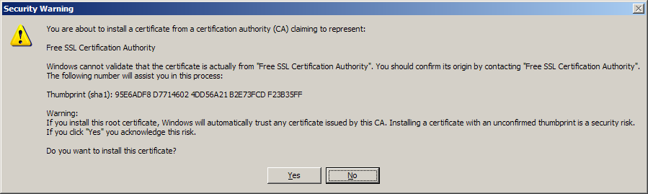
Click Yes

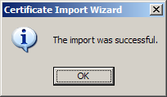

Opera

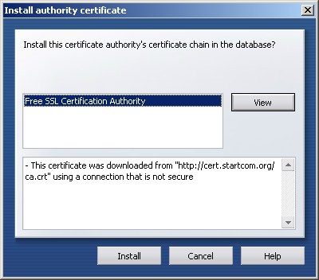

Click Install

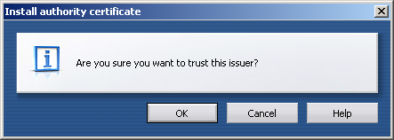

Click OK

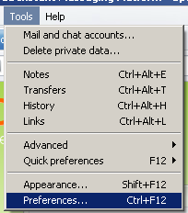
Go to the Tools menu and select Preferences

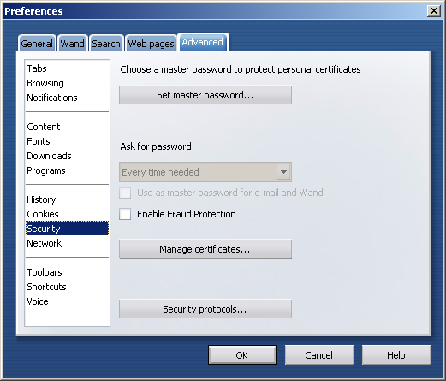

Go to the Advanced tab, click Security on the left side and click Manage certificates

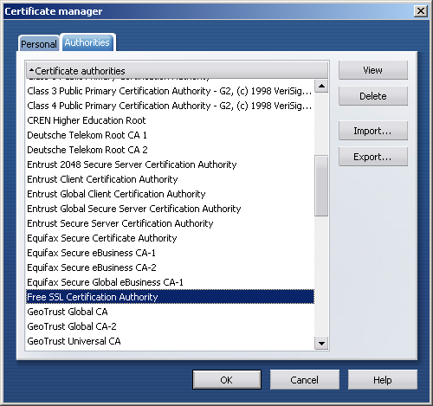
Go to the Authorities tab and find “Free SSL Certification Authority”a and click View

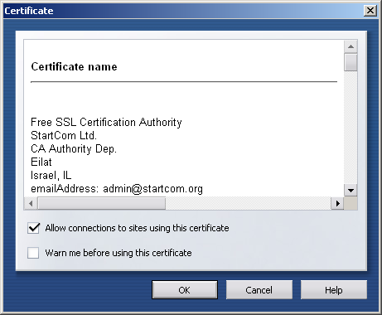

Make sure the “Allow connections...” box is checked and the “Warn me...” box is not.

