
DISEASE INTELLIGENCE REPORT
Alzheimer's disease
Comprehensive Clinical & Market Intelligence

Prepared by: Aganitha Cognitive Solutions
Generated: 14 May 2026
Classification: Confidential — For Internal Research Use Only
Intended Use: AI-generated report for internal research purposes only

Alzheimer's disease
Comprehensive pharmaceutical disease landscape report covering epidemiology, pathophysiology, clinical presentation, diagnosis, treatment, pipeline and market dynamics
Prepared by: Aganitha Cognitive Solutions
Generated: 14 May 2026
Classification: Confidential — For Internal Research Use Only

Table of Contents
1. [Disease Overview](#disease-overview)
2. [Epidemiology](#epidemiology)
3. [Etiology & Risk Factors](#etiology--risk-factors)

Disease Overview
Systemic Lupus Erythematosus (SLE) is a chronic, multisystem autoimmune disorder characterized by a loss of self-tolerance and the production of pathogenic autoantibodies targeting various nuclear antigens.

Epidemiology

Prevalence
Approximately 1 in 1,000 globally (100 per 100,000 population).

Incidence Rate
5.1 per 100,000 per year globally.

Geographic Distribution
| Region | Prevalence Per 100k | Notes |
| --- | --- | --- |
| North America | 150 | Highest in African American and Hispanic women. |
| Europe | 120 | Higher in Southern Europe. |

Demographics
Age Group: 15 to 45 years
Sex Distribution: 9:1 female-to-male ratio
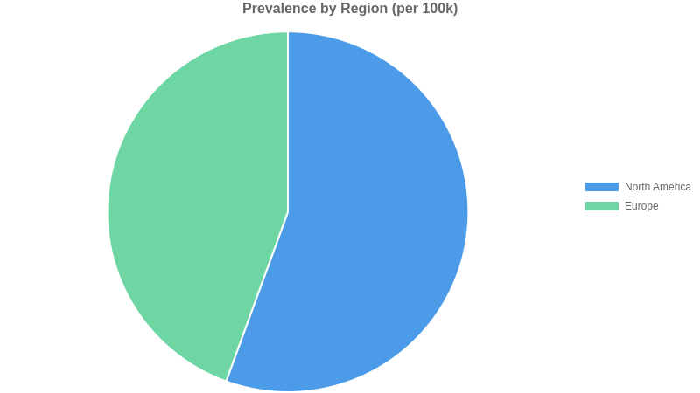

Etiology & Risk Factors
Multiple Sclerosis (MS) is a complex neuroinflammatory disease resulting from the convergence of a polygenic risk profile and specific environmental catalysts.
