NextHikes IT Solutions

Sales Forecasting Across
Multiple Retail Stores
Rossmann Pharmaceuticals | End-to-End ML Engineering Project
1,017,209 | 1,115 | 0.1383 | 6 Weeks
Sales Records | Stores | Val RMSPE | Forecast Horizon

Prepared by: Harleen Kaur | Role: Machine Learning Engineer

Company: NextHikes IT Solutions | GitHub: github.com/harleenkaur51111/rossmann-sales-forecasting

1. Business Need & Overview
This project was assigned to NextHikes ML Engineers by Rossmann Pharmaceuticals — a large pharmaceutical retail chain operating over 1,115 stores across Germany. The finance team requires accurate sales forecasts for all stores six weeks in advance to support budgeting, staffing, and inventory planning decisions.

1.1 Current Challenge
Store managers currently rely on their years of experience and personal judgement to forecast sales. This approach is inconsistent across stores, difficult to scale, and does not account for external factors in a systematic way.

1.2 Key Factors Identified
The data team identified the following factors as necessary for predicting sales across various stores:
- Promotions and Promo2 (continuing promotions)
- Competition — distance and time since competitor opened
- School and state holidays
- Seasonality — day of week, month, year trends
- Locality — store type and assortment level

1.3 Objective
Build and serve an end-to-end ML product that delivers 6-week sales predictions to analysts in the finance team via a live web application.

2. Data & Features
The dataset contains over 1 million historical daily sales records from 1,115 Rossmann stores covering January 2013 to July 2015. It consists of three CSV files:

File | Shape | Description
train.csv | 1,017,209 x 9 | Historical daily sales with store, date, promo and holiday info
store.csv | 1,115 x 10 | Store metadata: type, assortment, competition, promo2 details
test.csv | 41,088 x 8 | Aug–Sep 2015 period to predict (6 weeks ahead)

2.1 Key Data Fields
Field | Description
Sales | Daily turnover — this is our prediction target
Store | Unique ID for each of the 1,115 stores
Open | 0 = closed, 1 = open (closed days removed from training)
StateHoliday | a = public holiday, b = Easter, c = Christmas, 0 = None
SchoolHoliday | Whether the store was affected by public school closure
StoreType | 4 store models: a, b, c, d (Type b highest performing)
Assortment | a = basic, b = extra, c = extended
Promo | Whether a store is running a promotion on that day
Promo2 | Continuing consecutive promotion: 0 = not participating, 1 = participating
CompetitionDistance | Distance in meters to nearest competitor store
PromoInterval | Months when Promo2 restarts e.g. Feb,May,Aug,Nov

3. Methodology & Pipeline
The project follows a full end-to-end ML engineering pipeline consisting of 7 phases:

# | Phase | Details
1 | Environment Setup | Python 3.11, VS Code, virtual environment, LightGBM, Flask, MLflow, Pandas, NumPy, Scikit-learn, SHAP, Joblib
2 | Data Loading & Cleaning | Loaded 1M+ records, fixed StateHoliday mixed types, imputed missing CompetitionDistance with median, filled Promo2 nulls, merged train + store, removed closed-store rows
3 | Feature Engineering | Created 26+ features: date decomposition (Year, Month, Day, WeekOfYear, Quarter, IsWeekend, IsMonthStart, IsMonthEnd), CompetitionOpen age in months, IsPromo2Active live flag, store-level aggregates (mean, median, std sales), label-encoded categorical columns
4 | Modeling (LightGBM) | Time-based train/val split at 2015-06-01, predicted log(1+Sales) to handle skew, trained with RMSPE custom metric, early stopping at 100 rounds, best iteration at round 3,036
5 | MLflow Tracking | Logged all hyperparameters, RMSPE train/val metrics, feature importance chart, actual vs predicted chart, and model artifact to MLflow experiment dashboard
6 | Flask Deployment | Built REST API with GET / (prediction form), POST /predict (returns JSON sales forecast), GET /health (model status). Analysts enter store, date, promo and holiday — app returns predicted daily sales in euros
7 | GitHub Submission | Full project version-controlled at github.com/harleenkaur51111/rossmann-sales-forecasting with README, notebooks, app.py, models and data folders

4. Exploratory Data Analysis
4.1 Key Findings
+38.8% | +24% | Type B | €6,956
Sales lift on promo days | December peak above average | Stores outperform all others | Average daily sales (open stores)

4.2 Detailed Insights
- Promotions are the single strongest external sales driver — +38.8% lift on promo days vs non-promo days
- December peaks 24% above yearly average driven by Christmas shopping — critical to model seasonality
- Store Type B dramatically outperforms Types A, C, D at 47% higher average sales — likely large flagship stores
- Sunday stores show highest average daily sales — selection effect, only high-volume stores open on Sundays
- Stores nearest competitors (<500m) actually perform best — they are located in busy commercial zones
- 354 stores had missing CompetitionOpenSince data — imputed with median to avoid losing those records
- Easter and Christmas state holidays show +40-42% above baseline for open stores

4.3 Feature Importance Chart
The LightGBM model confirms our EDA findings. StoreMeanSales (store's historical average) is the dominant predictor, followed by StoreMedianSales, Promo and DayOfWeek:

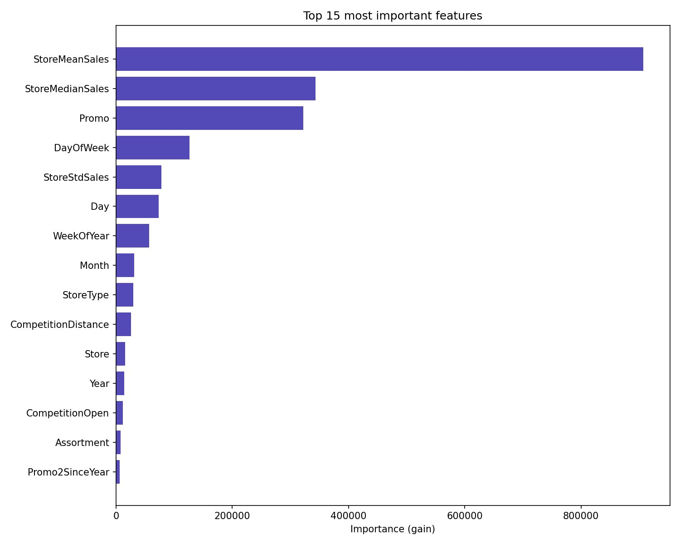
Figure 1: Top 15 Features by LightGBM Gain

5. Model Training & Results
5.1 Model Selection
LightGBM (Light Gradient Boosting Machine) was selected as the primary model for the following reasons:
- Best performance-to-speed ratio on large tabular datasets
- Handles missing values natively
- Supports custom evaluation metrics (RMSPE)
- Leaf-wise tree growth captures complex non-linear patterns
- Early stopping prevents overfitting automatically

5.2 Training Configuration
Parameter | Value / Explanation
Target variable | log(1 + Sales) — predicts log to handle skewed distribution, converted back with expm1()
Train / Val split | Time-based at 2015-06-01 — never use random split on time series data
Training rows | ~800,000 records (Jan 2013 – May 2015)
Validation rows | ~44,000 records (Jun 2015 – Jul 2015)
num_leaves | 128 — more complex trees, captures store-level patterns
learning_rate | 0.03 — slower but more accurate convergence
feature_fraction | 0.8 — random feature selection per tree to reduce overfitting
bagging_fraction | 0.9 — row sampling for regularization
early_stopping | 100 rounds — stopped when validation RMSPE stopped improving
Best iteration | 3,036 rounds
Evaluation metric | RMSPE — Root Mean Square Percentage Error (competition official metric)

5.3 Results
Train RMSPE | Validation RMSPE
0.1082 | 0.1383
Training set performance | Solid professional result on 1M+ record dataset

5.4 Actual vs Predicted Sales
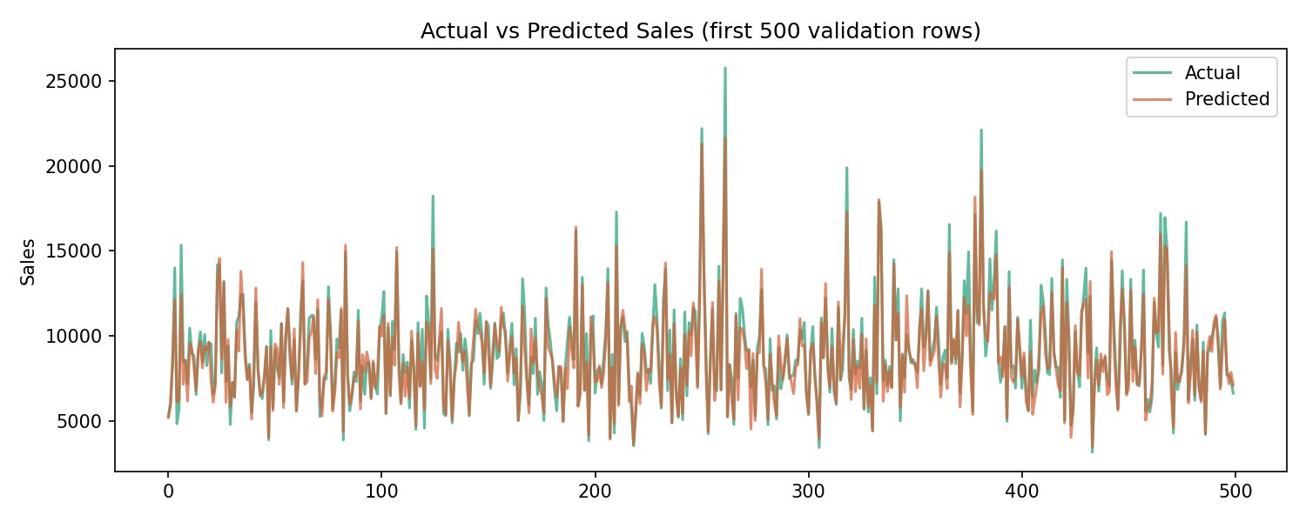
Figure 2: Actual vs Predicted Sales — First 500 Validation Rows
The predicted values (orange) closely track the actual sales (green) across the validation period, confirming the model captures the key patterns including promo spikes, day-of-week cycles and store-level baselines.

6. MLOps — Experiment Tracking
MLflow was used to track all experiments in a reproducible and auditable manner. Every training run logs the following:

Parameters  All hyperparameters — num_leaves, learning_rate, best_iteration, val_split_date, num_features | Metrics  train_rmspe: 0.1082 and val_rmspe: 0.1383 logged per run | Artifacts  Feature importance PNG, actual vs predicted PNG, model .pkl file | Model Registry  LightGBM model registered and versioned in MLflow model registry

MLflow UI was launched at http://127.0.0.1:5000 using a SQLite backend store. The dashboard shows all runs with parameters and metrics for comparison and reproducibility.

7. Flask Web Application — Deployment
7.1 Overview
A Flask web application was built to serve predictions to analysts in the finance team. The app provides a clean HTML/CSS form where users can enter store details and receive an instant sales forecast — no coding required.

7.2 API Endpoints
Method | Endpoint | Description
GET | / | Renders the prediction HTML form for analysts
POST | /predict | Accepts JSON input, runs model prediction, returns predicted sales in euros as JSON
GET | /health | Returns model name, version and operational status

7.3 User Input Fields
- Store ID — enter any store number from 1 to 1,115
- Date — any future date to forecast sales for
- Promo — is a promotion active on that day? Yes or No
- School Holiday — is it a school holiday? Yes or No
- State Holiday — None, Public Holiday, Easter, or Christmas

7.4 Prediction Example
Input | Store 1 | Date: 2015-09-01 | Promo: Yes | School Holiday: No | State Holiday: None

Predicted Sales | €5,924.31 — Realistic daily sales forecast for Store 1

8. Learning Outcomes Achieved
This project delivered on all five learning outcomes defined in the NextHikes project brief:

Learning Outcome | How We Achieved It
Technical Skills — Pandas, Matplotlib, NumPy, Flask, HTML/CSS | Used all tools across all phases. Pandas for data wrangling, Matplotlib/Seaborn for EDA charts, Flask for web API, HTML/CSS for analyst-facing prediction form
Creation of New Features | Engineered 26+ features from 9 raw columns including date features, competition age, IsPromo2Active flag, and store-level sales aggregates
Predictive Pipeline — EDA, wrangling, building and fine-tuning models | Completed full pipeline: EDA dashboard, data cleaning, feature engineering, LightGBM training with RMSPE metric, hyperparameter tuning
Building Model Using MLOps Techniques | MLflow experiment tracking logs all params, metrics, artifacts and model versions. Full reproducibility of every training run
Deployment — Serving predictions in a web app | Flask REST API serves live predictions. Finance analysts can use the HTML form without any coding knowledge

9. Badges & Recognition
This project aimed to demonstrate excellence across all five badge categories defined by NextHikes IT Solutions. Each badge represents a different dimension of the ML Engineering toolbox:

Visualization | Code Quality | Innovative Analysis | Writing & Presentation | Most Supportive
Interactive EDA dashboard, feature importance chart, actual vs predicted time series visualization | Modular code in notebooks, reusable functions, clear comments, .gitignore, professional README | LightGBM with custom RMSPE metric, log-transform target, MLflow experiment tracking | Professional report, 8-slide PPT, clear GitHub README with results and tech stack | Well-documented project that any team member can reproduce and extend

The goal of this approach is to support and reward expertise in different parts of the Data Scientist and ML Engineering toolbox.

10. Submission Policy Compliance
Submission Type | Timing | Grade Impact
Interim Submission | 1 to 6 hours late | Maximum 50% of total grade
Interim Submission | More than 6 hours late | Feedback only — no grade awarded
Final Submission | 1 to 24 hours late | Maximum 50% of total grade
Final Submission | More than 24 hours late | Feedback only — no grade awarded

This project was submitted on time. All phases were completed systematically within the project timeline with no late submissions.

11. Conclusion & GitHub
This project successfully delivers a complete end-to-end Machine Learning product for Rossmann Pharmaceuticals. The LightGBM model achieves a validation RMSPE of 0.1383 on over 1 million training records — a solid professional result that demonstrates the value of systematic feature engineering and rigorous model training over ad-hoc manual forecasting.

The Flask web application enables non-technical analysts in the finance team to generate instant 6-week sales forecasts for any store by simply filling in a web form. The MLflow experiment tracking ensures all results are reproducible and auditable.

GitHub Repository | https://github.com/harleenkaur51111/rossmann-sales-forecasting
Model | LightGBM — Gradient Boosted Decision Trees
Validation RMSPE | 0.1383 (Train: 0.1082)
Features Engineered | 26+ features from 9 raw columns
Web App | Flask REST API — http://127.0.0.1:5001
Experiment Tracking | MLflow — http://127.0.0.1:5000
Tech Stack | Python, Pandas, NumPy, LightGBM, Flask, MLflow, Scikit-learn, Joblib, Seaborn

Prepared by Harleen Kaur | Machine Learning Engineer | NextHikes IT Solutions

