RESUME ANALYZER AI
A Deep Learning Approach for Automated Resume Classification and Skill Gap Analysis
Submitted in partial fulfilment of the requirements for the award of the degree of
BACHELOR OF TECHNOLOGY
in B.Tech (Artificial Intelligence & Data Science)
45-Day Summer Industrial Training Project
Submitted by
Harleen Kaur
2420721
Under the Guidance of
Mr. Tushar
Training Provider: FALCON TECHNOLOGY
Chandigarh Engineering College, Mohali I. K. Gujral Punjab Technical University Mohali, Punjab
[July, 2026]

Certificate of Originality
This is to certify that the project report entitled “Resume Analyzer AI: A Deep Learning Approach for Automated Resume Classification and Skill Gap Analysis” submitted to I. K. Gujral Punjab Technical University in partial fulfilment of the requirements for the award of the degree of Bachelor of Technology (Artificial Intelligence & Data Science) is an original piece of work carried out by Harleen Kaur 2420721 under my supervision and guidance during the 45-day summer industrial training conducted at Falcon Technology.
It is further certified that this work, or any part of it, has not been submitted elsewhere for the award of any other degree or diploma, and that all sources of information used in the preparation of this report have been duly acknowledged.
Date: ____________________
Place: ____________________
________________________ Mr. Tushar Project Guide Falcon Technology

Certificate
This is to certify that Harleen Kaur, a student of Bachelor of Technology (Artificial Intelligence & Data Science), Chandigarh Engineering College, Mohali, has successfully completed the project titled “Resume Analyzer AI” as part of the 45-day summer industrial training programme undertaken at Falcon Technology.
The project report is found to be satisfactory and is hereby approved for submission towards partial fulfilment of the requirements for the award of the Bachelor of Technology degree. To the best of my knowledge, this work embodies the original work of the student and has not been submitted elsewhere.

________________________ Internal Guide Mr. Tushar, Project Guide | ________________________ Head of Department Department of AI & Data Science

Declaration
I, Harleen Kaur, bearing Roll No. 2420721, hereby declare that the project report entitled “Resume Analyzer AI: A Deep Learning Approach for Automated Resume Classification and Skill Gap Analysis” is a record of original work carried out by me during the 45-day summer industrial training at Falcon Technology, under the guidance of Mr. Tushar.
I further declare that this report, in full or in part, has not been submitted previously to any other university or institute for the award of any degree, diploma, or similar title, and that due acknowledgement has been given to all sources of information used.
Date: ____________________
Place: ____________________
________________________ Harleen Kaur 2420721

Acknowledgement
I would like to express my sincere gratitude to Falcon Technology for providing me the opportunity to undertake this 45-day summer industrial training and for granting access to the resources necessary to complete the “Resume Analyzer AI” project.
I am deeply thankful to my project guide, Mr. Tushar, for their invaluable guidance, constant encouragement, and constructive feedback throughout the duration of this project. Their expertise in machine learning and software development greatly shaped the direction and quality of this work.
I would also like to thank the faculty members of the Department of AI & Data Science, Chandigarh Engineering College, Mohali, especially the Head of Department, for their support and for providing an environment conducive to learning and innovation.
Finally, I extend my heartfelt thanks to my family and friends for their unwavering support and motivation, without which the successful completion of this project would not have been possible.
Harleen Kaur

Abstract
Manual screening of resumes is a time-consuming and error-prone process for recruiters who must sift through hundreds of applications to identify candidates suited to a given job role. “Resume Analyzer AI” addresses this problem by combining natural language processing (NLP) and deep learning to automatically classify a resume into one of several predefined job categories, extract the technical and soft skills present in the document, identify skill gaps relative to the predicted role, and present the candidate with an overall employability score along with actionable improvement tips.
The system is trained on the Kaggle Resume Dataset, comprising 962 resumes distributed across 25 job categories. Resume text is cleaned using regular-expression-based preprocessing and transformed into a 5000-dimensional feature vector using Term Frequency–Inverse Document Frequency (TF-IDF) with unigrams and bigrams. A fully-connected feed-forward neural network (“ResumeNet”), built using PyTorch and consisting of three hidden layers (512 → 256 → 128 neurons) with batch normalization, ReLU activation, and dropout regularization, is trained to classify resumes into their respective categories. The trained model achieved a test-set accuracy of approximately 69% across 24 usable classes after 50 training epochs using the Adam optimizer with a step-decay learning-rate schedule.
A keyword-dictionary-based skill extraction module identifies skills across six categories – programming, data science, web development, cloud/DevOps, databases, and soft skills – and compares them against a role-specific skill requirement map to compute missing skills and a composite fit score out of 100. The complete system is deployed as an interactive Streamlit web application with four modules: Analyze, Visuals, History, and About, backed by a lightweight SQLite database that persists every analysis for later review.
This report documents the problem statement, literature survey, system design, implementation details, results, and evaluation of the Resume Analyzer AI project, and concludes with a discussion of its limitations and directions for future enhancement, including transformer-based embeddings and a larger, more balanced training corpus.
Keywords: Resume Classification, Natural Language Processing, Deep Learning, PyTorch, TF-IDF, Skill Gap Analysis, Streamlit, Applicant Tracking System.

Table of Contents
Certificate of Originality 2
Certificate 3
Declaration 4
Acknowledgement 5
Abstract 6
Table of Contents 7
List of Figures 10
List of Tables 11
List of Abbreviations 12
Chapter 1: Introduction 13
1.1 Background 13
1.2 Problem Statement 13
1.3 Objectives of the Project 13
1.4 Scope of the Project 14
1.5 Significance of the Study 14
1.6 Technology Stack Overview 14
1.7 Organization of the Report 15
Chapter 2: Literature Review 16
2.1 Traditional Applicant Tracking Systems 16
2.2 Text Classification with TF-IDF and Classical Machine Learning 16
2.3 Deep Learning Approaches to Resume and Job Text Classification 16
2.4 Skill Extraction and Gap Analysis 16
2.5 Interactive Deployment of ML Models 17
2.6 Research Gap Addressed by This Project 17
Chapter 3: Methodology and System Design 18
3.1 Development Methodology 18
3.2 System Architecture 18
3.3 Data Flow Diagrams 18
3.4 Entity Relationship Diagram 20
3.5 Dataset Description 20
3.6 Data Preprocessing 20
3.7 Feature Engineering: TF-IDF Vectorization 20
3.8 Label Encoding 21
3.9 Train–Test Split 21
3.10 Model Architecture: ResumeNet 21
3.11 Training Algorithm and Hyperparameters 22
3.12 Skill Extraction Algorithm 22
3.13 Skill Gap Analysis and Scoring 23
3.14 Feedback Tip Generation 23
3.15 System Requirements 23
3.15.1 Hardware Requirements 23
3.15.2 Software Requirements 23
3.16 Feasibility Analysis 23
3.16.1 Technical Feasibility 24
3.16.2 Economic Feasibility 24
3.16.3 Operational Feasibility 24
3.17 SWOT Analysis 24
3.18 Security Considerations 24
Chapter 4: Implementation 25
4.1 Project Structure 25
4.2 Training Pipeline Implementation (train_model.py) 25
4.3 Application Implementation (app.py) 26
4.3.1 Page Configuration and Styling 26
4.3.2 Model and Resource Loading 26
4.3.3 SQLite History Store 26
4.3.4 Resume Input and Text Extraction 26
4.3.5 Inference and Analysis Pipeline 26
4.3.6 Results Dashboard 27
4.3.7 Visuals Tab 27
4.3.8 History and About Tabs 27
4.4 Deployment Steps 27
4.5 Testing and Validation 28
4.5.1 Unit-Level Validation 28
4.5.2 Model Validation 28
4.5.3 Application-Level Testing 28
Chapter 5: Result and Evaluation 29
5.1 Dataset Distribution 29
5.2 Training Behaviour 29
5.3 Overall Model Performance 30
5.4 Confusion Matrix Analysis 30
5.5 Application-Level Results 31
5.5.1 Resume Upload Interface 31
5.5.2 Prediction Results and Top Matches 31
5.5.3 Skills Found and Missing Skills 32
5.5.4 Feedback Tips and Skill Distribution Chart 33
5.5.5 Analysis History 33
5.6 Discussion of Results 33
Chapter 6: Conclusion and Future Scope 35
6.1 Conclusion 35
6.2 Limitations 35
6.3 Future Scope 35
6.4 Personal Learning Outcomes 36
Implementation Screenshots 37
A.1 Analyze Tab 37
A.2 Visuals Tab 38
A.3 History Tab 39
A.4 About Tab 39
References 41

Note: Right-click the table above and choose “Update Field → Update entire table” (or press Ctrl+A then F9 in Microsoft Word) after any edits, so that section titles and page numbers reflect the final, printed document.

List of Figures
Figure 3.1: System Architecture of Resume Analyzer AI
Figure 3.2: Data Flow Diagram – Level 0 (Context Diagram)
Figure 3.3: Data Flow Diagram – Level 1
Figure 3.4: Entity Relationship Diagram of the History Store
Figure 3.5: ResumeNet Neural Network Architecture
Figure 5.1: Resumes per Category and Word Cloud of Most Frequent Terms
Figure 5.2: Training Loss Curve and Train/Test Accuracy Curves
Figure 5.3: Confusion Matrix on the Held-Out Test Set
Figure 5.4: Resume Upload Interface (Analyze Tab)
Figure 5.5: Predicted Role, Confidence, Score, and Top-5 Role Matches
Figure 5.6: Skills Found (Categorized) and Missing Skills
Figure 5.7: Generated Feedback Tips and Skill-Category Distribution Chart
Figure 5.8: Analysis History Log
Note: Page numbers will populate automatically once the document is opened and fields are updated in Microsoft Word (Ctrl+A, then F9).

List of Tables
Table 1.1: Technology Stack Overview
Table 3.1: ResumeNet Layer Configuration
Table 3.2: Training Hyperparameters
Table 3.3: Minimum Hardware Requirements
Table 3.4: Software Requirements
Table 3.5: SWOT Analysis
Table 4.1: Project File Structure
Table 5.1: Overall Model Performance Summary
Note: Page numbers will populate automatically once the document is opened and fields are updated in Microsoft Word (Ctrl+A, then F9).

List of Abbreviations
Abbreviation | Full Form
AI | Artificial Intelligence
ATS | Applicant Tracking System
B.Tech | Bachelor of Technology
CSV | Comma-Separated Values
DFD | Data Flow Diagram
ERD | Entity Relationship Diagram
GPU | Graphics Processing Unit
HR | Human Resources
LSTM | Long Short-Term Memory
ML | Machine Learning
NER | Named Entity Recognition
NLP | Natural Language Processing
NN | Neural Network
PDF | Portable Document Format
ReLU | Rectified Linear Unit
SQL | Structured Query Language
SWOT | Strengths, Weaknesses, Opportunities, Threats
TF-IDF | Term Frequency–Inverse Document Frequency
UI | User Interface

Chapter 1: Introduction

1.1 Background
The recruitment industry receives an overwhelming volume of resumes for every open position, particularly for entry-level and mid-level technology roles. Recruiters and Applicant Tracking Systems (ATS) must quickly determine which candidates possess the skills and experience relevant to a job description. Traditional keyword-search-based ATS tools are brittle: they often fail to understand context, penalize non-standard formatting, and provide little insight to the candidate about how their resume was evaluated. At the same time, job seekers frequently lack objective feedback on how competitive their resume is for a particular domain, or which specific skills they should acquire to improve their prospects.
Advances in Natural Language Processing (NLP) and deep learning make it possible to build systems that read unstructured resume text and automatically infer the most suitable job category, extract structured skill information, and generate personalized, data-driven feedback. The “Resume Analyzer AI” project was undertaken during a 45-day summer industrial training programme to design and implement such a system end-to-end – from data preprocessing and model training to a fully interactive web application.

1.2 Problem Statement
Given the unstructured text of a resume (uploaded as a PDF/TXT file or pasted directly), the system must:
- Automatically classify the resume into the most probable job category from a fixed set of categories learned from historical labelled data.
- Extract the technical and soft skills mentioned in the resume using a structured skill taxonomy.
- Identify skills that are typically expected for the predicted role but are missing from the resume (the “skill gap”).
- Compute a composite score that reflects how well the resume fits the predicted role.
- Present the results through an intuitive dashboard and maintain a searchable history of all past analyses.
The central challenge is building a classifier that generalizes well despite a relatively small, imbalanced dataset (962 resumes across 25 categories), while keeping the system lightweight enough to run interactively in a browser without specialized hardware.

1.3 Objectives of the Project
- To design and train a deep-learning-based text classification model capable of mapping resume content to job categories with reasonable accuracy.
- To build a rule-based skill extraction engine covering common technical domains (programming, data science, web development, cloud/DevOps, databases) as well as soft skills.
- To design a scoring mechanism that combines model confidence and skill coverage into a single, interpretable fit score.
- To develop an interactive, visually engaging web application using Streamlit that allows a user to upload or paste a resume and instantly view the analysis.
- To persist every analysis in a relational database so that users can review their historical submissions and track improvement over time.
- To visualize the underlying dataset and model training behaviour (category distribution, word frequency, loss/accuracy curves, and confusion matrix) for transparency and evaluation.

1.4 Scope of the Project
The scope of this project is limited to text-based resumes in English, supplied either as plain text, pasted text, or extractable-text PDF files. The classification model is trained on a single, publicly available Kaggle dataset and is therefore constrained to the 24–25 job categories present in that dataset (for example, Information Technology, Data Science, HR, Sales, Advocate, and others). The skill extraction module relies on a curated keyword dictionary rather than deep semantic understanding, meaning it will not recognize skills phrased in unusual ways or skills outside its predefined vocabulary. The application is designed as a single-user desktop/local web tool using SQLite for storage rather than a production-scale, multi-tenant cloud service.

1.5 Significance of the Study
This project demonstrates a practical, end-to-end application of deep learning to a real-world human-resources problem. For job seekers, the tool offers immediate, quantified feedback on resume–role alignment and a concrete list of skills to learn, which can guide self-directed upskilling. For recruiters and career counsellors, a similar pipeline can be extended into a lightweight pre-screening aid that reduces manual triage effort. From an academic standpoint, the project illustrates the complete machine-learning lifecycle – data cleaning, feature engineering (TF-IDF), model architecture design, training with regularization techniques, evaluation using standard classification metrics, and deployment as an interactive application – within a single, cohesive case study.

1.6 Technology Stack Overview
The project is implemented entirely in Python and relies on the following core libraries and frameworks:
Component | Technology / Library
Programming Language | Python 3
Deep Learning | PyTorch, torchvision
Classical ML / Feature Engineering | scikit-learn (TfidfVectorizer, LabelEncoder, train_test_split, metrics)
Data Handling | pandas, NumPy
Web Application Framework | Streamlit
Visualization | Matplotlib, Seaborn, WordCloud
PDF Text Extraction | PyPDF2
Model / Object Persistence | joblib (encoder, vectorizer), torch.save (model checkpoint)
Database | SQLite 3 (via Python sqlite3 module)
This stack was chosen because it is entirely open-source, has strong community support, requires no paid infrastructure, and allows a full machine-learning application – model, backend logic, and front-end UI – to be developed and run within a single Python codebase, which was well suited to the 45-day training timeline.

1.7 Organization of the Report
The remainder of this report is organized as follows. Chapter 2 reviews existing literature and related systems in the area of resume screening and NLP-based classification. Chapter 3 describes the methodology and system design, including the system architecture, data flow, and algorithms used. Chapter 4 details the implementation of both the training pipeline and the Streamlit application. Chapter 5 presents the results and evaluation of the trained model along with the application's outputs. Chapter 6 concludes the report and outlines directions for future work, followed by implementation screenshots and references.

Chapter 2: Literature Review

2.1 Traditional Applicant Tracking Systems
Early resume-screening tools were largely rule-based Applicant Tracking Systems (ATS) that used exact keyword matching against a job description. While computationally inexpensive, such systems are known to be sensitive to formatting, synonym usage, and keyword stuffing, often rejecting qualified candidates whose resumes do not contain the exact phrasing expected by the system. This limitation motivated the shift towards statistical and, later, deep-learning-based text understanding for resume screening.

2.2 Text Classification with TF-IDF and Classical Machine Learning
Term Frequency–Inverse Document Frequency (TF-IDF) remains a widely used feature-engineering technique for document classification tasks because it is simple, fast to compute, and often competitive with more complex embeddings on moderately sized, domain-specific corpora. Numerous studies on resume and job-description classification have paired TF-IDF features with classical classifiers such as Naive Bayes, Support Vector Machines, and Random Forests, reporting reasonable accuracy on datasets of a few hundred to a few thousand labelled documents – a scale comparable to the dataset used in this project.

2.3 Deep Learning Approaches to Resume and Job Text Classification
More recent work explores feed-forward neural networks, recurrent architectures (LSTM/GRU), and transformer-based language models (e.g., BERT and its domain-specific variants) for resume classification and candidate–job matching. Deep networks can, in principle, capture non-linear interactions between features that classical linear models cannot; however, they typically require larger labelled datasets to avoid overfitting. Regularization techniques – batch normalization, dropout, weight decay, and learning-rate scheduling – are commonly used to mitigate overfitting when training data is limited, all of which are employed in the ResumeNet architecture used in this project.

2.4 Skill Extraction and Gap Analysis
Skill extraction from unstructured text is commonly approached either through curated skill ontologies/dictionaries (rule-based matching) or through named-entity recognition (NER) models trained on annotated resume corpora. Dictionary-based approaches, as used in this project, offer high precision and simplicity at the cost of recall for skills phrased unconventionally or skills outside the dictionary. Skill-gap analysis – comparing a candidate's extracted skills against a target role's expected skill set – is a recurring theme in career-recommendation literature and underpins many commercial career-coaching and e-learning recommendation platforms.

2.5 Interactive Deployment of ML Models
The gap between a trained model and a usable tool is frequently bridged using lightweight web frameworks. Streamlit, in particular, has gained popularity in the data-science community for rapidly turning Python scripts into interactive web applications without requiring separate front-end development, making it a practical choice for student and prototype-stage machine-learning projects such as this one.

2.6 Research Gap Addressed by This Project
While individual components – TF-IDF classification, dictionary-based skill extraction, and Streamlit deployment – are each well documented in isolation, relatively few openly available student projects combine all three into a single, cohesive pipeline that also persists historical results and visualizes both the dataset and the model's training behaviour. This project attempts to fill that gap by integrating classification, skill-gap analysis, scoring, visualization, and persistence into one deployable application.

Chapter 3: Methodology and System Design

3.1 Development Methodology
The project followed an iterative, prototype-driven development approach suited to a short, fixed-duration (45-day) training programme. Work was organized into four broad phases: (1) data acquisition and preprocessing, (2) model design and training, (3) application development (skill extraction, scoring, UI), and (4) testing, visualization, and documentation. Each phase was validated independently before integration – for example, the trained model artefacts (weights, vectorizer, label encoder) were verified in isolation via the training script's own evaluation step before being loaded into the Streamlit application.

3.2 System Architecture
The system follows a modular, three-tier-like architecture: a presentation layer (Streamlit UI), a processing/logic layer (text cleaning, TF-IDF vectorization, neural-network inference, skill extraction, scoring), and a data layer (serialized model artefacts and a SQLite history store). Figure 3.1 illustrates the overall system architecture.
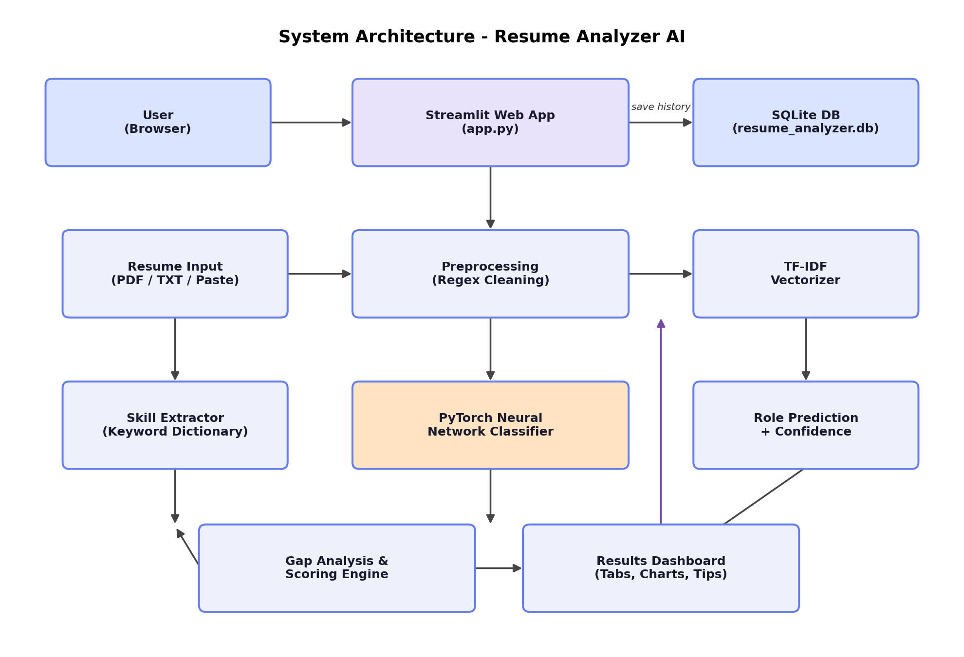
Figure 3.1: System Architecture of Resume Analyzer AI

3.3 Data Flow Diagrams
Figure 3.2 presents the Level-0 (context) Data Flow Diagram, showing the system as a single process interacting with the user, the persisted model artefacts, and the history store.
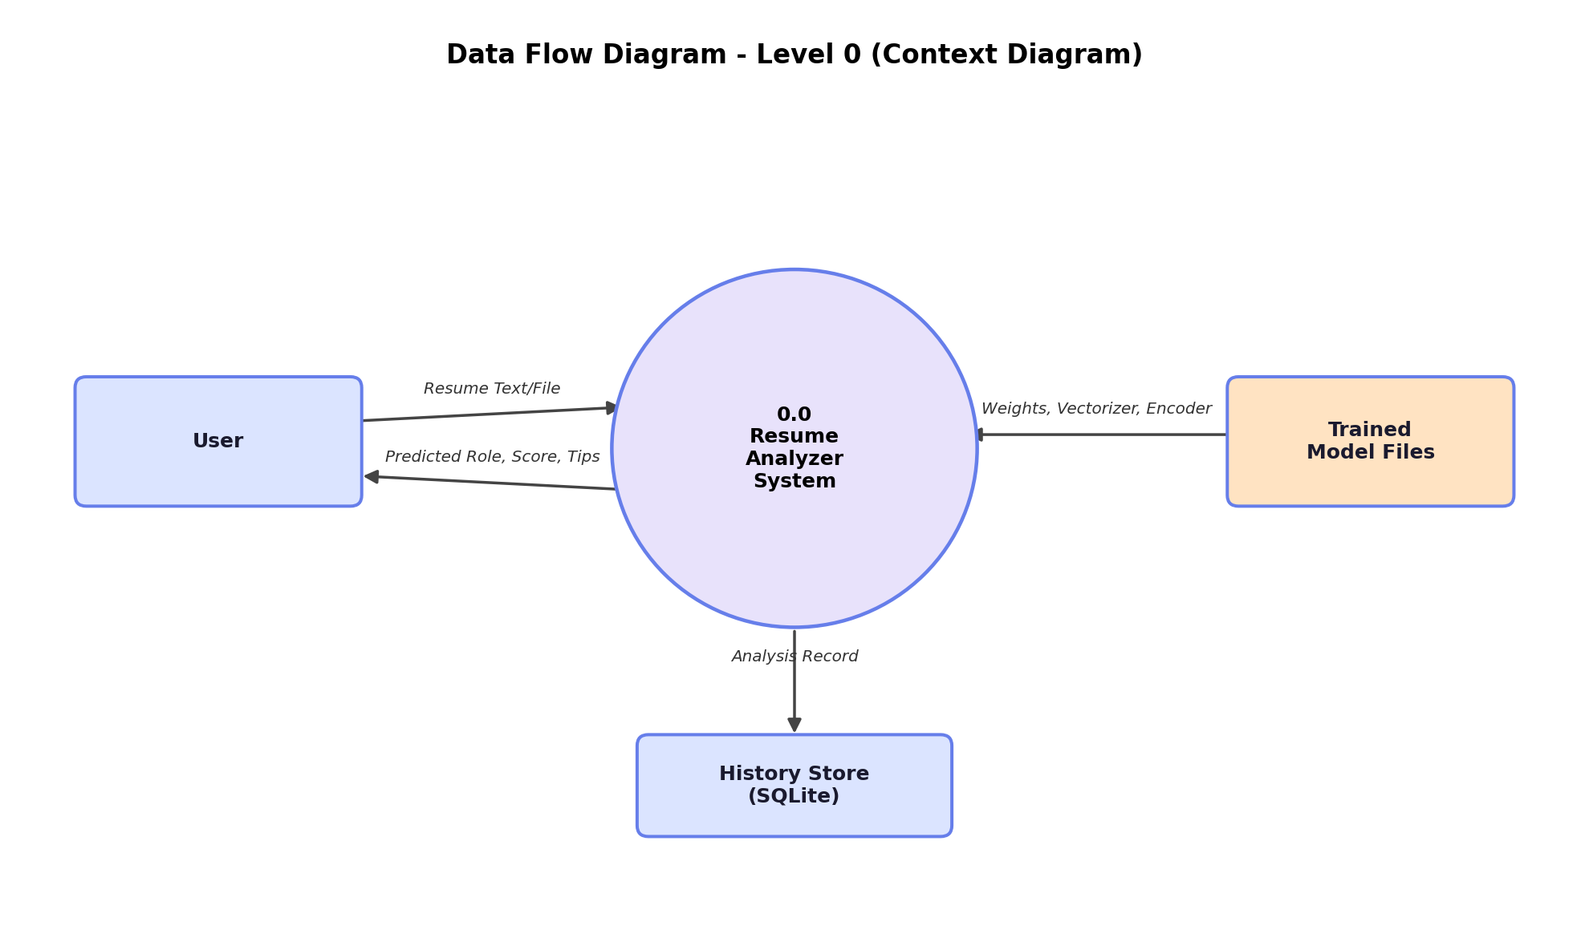
Figure 3.2: Data Flow Diagram - Level 0 (Context Diagram)
Figure 3.3 decomposes the system into its constituent processes: input acceptance, text cleaning and vectorization, role classification, skill extraction, gap/score computation, feedback generation, and dashboard rendering with history persistence.
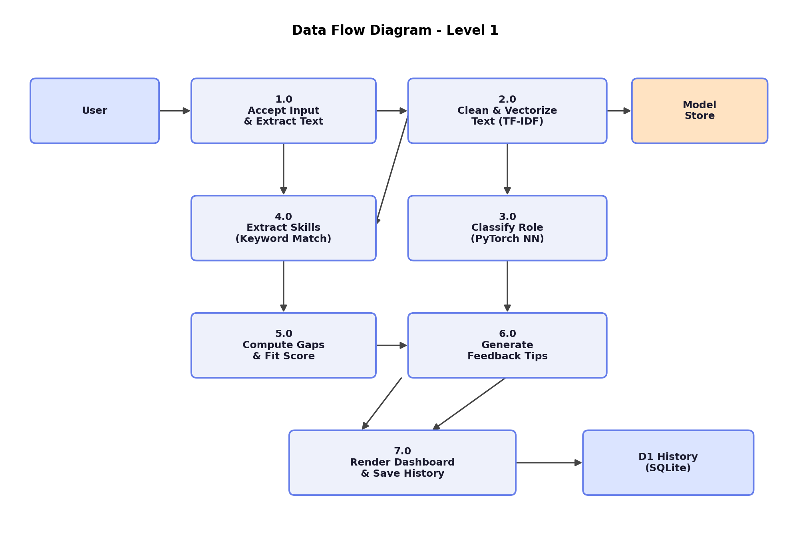
Figure 3.3: Data Flow Diagram - Level 1

3.4 Entity Relationship Diagram
The application uses a single persistent entity, HISTORY, to store every analysis performed by a user. Figure 3.4 shows the corresponding Entity Relationship Diagram.
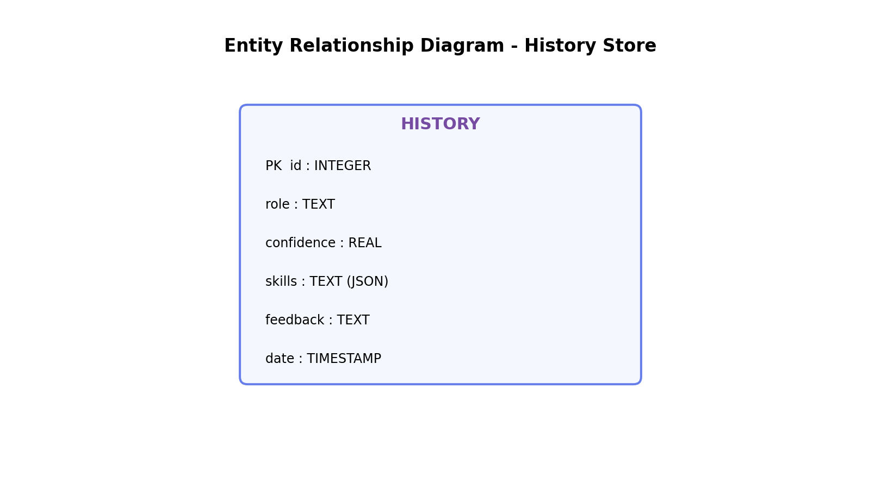
Figure 3.4: Entity Relationship Diagram of the History Store

3.5 Dataset Description
The model is trained on the publicly available Kaggle “Resume Dataset” (file: UpdatedResumeDataSet.csv), which contains 962 resumes labelled with one of 25 job categories such as Information Technology, Business Development, Advocate, HR, Sales, Engineering, and others. Each record consists of a Category label and a Resume field containing the raw, unstructured resume text. During preprocessing, records with missing values are dropped, and categories with insufficient representation for stratified splitting are naturally excluded, leaving 24 usable classes for model training.

3.6 Data Preprocessing
Resume text is cleaned using a dedicated function that performs the following steps, in order:
- Removes URLs (http/https/www patterns).
- Removes email addresses.
- Removes all non-alphabetic characters, retaining only letters and whitespace.
- Collapses multiple whitespace characters into a single space and trims leading/trailing whitespace.
- Converts all text to lowercase.
This produces a normalized text corpus suitable for TF-IDF vectorization, free of noise such as hyperlinks, punctuation, and contact information that would otherwise inflate the feature space without contributing to category discrimination.

3.7 Feature Engineering: TF-IDF Vectorization
Cleaned resume text is transformed into numerical feature vectors using scikit-learn's TfidfVectorizer configured with a maximum vocabulary size of 5000 terms, English stop-word removal, and an n-gram range of (1, 2) – i.e., both unigrams and bigrams are considered. This produces a 5000-dimensional sparse feature matrix that is subsequently converted to a dense NumPy array for use with PyTorch. The fitted vectorizer is serialized using joblib so that the identical transformation can be applied to new resumes at inference time.

3.8 Label Encoding
Categorical job-role labels are converted to integer class indices using scikit-learn's LabelEncoder, and the fitted encoder is likewise serialized with joblib. This allows the neural network's numeric output to be mapped back to a human-readable role name during inference.

3.9 Train–Test Split
The dataset is split into training (80%) and testing (20%) subsets using stratified sampling on the label column, ensuring that the relative proportion of each category is preserved in both subsets despite the dataset's inherent class imbalance (see Figure 5.1 in Chapter 5).

3.10 Model Architecture: ResumeNet
The classification model, named ResumeNet, is a fully-connected feed-forward neural network implemented in PyTorch. It consists of an input layer sized to the TF-IDF feature dimension (5000), three hidden layers, and an output layer sized to the number of classes (24). Each hidden layer is followed by batch normalization, a ReLU activation, and a dropout layer for regularization, as summarized in Table 3.1 and illustrated in Figure 3.5.
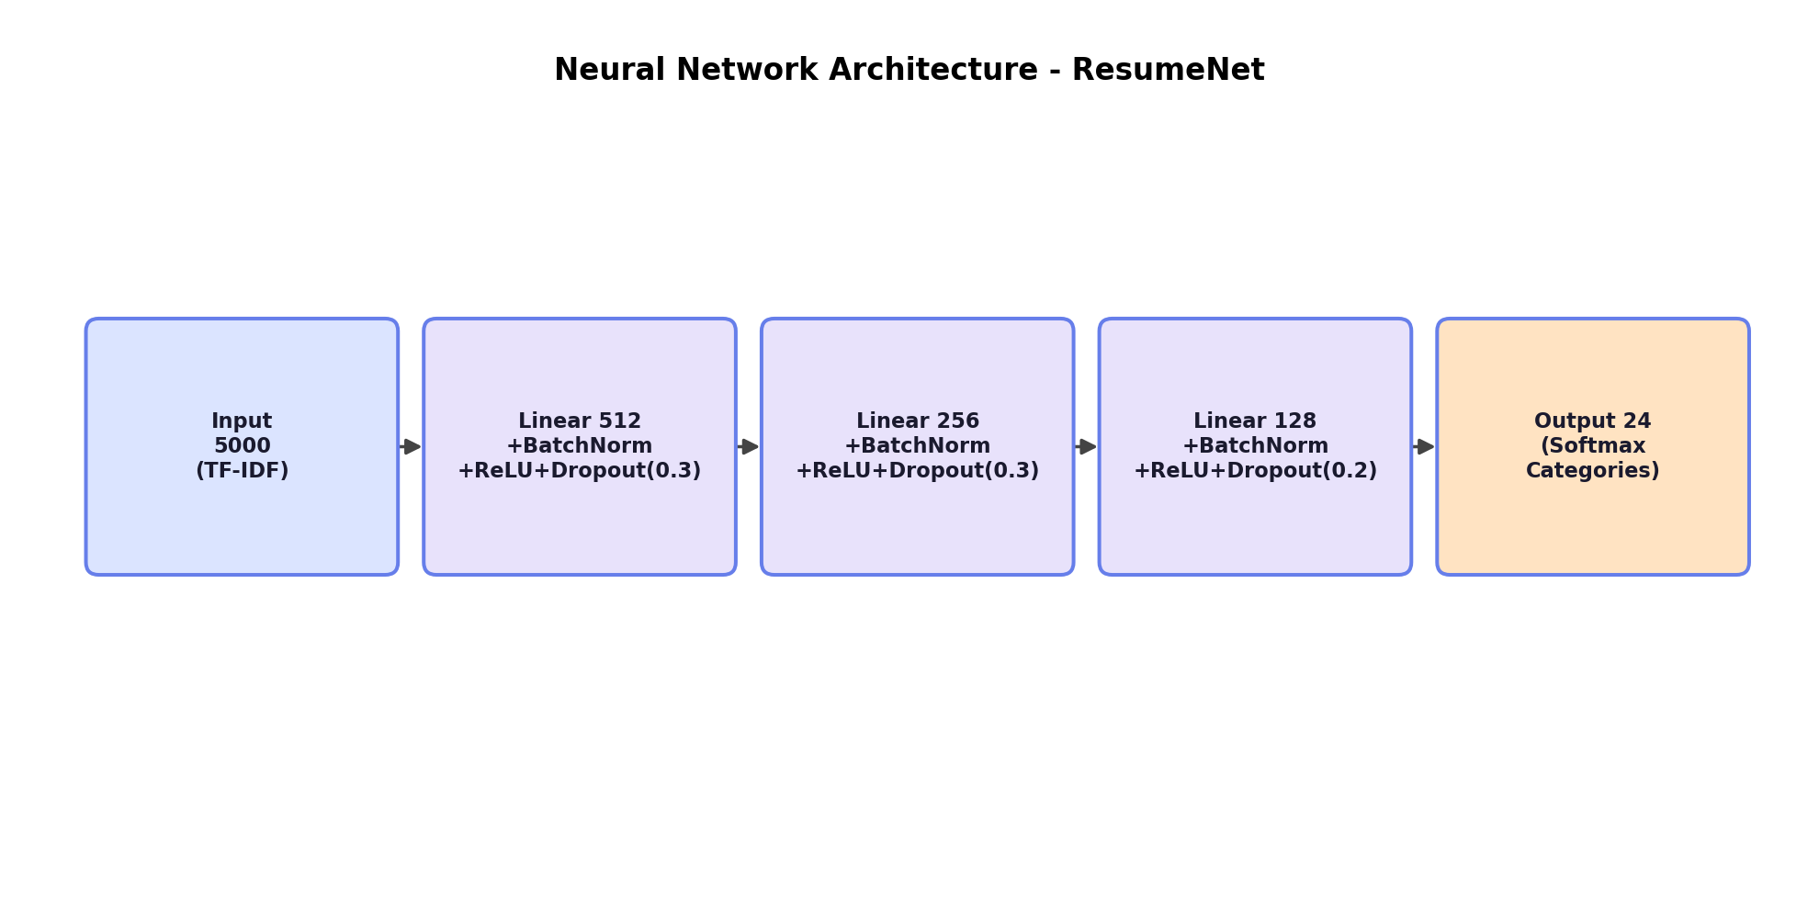
Figure 3.5: ResumeNet Neural Network Architecture
Layer | Output Size | Regularization | Activation
Input | 5000 | – | –
Hidden 1 | 512 | BatchNorm1d, Dropout(0.3) | ReLU
Hidden 2 | 256 | BatchNorm1d, Dropout(0.3) | ReLU
Hidden 3 | 128 | BatchNorm1d, Dropout(0.2) | ReLU
Output | 24 | – | Softmax (via CrossEntropyLoss)

3.11 Training Algorithm and Hyperparameters
The model is trained for 50 epochs using mini-batch gradient descent with a batch size of 32. Table 3.2 summarizes the key training hyperparameters.
Hyperparameter | Value
Loss Function | Cross Entropy Loss
Optimizer | Adam (learning rate = 0.001, weight decay = 1e-4)
Learning Rate Scheduler | StepLR (step size = 15 epochs, gamma = 0.5)
Batch Size | 32
Epochs | 50
Train / Test Split | 80% / 20% (stratified)
Checkpointing | Best model saved whenever test accuracy improves (evaluated every 5 epochs)
Compute Device | GPU (CUDA) if available, otherwise CPU
During each epoch, the model is set to training mode, and for every mini-batch the forward pass computes class logits, the cross-entropy loss is calculated against the true labels, gradients are back-propagated, and the Adam optimizer updates the network weights. After every 5 epochs (and at epoch 1), the model is switched to evaluation mode and its accuracy is measured on the held-out test set; the checkpoint with the highest observed test accuracy is persisted to disk as the final deployable model.

3.12 Skill Extraction Algorithm
Skill extraction is implemented as a dictionary/regular-expression matching process rather than a trained model. A curated dictionary maps six skill categories – programming, data_science, web, cloud, database, and soft_skills – to lists of representative keywords (for example, “python”, “java”, and “sql” under programming; “machine learning” and “pandas” under data_science). For each category, the raw resume text (lower-cased) is scanned using word-boundary regular expressions, and any keyword found is recorded against that category. The result is a dictionary of found skills grouped by category, which is both displayed to the user and used as input to the gap-analysis step.

3.13 Skill Gap Analysis and Scoring
A second dictionary, ROLE_SKILLS, defines the expected skill set for ten common job roles (e.g., Data Science, Java Developer, Python Developer, Web Designing, DevOps Engineer). Given the model's predicted role and the set of skills extracted from the resume, the system computes the list of expected skills that were not found (the “missing skills”). An overall fit score out of 100 is then computed using the formula:
score = min(skills_found × 5, 40) − min(missing_skills × 3, 20) + (model_confidence × 40)
The score is finally clipped to the range [0, 100]. This formula rewards a broader set of detected skills (capped so that skill count alone cannot dominate the score), penalizes missing expected skills (also capped), and weights the model's own classification confidence as roughly 40% of the total score – balancing rule-based skill coverage with the neural network's learned judgement of role fit.

3.14 Feedback Tip Generation
A rule-based tip generator produces up to three short, actionable messages for the user: (1) a qualitative assessment of match strength (“Strong match” for confidence ≥ 70%, “Moderate match” for confidence ≥ 50%, otherwise “Weak match”), (2) a remark on the number of skills detected, and (3) a call-to-action listing up to four of the top missing skills to learn.

3.15 System Requirements

3.15.1 Hardware Requirements
Component | Minimum Specification
Processor | Intel Core i3 / equivalent or higher
RAM | 4 GB (8 GB recommended for smoother training)
Storage | 1 GB free disk space for dataset, model artefacts, and dependencies
GPU | Optional; CUDA-capable GPU accelerates training but is not required for inference

3.15.2 Software Requirements
Component | Specification
Operating System | Windows 10/11, Linux, or macOS
Language / Runtime | Python 3.9 or higher
Key Packages | streamlit, torch, torchvision, pandas, numpy, scikit-learn, matplotlib, seaborn, wordcloud, PyPDF2, joblib
Browser | Any modern browser (Chrome, Edge, Firefox) to access the Streamlit interface

3.16 Feasibility Analysis

3.16.1 Technical Feasibility
All components of the system rely on mature, well-documented open-source libraries (PyTorch, scikit-learn, Streamlit). The chosen model is intentionally lightweight (a fully-connected network rather than a large transformer), allowing both training and inference to run comfortably on commodity hardware without a dedicated GPU, which was verified during development.

3.16.2 Economic Feasibility
The entire technology stack is free and open-source, and the dataset used is freely available on Kaggle. No paid APIs, cloud GPU instances, or licensed software are required, making the solution economically feasible for a student project and for small-scale deployment.

3.16.3 Operational Feasibility
The Streamlit interface requires no technical expertise from the end user beyond uploading a file or pasting text and clicking a button, making the tool operationally accessible to both job seekers and non-technical HR staff.

3.17 SWOT Analysis
Strengths | Weaknesses | Opportunities | Threats
Fully open-source stack; fast, lightweight model; integrated skill-gap analysis; interactive dashboard | Small, imbalanced training dataset; keyword-based skill extraction has limited recall; moderate test accuracy (~69%) | Can be extended with transformer embeddings, larger datasets, and multi-language support | Rapid evolution of resume formats and job-role definitions; competition from established commercial ATS tools

3.18 Security Considerations
Since the application processes potentially sensitive personal data (candidate resumes), the following measures are recommended and, where applicable, implemented: local-only SQLite storage rather than transmitting resume content to third-party services; input validation to reject excessively short or malformed submissions; and sanitization of extracted text prior to rendering to mitigate injection issues in the web interface. As the current implementation is a single-user local/training deployment, authentication and encryption-at-rest were considered out of scope but are identified as prerequisites for any production deployment (see Chapter 6).

Chapter 4: Implementation

4.1 Project Structure
The project is organized into two principal Python scripts and a set of supporting artefacts, as summarized below:
File / Folder | Purpose
train_model.py | Loads and cleans the dataset, performs TF-IDF vectorization and label encoding, defines and trains the ResumeNet model, evaluates it, and saves all artefacts and metrics.
app.py | Streamlit web application that loads the trained artefacts, accepts resume input, runs inference, performs skill extraction and gap analysis, renders the dashboard, and manages the SQLite history store.
requirements.txt | Lists all Python package dependencies required to run the project.
data/UpdatedResumeDataSet.csv | Kaggle Resume Dataset used for training (user-supplied).
models/ | Output folder for the trained model checkpoint (resume_classifier.pth), the TF-IDF vectorizer, label encoder (.pkl files), and training metrics (metrics.json).
resume_analyzer.db | SQLite database file auto-created by the Streamlit app to store analysis history.

4.2 Training Pipeline Implementation (train_model.py)
The training script is organized into seven sequential steps, mirroring standard machine-learning pipeline practice:
- Import Libraries – imports json, re, pathlib, joblib, NumPy, pandas, PyTorch (nn, optim, DataLoader/TensorDataset), and relevant scikit-learn modules.
- Load Dataset – reads UpdatedResumeDataSet.csv from the data/ folder into a pandas DataFrame and reports the number of resumes and unique categories.
- Handle Missing Values – reports the count of missing values and drops incomplete rows using dropna().
- Clean Text and Encode Labels – applies the clean_text() regular-expression pipeline to every resume, fits a LabelEncoder on the Category column, and persists the encoder.
- Feature Engineering and Split – fits a TfidfVectorizer (max_features=5000, English stop words, ngram_range=(1,2)) on the cleaned text, persists the vectorizer, and performs an 80/20 stratified train–test split, wrapping the resulting arrays in PyTorch TensorDataset/DataLoader objects with a batch size of 32.
- Define and Train the Model – instantiates the ResumeNet neural network (Section 3.10), the Adam optimizer, CrossEntropyLoss, and a StepLR scheduler, then runs the training loop for 50 epochs, periodically evaluating on the test set and checkpointing the best-performing weights.
- Evaluate and Save Metrics – reloads the best checkpoint, generates predictions on the test set, computes accuracy, a full classification report, and a confusion matrix, and serializes all metrics (including per-epoch loss/accuracy history) to models/metrics.json for later visualization.
A representative excerpt of the model definition, faithfully reflecting the implementation, is shown below:
class ResumeNet(nn.Module): def __init__(self, inp, out): super().__init__() self.net = nn.Sequential( nn.Linear(inp, 512), nn.BatchNorm1d(512), nn.ReLU(), nn.Dropout(0.3), nn.Linear(512, 256), nn.BatchNorm1d(256), nn.ReLU(), nn.Dropout(0.3), nn.Linear(256, 128), nn.BatchNorm1d(128), nn.ReLU(), nn.Dropout(0.2), nn.Linear(128, out) ) def forward(self, x): return self.net(x)

4.3 Application Implementation (app.py)

4.3.1 Page Configuration and Styling
The application sets a wide-layout Streamlit page and injects a custom CSS theme (dark gradient background, glassmorphism-style cards, gradient header and buttons, and colour-coded tip/success boxes) via st.markdown() with unsafe_allow_html=True, giving the tool a distinctive, modern appearance rather than Streamlit's default styling.

4.3.2 Model and Resource Loading
The load_model() function, decorated with @st.cache_resource so that it executes only once per session, loads the label encoder and TF-IDF vectorizer via joblib and the model checkpoint via torch.load, reconstructs the ResumeNet architecture, loads the saved weights, and sets the model to evaluation mode. The dataset and training metrics are similarly loaded once via @st.cache_data-decorated helper functions, avoiding redundant disk reads on every user interaction.

4.3.3 SQLite History Store
On startup, init_db() creates a history table (if it does not already exist) with columns id, role, confidence, skills, feedback, and date (defaulting to the current timestamp). The save() function inserts a new row after every analysis, serializing the list of found skills as a JSON string; get_history() retrieves the 50 most recent rows in descending order for display in the History tab.

4.3.4 Resume Input and Text Extraction
Users choose between two input methods via a radio button: Upload File (PDF or TXT, up to 200 MB) or Paste Text (a multi-line text area). For PDF uploads, read_pdf() uses PyPDF2.PdfReader to extract text page-by-page; for TXT uploads, the raw bytes are decoded as UTF-8 with errors ignored. A minimum length check (50 characters) guards against empty or accidental submissions.

4.3.5 Inference and Analysis Pipeline
When the user clicks the “Analyze Resume” button, the following sequence executes inside a spinner for visual feedback:
- The resume text is cleaned using the same clean() function used during training and transformed into a TF-IDF vector using the loaded vectorizer.
- The vector is passed through the model; a softmax is applied to the output logits to obtain class probabilities, and the class with maximum probability (and its confidence) is selected via torch.max().
- The predicted class index is mapped back to a role name using the label encoder's inverse_transform().
- find_skills() scans the raw resume text against the skill dictionary to produce the found-skills structure.
- missing() compares found skills against the role-specific requirement list to compute the skill gap.
- tips() generates the feedback messages, and score() computes the composite fit score.
- The result (role, confidence, flattened skill list, feedback) is persisted to the SQLite history table via save().

4.3.6 Results Dashboard
The dashboard renders the predicted role as a prominent gradient “pill” badge, followed by three metric cards (Confidence, Score, Skills), a Top-5 role match table (built from torch.topk over the class probabilities), category-grouped skill tag chips, a list of missing skills with call-to-action styling, colour-coded tip boxes (green for positive feedback, amber otherwise), and a horizontal bar chart (rendered with Matplotlib, styled to match the app's dark theme) showing the number of skills detected per category.

4.3.7 Visuals Tab
The Visuals tab renders dataset-level and model-level charts: a horizontal bar chart of resume counts per category (using a Plasma colour map), a word cloud of the most frequent terms across all resumes (or a pie chart of the top six categories as a fallback if the wordcloud package is unavailable), the overall test accuracy and class-count metric cards, the training loss curve, the train-vs-test accuracy curve, and a Seaborn heatmap of the confusion matrix – all sourced directly from models/metrics.json produced during training.

4.3.8 History and About Tabs
The History tab displays all past analyses (up to 50 most recent) in a sortable, searchable Streamlit dataframe with confidence formatted as a percentage. The About tab presents a static summary of the project, its tech stack, model architecture, and dataset statistics for quick reference by anyone using the deployed application.

4.4 Deployment Steps
The application is run locally using the following sequence of commands:
- Install dependencies: pip install -r requirements.txt
- Place the Kaggle dataset at data/UpdatedResumeDataSet.csv.
- Train the model and generate artefacts: python train_model.py
- Launch the web application: streamlit run app.py
- Access the application in a browser at the local URL printed by Streamlit (typically http://localhost:8501).

4.5 Testing and Validation

4.5.1 Unit-Level Validation
Each preprocessing function (clean_text/clean, find_skills, missing, score, tips) was validated independently during development by passing representative sample resumes and manually verifying the extracted skills, computed score, and generated feedback against expected values.

4.5.2 Model Validation
The trained model was validated using a held-out 20% stratified test split that the model never saw during training. Standard classification metrics – accuracy, precision, recall, and F1-score per class – were computed via scikit-learn's classification_report, and a confusion matrix was generated to visualize class-wise misclassification patterns (see Chapter 5).

4.5.3 Application-Level Testing
- Input validation testing: verified that submissions shorter than 50 characters are rejected with a warning.
- File-type testing: verified correct text extraction for both PDF and TXT uploads, and graceful warning messages when PDF text extraction fails (e.g., for scanned/image-only PDFs).
- Persistence testing: verified that each analysis correctly appears in the History tab immediately after submission, with accurate role, confidence, and timestamp values.
- Cross-session testing: verified that cached model/data loaders (@st.cache_resource, @st.cache_data) correctly avoid reloading on every UI interaction while still reflecting the latest trained artefacts after re-training.

Chapter 5: Result and Evaluation

5.1 Dataset Distribution
Figure 5.1 shows the number of resumes available per job category in the training dataset. The distribution is imbalanced: categories such as Information Technology, Business Development, Advocate, Chef, Finance, and Engineering have close to the maximum representation (around 118–120 resumes each), while categories such as BPO, Automobile, and Agriculture are represented by considerably fewer samples (as few as ~20–40 resumes). This imbalance is a primary contributor to lower per-class accuracy on minority categories, discussed further in Section 5.4.
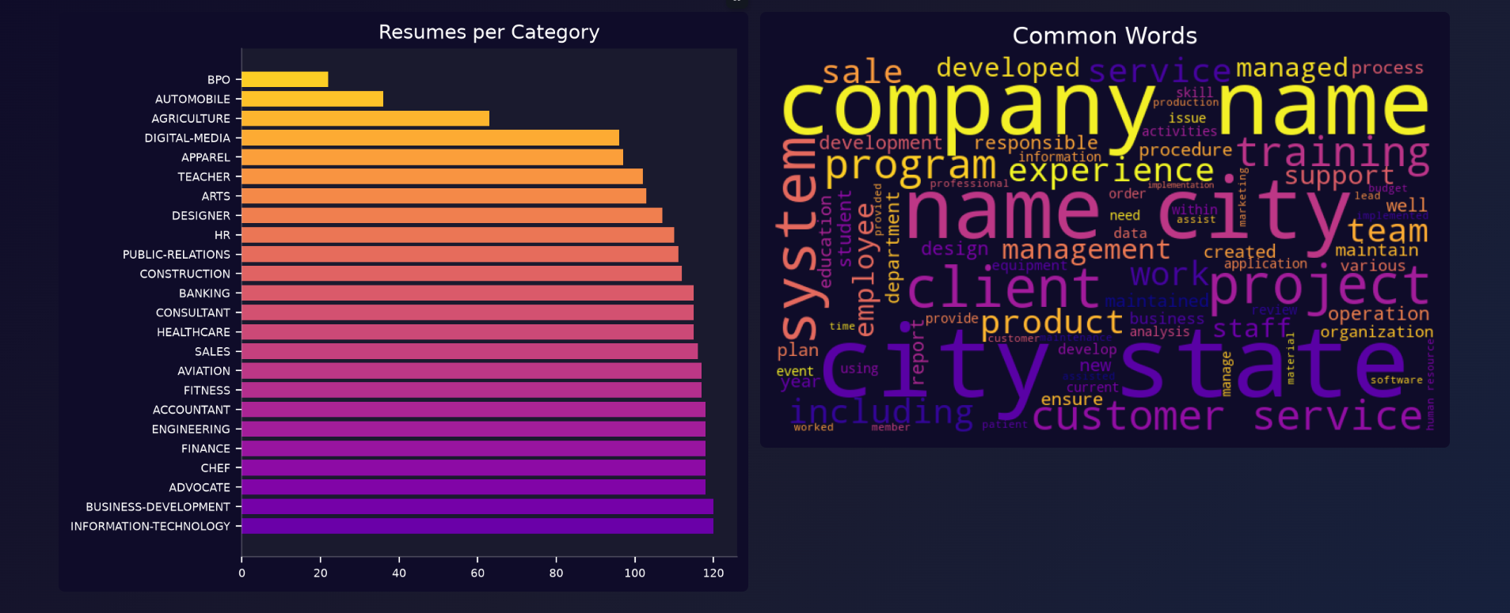
Figure 5.1: Resumes per Category (left) and Word Cloud of Most Frequent Terms (right)
The accompanying word cloud highlights the most frequent terms across all resumes after cleaning – dominant terms include “company”, “name”, “city”, “state”, “team”, “project”, “management”, and “experience”, reflecting the boilerplate structure common to most resumes (company/location headers, work-experience descriptions) rather than role-specific vocabulary alone.

5.2 Training Behaviour
Figure 5.2 shows the training loss curve and the train-versus-test accuracy curves recorded over 50 epochs. The training loss drops sharply within the first 10 epochs and approaches zero thereafter, while training accuracy rapidly saturates near 100%. Test accuracy, however, plateaus much earlier and at a substantially lower level (approximately 65–69%), indicating a clear overfitting gap between training and generalization performance – an expected outcome given the relatively small dataset size (962 resumes) relative to the model's capacity and the large 5000-dimensional input space.
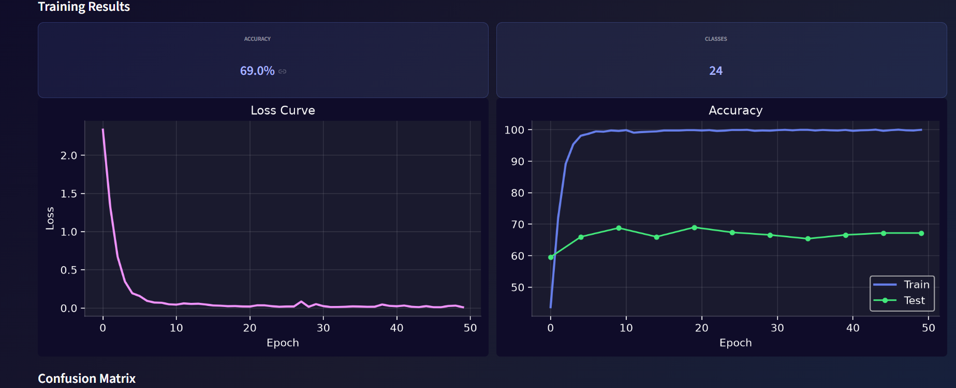
Figure 5.2: Training Loss Curve and Train/Test Accuracy Curves over 50 Epochs

5.3 Overall Model Performance
The best checkpoint, selected by maximum test accuracy during training, achieved a final test-set accuracy of 69.0% across 24 classes. Table 5.1 summarizes the headline results.
Metric | Value
Test Accuracy | 69.0%
Number of Classes | 24
Training Epochs | 50
Train Accuracy (final) | ~100% (overfit)
Total Resumes Used | 962
Given the moderate dataset size and high class count (24 classes with substantial vocabulary overlap between related roles, e.g., Consultant vs. Business-Development, or Chef vs. Aviation catering-adjacent roles), a test accuracy of 69% represents reasonable, though not exceptional, discriminative performance – considerably better than the ~4% random-guess baseline for 24 balanced classes, but with clear room for improvement discussed in Chapter 6.

5.4 Confusion Matrix Analysis
Figure 5.3 shows the confusion matrix computed on the test set, with true labels on the vertical axis and predicted labels on the horizontal axis (diagonal cells represent correct predictions).
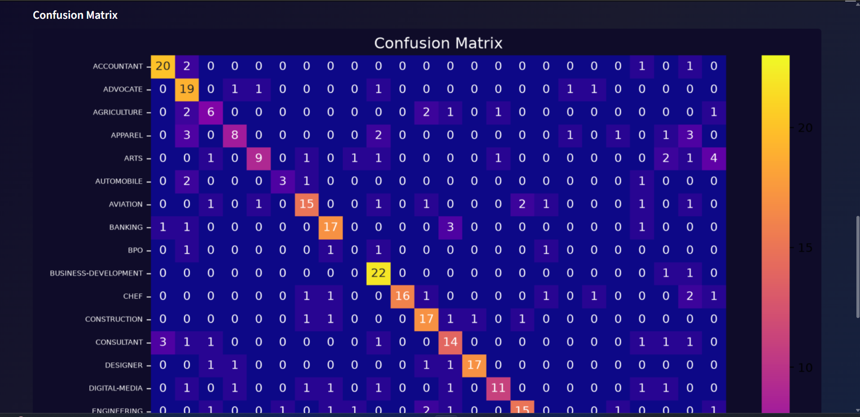
Figure 5.3: Confusion Matrix on the Held-Out Test Set
The matrix shows strong diagonal dominance for well-represented, linguistically distinctive categories such as Business-Development (22 correct), Accountant (20 correct), Advocate (19 correct), and Construction (17 correct). Categories with fewer training samples or overlapping vocabulary – for example, Automobile, Apparel, and Agriculture – show more off-diagonal confusion, consistent with the class-imbalance observation from Section 5.1. This pattern confirms that classification errors are concentrated in minority classes and in role pairs that naturally share similar resume vocabulary (e.g., operations- and management-oriented roles).

5.5 Application-Level Results
The following subsections present representative output from the deployed Streamlit application for a sample resume analyzed against the trained model, illustrating the end-to-end user experience.

5.5.1 Resume Upload Interface
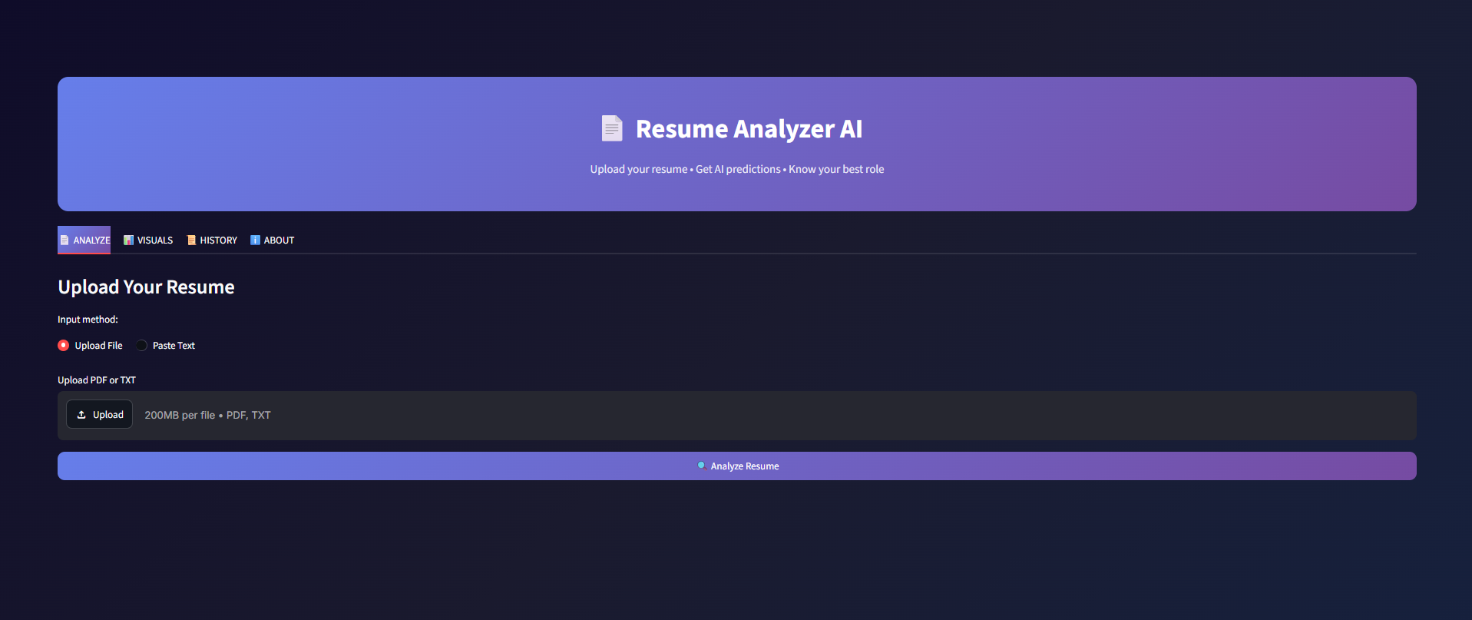
Figure 5.4: Resume Upload Interface (Analyze Tab)

5.5.2 Prediction Results and Top Matches
For the sample resume analyzed, the system predicted the role INFORMATION-TECHNOLOGY with a confidence of 21%, a composite fit score of 25.5/100, and 7 skills detected, as shown in Figure 5.5. The Top Matches table lists the five most probable categories with their associated match percentages, giving the user visibility into close alternative role fits (in this case, Construction and Business-Development were the next closest categories).
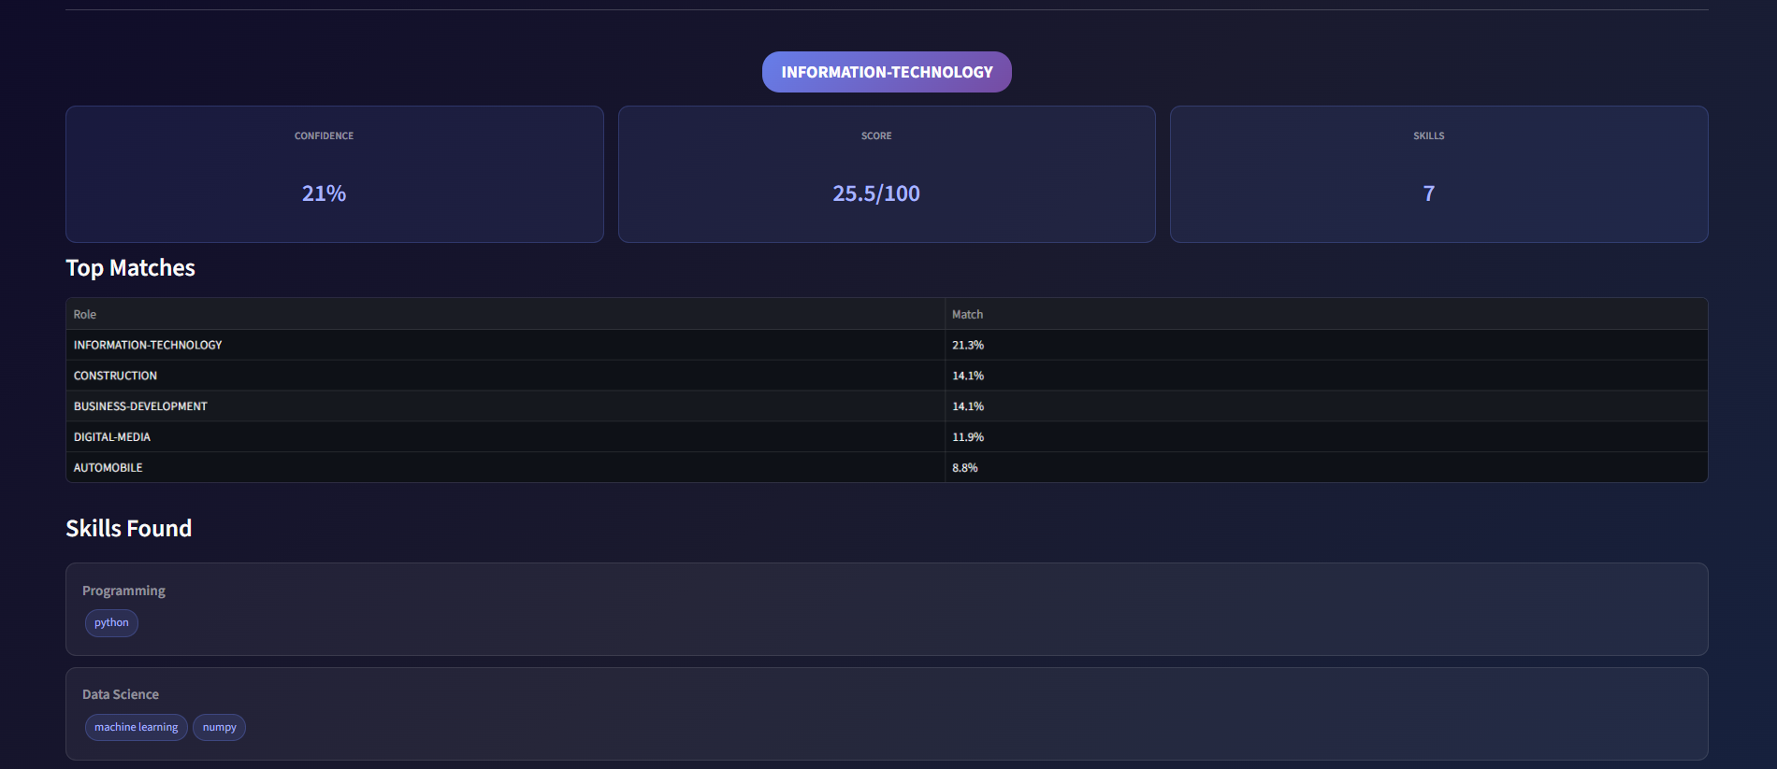
Figure 5.5: Predicted Role, Confidence, Score, and Top-5 Role Matches
The relatively low confidence (21%) for this particular sample illustrates a realistic, moderately ambiguous resume where the extracted skill set (Python, machine learning, numpy) only partially aligns with the strongest Information-Technology signal, resulting in probability mass being spread across several plausible categories rather than concentrated on one – a useful, honest reflection of the underlying model's uncertainty rather than an overconfident single-label prediction.

5.5.3 Skills Found and Missing Skills
The system correctly grouped the detected skills into their respective categories (Programming: python; Data Science: machine learning, numpy; Cloud: git; Soft Skills: communication, teamwork, problem solving) and identified five missing skills expected for the Information-Technology role – java, sql, javascript, aws, and linux – as shown in Figure 5.6.
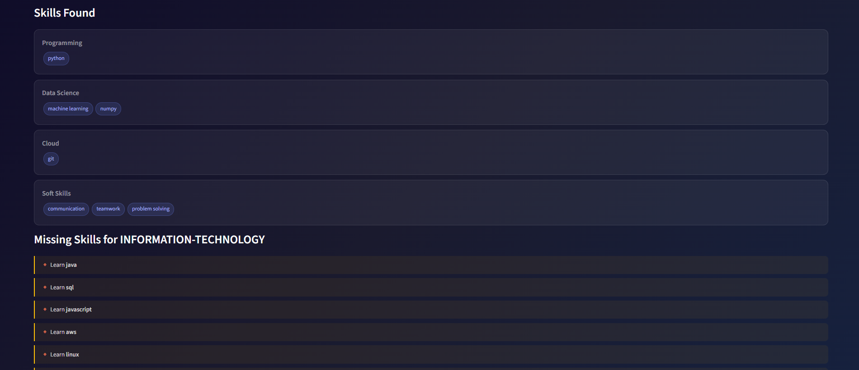
Figure 5.6: Skills Found (Categorized) and Missing Skills for the Predicted Role

5.5.4 Feedback Tips and Skill Distribution Chart
Based on the low confidence and limited skill count, the system generated three feedback tips: a “weak match” warning, a prompt to add more skills (only 7 found), and a targeted learning recommendation listing the top missing skills. The accompanying bar chart visualizes the distribution of detected skills across categories, as shown in Figure 5.7.
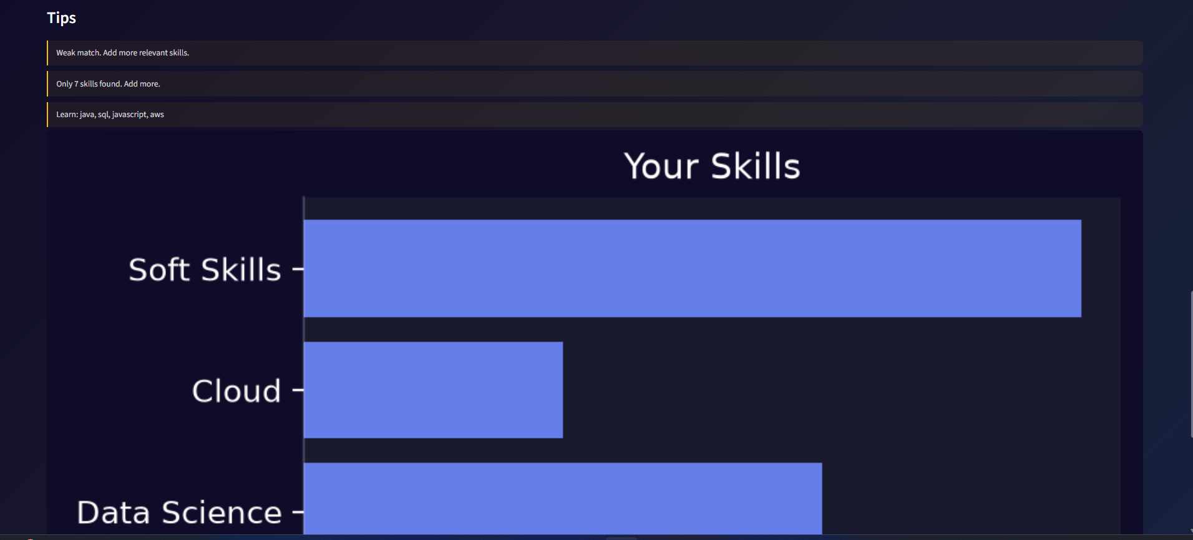
Figure 5.7: Generated Feedback Tips and Skill-Category Distribution Chart

5.5.5 Analysis History
Every analysis performed is logged to the SQLite history store with a timestamp, enabling the user to review past submissions, as shown in Figure 5.8. Repeated analyses of the same resume text correctly return identical role, confidence, and skill results, confirming the determinism of the inference pipeline (given the model is in evaluation mode, dropout and batch-norm behave deterministically).
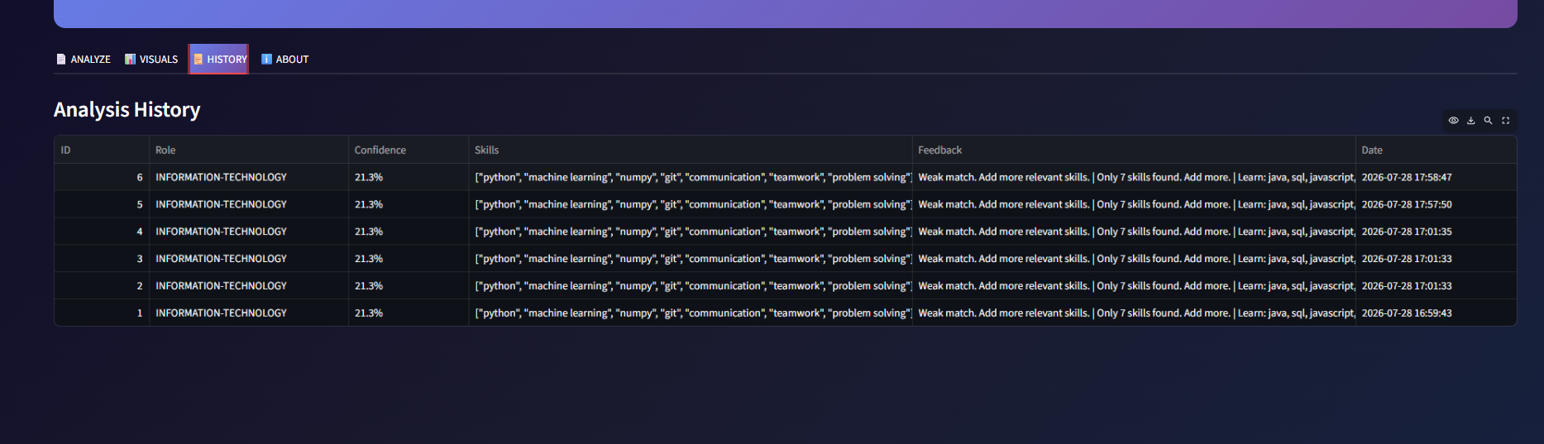
Figure 5.8: Analysis History Log

5.6 Discussion of Results
Overall, the results demonstrate that a lightweight, fully-connected neural network trained on TF-IDF features can achieve reasonably competent resume classification (69% test accuracy over 24 classes) using only a modest, imbalanced dataset of 962 samples, without requiring GPU infrastructure or large pretrained language models. The skill-extraction and gap-analysis layer adds practical, human-interpretable value on top of the raw classification output, directly supporting the project's core objective of providing actionable feedback rather than a bare category label. The observed overfitting gap (near-100% train accuracy versus ~69% test accuracy) is the primary limitation identified through evaluation and is addressed in the recommendations for future work in Chapter 6.

Chapter 6: Conclusion and Future Scope

6.1 Conclusion
This project successfully designed, implemented, and evaluated “Resume Analyzer AI”, an end-to-end deep-learning-based system that classifies resumes into job categories, extracts and categorizes candidate skills, identifies role-specific skill gaps, and computes an interpretable composite fit score, all delivered through an interactive Streamlit web application backed by a SQLite history store. Using a fully-connected neural network (ResumeNet) trained on TF-IDF features derived from the Kaggle Resume Dataset, the system achieved a test accuracy of approximately 69% across 24 job categories – a reasonable result given the dataset's modest size and class imbalance.
Beyond the classification model itself, the project demonstrates a complete, practical machine-learning application lifecycle: data acquisition and cleaning, feature engineering, model design with explicit regularization (batch normalization, dropout, weight decay, learning-rate scheduling), rigorous held-out evaluation (accuracy, classification report, confusion matrix), and deployment as a polished, user-facing tool with persistent history and rich data visualizations. The 45-day training period was sufficient to carry this pipeline from raw dataset to a fully working, deployable application, fulfilling all objectives outlined in Chapter 1.

6.2 Limitations
- The dataset (962 resumes across 24–25 categories) is small and imbalanced, limiting the model's ability to generalize, particularly for under-represented categories such as BPO, Automobile, and Agriculture.
- TF-IDF features capture word frequency but not deep semantic or contextual meaning, so resumes using synonyms or non-standard phrasing for the same skills may be misclassified or under-scored.
- The skill-extraction dictionary is finite and manually curated; skills expressed in unlisted terminology, abbreviations, or non-English text will not be detected.
- The observed gap between training accuracy (~100%) and test accuracy (~69%) indicates overfitting that could be further reduced with more data, stronger regularization, or simpler models relative to the feature dimensionality.
- The role-to-skill requirement mapping currently covers only ten common roles; resumes classified into categories outside this map do not receive a missing-skills breakdown.
- The application is designed for single-user, local deployment (SQLite, no authentication) and would require architectural changes for secure, multi-user production use.

6.3 Future Scope
- Adopt contextual embeddings (e.g., BERT or a lightweight distilled transformer) in place of, or alongside, TF-IDF to better capture semantic similarity between differently worded but equivalent skills and experience descriptions.
- Expand and rebalance the training dataset, potentially through data augmentation or by incorporating additional publicly available resume corpora, to improve minority-class performance.
- Replace or supplement the fixed skill dictionary with a trained Named Entity Recognition (NER) model for open-vocabulary skill extraction.
- Extend the ROLE_SKILLS mapping to cover all categories present in the dataset, and allow the map to be edited or extended by an administrator through the UI.
- Introduce resume-to-job-description matching, allowing a user to paste a specific job description and receive a tailored fit score against that posting rather than only a generic category.
- Add user authentication and per-user history isolation, and migrate from SQLite to a production-grade database (e.g., PostgreSQL) for multi-user deployment.
- Package the application using Docker and deploy it to a cloud platform (e.g., Streamlit Community Cloud, AWS, or Azure) for public accessibility.
- Incorporate explainability techniques (e.g., SHAP or attention visualization) to show which words or phrases most influenced the predicted role, increasing user trust in the system's recommendations.

6.4 Personal Learning Outcomes
Undertaking this project provided hands-on experience across the full machine-learning application stack: dataset handling with pandas, feature engineering with scikit-learn, neural-network design and training with PyTorch (including practical use of batch normalization, dropout, and learning-rate scheduling), model evaluation methodology, and rapid application development with Streamlit. The project also reinforced the importance of iterative testing, version-controlled artefact management (model checkpoints, vectorizers, encoders), and communicating technical results through clear visualizations – skills directly transferable to future academic and professional machine-learning work.

Implementation Screenshots
This appendix presents the complete set of application screenshots captured from the deployed Streamlit interface, covering all four functional tabs of Resume Analyzer AI.

A.1 Analyze Tab
Screenshot A.1: Upload Your Resume interface
Screenshot A.2: Prediction results, confidence/score/skills metrics, and top matches
Screenshot A.3: Categorized skills found and missing skills for the predicted role
Screenshot A.4: Feedback tips and skill-category distribution chart

A.2 Visuals Tab
Screenshot A.5: Resumes-per-category chart and common-words word cloud
Screenshot A.6: Training accuracy/classes summary, loss curve, and accuracy curve
Screenshot A.7: Confusion matrix heatmap

A.3 History Tab
Screenshot A.8: Analysis history log with timestamps

A.4 About Tab
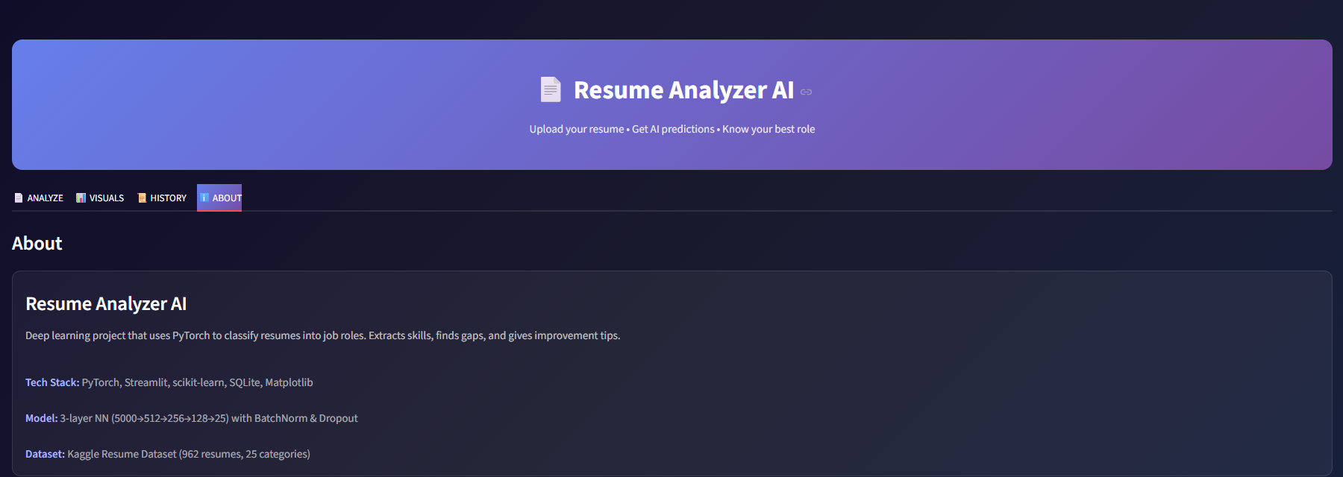
Screenshot A.9: About page with tech stack, model, and dataset summary

References
[1] Kaggle, “Resume Dataset,” UpdatedResumeDataSet.csv, publicly available dataset used for training and evaluation of the resume classification model.
[2] A. Paszke et al., “PyTorch: An Imperative Style, High-Performance Deep Learning Library,” Advances in Neural Information Processing Systems (NeurIPS), 2019.
[3] F. Pedregosa et al., “Scikit-learn: Machine Learning in Python,” Journal of Machine Learning Research, vol. 12, pp. 2825–2830, 2011.
[4] S. Ioffe and C. Szegedy, “Batch Normalization: Accelerating Deep Network Training by Reducing Internal Covariate Shift,” Proceedings of the 32nd International Conference on Machine Learning (ICML), 2015.
[5] N. Srivastava, G. Hinton, A. Krizhevsky, I. Sutskever, and R. Salakhutdinov, “Dropout: A Simple Way to Prevent Neural Networks from Overfitting,” Journal of Machine Learning Research, vol. 15, pp. 1929–1958, 2014.
[6] D. P. Kingma and J. Ba, “Adam: A Method for Stochastic Optimization,” International Conference on Learning Representations (ICLR), 2015.
[7] G. Salton and C. Buckley, “Term-Weighting Approaches in Automatic Text Retrieval,” Information Processing & Management, vol. 24, no. 5, pp. 513–523, 1988. (Foundational reference for TF-IDF weighting.)
[8] Streamlit Inc., “Streamlit Documentation,” https://docs.streamlit.io (accessed during project development).
[9] The pandas development team, “pandas: Powerful Python Data Analysis Toolkit,” https://pandas.pydata.org.
[10] J. D. Hunter, “Matplotlib: A 2D Graphics Environment,” Computing in Science & Engineering, vol. 9, no. 3, pp. 90–95, 2007.
[11] M. Waskom, “seaborn: Statistical Data Visualization,” Journal of Open Source Software, vol. 6, no. 60, p. 3021, 2021.
[12] PyPDF2 Contributors, “PyPDF2 Documentation,” https://pypdf2.readthedocs.io.
[13] SQLite Consortium, “SQLite Documentation,” https://www.sqlite.org/docs.html.
[14] Devashish, A. Amritanshu, “WordCloud for Python,” https://github.com/amueller/word_cloud.

