PRACTICAL 7
WIRESHARK – NETWORK PACKET ANALYSIS
Packet Capture, ICMP Filtering and Protocol Hierarchy Analysis

1. Aim
To capture network packets using Wireshark, filter ICMP traffic, examine packet details, and analyze the captured traffic using Protocol Hierarchy Statistics.

2. Software and Environment
Operating System | Kali Linux
Wireshark Version | 4.6.0
Capture Interface | eth0
Source IP | 10.0.2.15
Destination IP | 10.0.2.2
Test Protocol | ICMP

3. Procedure

3.1 Verify Wireshark Installation
The installed Wireshark version was verified from the terminal. Wireshark 4.6.0 was available and working.

3.2 Select Network Interface
Wireshark was opened and the eth0 interface was selected for live packet capture.

3.3 Start Packet Capture
A live capture was started on eth0. Wireshark displayed the status indicating that capture was in progress.

3.4 Generate ICMP Traffic
ICMP traffic was generated by sending four ping requests to 10.0.2.2. The ping completed successfully with 4 packets transmitted, 4 received and 0% packet loss.

3.5 Apply ICMP Display Filter
The Wireshark display filter `icmp` was applied. The packet list then showed ICMP Echo Request and Echo Reply traffic between 10.0.2.15 and 10.0.2.2.

3.6 Inspect Packet Details
An ICMP packet was selected and its Frame, Ethernet II, Internet Protocol Version 4 and Internet Control Message Protocol sections were visible in the packet details pane.

3.7 Protocol Hierarchy Analysis
Statistics → Protocol Hierarchy was opened. With the ICMP display filter active, the hierarchy showed Frame → Ethernet → Internet Protocol Version 4 → Internet Control Message Protocol. The displayed filtered traffic contained 8 packets.

4. Protocol Hierarchy Evidence
The captured and filtered traffic was analyzed through Protocol Hierarchy Statistics. The screenshot below shows the protocol tree and confirms that the displayed packets are ICMP over IPv4.
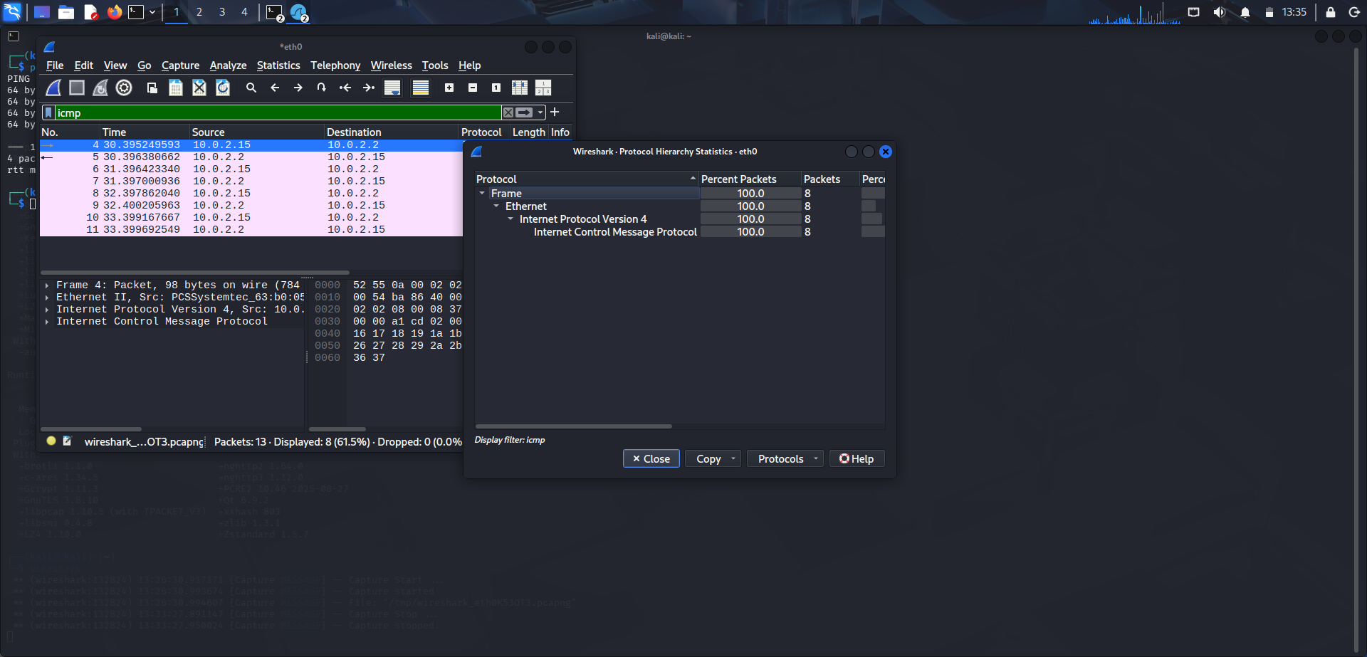
Figure 1: Wireshark ICMP packet capture and Protocol Hierarchy Statistics

5. Observations
- Wireshark successfully captured traffic from eth0.
- The `icmp` display filter isolated ICMP packets.
- ICMP traffic was observed between 10.0.2.15 and 10.0.2.2.
- The packet details pane identified Ethernet II, IPv4 and ICMP protocol layers.
- Protocol Hierarchy Statistics showed ICMP under Internet Protocol Version 4.

6. Result
Wireshark was successfully used to capture and analyze network traffic. ICMP packets were generated using ping, filtered using the `icmp` display filter, inspected at protocol level, and analyzed using Protocol Hierarchy Statistics.

7. Conclusion
The practical demonstrated the basic workflow of network packet analysis with Wireshark, including interface selection, live capture, display filtering, packet inspection and protocol hierarchy analysis.

