DVWA PRACTICAL DOCUMENTATION
Successful Vulnerability Demonstrations – Screenshots & Results
Compiled from the DVWA practical work completed in this conversation

Scope
This document consolidates the DVWA practicals that were successfully demonstrated during the sessions. Only findings supported by the conversation and available screenshots are included. The final Brute Force attempt shown in the session was unsuccessful, so it is listed separately as tested, not as a successful compromise.

1. Practical – Authorisation Bypass

Aim
Demonstrate access to an administration-only user-management feature as a non-admin user.

Evidence / Observation
The DVWA page stated that the feature should only be accessible by the admin user and displayed the user-management/update interface.
Screenshot Evidence
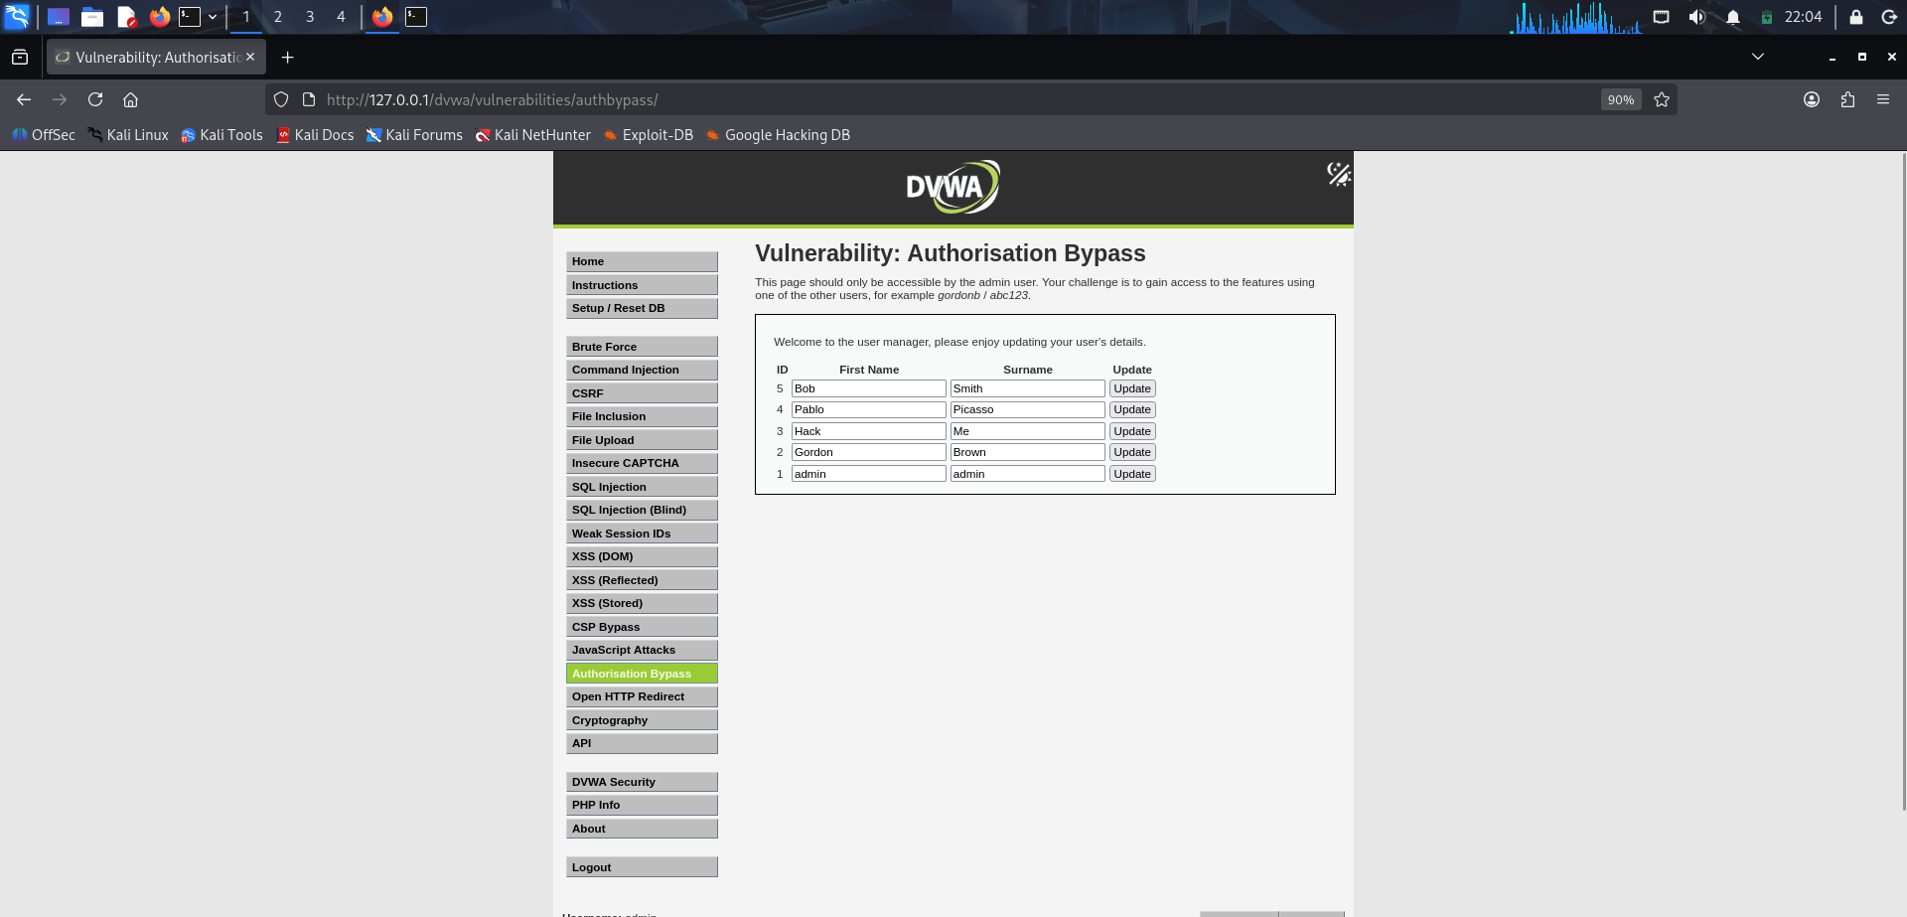

Result
Authorisation bypass was demonstrated in the controlled DVWA lab.

2. Practical – DOM Based Cross Site Scripting (XSS)

Aim
Demonstrate client-side DOM-based XSS behavior in the DVWA language-selection page.

Evidence / Observation
The DOM Based XSS page was successfully opened and tested during the practical session.
Screenshot Evidence
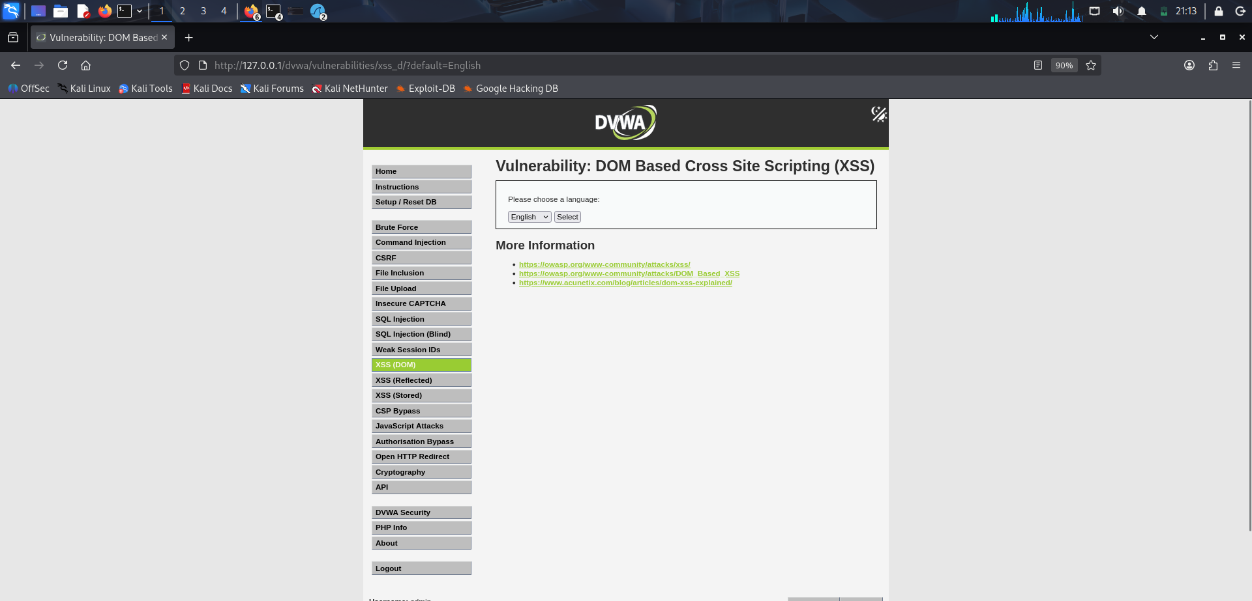

Result
DOM Based XSS practical was successfully demonstrated.

3. Practical – Stored Cross Site Scripting (XSS)

Aim
Demonstrate persistent XSS through the DVWA guestbook/comment functionality.

Evidence / Observation
The Stored XSS page was used with a script payload in the Name field during the session.
Screenshot Evidence
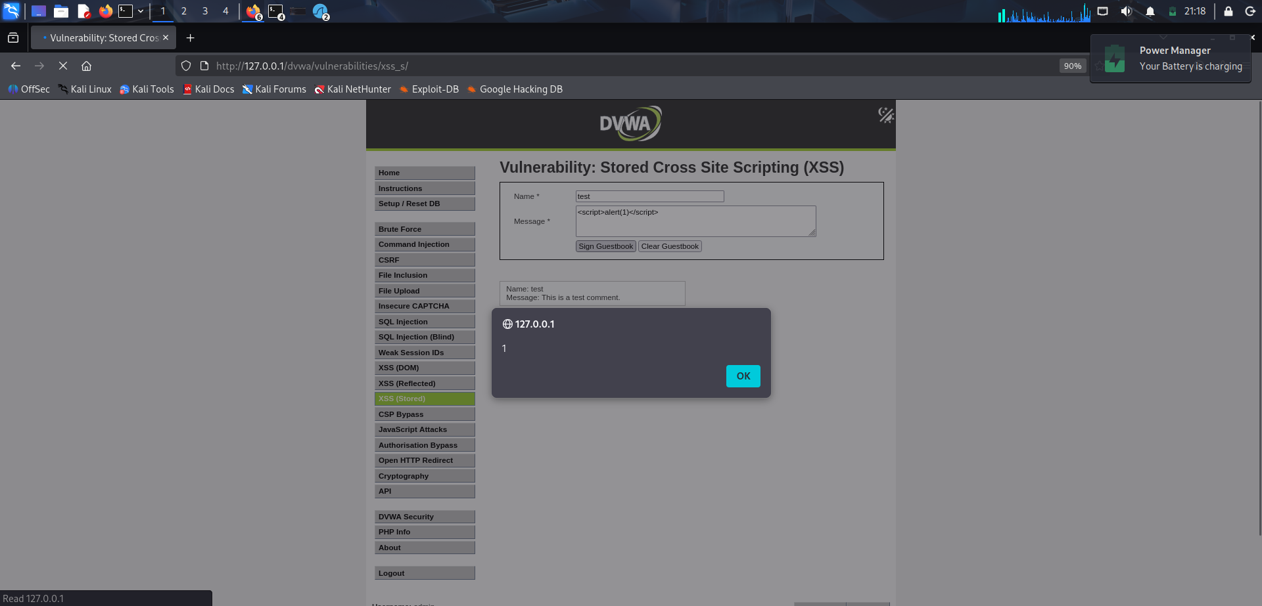

Result
Stored XSS practical was successfully demonstrated in the local lab.

4. Practical – Content Security Policy (CSP) Bypass

Aim
Study the CSP configuration and test the CSP Bypass functionality provided by DVWA.

Evidence / Observation
The CSP Bypass page was opened and the browser Network/Inspector information was examined as part of the practical.
Screenshot Evidence
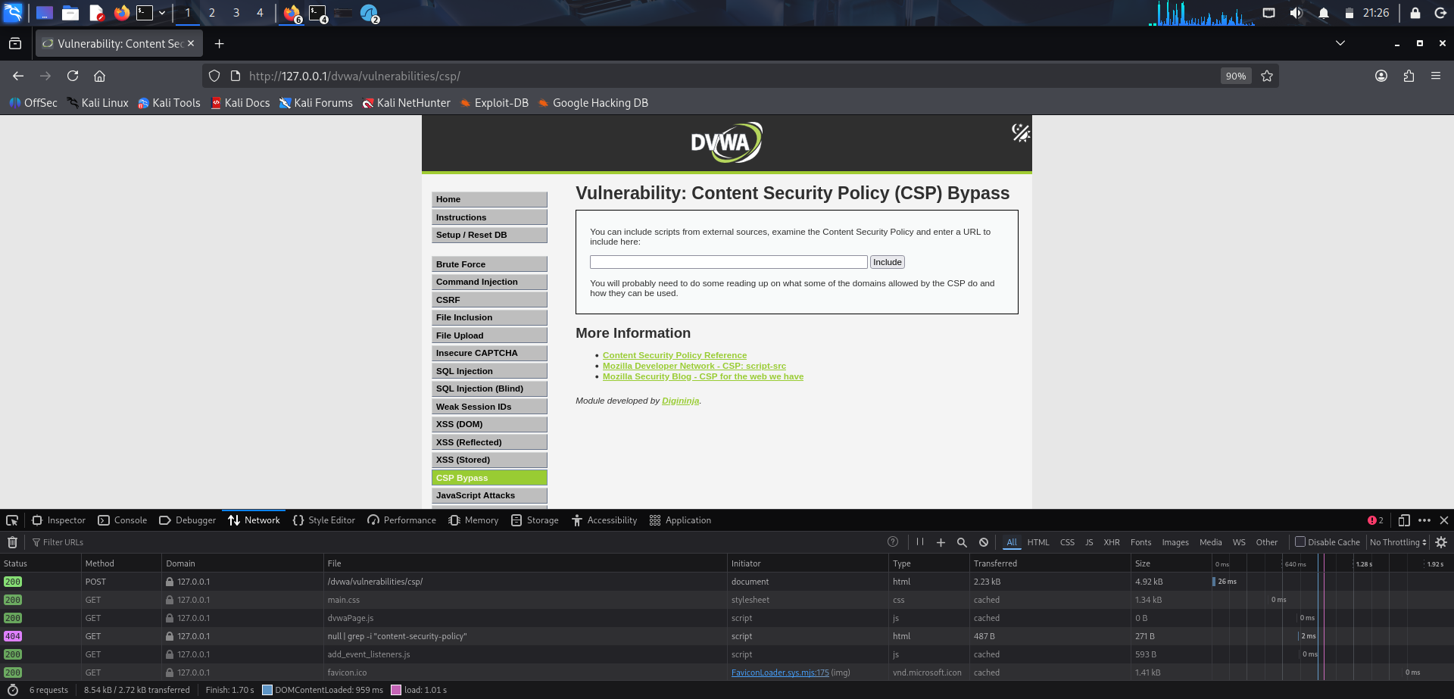

Result
CSP Bypass practical was completed as part of the DVWA session.

5. Practical – JavaScript Attacks

Aim
Demonstrate the JavaScript Attacks challenge in DVWA.

Evidence / Observation
The JavaScript Attacks module was opened and the user-manager functionality was exercised; a successful save message was observed during the session.
Screenshot Evidence
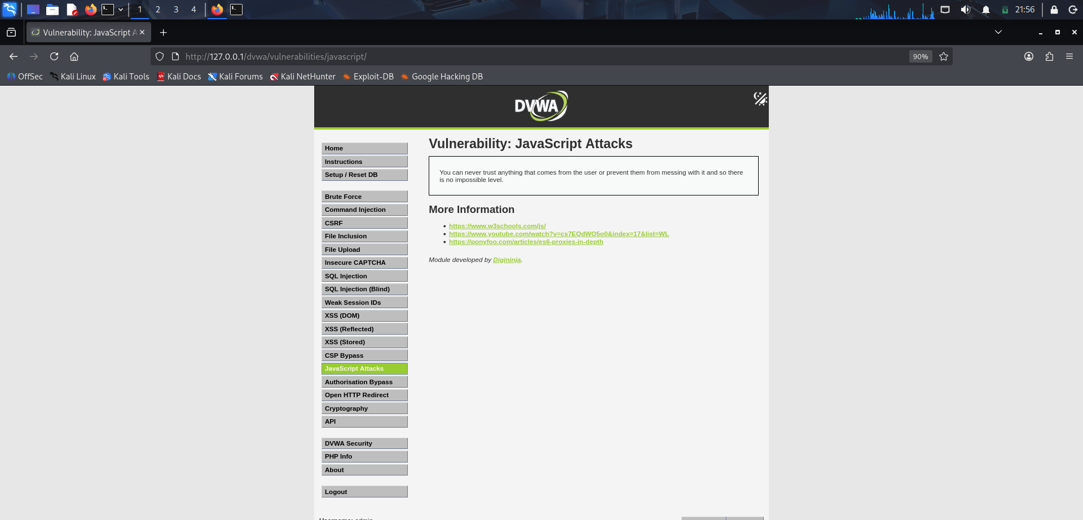

Result
JavaScript Attacks practical was successfully completed.

6. Practical – Open HTTP Redirect

Aim
Demonstrate an open/unvalidated HTTP redirect using the DVWA vulnerable redirect endpoint.

Evidence / Observation
The vulnerable endpoint redirected the browser to example.com. The session also identified the vulnerable source using the redirect parameter.
Screenshot Evidence
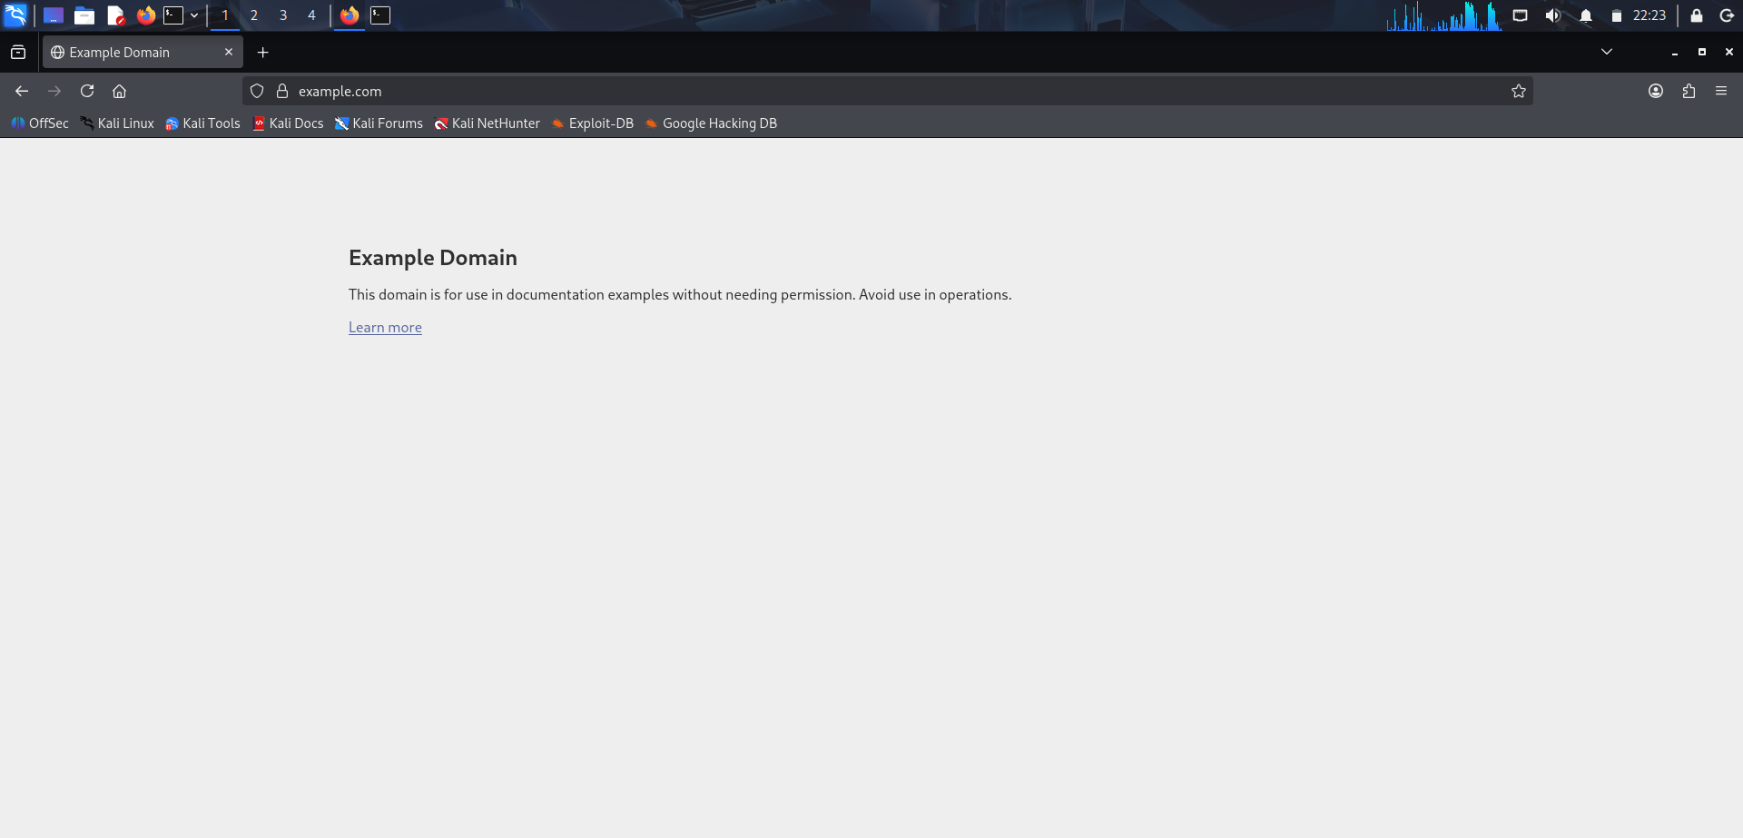

Result
Open HTTP Redirect was successfully confirmed.

7. Practical – Cryptography Problems

Aim
Decode the intercepted DVWA message and use the recovered value in the provided login form.

Evidence / Observation
The intercepted message was decoded successfully. The recovered password was used and the page displayed a successful welcome-back message.
Screenshot Evidence
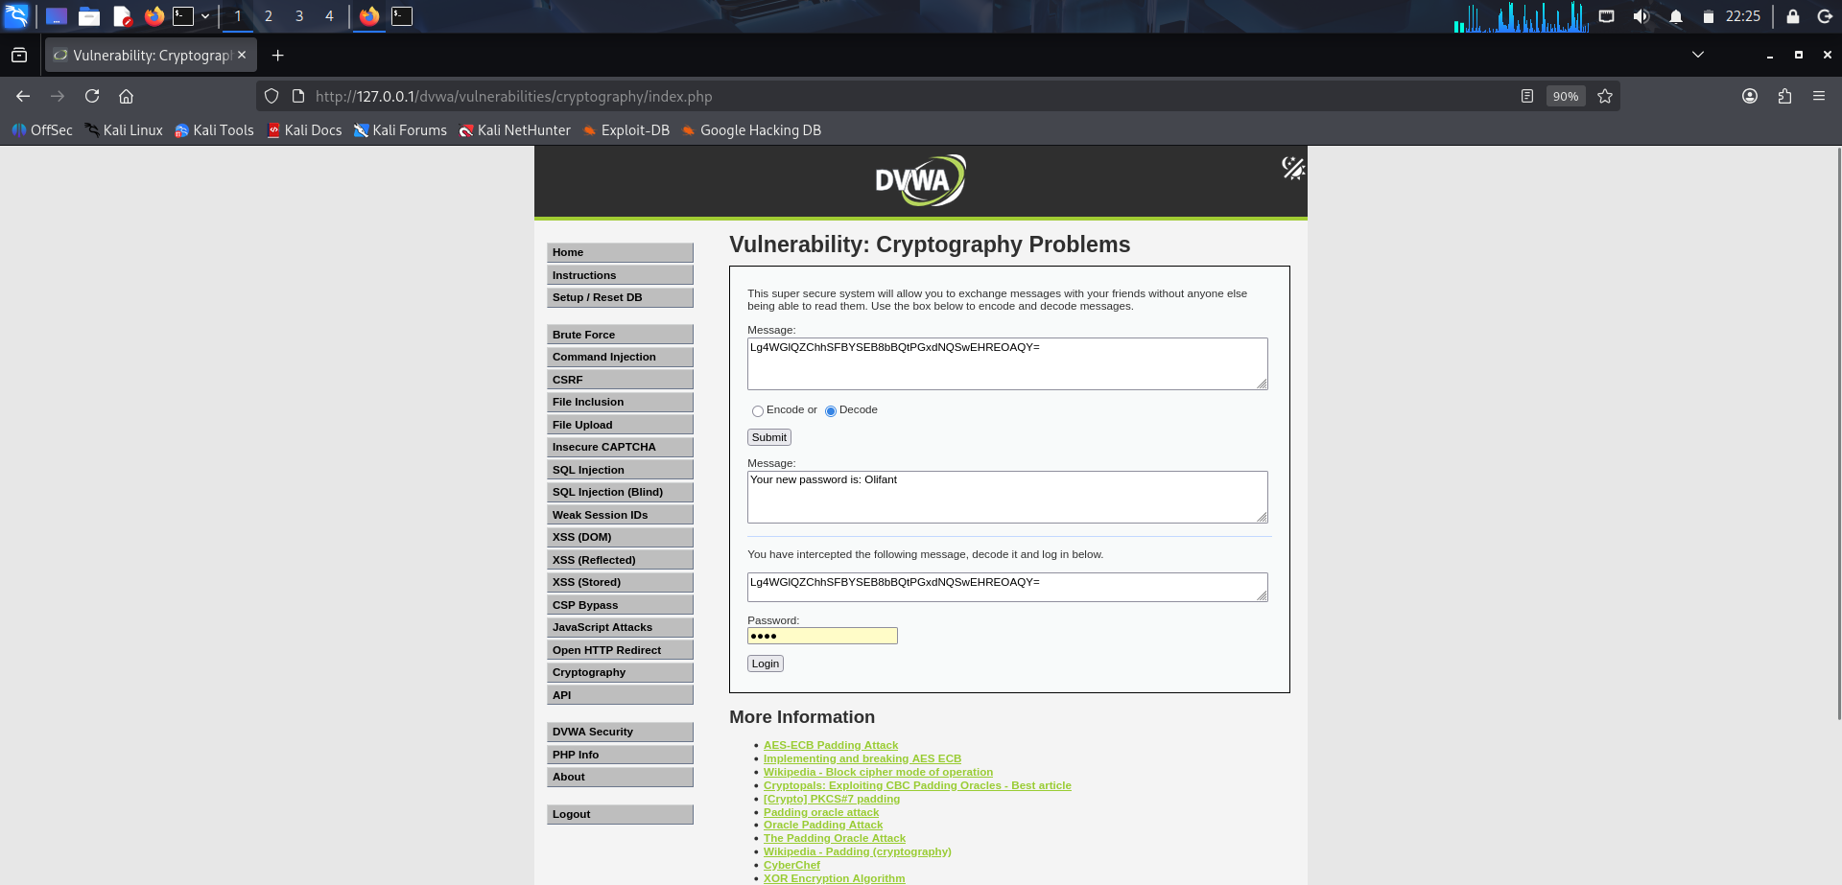

Result
Cryptography practical was successfully completed.

8. Practical – API Security

Aim
Demonstrate insecure API versioning and sensitive information disclosure.

Evidence / Observation
The v2 API returned user information without the password field. The legacy v1 endpoint returned additional password-hash data for individual users.
Screenshot Evidence
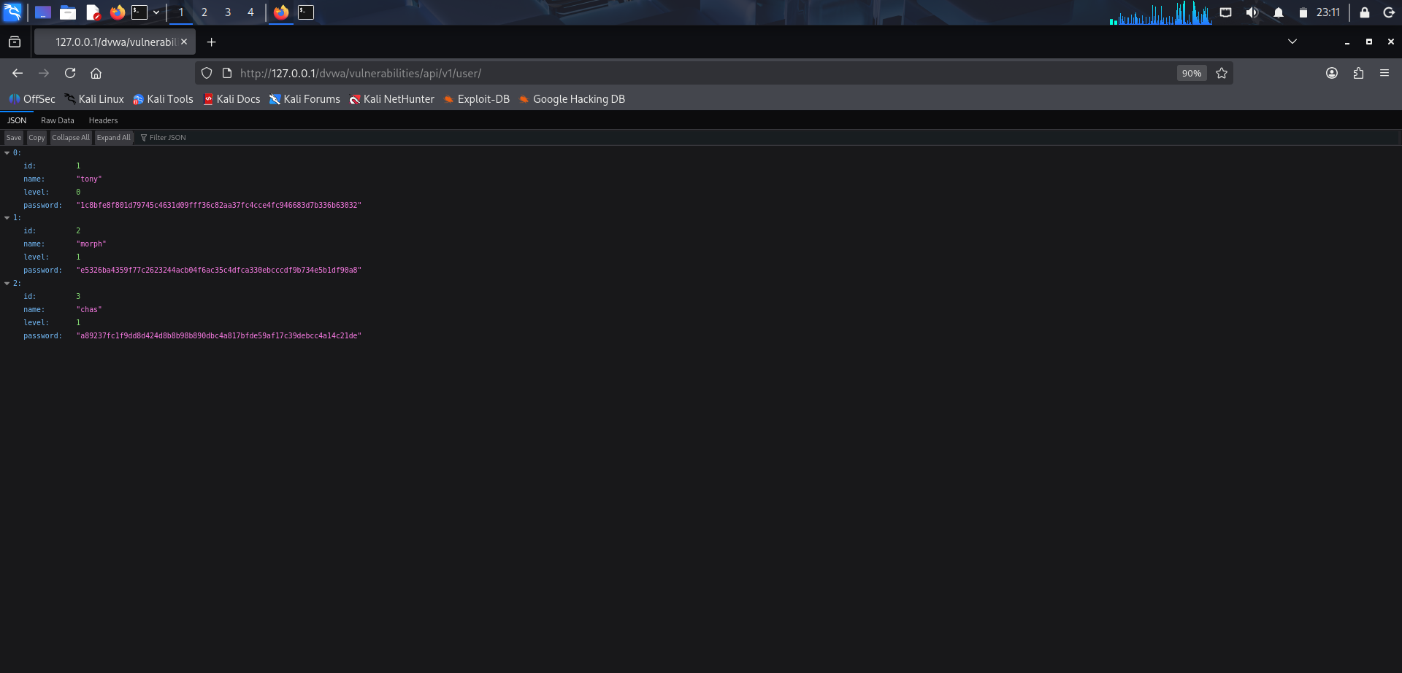

Result
API Security vulnerability was successfully confirmed.

API Security – Additional Evidence
The session produced the following successful API observations:
- GET /dvwa/vulnerabilities/api/v2/user/ returned HTTP 200 and user records containing id, name and level.
- GET /dvwa/vulnerabilities/api/v1/user/1 returned HTTP 200 and additionally exposed a password-hash field.
- GET /dvwa/vulnerabilities/api/v1/user/2 returned HTTP 200 and additionally exposed a password-hash field.
Conclusion: the legacy v1 API exposed sensitive credential-related information that was not exposed by v2.

Practical 8 – Brute Force (Tested, Not Successfully Compromised)
The Brute Force module was opened and a login request using username 'admin' and the test password 'Test@12345' was submitted. The application returned 'Username and/or password incorrect.'
Screenshot Evidence – Failed Login Attempt
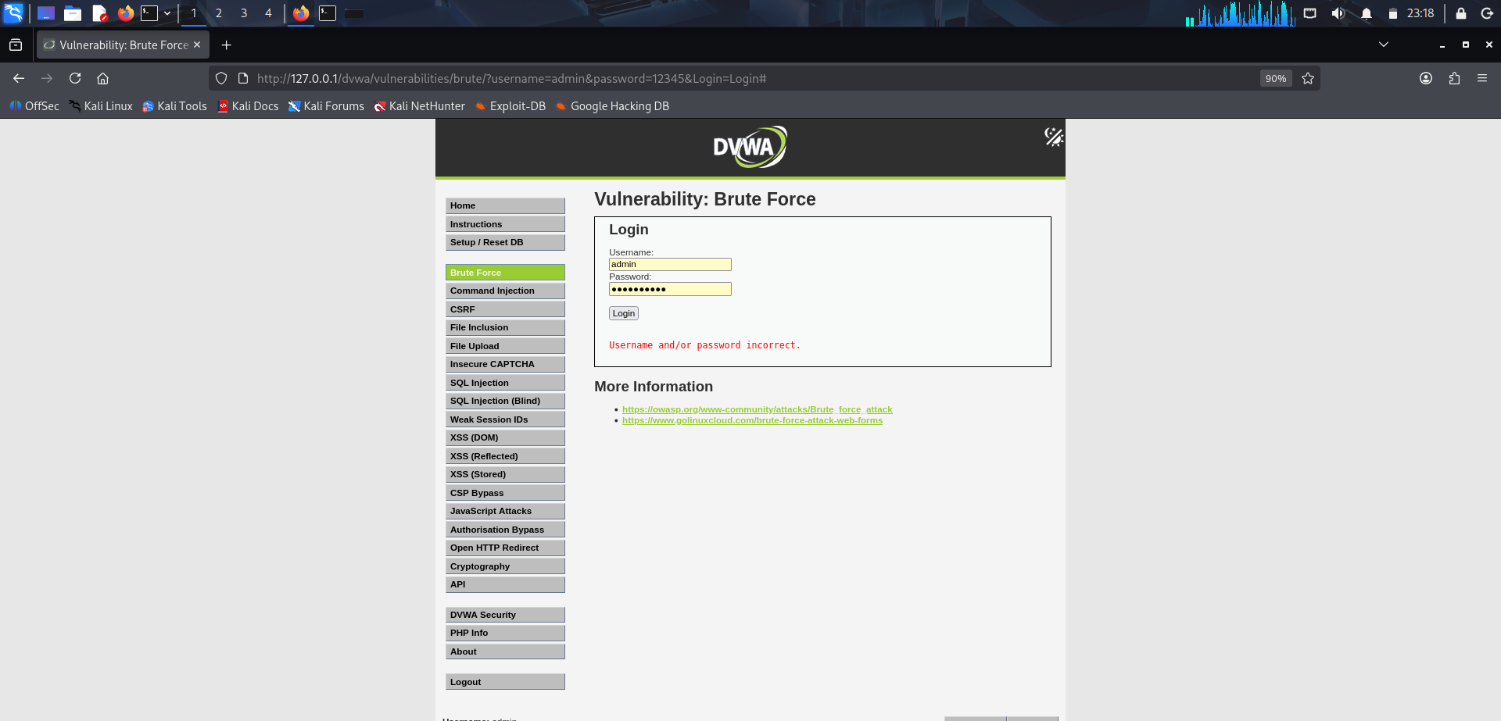
Status: module tested successfully, but the particular credential attempt shown was unsuccessful. It is therefore not reported as a successful password compromise.

Summary of Completed Successful DVWA Practicals
- 1. Practical – Authorisation Bypass
- 2. Practical – DOM Based Cross Site Scripting (XSS)
- 3. Practical – Stored Cross Site Scripting (XSS)
- 4. Practical – Content Security Policy (CSP) Bypass
- 5. Practical – JavaScript Attacks
- 6. Practical – Open HTTP Redirect
- 7. Practical – Cryptography Problems
- 8. Practical – API Security
Note: Reflected XSS was also worked through during the conversation, but a matching screenshot file was not reliably available in the current file set, so no screenshot has been invented for it.

