PRACTICAL 9
Command Injection – DVWA
Web Application Security Practical
Environment: DVWA on localhost (127.0.0.1)

Practical No. | 9
Topic | Command Injection
Application | Damn Vulnerable Web Application (DVWA)
Target | 127.0.0.1

1. Aim
To study and demonstrate the Command Injection vulnerability in DVWA and observe how input filtering differs across Low, Medium and High security levels.

2. Practical Overview
The DVWA Command Injection module provides a ping form where an IP address is supplied by the user and incorporated into a system command. During this practical, the normal 127.0.0.1 input was tested at different security levels and the corresponding source code was reviewed.

3. Procedure and Screenshots
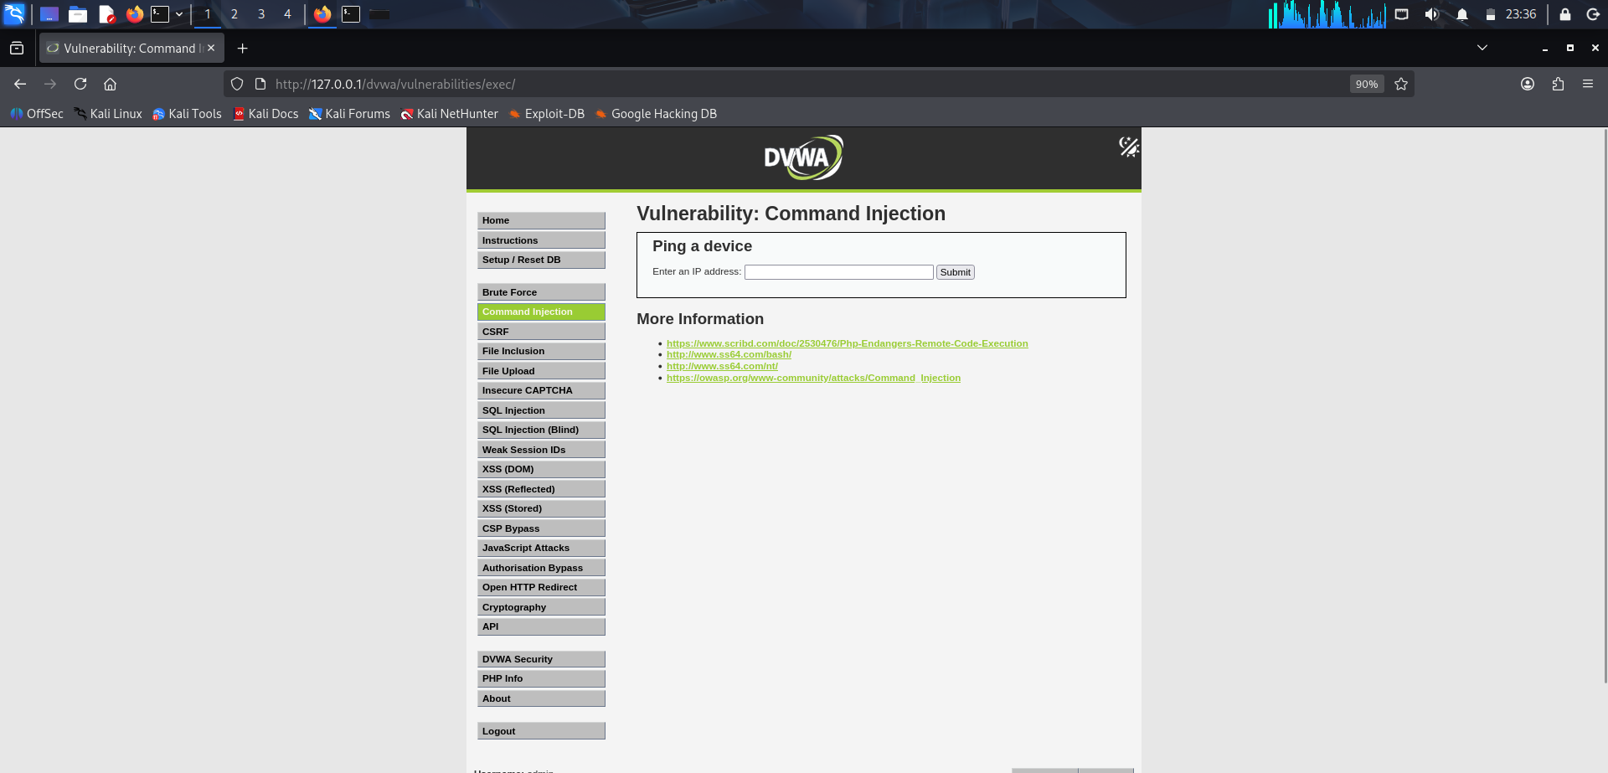
Figure 1 – DVWA Command Injection initial page
The Command Injection module is opened and the “Ping a device” input field is available.
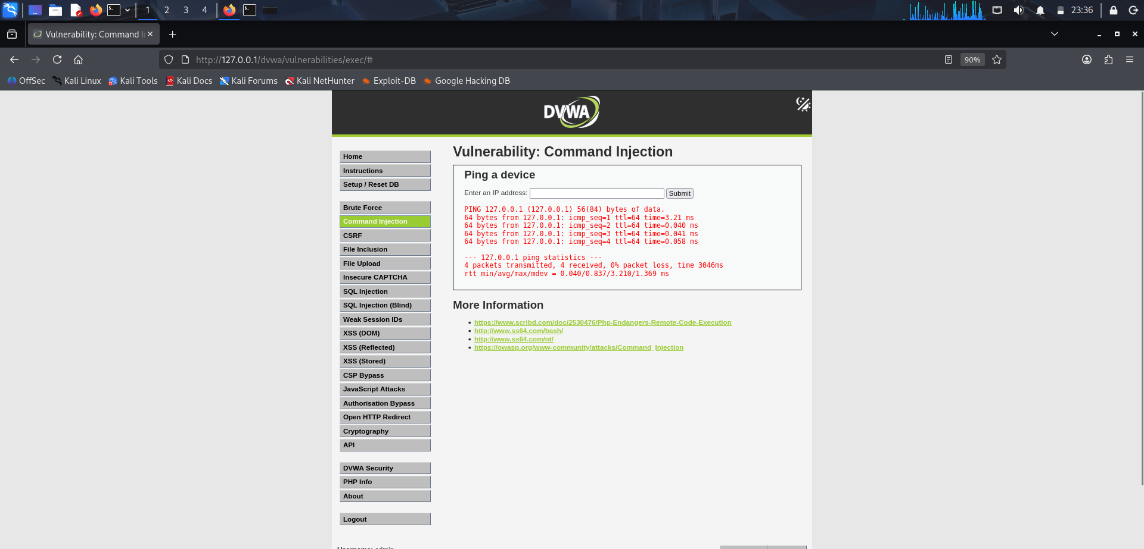
Figure 2 – Low-level normal input test
The input 127.0.0.1 produces a successful ping response, confirming normal command execution.
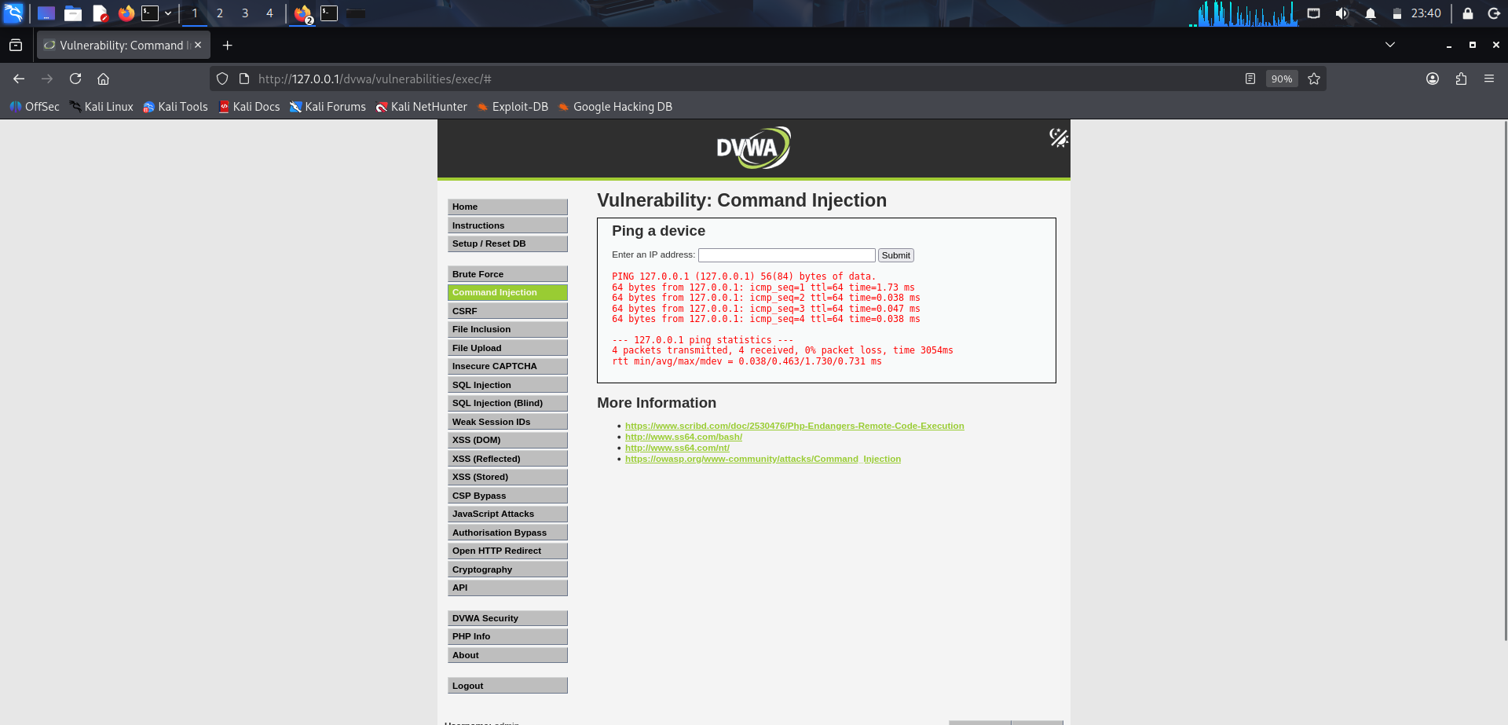
Figure 3 – Medium-level normal input test
At Medium level, 127.0.0.1 again produces a successful ping response.
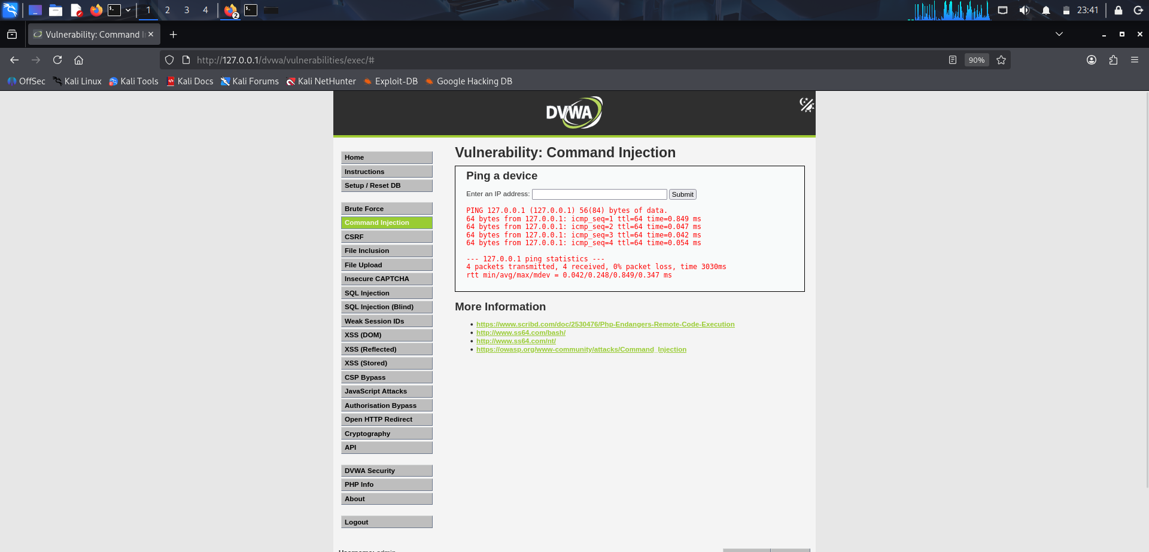
Figure 4 – High-level normal input test
At High level, 127.0.0.1 also produces a successful ping response.

4. Source Code Analysis

4.1 Medium Security – medium.php
The supplied source shows that the application reads the user-controlled ip parameter, removes the strings && and ; using str_replace(), and then passes the resulting value to shell_exec() as part of the ping command.
$target = $_REQUEST[ 'ip' ];
$substitutions = array(
'&&' => '',
';' => '',
);
$target = str_replace(
array_keys( $substitutions ),
$substitutions,
$target
);
$cmd = shell_exec( 'ping -c 4 ' . $target );

4.2 High Security – high.php
The supplied High-level source applies a larger blacklist. It removes ||, &, ;, | , -, $, parentheses and backticks before using the resulting target in shell_exec().
$target = trim($_REQUEST[ 'ip' ]);
$substitutions = array(
'||' => '',
'&' => '',
';' => '',
'| ' => '',
'-' => '',
'$' => '',
'(' => '',
')' => '',
'`' => '',
);
$target = str_replace(
array_keys( $substitutions ),
$substitutions,
$target
);
$cmd = shell_exec( 'ping -c 4 ' . $target );

5. Observations
- The Command Injection page accepts an IP address and executes a ping operation.
- 127.0.0.1 returned successful ping output during the Low, Medium and High tests.
- Medium security uses a blacklist for && and ; before passing the value to shell_exec().
- High security uses a broader blacklist of shell metacharacters/operators.
- The source code shows that the user-controlled target is ultimately concatenated into a shell command.

6. Result
The DVWA Command Injection practical was successfully performed. Normal ping execution was verified at Low, Medium and High security levels, and the supplied source code was reviewed to understand the different blacklist-based filtering mechanisms.

7. Conclusion
This practical demonstrates why user-controlled input should not be directly concatenated into operating-system commands. Blacklist-based filtering can reduce some inputs but is not a substitute for safe command construction and strict input validation.

