PRACTICAL – 3
Metasploit Framework: SMB Service Version Scanning
Documentation based on the screenshots provided in 3.docx

Tool | Metasploit Framework
Framework Version | 6.4.99-dev
Module Used | auxiliary/scanner/smb/smb_version
Target | 10.0.2.2

1. Aim
To use the Metasploit Framework to identify the SMB protocol versions and related SMB characteristics exposed by the target host 10.0.2.2.

2. Requirements
- Kali Linux
- Metasploit Framework
- A lab/authorized target host (10.0.2.2)
- Network connectivity between the scanner and the target

3. Practical Procedure
1. Launch Metasploit and verify the framework version. The screenshot shows `msfconsole --version` followed by Metasploit Framework 6.4.99-dev.
2. Open the Metasploit help menu. The `help` command displays Core Commands and Module Commands, confirming that the console is operational.
3. Search for SMB scanner modules. The command `search type:auxiliary scanner smb` is used to locate SMB-related auxiliary scanner modules.
4. Select the SMB version scanner. The module `auxiliary/scanner/smb/smb_version` is selected.
5. Display module options. The `show options` command displays RHOSTS, RPORT and THREADS. RHOSTS is required.
6. Set the target host. RHOSTS is set to `10.0.2.2`.
7. Run the scanner. The `run` command executes the SMB version scanner against the configured target.

4. Important Commands Used
- msfconsole --version
- msfconsole
- help
- search type:auxiliary scanner smb
- use auxiliary/scanner/smb/smb_version
- show options
- set RHOSTS 10.0.2.2
- run
- back
- version

5. Screenshots / Evidence

Screenshot 1 – Metasploit startup and help menu
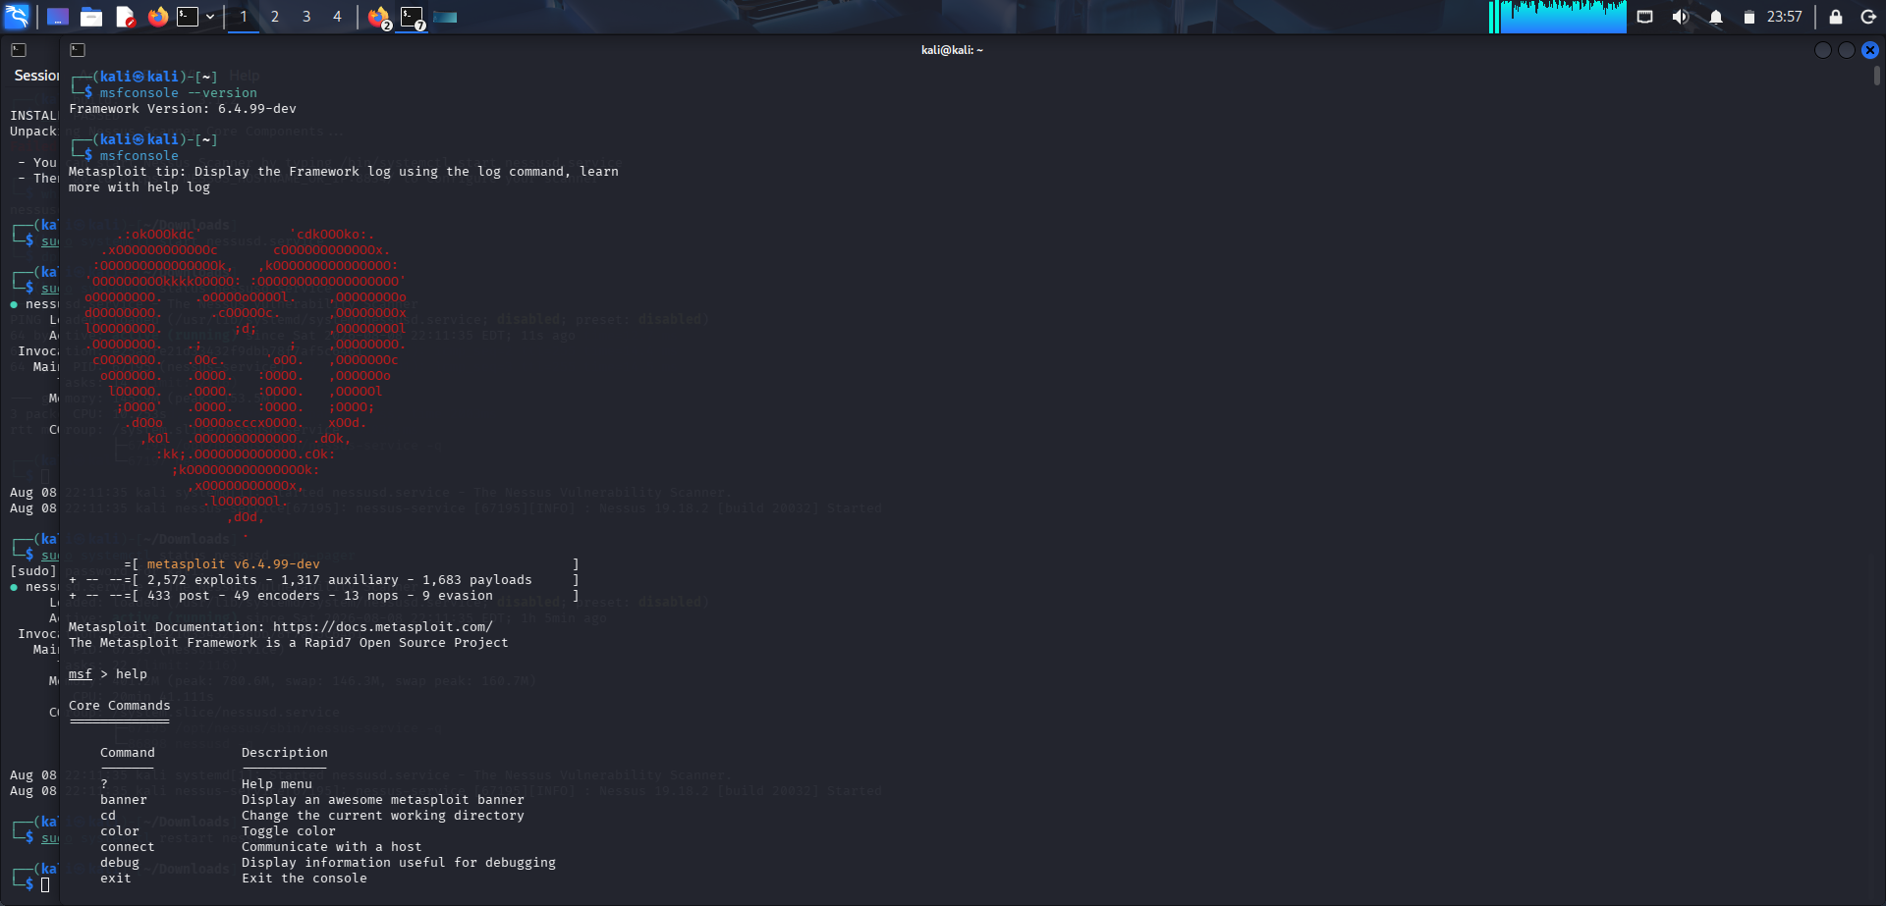
Shows Metasploit Framework 6.4.99-dev starting successfully and the help menu with core commands.

Screenshot 2 – Metasploit help/module commands
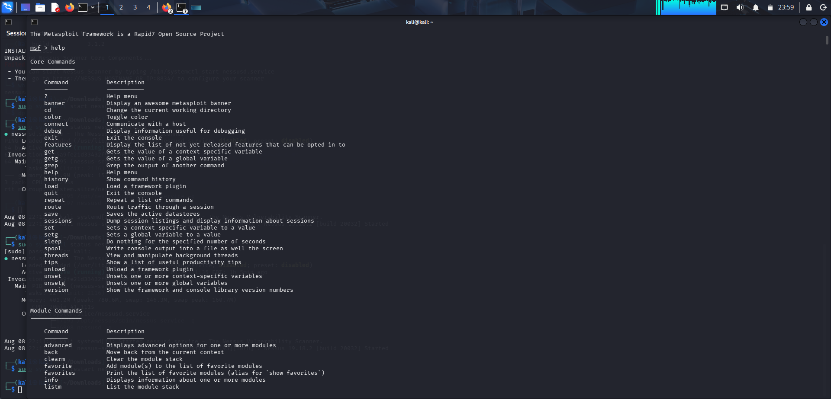
Shows the continuation of the help output, including module-related commands.

Screenshot 3 – SMB version module configuration and result

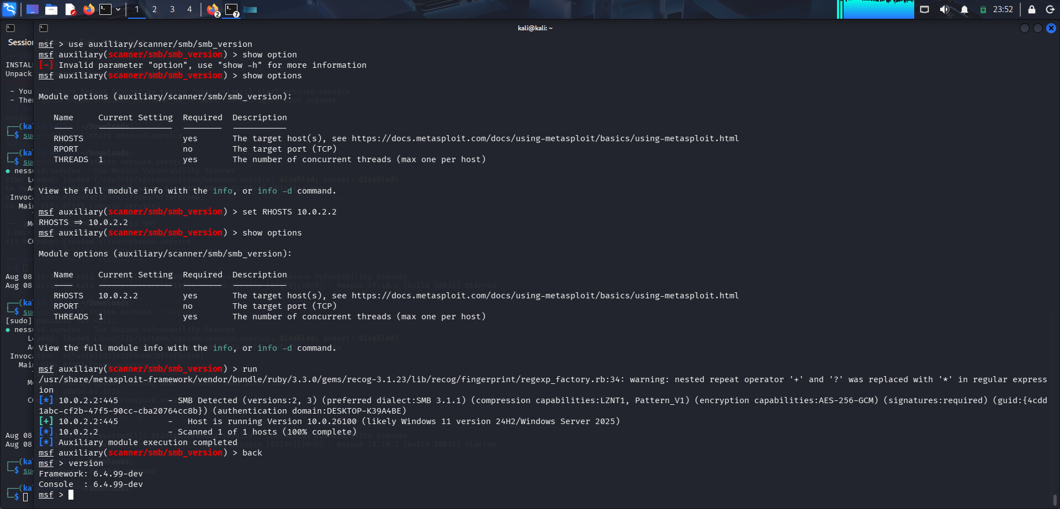
Shows the SMB version module, RHOSTS set to 10.0.2.2, execution, and the detected SMB information

Screenshot 4 – Auxiliary scanner search

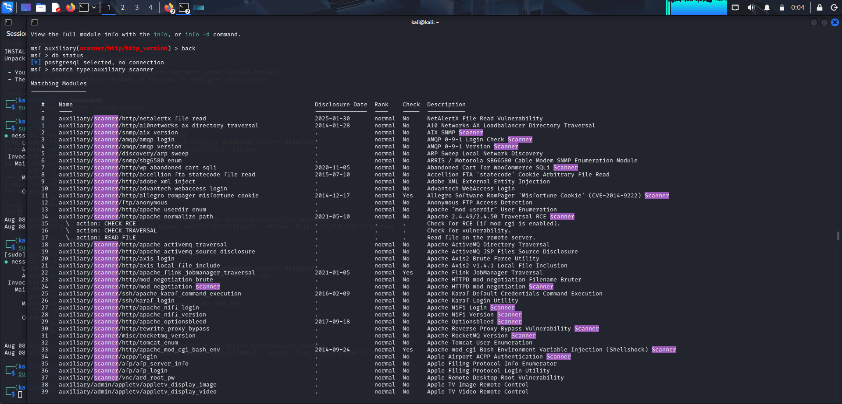
Shows a search for auxiliary scanner modules and the available scanner entries.

Screenshot 5 – SMB scanner options and execution
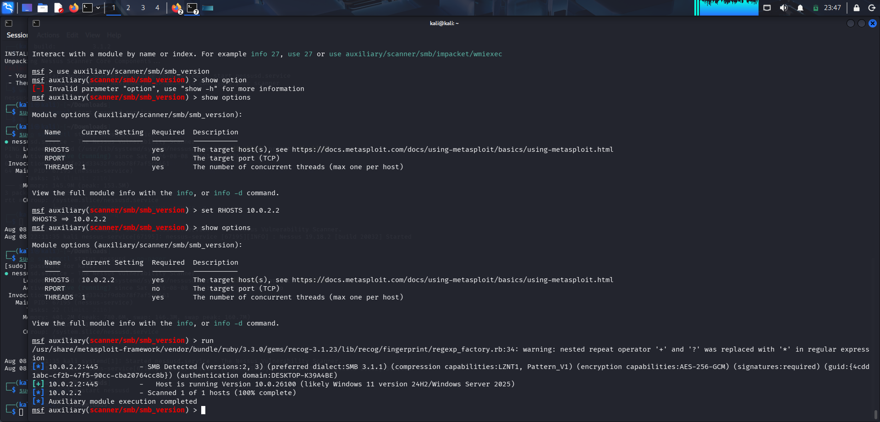
Shows `show options`, RHOSTS set to 10.0.2.2, and the SMB scan output

Screenshot 6 – SMB scanner module search

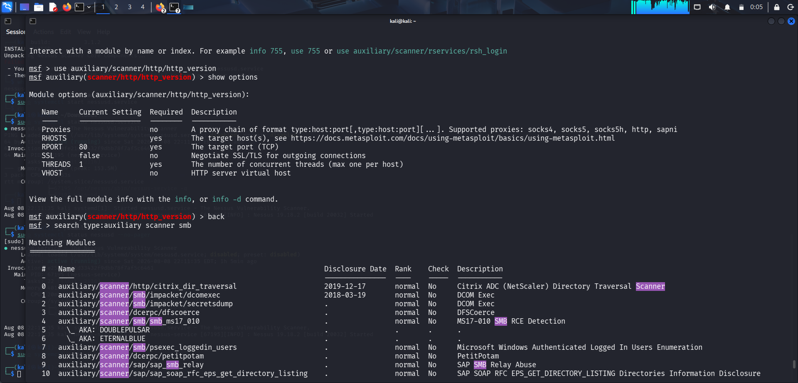
Shows the command used to search SMB-related auxiliary scanner modules, including smb_version

Screenshot 7 – SMB version scan configuration
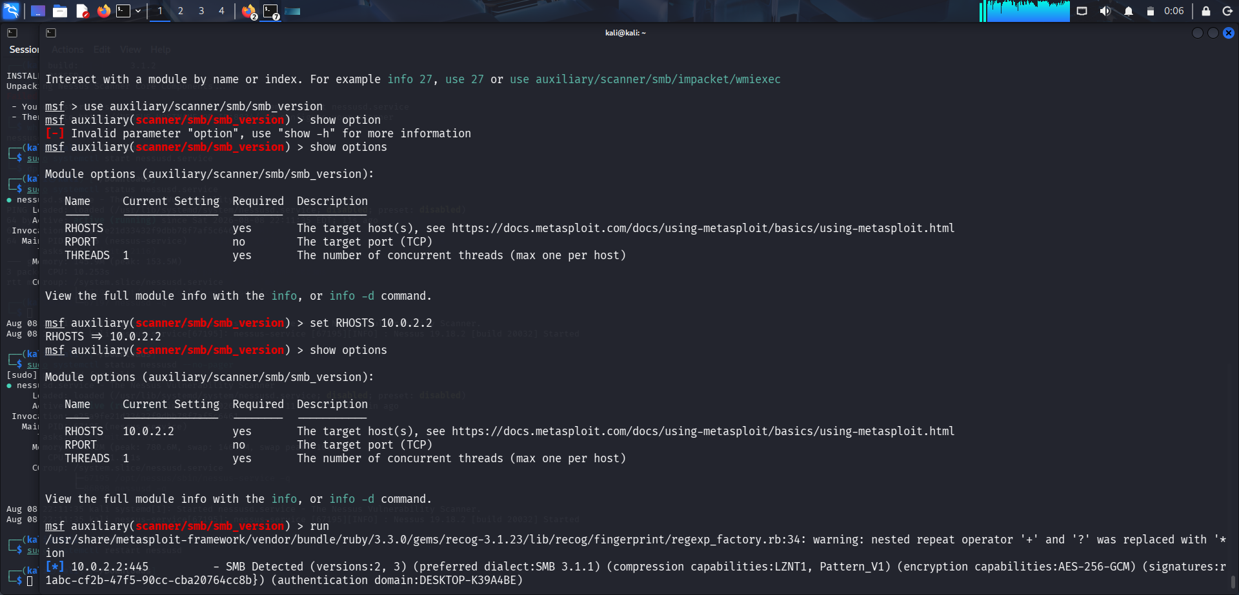
Shows the final RHOSTS configuration and the beginning of the SMB detection result.

6. Observed Result
The SMB version scanner successfully contacted 10.0.2.2 on TCP port 445 and identified SMB versions 2 and 3. The preferred dialect was reported as SMB 3.1.1. The output also reported compression capabilities LZNT1 and Pattern_V1, AES-256-GCM encryption capabilities, required SMB signatures, and the authentication domain DESKTOP-K39A4BE.
The scanner further identified the host as running version 10.0.26100, reported by Metasploit as likely Windows 11 version 24H2 / Windows Server 2025.

7. Result
The practical was completed successfully. Metasploit was launched, the SMB version scanner module was selected and configured, and the target's SMB implementation was successfully identified.

8. Conclusion
This practical demonstrated how Metasploit auxiliary scanner modules can be used for service identification. The SMB version scanner provided useful information about the target's SMB protocol versions and security capabilities without performing exploitation.

9. Note
This documentation is limited to the actions and results visible in the supplied screenshots. The screenshots demonstrate Metasploit operation and SMB version detection; they do not show a successful exploit, Meterpreter session, reverse shell, or post-exploitation activity.

