PRACTICAL 6
SNORT IDS
Intrusion Detection System Configuration and ICMP Alert Testing

1. Aim
To install and configure Snort IDS on Kali Linux, monitor network traffic on the eth0 interface, create a custom ICMP detection rule, and verify that Snort generates alerts for ICMP traffic.

2. Lab Environment
Operating System | Kali Linux
IDS | Snort 3.12.2.0
Network Interface | eth0
IP Address | 10.0.2.15/24
Test Target | 10.0.2.2
Detection Protocol | ICMP

3. Procedure

1. Snort Installation
Snort was installed from the Kali rolling repository. The installation output confirms that Snort 3.12.2.0 and its supporting packages were configured successfully.
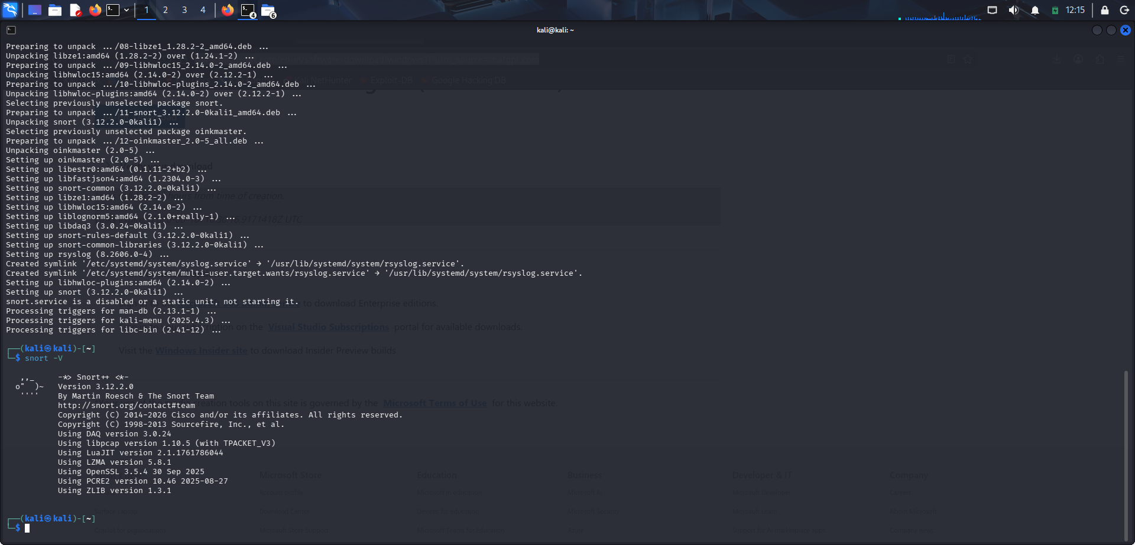
Figure 1: Snort 3.12.2.0 installation output

2. Network Interface Identification
The active network interface was identified using `ip -br addr`. The interface used for monitoring was eth0 with IPv4 address 10.0.2.15/24.
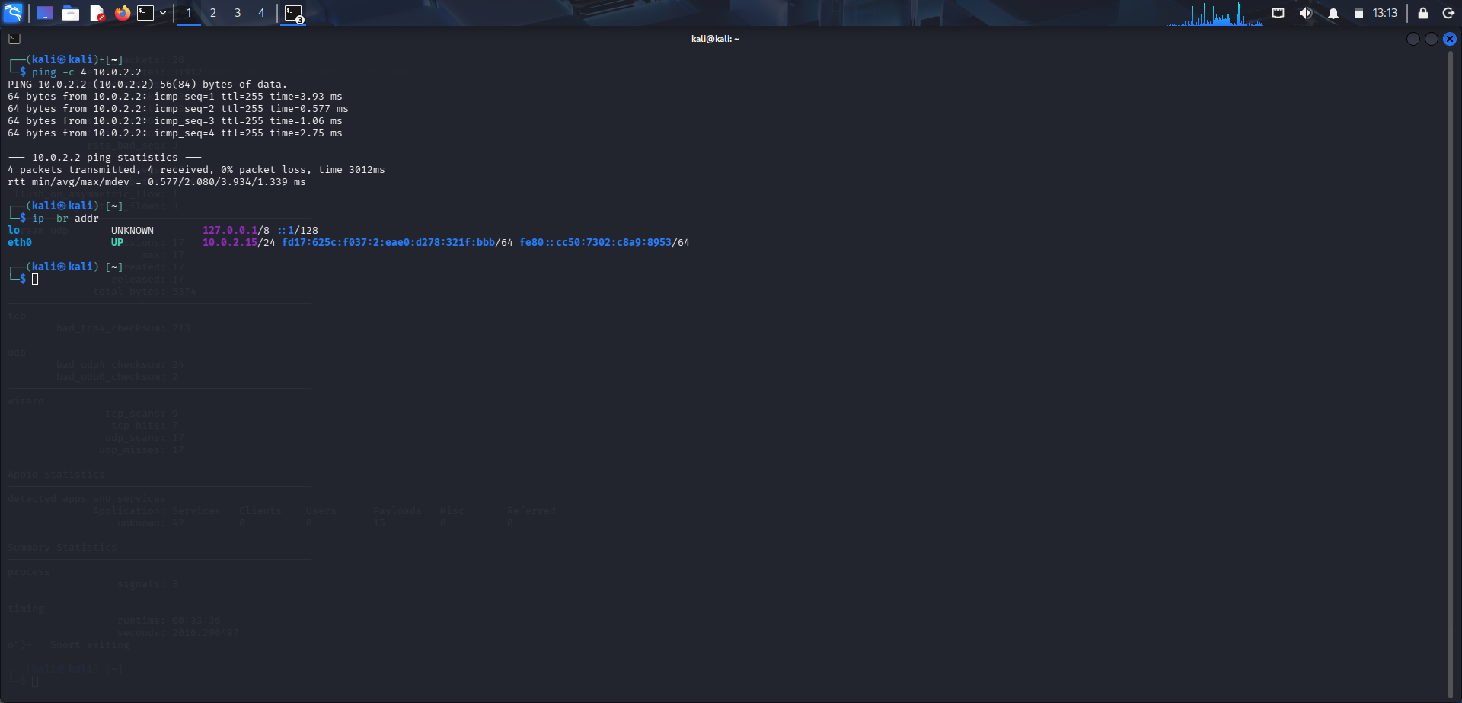
Figure 2: Network interface and connectivity information

3. Snort Configuration Validation and Packet Processing
The Snort configuration was tested and the captured evidence shows the configuration loaded successfully. Snort then entered passive packet-processing mode on eth0.
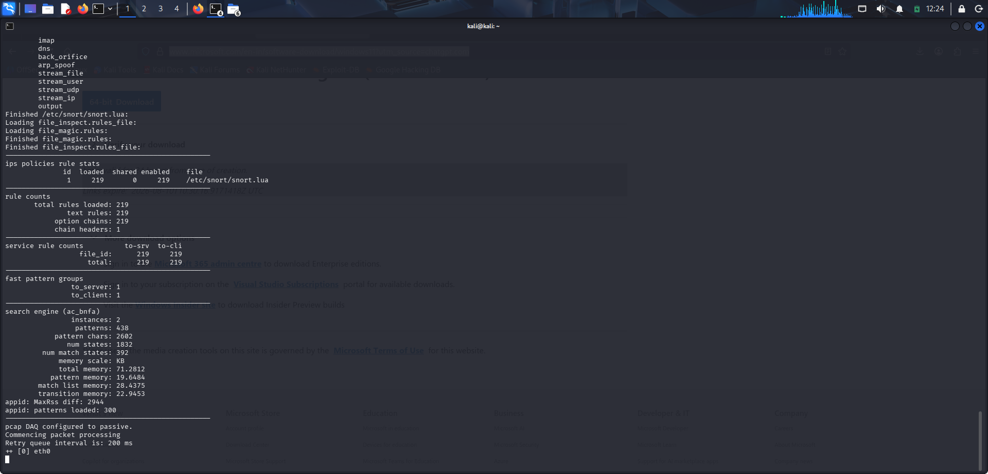
Figure 3: Snort configuration validation and packet processing

4. Custom ICMP Detection Rule
A local Snort rule was created in `/etc/snort/rules/local.rules` to generate an alert whenever ICMP traffic is observed. The rule used SID 1000001 and the message `LOCAL ICMP TEST ALERT`.
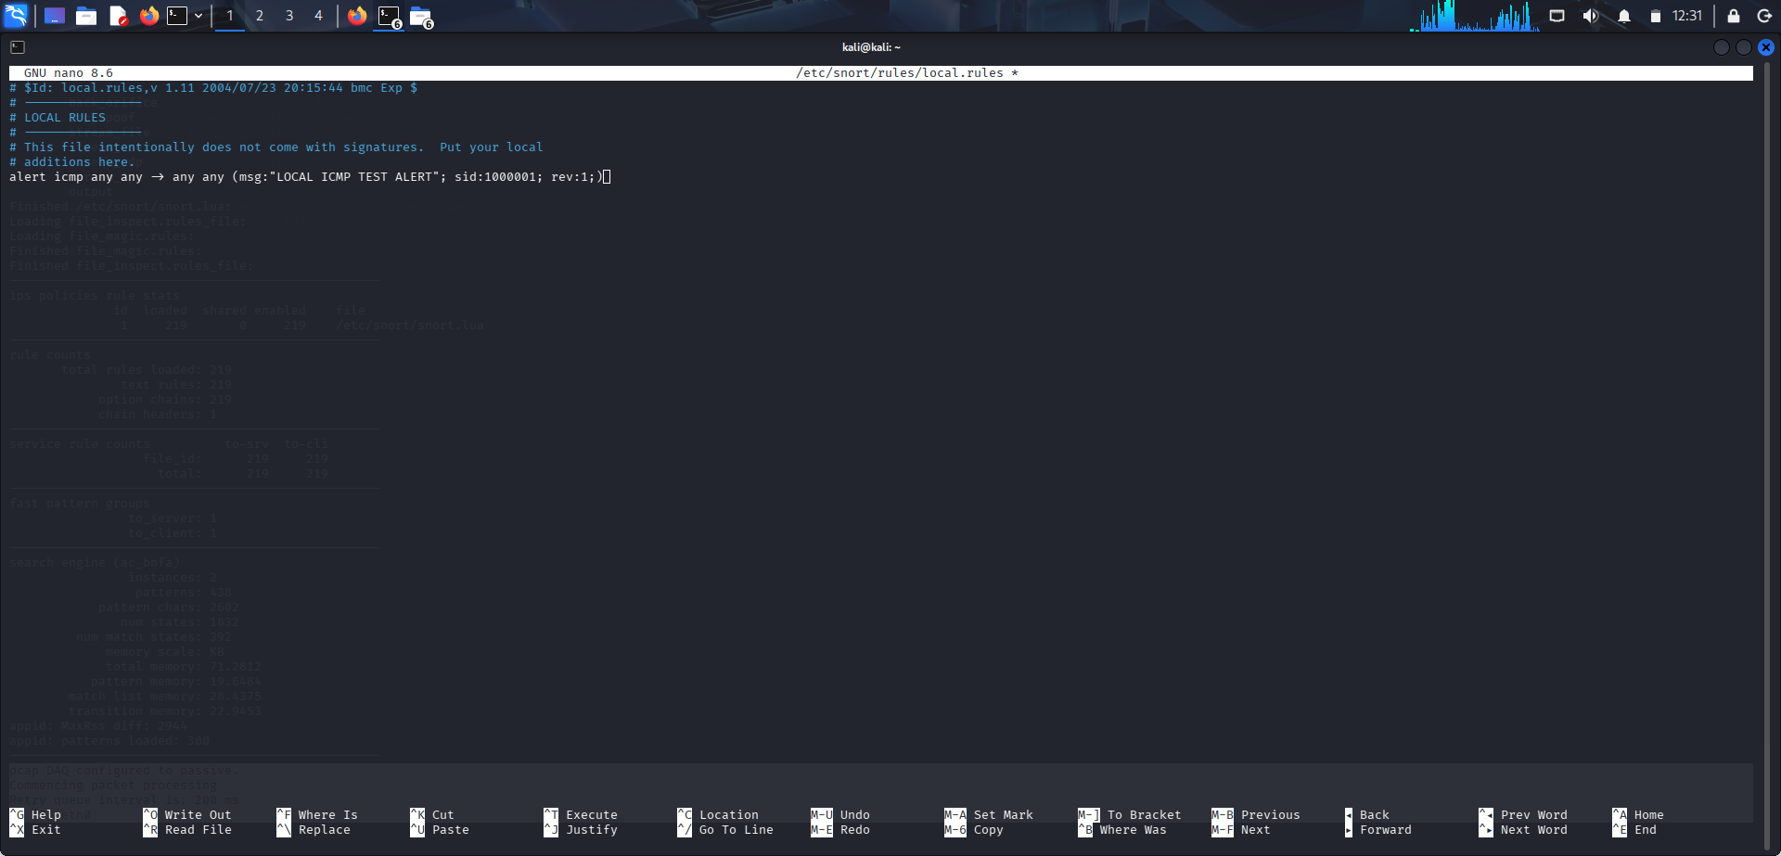
Figure 4: Custom ICMP rule in local.rules

5. ICMP Test Traffic
ICMP test traffic was generated with a four-packet ping to 10.0.2.2. The test completed successfully with 4 packets transmitted, 4 received, and 0% packet loss.
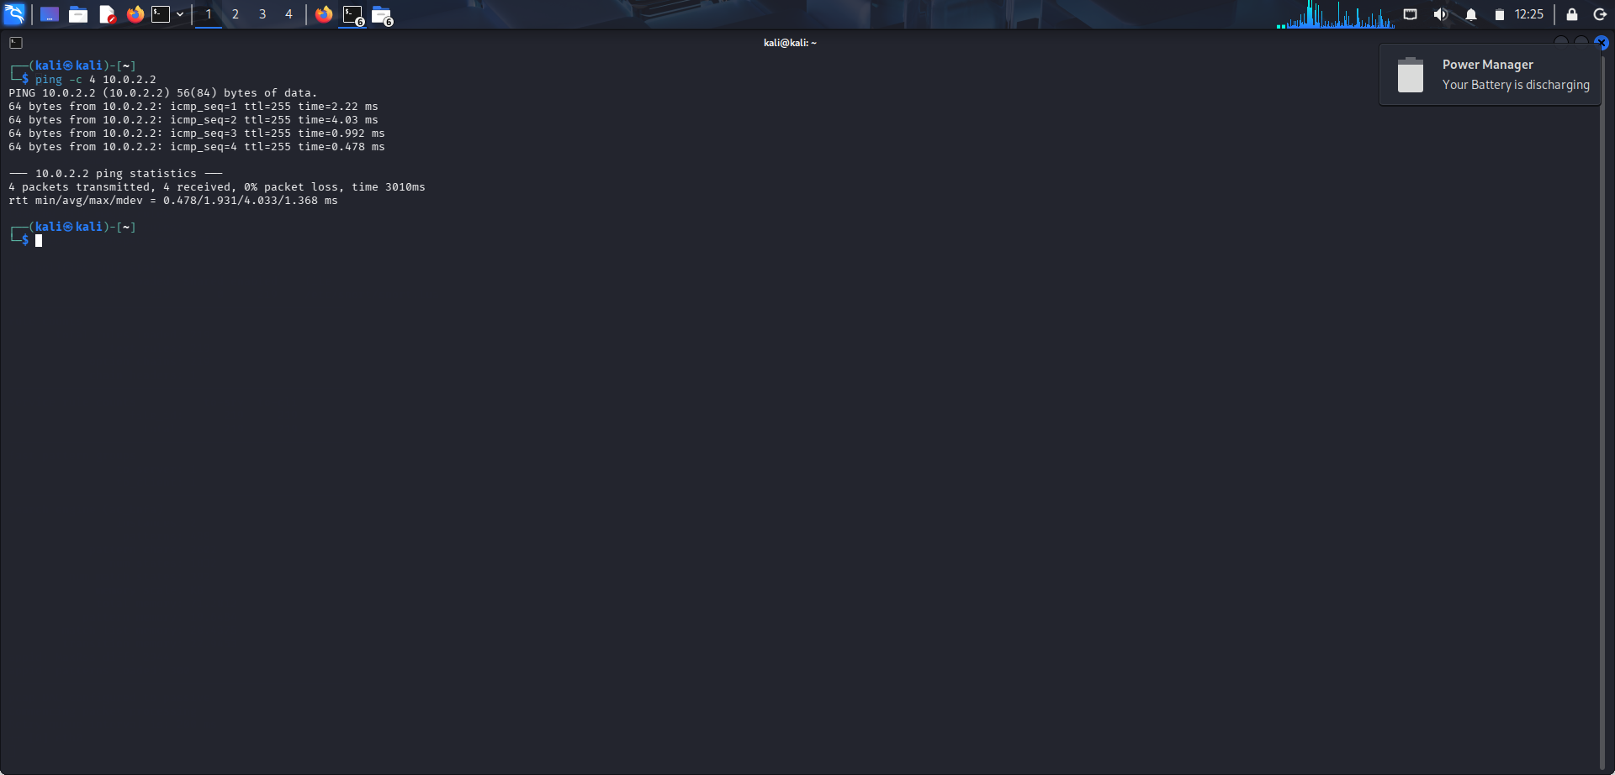
Figure 5: ICMP connectivity test

6. Snort Alert Detection
Snort was run in passive mode on eth0 with the custom rule loaded. The alert output confirms that the rule fired for ICMP traffic, including traffic between 10.0.2.15 and 10.0.2.2.
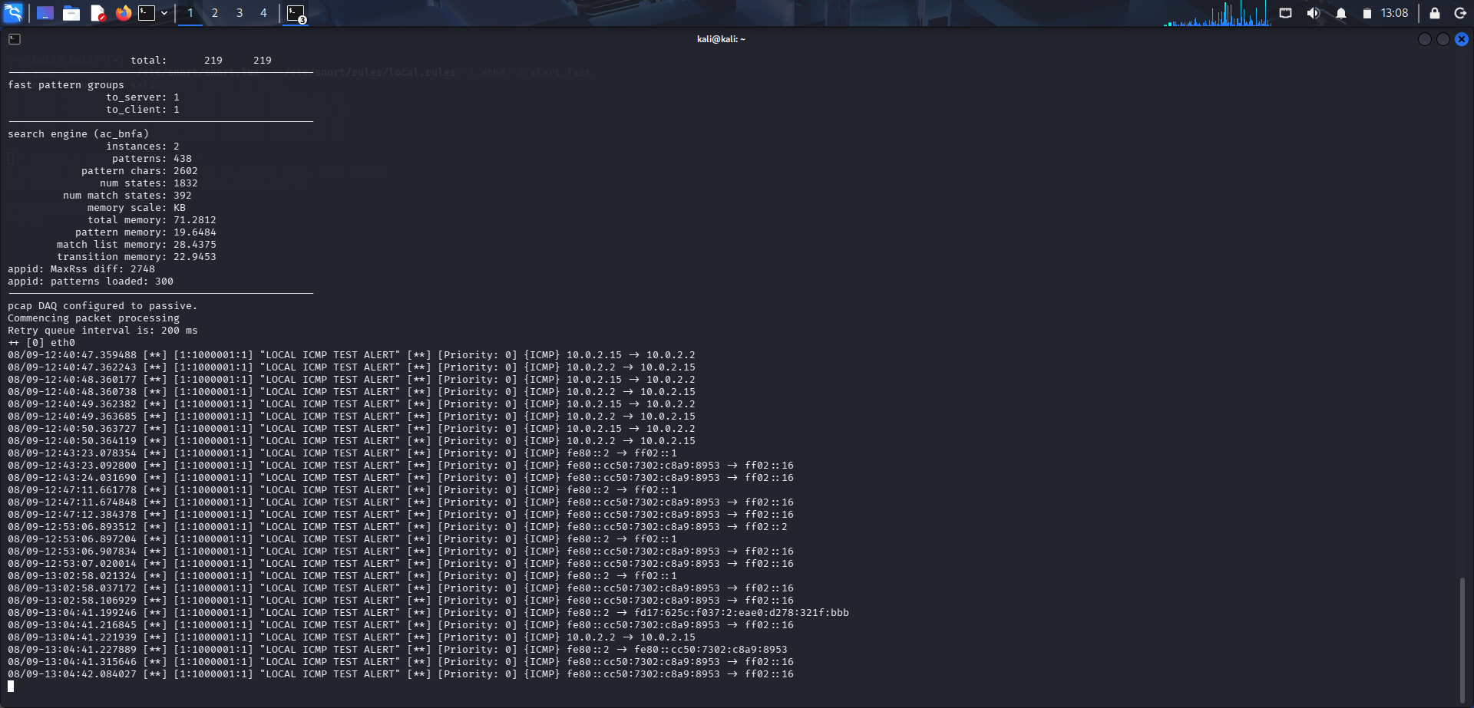
Figure 6: Successful Snort ICMP alerts

4. Key Evidence
- Snort version installed: 3.12.2.0.
- Monitoring interface: eth0.
- Snort configuration validation completed with 0 warnings.
- Custom rule SID: 1000001.
- ICMP connectivity test: 4/4 packets received; 0% packet loss.
- Snort generated the alert message: LOCAL ICMP TEST ALERT.

5. Result
Snort IDS was successfully installed and configured on Kali Linux. The eth0 interface was monitored in passive mode, a custom ICMP detection rule was validated, and test ICMP traffic successfully triggered Snort alerts. Therefore, the basic Snort IDS detection workflow was successfully demonstrated.

6. Screenshot Index
Figure | Evidence | Use in Documentation
1 | Snort installation | Installation proof
2 | eth0 / IP / ping | Network setup proof
3 | Configuration + packet processing | IDS startup proof
4 | local.rules ICMP rule | Rule creation proof
5 | Successful ping | Test traffic proof
6 | LOCAL ICMP TEST ALERT | Alert/detection proof

