

UNIVERSITY INSTITUTE OF COMPUTING

PROJECT REPORT DATA SCIENCE USING EXCEL

PROJECT NAME:
Student Result Management System Using MS Excel

SubmittedBy: Submittedto:
Name:HarmandeepKaur Mr:Parwansir
UID:24BCA10295 AsistentProfessor Branch:BCA
Section:2(B)

1. Introduction
In today’s digital era, data management plays a very important role in educational institutions. Schools and colleges handle a large amount of student data including marks, attendance, grades, and performance reports. Managing this data manually can be time-consuming and prone to errors.
Microsoft Excel is one of the most widely used spreadsheet applications that helps in organizing, calculating, analyzing, and presenting data in a structured format. It provides various built-in formulas, functions, charts, and tools that make data handling efficient and accurate.
This project titled “Student Result Management System Using MS Excel” is designed to automate the calculation of student marks, percentage, grades, and overall performance summary. The system helps in maintaining records in a systematic manner and provides a visual dashboard for analysis.

2. Objectives of the Project
The main objectives of this project are:
2.1 To create a systematic record of student marks.
2.2 To automate total and percentage calculations using Excel formulas.
2.3 To assign grades automatically based on predefined criteria.
2.4 To reduce manual errors in calculation.
2.5 To generate a summary report of overall class performance.
2.6 To create charts and dashboards for better visualization.

3. Literature Review
In recent years, many educational institutions have adopted digital tools for managing student data. Traditional manual systems are time-consuming and prone to errors.
Various software solutions such as ERP systems and database management systems are used for handling academic records. However, these systems can be costly and complex.
Microsoft Excel remains one of the most accessible and cost-effective tools for small-scale data management. It provides powerful features such as formulas, charts, pivot tables, and data analysis tools.
This project is based on the idea of using Excel as a simple and efficient tool for managing student results.

4. Scope of the Project
The scope of this project is limited to managing student academic performance for a class with three subjects.
4.1 It can be used by teachers to manage results.
4.2 It can be used by college administrators.
4.3 It is useful for coaching institutes.
4.4 It is suitable for small educational institutions.
The system can be expanded in the future by adding attendance, more subjects, and advanced analytics.

5. Methodology
The following methodology is used in this project:
5.1 Data Collection – Sample student data is created.
5.2 Data Entry Design – Excel sheet is designed with proper columns.
5.3 Formula Application – Formulas are applied for calculations.
5.4 Dashboard Creation – Summary sheet is created.
5.5 Testing – The system is tested with different inputs.
This approach ensures accuracy and efficiency.

6. Tools and Technologies Used
The following tools are used:
6.1 Microsoft Excel (2016 or later)
6.2 Excel Formulas (SUM, IF, AVERAGE, COUNTIF, RANK)
6.3 Charts (Pie Chart, Bar Chart, Column Chart)
6.4 Conditional Formatting
Excel is chosen because it is easy to use and widely available.

7. Data Description
The dataset includes student academic details:
7.1 Roll Number
7.2 Student Name
7.3 Subject 1 Marks
7.4 Subject 2 Marks
7.5 Subject 3 Marks
7.6 Total Marks
7.7 Percentage
7.8 Grade
This dataset is used to demonstrate the system.

8. Project Structure

8.1 Sheet 1: Student Data Entry
This sheet contains:
- Roll Number
- Student Name
- Subject Marks
- Total Marks
- Percentage
- Grade
- Rank
Formulas Used:
Total Marks:
=SUM(C2:E2)
Percentage:
=F2/300*100
Grade:
=IF(G2>=90,"A+",IF(G2>=75,"A",IF(G2>=60,"B",IF(G2>=50,"C","Fail"))))
Rank:
=RANK(G2,$G$2:$G$21,0)

8.2 Sheet 2: Dashboard / Summary
This sheet includes:
- Total students
- Average percentage
- Highest percentage
- Lowest percentage
- Pass/Fail count
- Grade distribution
Functions Used:
Average: =AVERAGE(G2:G21)
Max: =MAX(G2:G21)
Min: =MIN(G2:G21)
Fail Count: =COUNTIF(H2:H21,"Fail")

9. Charts Used
The following charts are used:
9.1 Column Chart – Shows student percentage
9.2 Pie Chart – Shows grade distribution
9.3 Bar Chart – Shows subject-wise performance
Charts update automatically when data changes.

10. Working of the Project
The user enters student marks in the Excel sheet. The system automatically calculates:
10.1 Total marks
10.2 Percentage
10.3 Grade
10.4 Rank
The dashboard updates automatically.

11. Detailed Working with Example
Example:
Subject 1 = 80
Subject 2 = 70
Subject 3 = 90
Total = 240
Percentage = 80%
Grade = A
This shows how Excel automates calculations.

12. Applications of the System
This system can be used in:
12.1 Schools
12.2 Colleges
12.3 Coaching institutes
12.4 Personal use
It improves efficiency and accuracy.

13. Advantages of the System
13.1 Saves time and effort
13.2 Reduces errors
13.3 Easy to use
13.4 Provides quick results
13.5 Better data organization

14. Limitations of the System
14.1 Manual data entry required
14.2 Suitable for small datasets
14.3 Requires Excel knowledge

15. Future Enhancements
15.1 Add attendance system
15.2 Add more subjects
15.3 Automated report card
15.4 Use Pivot Tables
15.5 Add VBA automation

16. Result and Discussion
The system successfully manages student data and provides accurate results. It reduces manual work and helps in analysis.

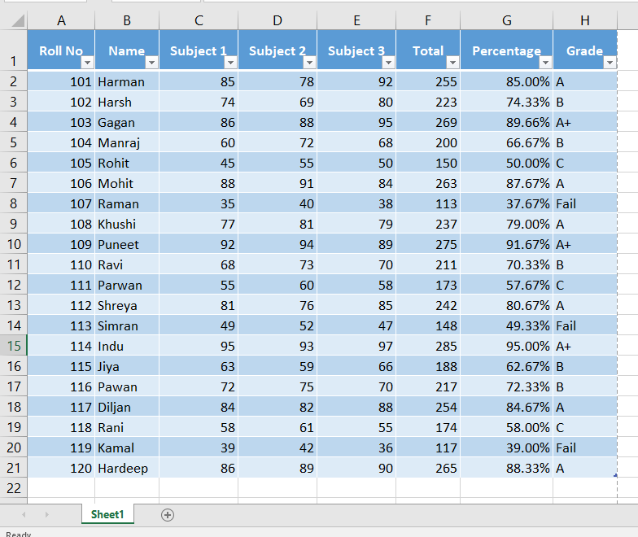

Summary Data (For Dashboard Sheet)

̙ Total Students

20

̙ Average Percentage

72.22%

̙ Highest Percentage

95.00%

̙ Lowest Percentage

37.67%

̙ Grade Distribution

Grade Count

A+ 4

A 6

B 6

C 3

If you want, I can now give you:

Pivot Table format

Ready dashboard layout design

Viva explanation script

Advanced version with 5 subjects

CSV format copy-paste data

Tell me what you need next

how many columns do i need to make

For your Student Result Management System, you need:

̙ Minimum Columns Required: 8 Columns

Here is the structure

Column

No.

Column

Name

1 Roll No

2 Name

3 Subject 1

4 Subject 2

5 Subject 3

6 Total

7 Percentage

8 Grade

17. Conclusion
The Student Result Management System developed using Microsoft Excelsuccessfullydemonstrateshowspreadsheetsoftwarecanbeused for academic data management.
The system simplifies result calculation, reduces errors, and provides meaningfulinsightsthroughchartsandsummaries.Itisapracticaland user-friendly solution for managing student performance.
ThisprojecthighlightstheimportanceandusefulnessofMSExcelin educational institutions and real-world data management.

