**Top YouTubers**

**By:**

**Harman Lal**

**(300343291)**

For the completion of course **CSIS 3860 Data Visualization**

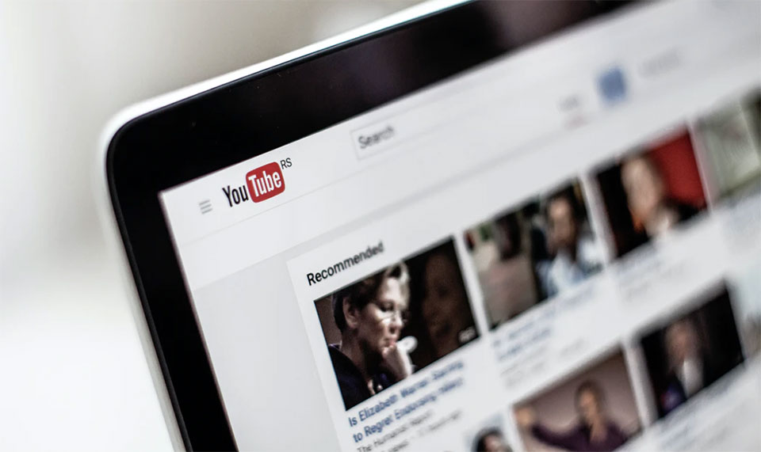

**Your choice of the visualization tool and your justification for choosing this tool?**

The Visualization Tool Used for this Project is Tableau. The reason for this particular tool is that Tableau assists in putting knowledge into practise, shortens analysis times, and alters behaviours to make people more data-driven.

Tableau is an extremely efficient application for quickly producing interactive data displays. It is really easy to use and basic. Similar to the pivot table graphs in Excel, Tableau can produce complicated graphs. Additionally, it can process a lot more input and calculate datasets quickly.

**What motivated you to choose your topic and your choice of visualizations using the data and what has driven you to choose these visualizations ?**

The reason behind this topic is that YouTube is the most popular app nowadays and a lot of people make earnings via Youtube. It provides a lot of services such as,

Community of YouTube

The debut of YouTube Community, a new social networking function, was announced in September 2016.

This is only accessible to people who have more than 500 subscribers. Community posts may contain text, video, GIFs, and photos.

YouTube Go's logo

An Android app called YouTube Go was created with the goal of making YouTube more accessible on mobile devices in developing nations. It differs from the business's standard Android app and enables users to download and share videos. Additionally, it gives customers more options for managing their mobile data and video resolution, as well as the ability to preview videos and share downloaded media via Bluetooth. Google announced in May 2022 that YouTube Go would be discontinued in August of that same year.

YouTube Music

Lyor Cohen, the co-founder of 300 Entertainment and a senior executive at Warner Music Group, was appointed Global Head of Music by YouTube on September 28, 2016.

Early in 2018, Cohen started to tease the potential debut of YouTube's upcoming paid music streaming service, a platform that would go up against rivals like Spotify and Apple Music.

YouTube Music, a music streaming service, went live on May 22, 2018.

Premium YouTube

YouTube's premium subscription service is called YouTube Premium (formerly known as YouTube Red). It provides access to original programmes, ad-free streaming, and mobile device offline and background video playback. [417] When "Music Key," a paid music streaming service, was first introduced on November 12, 2014, it was planned to replace and integrate with the Google music.

**Any relevant information on how you completed the solution: this can include your scenarios for various visualizations you came up with (i.e., the questions, choice of calculated fields and parameters, etc.)?**

The Data is obtained from Kaggle. There were a lot of inconsistent columns in the Data and the changes needed to be made. The Visualizations are based on the Top YouTube Trends across the World.

**A brief discussion of your visual analysis results and their managerial/practical implications**

The first Visualization gives us the insights on YouTube channels with maximum reviews. Where we can see that the top channels preferred Nursery Rhymes is on the Top followed by Like Nastya, Kids Diana show etc.

The second Visualization gives us the information about the Top viewers across the globe. The US has the most Number of Viewers followed by Canada, India, Europe and so on.

The third Visualizations provides the insights for number of followers in different Categories. Gaming and Apps has the highest percentage of 57.36% and Science and Tech has the least with 2.43%. we can see that Music is third most poplar thing with the percentage of 15.78%.

The fourth Visualization tells us about the Top Users where Gaming and app is the highest and Toys and colors are least preferred. This plot gives us insights about categories.

Talking about the Dashboard Maximum Viewers, It shows us Popular Youtube channels with respect to Different countries, categories and Top users. It is a Functional Dashboard if you click on any one the visualization it will give you the corresponding attributes related to it. Also, you can filter it by How many Numbers you want as in Top 25 or Top 50 and so on.

The functional button will lead you to second dashboard Different Genres and Channels. Where if you click on any category of music, it will give you the corresponding channels related to that category. Furthermore, if you hover over the channel it will take you the website url of that particular channel. It also has a functional back button that will take to you to the first Dashboard. This way you can switch between the dashboards.

The Story “best Youtubers” Gives the insight about what YouTube is? How to become a member? Global Viewers, Top 3 YouTubers among young generation and main YouTubers.

For the story Canva app was used to create the templates.