**CHAPTER 8**

**Object Model**

The Clinical Laboratory Management System described in methodology of Data dictionary and class diagram. In which different collection of data sources were supposed to construct this medical laboratory management system and the relationship of classes that compose the system.

**8.1 Data Dictionary**

* **Table:** Working glossary for Medical Laboratory Management System. Keeping track of important terms and their definitions ensures consistency in the specification and ensures that developers use the language of the client.
* **Test:**This test measures your understanding of sentence structure how sentences are put together and what makes a sentence complete and clear.
* **Patient:**The customers in Lab. who a laboratory specimen is a biological Specimen taken by sampling, that is, gathered matter of a medical Patient’s tissue, fluid, or other. Prescription. And get bill for that tests.
* ICMR: Indian Council of Medical Research.
* GCP: Indian Good Clinical Practices.
* CDSCO: Central Drugs Standard Control Organization.

**8.2 Data Flow Diagram (DFD)**

A **data flow diagram** (**DFD**) is a graphical representation of the "flow" of data through an information system, modelling its process aspects. A **DFD** is often used as a preliminary step to create an overview of the system without going into great detail, which can later be elaborated.

**8.2.1 CLMS DFD**

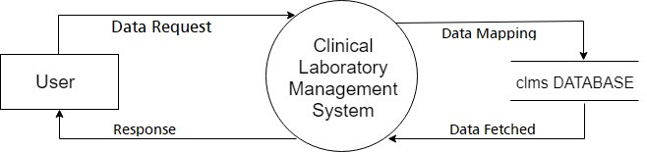

**8.2.2 Services DFD**

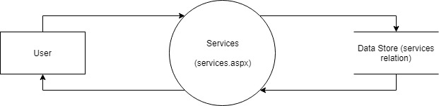

**8.2.3 Appointment DFD**

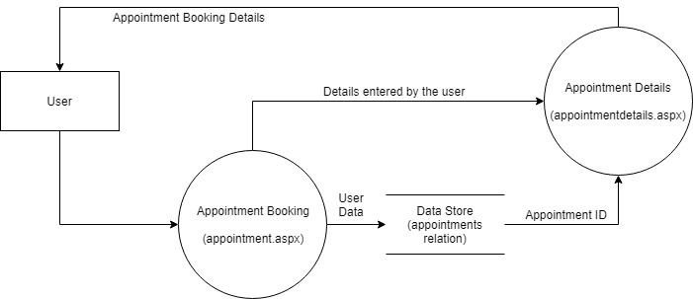

**8.2.4 Enquire DFD**

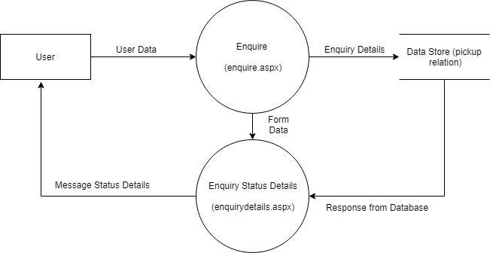

**8.2.5 Sample Pickup DFD**

