Multimodal IMDB Film Classification
Report

1. Introduction
This report evaluates two deep learning models trained to classify movies from the IMDB dataset by genre. The first model is a Convolutional Neural Network (CNN) that looks at movie poster images. The second is a Bidirectional Long Short-Term Memory network (BiLSTM) that reads the text overview of each film. Both models perform multi-label classification, meaning a single film can belong to more than one genre at the same time. The goal of this report is to explain how well each model performed and why, using real examples from the dataset.

2. Data Processing

2.1 Image Processing

Poster images were resized to 64×64 and normalized to float32 (0–1). During training, augmentations like random flipping, brightness, contrast, and saturation changes were applied to improve generalization without altering labels. These were not used on validation data to keep evaluation unbiased.

2.2 Text Processing

Film overviews were vectorized using a TextVectorization layer (10,000-word vocab) fitted only on training data. An embedding layer mapped words to 265-dimensional vectors, with mask_zero=True to ignore padding in variable-length sequences.

3. Model Architectures

3.1 CNN for Poster Classification

The CNN uses residual blocks with skip connections to improve training stability. It has four blocks (32, 64, 128, 128 filters), followed by Global Average Pooling and a sigmoid output for multi-label prediction. The model uses binary cross-entropy loss and is trained for 50 epochs with Adam (learning rate 0.0001).

3.2 BiLSTM for Overview Classification

The model uses stacked Bidirectional LSTMs (256 and 128 units) to capture context in both directions, followed by a dense layer and 0.8 dropout to reduce overfitting. A sigmoid output handles multi-label classification, trained for 20 epochs with binary cross-entropy loss.

4. Training Results and Evaluation

4.1 CNN Performance

The CNN’s training loss decreased steadily, but validation loss plateaued or diverged after ~20 epochs, indicating overfitting. Precision improved while recall stayed low, meaning the model was cautious and missed many correct genres. Common genres (e.g., Drama, Comedy) were predicted better than rare ones (e.g., Documentary, Western), reflecting class imbalance in the dataset.

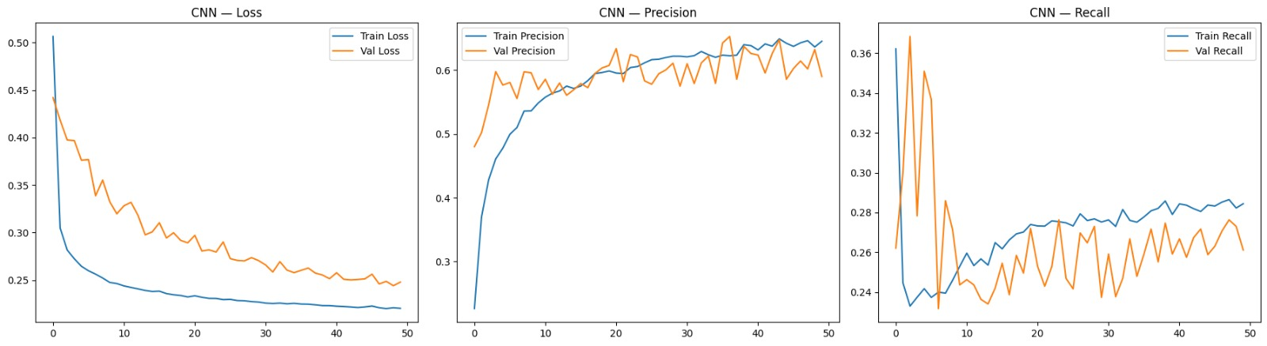

4.2 BiLSTM Performance

The BiLSTM outperformed the CNN, as text overviews provide clear genre cues (e.g., “murder” → Crime, “love” → Romance). It achieved higher accuracy and lower validation loss, with overfitting better controlled by 0.8 dropout, though a gap remained after ~10 epochs. Performance depends on overview quality, and some genres (e.g., Music, History) were occasionally confused due to similar vocabulary.

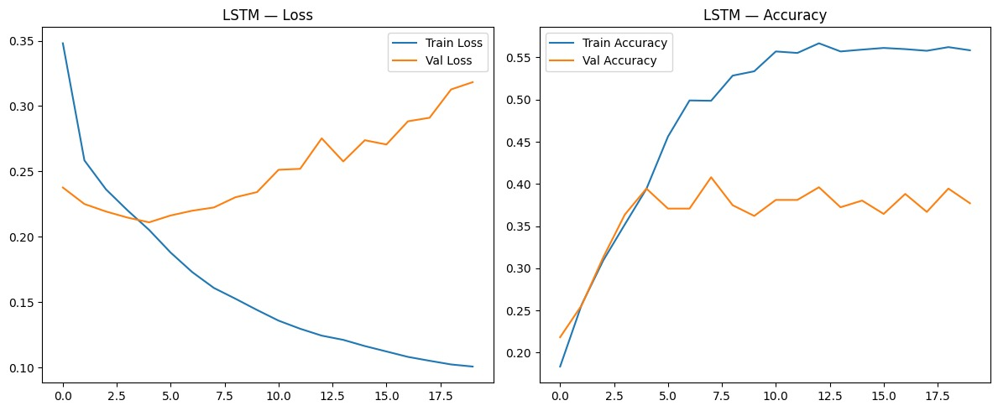

5. Example Predictions
To illustrate the models' behaviour, several films were selected from the test set and their top-3 predicted genres were compared against the ground truth.
Example 1 – Action/Drama film: The CNN correctly identified Action and Drama as the top genre, likely due to the dynamic and high-contrast visual style of the poster. The BiLSTM also correctly predicted Action (and Adventure) from the overview. Both models agreed on the top genre, which increased confidence in the prediction.
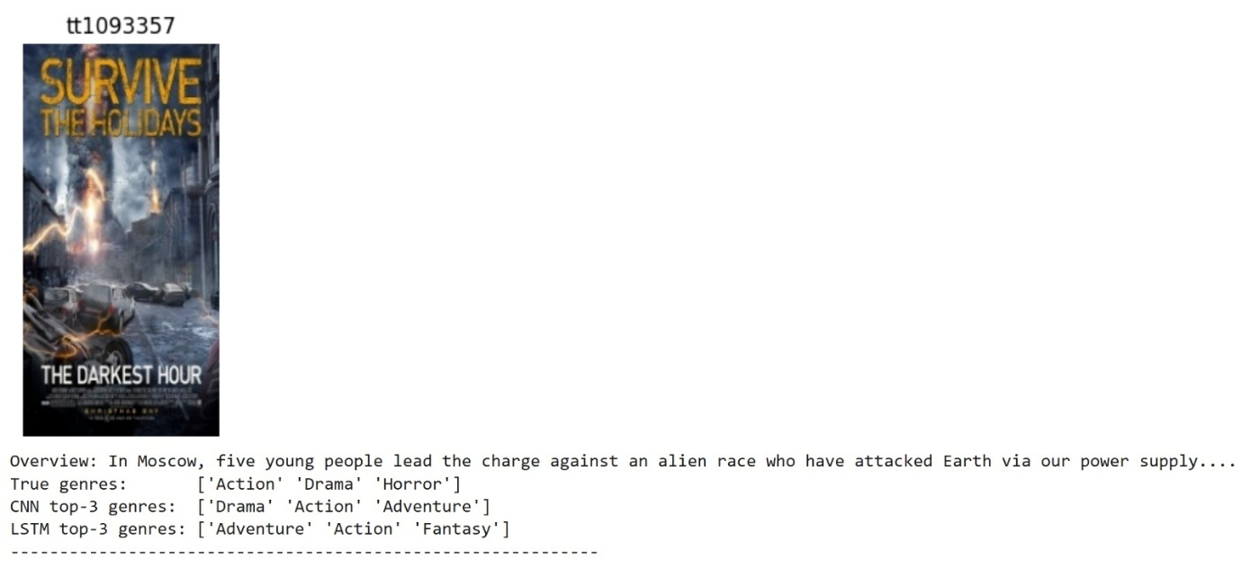
Example 2 – Drama/Romance film: The CNN predicted Drama correctly but missed Romance, likely because the poster showed a single character rather than a couple. The BiLSTM, however, picked up both Drama and Romance from the overview text, showing that language carries richer genre signals than visuals in this case.
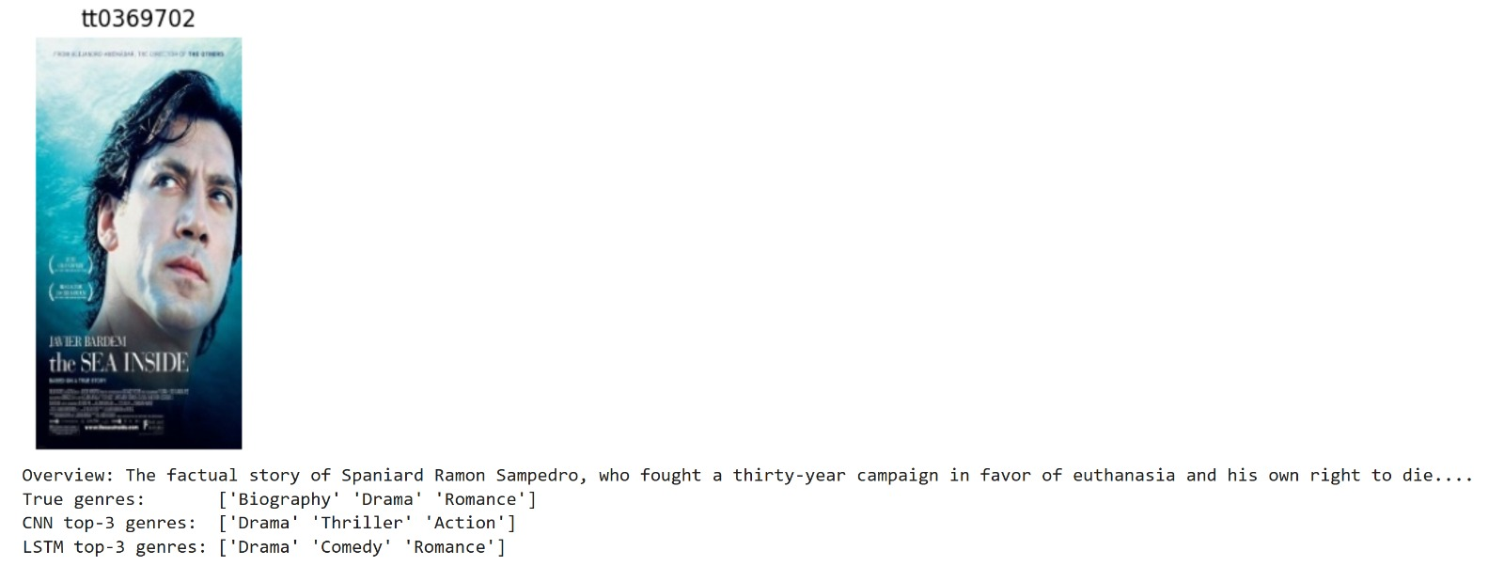

Example 3 – Horror film: This was a clear drawback of both CNN and LSTM. The BiLSTM and CNN both failed to recognize “Horror” genre. Instead, they identified it as “Action”, “Crime”, and “Drama” related.
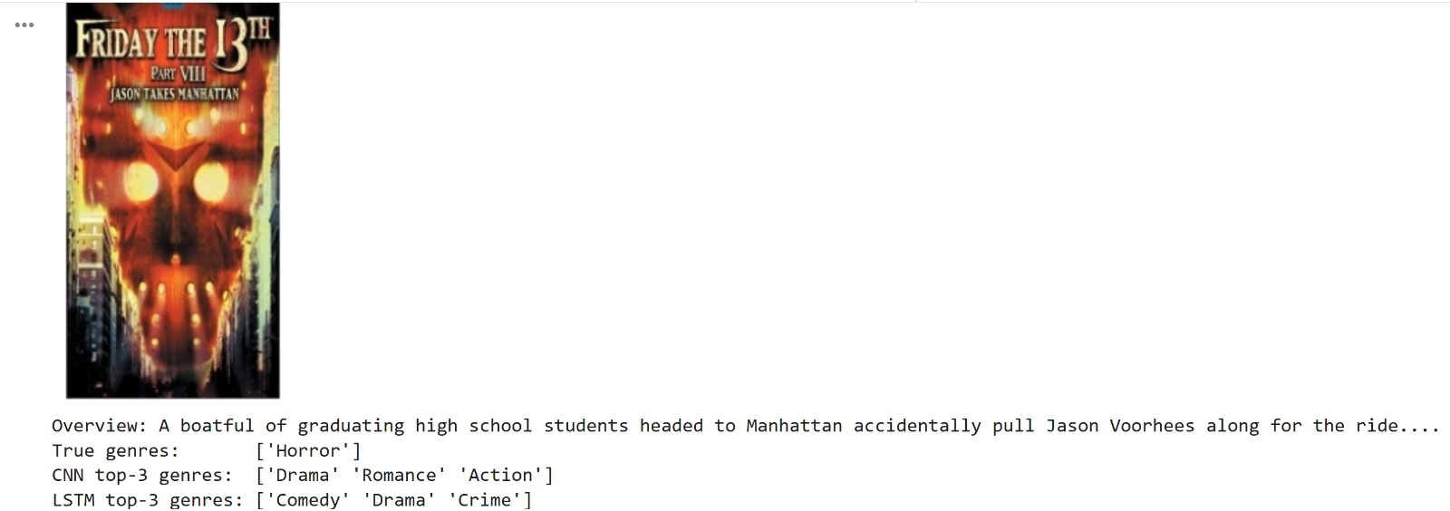

6. CNN vs BiLSTM – Which Is Better?

Overall, the BiLSTM outperformed the CNN since text provides clearer genre signals than images. Posters can be visually ambiguous, while overviews contain explicit cues. However, the CNN still adds value, and combining both in a multimodal model would likely improve performance by capturing both visual and textual features.

7. Conclusion
This assignment explored multi-label genre classification using deep learning. The BiLSTM outperformed the CNN due to stronger textual cues, while the CNN struggled with visual ambiguity and class imbalance but worked better for visually distinct genres. Key takeaways include using augmentation for images, dropout for text, and handling imbalanced data.
Future improvements can be: transfer learning (e.g., ResNet, BERT) and multimodal models combining text and images.

