PORTFOLIO
Harman Singh
Ph.D, Candidate in Geography & Climate Science
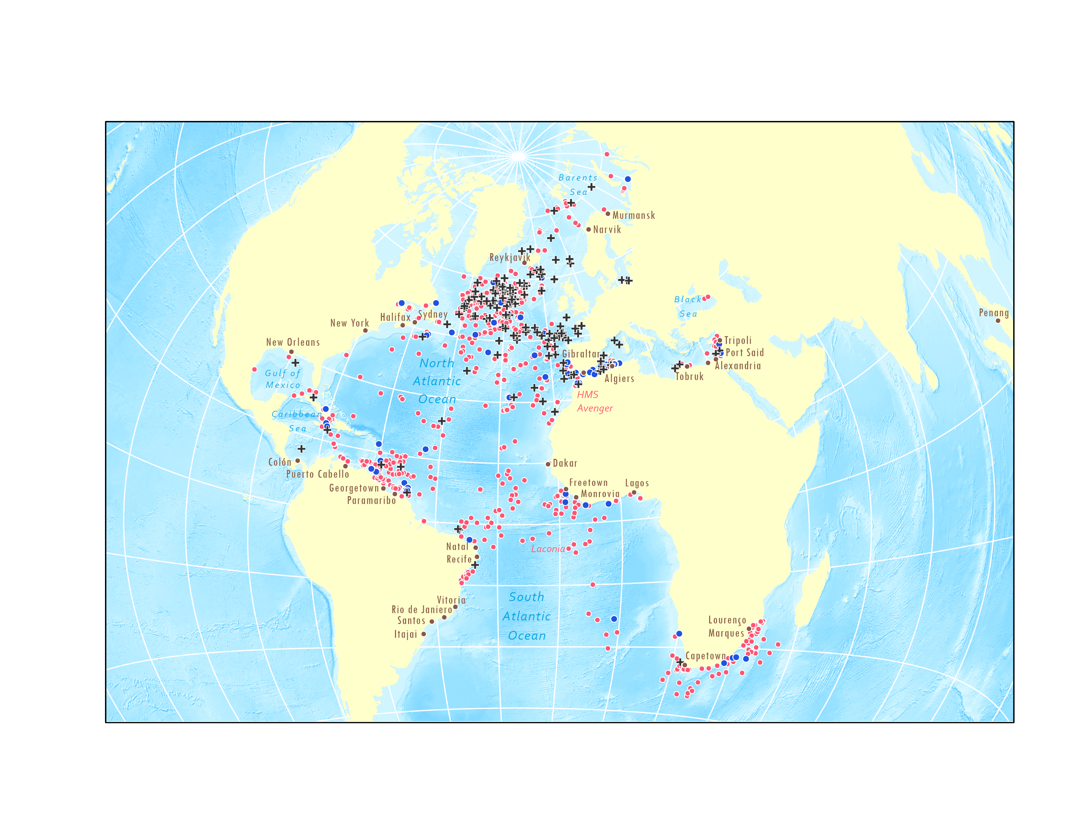
Chapter 2: The Global Distribution of Allied Vessels Sunk and Damaged and U-Boats Lost
Book: Navigating Treacherous Waters (unpublished)
Contributors: Harman Singh, Dr. Fritz Kessler

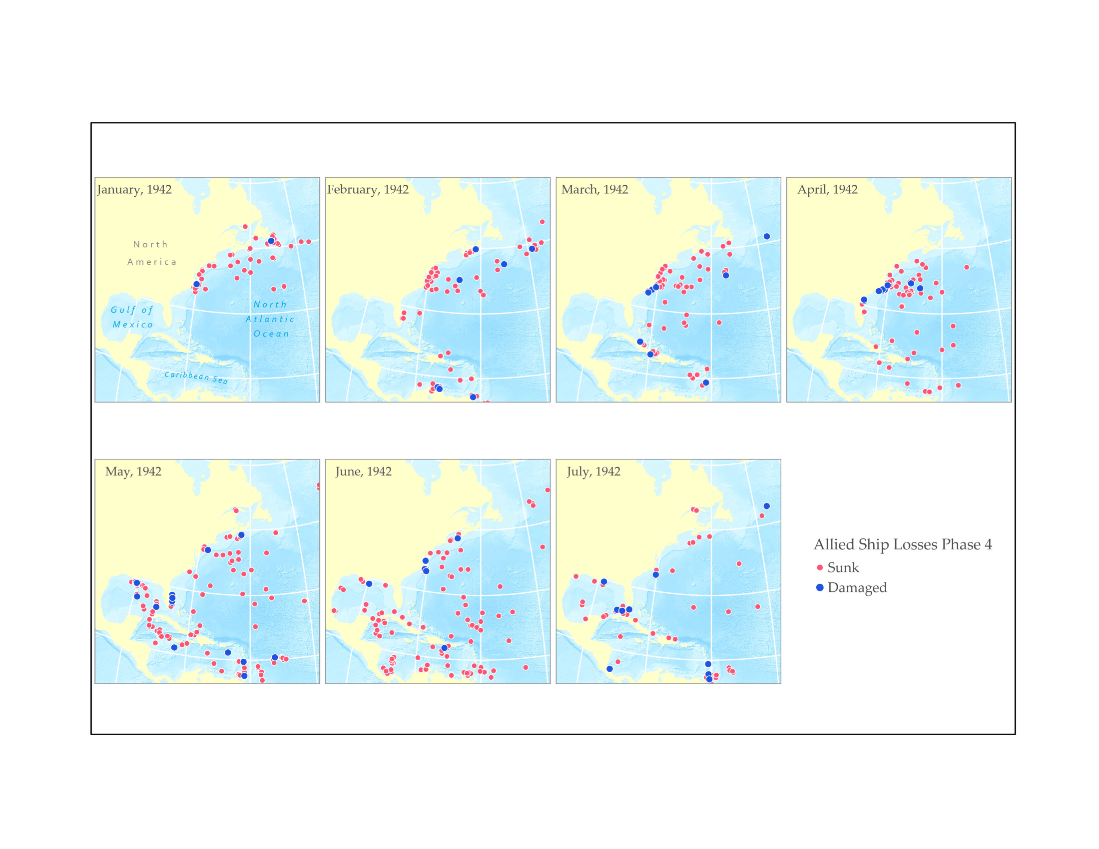
Chapter 3: The Distribution of Allied Vessels Sunk and Damaged by Theater of U-Boat Operations
Book: Navigating Treacherous Waters (unpublished)
Contributors: Harman Singh, Dr. Fritz Kessler

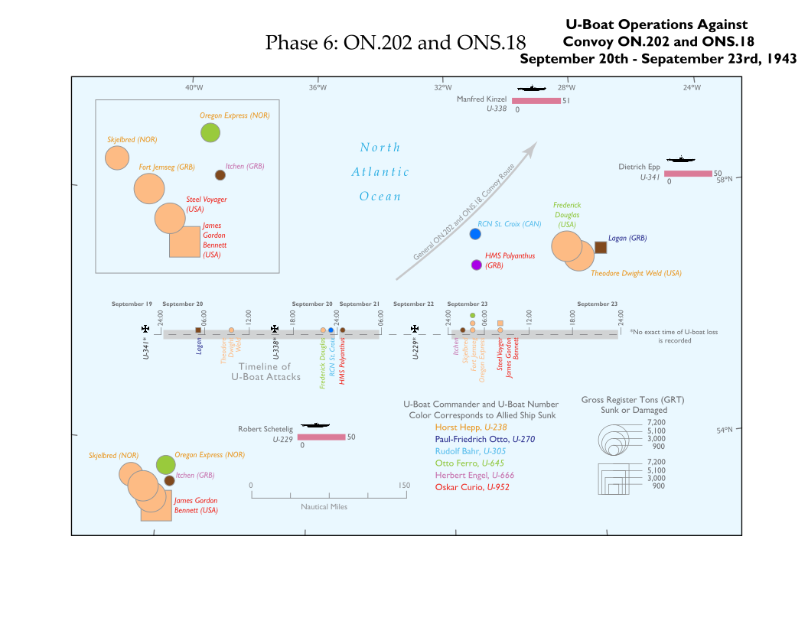
Chapter 4: Convoy Operations and Wolfpacks
Book: Navigating Treacherous Waters (unpublished)
Contributors: Harman Singh, Dr. Fritz Kessler

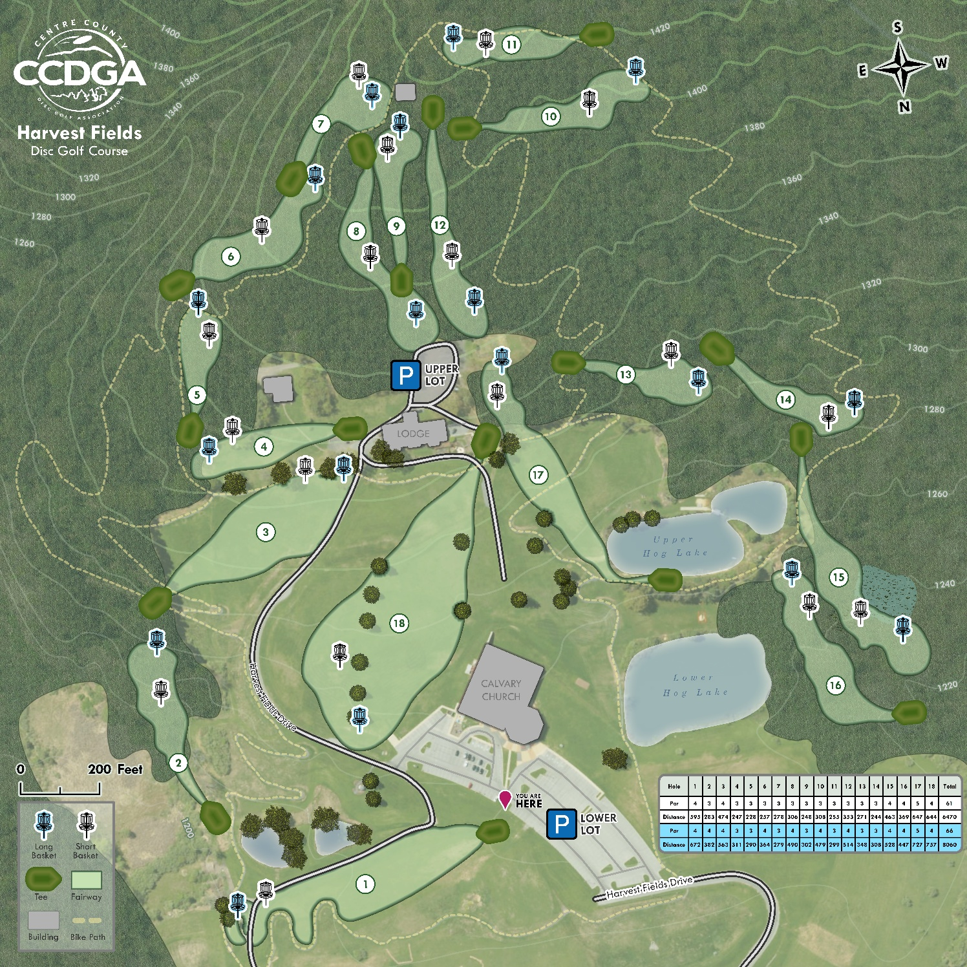
Harvest Fields Disc Golf Course
Client: Centre County Disc Golf Association
Contributors: Alro Nemerson, Harman Singh, Alicia Iverson

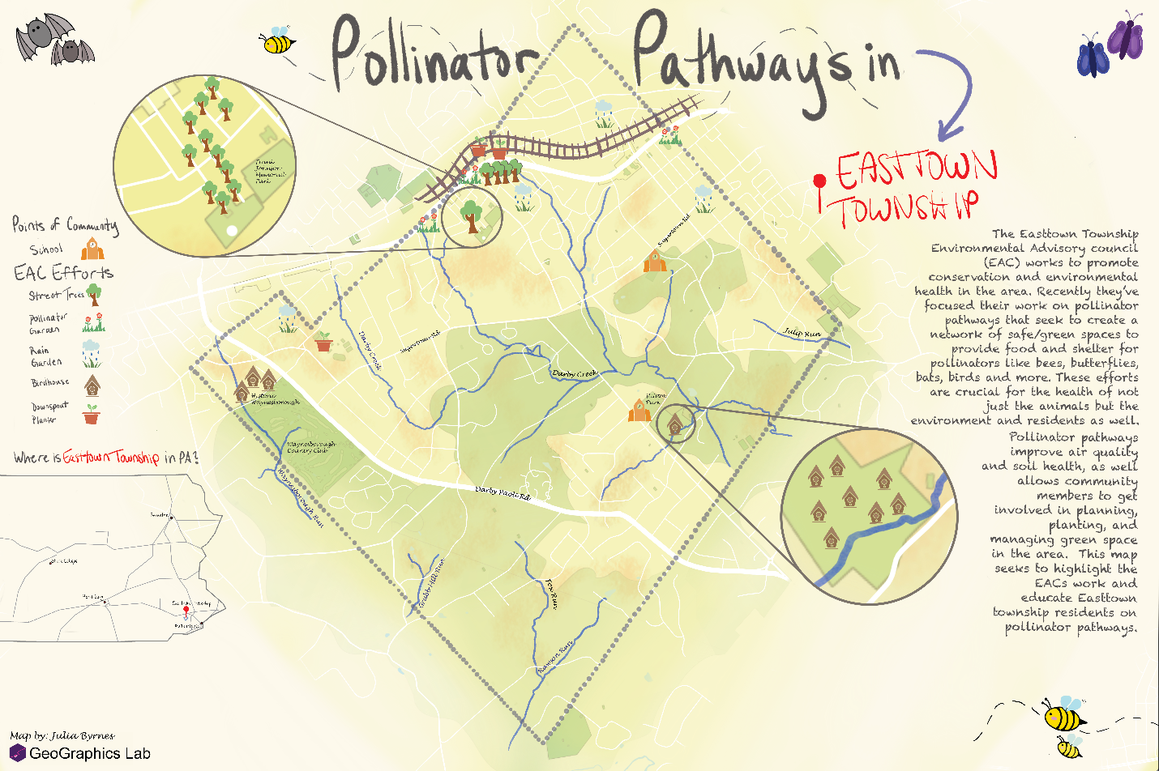

Pollinator Pathways in Easttown Township
Client: Easttown Township, PA
Contributors: Julia Byrnes, Harman Singh, Alicia Iverson

