Harmattan System UI Architecture
Subsystem Architecture Specification

Document code: | DSAXXXXX-EN
Version: | [?Version?]
Status: | Draft
Save date: | 03.09.2009
Author: | Matti Katila
Approver: | Olli FinniA
File: | 0000.doc
Lotus Notes Database: | Server: eslns43  Filename: NMP\OSSO\OSSO Docman

Change history:

Version | Date | Status | Author | Comments
0.1 | 31.8.2009 | Draft | Matti Katila | For first review.

Table of contents:

1 Document control 4
1.1 References 4
1.2 Glossary 4
1.3 Summary of changes in current version 4
2 Introduction 5
3 Architecture 6
3.1 System Context 6
3.1.1 Software 6
3.1.1.1 Interfaces provided 6
3.1.1.2 Interfaces required 7
3.2 Structural View 7
3.3 Behavioral View [? mandatory at X2-X4 ?] 10
3.4 Licensing and IPR view 11
3.5 Development 11
3.6 User Data, Settings, and Configurability [? mandatory at X1-X4 ?] 11
3.7 Packages 11
4 Performance 12
4.1 General Performance Considerations 12
4.2 Memory 12
4.3 Runtime 13
4.4 Power Consumption 13
5 Security Impact 14
6 Open items 15

Document control

References

Tag | Document name | Repository (with hyperlinks)
[ArchGoals] | Architecture Goals | http://wikis.in.nokia.com/MaemoSoftware/ArchitectureGoals
[SystemModel] | Maemo System Model | http://vawww004.ext.nokia.com/MagicDraw/official/Maemo%20Architecture/maemoarchitecture.html
[SystemSw] | System Software Architecture | DSA01685EN
[Performance] | Direct UI requirements & performance targets | http://eslns42.ntc.nokia.com/nmp/osso/maemoswdm.nsf/4194c016f5a4d810c225668c004d6c25/a81a1c1aed0d89e5c22575710031d101?OpenDocument

Glossary

Acronym or term | Description
API | Application Programming Interface

Summary of changes in current version

Introduction
This document is subsystem architecture specification of System Control UI (later SysUI). SysUI is part of Harmattan and it implements various user interfaces including but not limited to: PIN/PUK query, shutdown dialog, screen lock, profiles, settings views, and battery indications.
From production owner perspective SysUI is two hold. Part of the product belongs to cellular, such as PIN query and cellular settings, while the rest belongs to system software, such as screen lock and energy user interface.

Architecture
SysUI provides user interfaces to middleware components. It runs a specific daemon which connects to underlying services via D-Bus. Some user interfaces are designed to run as plugins in other components, e.g., control panel plugins. These plugins will use gconf as data bridge (IPC).

System Context
SysUI does not contribute to Maemo API.
SysUI uses DUI framework to implement user interfaces. It uses D-Bus interface to message with middleware layers and call service.
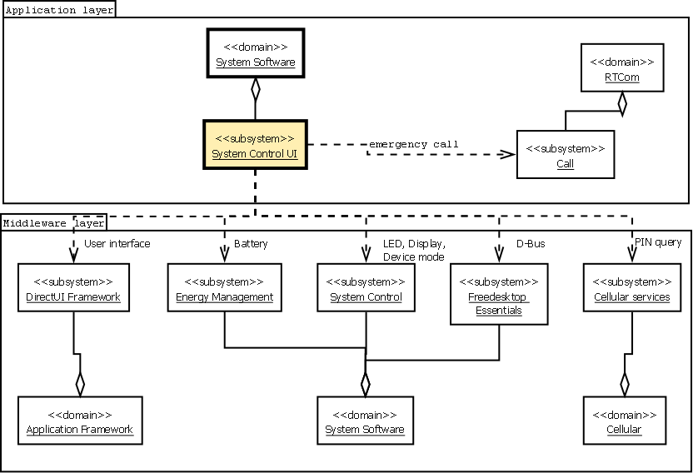
Figure 1 SysUI layers, domains, subsystems and depencies.

Software

Interfaces provided

Interface name | Interface type | Description
[? Using naming convention link to package name ?] | [? API, D-Bus, UI... ?] | [? Short description about the interface.?]

Table 1: Interfaces provided

Interfaces required

Subsystem | Interface name | Description
[? Providing Subsystem ?] | [? Using naming convention link to package name ?] | [? A reference, a short description of the interface, or the rational of using the interface. ?]
Call | libcallui-dev | Provides interface to make an emergency call.
DirectUI Framework | libdui-dev | The user interface libraries
DirectUI Framework | Notifications Framework | Provides non-interactive notifications rendering.  Provides missed events API for calls, messages and chats.
Energy Management | Battery | Provides changes on charging and battery levels.
Energy Management | Power Save Mode | Provides API to adjust power save mode settings.
System Control | libqmsystem-qt | Provides API for setting and reading, listening the states of  LED, Display mode, Device mode, Offline status, System, Orientation and System.
Freedesktop  Essentials | dbus | D-Bus IPC mechanism, even most of the protocols are wrapped with Qutified API.
Cellular Services | libcellular-qt | Provides SIM interface and emergency numbers.
Table 2: Interfaces used

Structural View
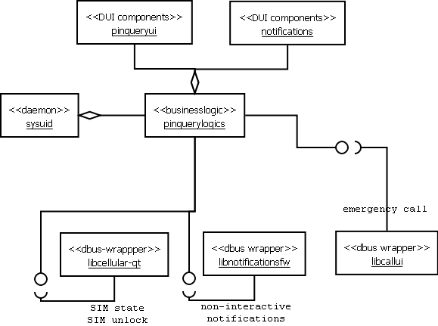
Figure 2 Structural view of PIN query.

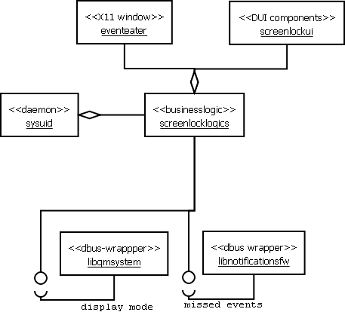
Figure 3 Structural view of screen lock.

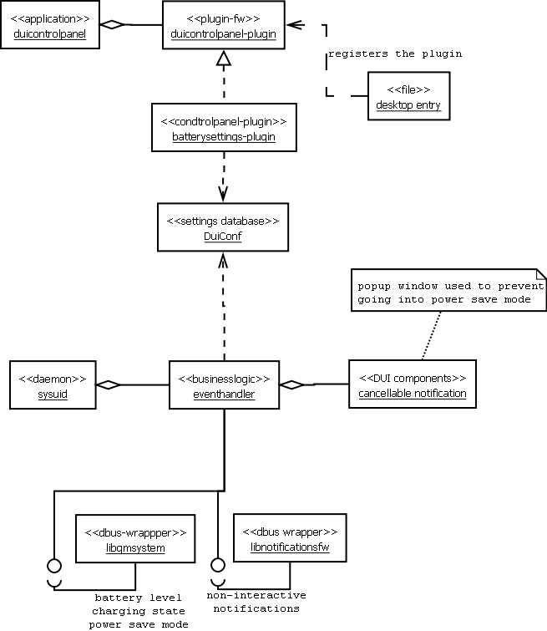

Behavioral View [? mandatory at X2-X4 ?]
SysUI daemon is started by upstart initscript when Direct UI framework and cellular daemon are ready.
On acting dead mode, only charging indication is provided. Otherwise more services are listened.
Notifications are reported to user interface, such as major changes in battery level, SIM hot-swapping.
A state machine of SIM states is shown in the following figure.
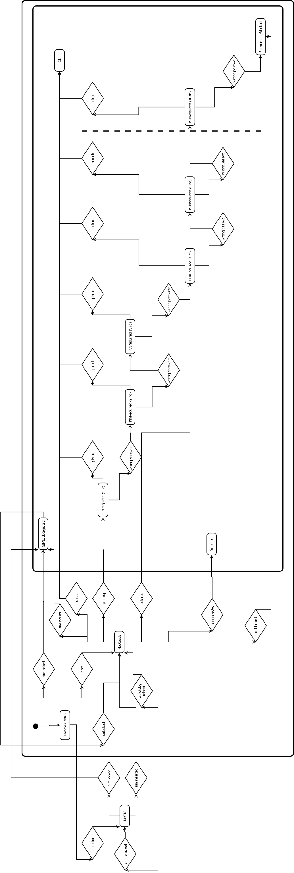
[? This view describes the behavior of the Subsystem. How end user or other Subsystems use this Subsystem? What is a typical usage scenario? Which steps are taken? What are the states in which the Subsystem may be? Which components are taking part in the behavior?
Use UML Behavior and Interaction diagrams: Sequence and/or Communication diagrams, Activity diagrams, State diagrams, Interaction overview diagram, and Timing diagrams to illustrate the functionality where applicable. ?]

Licensing and IPR view
Licensing information of packages is presented in 3.7.

Development
Development of SysUI is made possible in Scratchbox by simulating the middleware D-Bus interfaces. Thus, the D-Bus wrapping libraries connect to simulated services.

User Data, Settings, and Configurability
SysUI does not store user data. Settings are stored in middleware components or in GConf. No configuration is provided.

Packages
Table 3: Packages of SysUI.

Source packages | Certification | Copyright | Code release | Binary packages/License/Dependency type
system-ui | TBD | Nokia-closed | Forbidden | system-ui/Nokia/executed  system-ui-dbg/Nokia/data  system-ui-tests/Nokia/executed

Performance

General Performance Considerations
According to Direct UI requirements and performance targets:
- Shutdown target is 4 seconds. Notes:
  - Illusion of quick shutdown can be achieved if event can continue after display off.
  - Trolltech has demo with ~6 s shutdown. The most critical case is when battery is removed. How much time is left for shutdown then?
  - Shutdown can be done quickly if application FW is done crash-proof.
- Loc/unlock screen target is <100 ms. Notes:
  - SW OK.
  - HW OK, if we have pre-processor for touch. It can run 24/7 since it doesn’t require much power. This also depends on CPU sleep state.
  - When in touch state the device is in sleep mode.
- Open a sub view or a popup target is <100 ms. Notes:
  - OK
- Change UI rotation target is <1 s. Notes:
  - Requires transition effect that may affect the perceived response.
  - OK – supported by HWA
  - App needs to change its layout and therefore the duration is longer. Former 100 ms with HWA is OK, if we have a square aspect ratio.
- Response time to start/end call event target is <100 ms. Notes:
  - Needs to be fast response, if we want to create illusion of best phone also. In reality, the actual call tones start much later depending on NW performance etc.
  - Will have a separate cellular phone engine and depends on its state, SW speed, etc.

Memory
TBD
 | Explanation | Size [kB]
Flash/OneNAND | [? Explanation of key factors affecting to OneNAND consumption. OneNAND is assumed to have unix filesystem semantics. Only system critical files should reside in OneNAND. ?] | [? Estimated impact of the feature to OneNAND size. ?]
Flash/eMMC | [? Explanation of key factors affecting to eMMC consumption. eMMC is assumed to have FAT filesystem semantics. User data should reside in eMMC. ?] | [? Estimated impact of the feature to eMMC size. ?]
RAM/Idle | [? What is the impact of the feature to idle state RAM consumption, what libraries need to be loaded, what other services are required by this feature? ?] | [? Estimated impact of the feature to idle RAM. ?]
RAM/Peak | [? Explanation of key factors affecting to peak RAM consumption. ?] | [? Estimated impact of the feature to peak RAM usage. ?]

Runtime
SysUI has one user interface daemon running all the time. The daemon listens events and does not poll periodically.
SysUI’s impact to boot time must be considered. In current design PIN/PUK query is part of the daemon but it may be a separate application to minimize boot time. As SysUI uses multiple D-Bus wrapping libraries there’s certain slow down on daemon startup as wrapper libraries make connections to servers.

Power Consumption
TBD
[? List here all known or estimated impacts this subsystem has to power consumption. Estimate actual talk/standby time changes in minutes or %. Are there any configuration options or user settings related to this subsystem having impact on talk/standby time? What is the estimated battery life time when this subsystem is running continuously (e.g. MP3 playback time). ?]

Security Impact
Externally supplied data is being processed:
- PIN/PUK query involves handling user’s SIM card’s code(s).
User data or personal identifiable information handling:
- Screen lock shows event information in the view such as what’s the topic of unread email. When device lock is on the data content shall not be shown. Instead the view shows, e.g., five missed calls and three messages received.
Security threats:
- Window management in Harmattan is going to use simple manager. The stacking order of windows is defined with this manager. Now, screen lock is topmost window, dialer is second topmost window and device lock (i.e. data protection) window just below it. However, any application may set it’s window type and popup as a topmost window. Window type can not be security checked. No evaluation of actual security risks with the threat is provided.
- GConf is used as an IPC mechanism from settings to make the SysUI daemon to call certain services. From security point of view any application can read and write these settings with the GConf interface. No evaluation of actual security risks with the threat is provided.

Open items

# | Item | Status | Description
1 | Profiles | Open | Profiles architecture open. For example, shall it provide service interface to applications. What we actually mean when we talk about profiles with Harmattan?
2
3
4

