K-Nearest Neighbour Classification Algorithm (KNN)
KNN classification is a supervised, instance-based learning algorithm that classifies a new data point based on the majority class of its K closest neighbors in the training data.

A data point is likely to belong to the same class as the points closest to it.

Algorithm Steps (Classification)
Step 1: Choose K
- K = number of neighbors used to classify a new point
- Common values: 3, 5, 7
- Odd K avoids tie situations

Step 2: Compute Distance
Calculate distance between the test point and each training point.
Euclidean distance (most common):
$$d=\sqrt{\sum_{i=1}^{n}{(}x_{i}-y_{i})^{2}}$$
Other distance metrics:
- Manhattan
- Minkowski

Step 3: Identify K Nearest Neighbors
- Sort distances
- Select K points with the smallest distances

Step 4: Majority Voting
- Count class labels among neighbors
- The class with maximum votes is assigned
$$\hat{y}=\text{mode}(y_{1},y_{2},...,y_{k})$$

Example
Training data (2 classes):
Class A: ● ● ●
Class B: ▲ ▲
New data point lies closer to:
● ● ▲
For K = 3 → Prediction = Class A

Let try to apply KNN classification on Iris flower to classify it into its different species
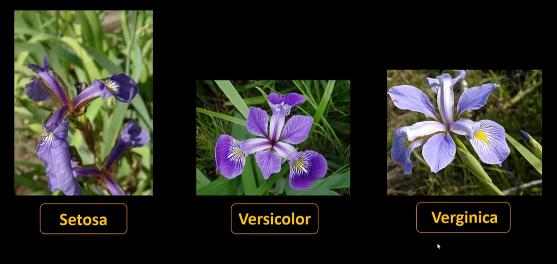
There are 3 known species of iris flower
Here is how they can be represented in the graph
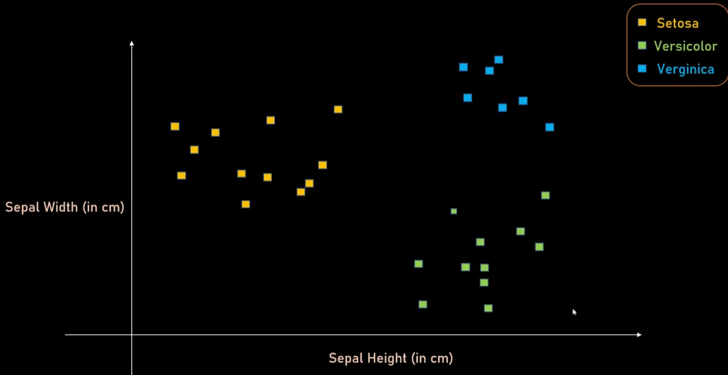

Let consider a new data point (yellow dot) and find its class/ category using KNN

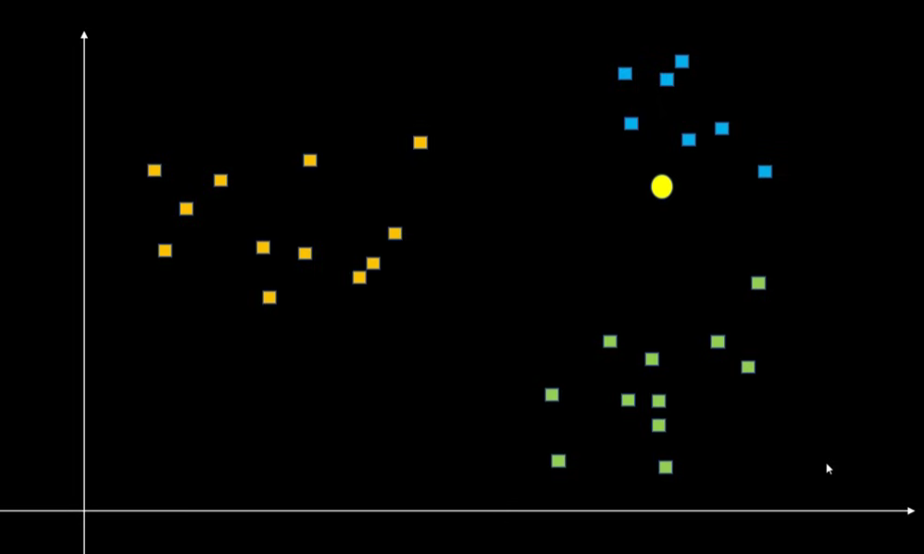
Step – 1 Choose a value for k. let say k=3
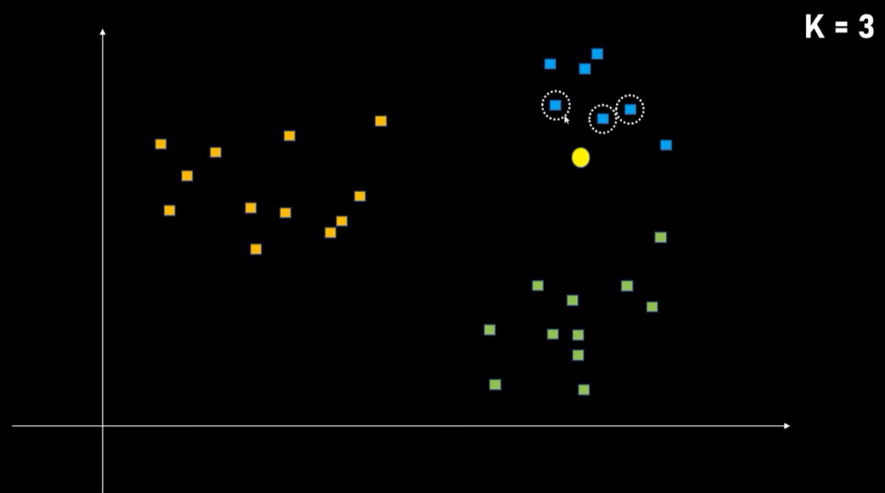
Step -2 find the distance of data point from the new data point using Euclidean distance
Step – 3 Sort the distances in ascending order
Step – 4 Pick the 3 closest data points or distances (because value of k = 3)
Step – 5 Find the class of the points, the new point will likely have the same class or the class of the majority data points

K values needs to be determined correctly. Otherwise it can give incorrect results as explained in the example below
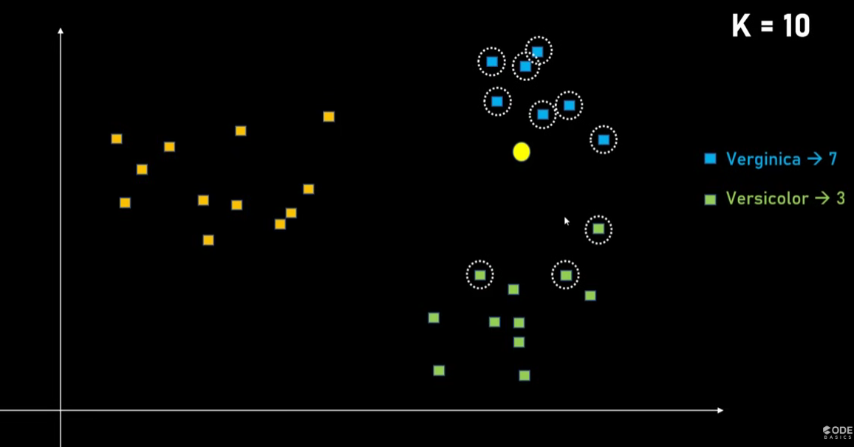
K= 10, new point belongs to Verginica Class
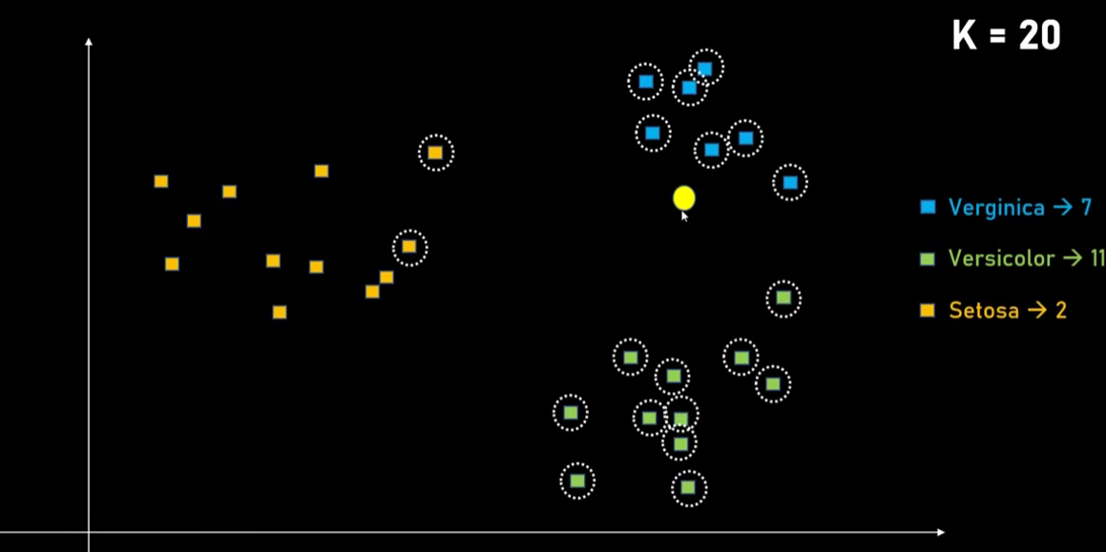
K = 20, since number of samples in verginica was less, majority is taken by c=versicolor and hence gives wrong prediction

How to find the best value of K?

Cross-Validation (Best & Most Used Method)
Step-by-step:
- Choose a range of K values (e.g., 1 to 25)
- Perform k-fold cross-validation
- Measure accuracy (or F1, precision, recall)
- Select K with best validation performance
✔️ This is the most reliable method

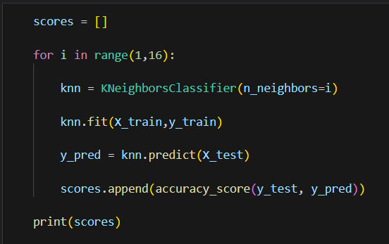

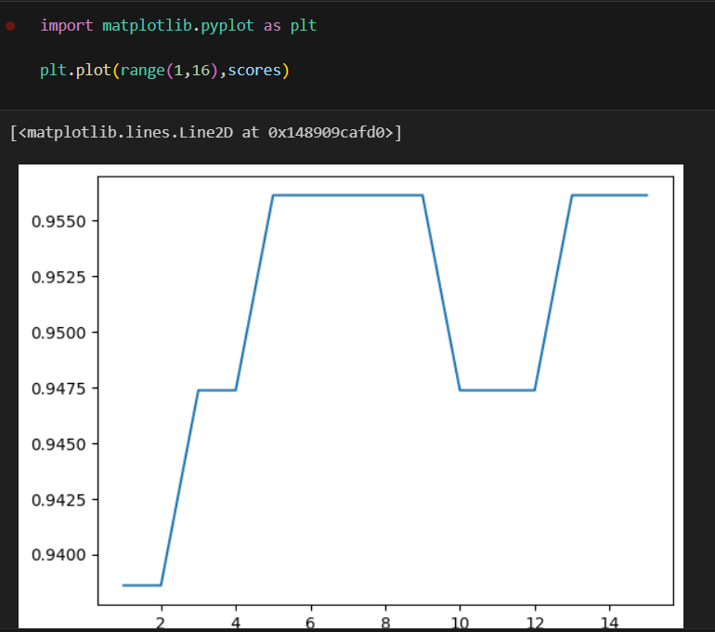

Looking the example, the best value for k can be 5, 6, 7, 8,9

Advantages ✅
- Simple and intuitive
- No assumptions about data distribution
- Effective for non-linear class boundaries
- Works for multi-class classification

Disadvantages ❌
- Computationally expensive
- Sensitive to:
  - Feature scale
  - Noise
  - Irrelevant features
- Requires storing entire dataset

Why Feature Scaling is important in KNN?
Because distance matters:
- StandardScaler
- MinMaxScaler
Without scaling → wrong neighbors chosen ❌

Questions

1. How can you choose the optimal value of K?
A. Randomly
B. Using training error only
C. Using cross-validation
D. Using maximum possible value
Answer: C. Using cross-validation

2. What does K represent in KNN?
A. Number of features
B. Number of clusters
C. Number of nearest neighbors
D. Number of iterations

3. Which distance metric is most commonly used in KNN?
A. Manhattan Distance
B. Euclidean Distance
C. Hamming Distance
D. Cosine Similarity

4. What happens when K is set too small (e.g., K = 1)?
A. Underfitting
B. Overfitting
C. No effect
D. Slower computation

5. How does KNN perform classification?
A. By averaging output values
B. By majority voting among neighbors
C. By minimizing loss function
D. By building decision trees

6. Which preprocessing step is most important for KNN?
A. One-hot encoding
B. Feature scaling (normalization/standardization)
C. Feature selection
D. PCA
Answer: B. Feature scaling (normalization/standardization)

7. Why is feature scaling important in KNN?
A. To reduce overfitting
B. To make training faster
C. To prevent features with larger scales from dominating distance
D. To reduce dimensionality
Answer: C. To prevent features with larger scales from dominating distance

