Support Vector Machine Algorithm (SVM)
SVM is a supervised machine learning algorithm used for classification (and regression).
It is especially powerful for binary classification and works well with high-dimensional data.

Find the best boundary (hyperplane) that separates classes with maximum margin.
Before learning SVM, we need to understand few terms
Hyperplane: A line (2D), plane (3D), or higher-dimensional plane separating classes
Margin: Distance between the hyperplane and the nearest points from each class
Support vectors: Data points that lie closest to the hyperplane; they define the margin

2️⃣ How It Works (Step by Step)
Step 1: Find Hyperplane
For linearly separable data, the hyperplane equation is:
$$w⋅x+b=0$$
Where:
- $w$= weight vector (orientation)
- $b$= bias (position)
- $x$= feature vector

Step 2: Maximize Margin
- The margin is the distance from hyperplane to nearest points:
$$\text{Margin}=\frac{2}{∣∣w∣∣}$$
- SVM finds $w$and $b$to maximize this margin.

Step 3: Handle Non-Linearly Separable Data (Kernel Trick discussed later)
- Some datasets are not linearly separable
- Introduce kernel trick to map data to higher dimensions
Common kernels:
- Linear
- Polynomial
- RBF / Gaussian
- Sigmoid

Let’s consider the same example of Iris flower that we discussed in KNN. In this example lets consider only 2 species
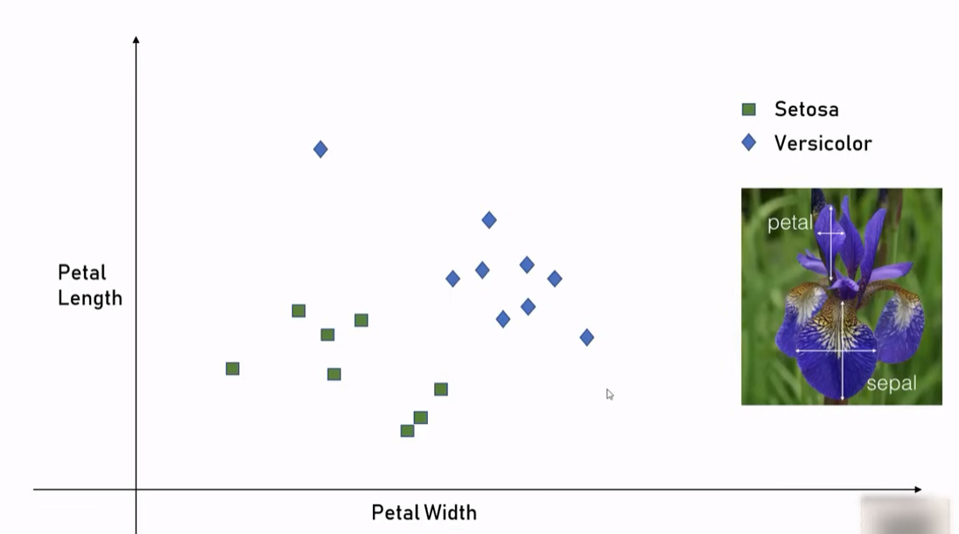

There can be multiple hyperplanes diving the region into 2 categories. How we can choose the optimal hyperplane or our decision boundary?
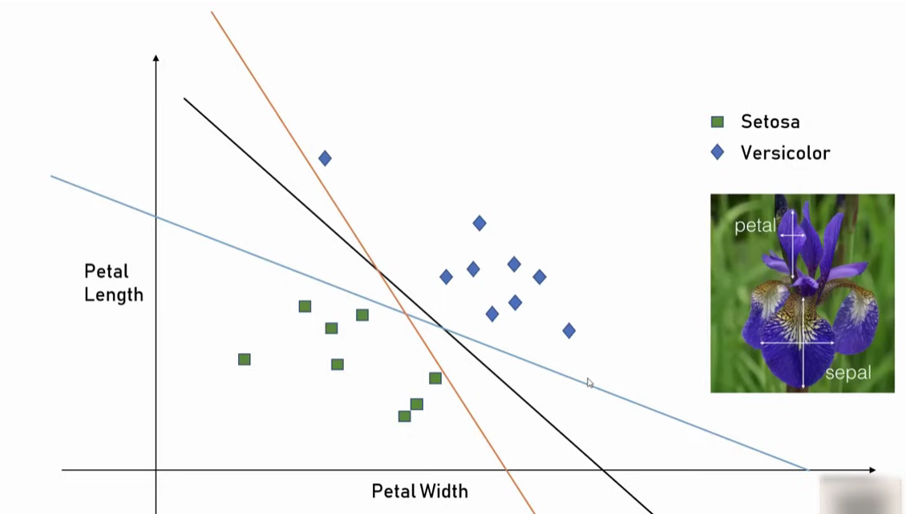
To get the optimal hyperplane, we need to get the maximum margin distance. Lets consider 2 hyperplanes into consideration for now.

Each hyperplane will calculate the distance (Hyperplane to nearest data point distance on both sides) called marginal distance. Whichever hyperplane will have the highest distance that hyperplane is considered as the optimal hyperplane
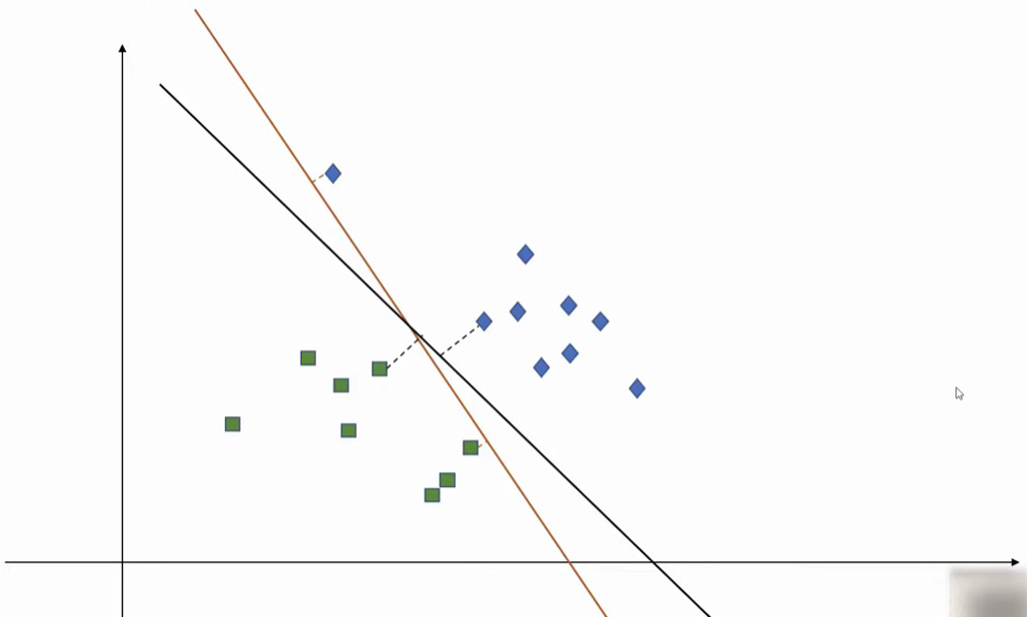

The distance between nearest datapoints is called margin distance
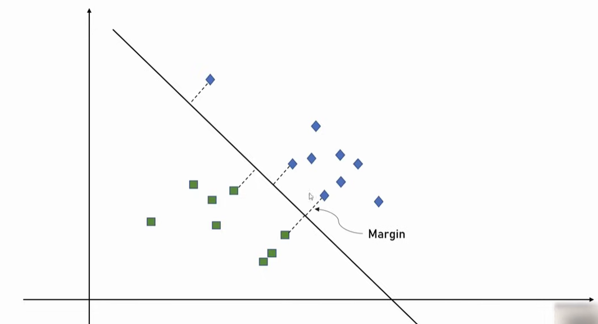

And the nearest datapoints are called support vectors
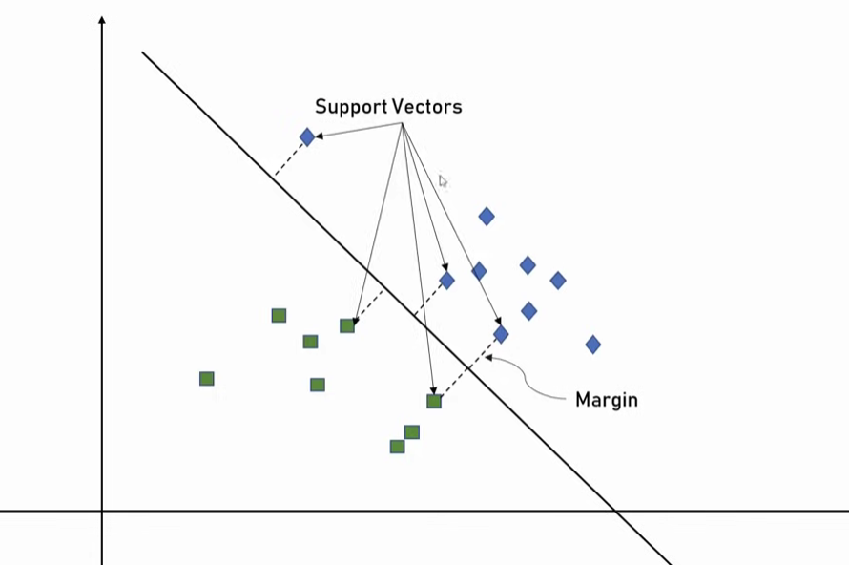

This is how the plane looks in the higher dimesions
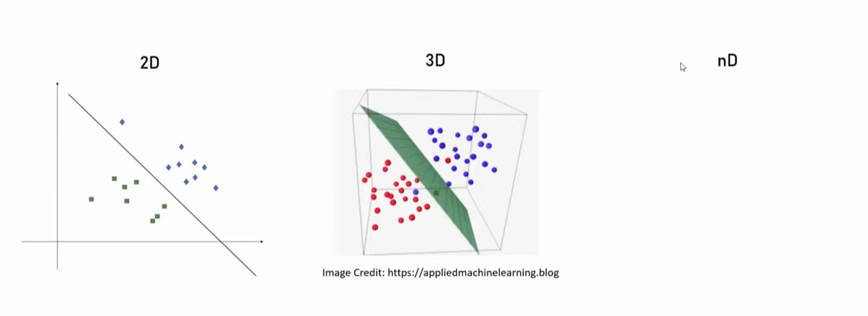
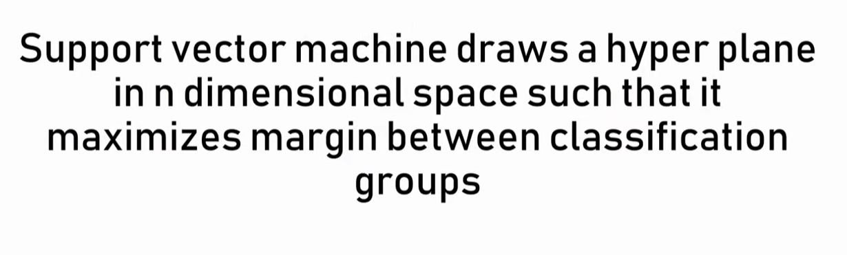

Step 4: Soft Margin (Handle Noise)
- Introduce C parameter to allow some misclassification
- Tradeoff between margin width and classification error
$$min⁡\frac{1}{2}∣∣w∣∣^{2}+C∑ξ_{i}$$
Where $ξ_{i}$= slack variables (penalty for misclassification)

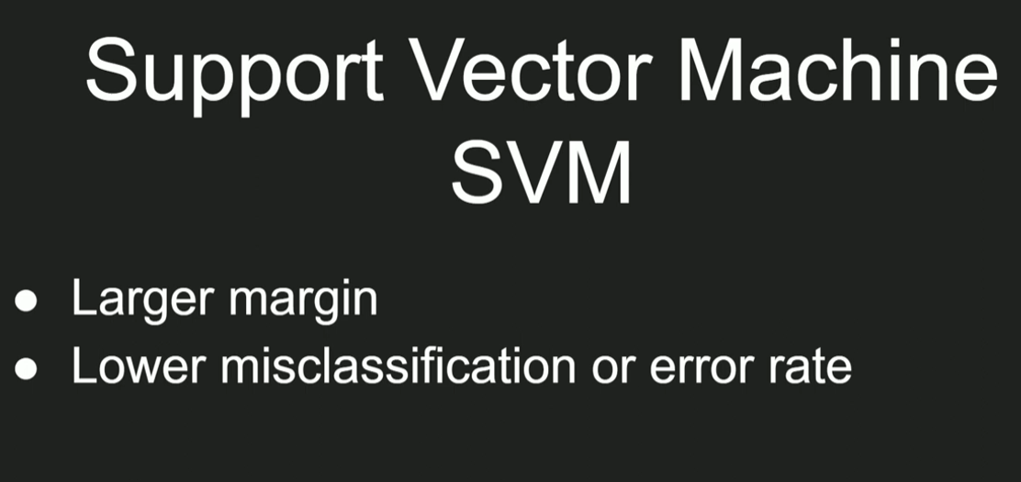

SVM looks at 2 things – larger margin and low misclassification rate

4️⃣ Advantages ✅
- Effective in high-dimensional spaces
- Works well with clear margin of separation
- Can handle non-linear data with kernels
- Robust to overfitting (especially with proper C)

5️⃣ Disadvantages ❌
- Computationally expensive on large datasets
- Sensitive to choice of kernel, C, and gamma
- Not very effective on noisy datasets with overlapping classes
- Hard to interpret in high dimensions

6️⃣ Hyperparameters
Parameter | Role
C | Regularization (soft margin)
Kernel | Maps data to higher dimension
Gamma | Controls RBF kernel width

Let’s discuss about these parameters in depth

What is Kernel Trick?
The Kernel Trick is a technique in SVM that allows us to implicitly map data to a higher-dimensional space without explicitly computing the coordinates in that space. This makes it possible to handle non-linearly separable data efficiently.

1️⃣ Why We Need It
- Problem: Some datasets cannot be separated with a straight line (linear hyperplane) in the original feature space.
Examples of non-linear data
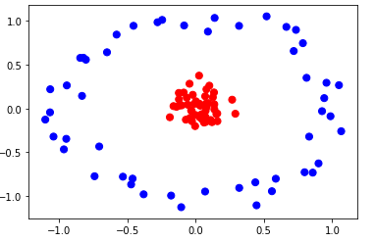

How this works?
Imagine you have a 2D sheet with dots in a circle. You can’t draw a straight line to separate them.
Now imagine lifting the center of the sheet into a 3D hill. Suddenly a flat plane can separate the dots easily.
The kernel trick is like a magic tool that lets you draw that plane without actually building the hill.

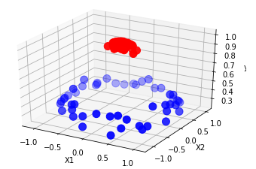

Regularization – c
What is C?
C controls the trade-off between:
- Maximizing the margin
- Minimizing classification errors
In simple words:
C decides how much the model cares about misclassifying training points.

Effect of C
🔹 Small C (Strong Regularization)
- Allows more misclassifications
- Larger margin
- Simpler decision boundary
- Better generalization
📌 Risk: Underfitting

🔹 Large C (Weak Regularization)
- Tries to classify all training points correctly
- Smaller margin
- Complex boundary
📌 Risk: Overfitting

Visualization Intuition
Small C → wide margin → ignores some points
Large C → tight margin → fits every point

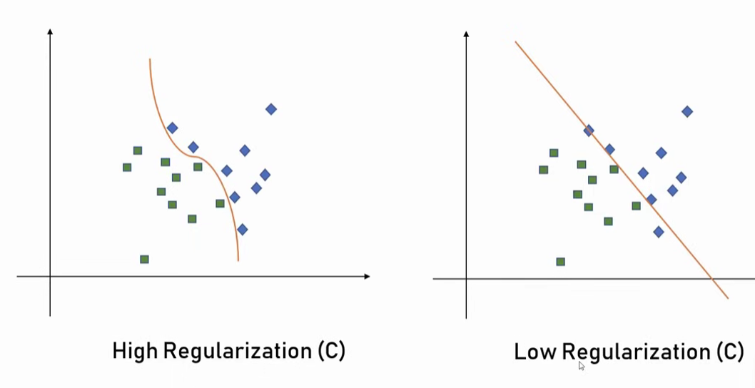

Gamma

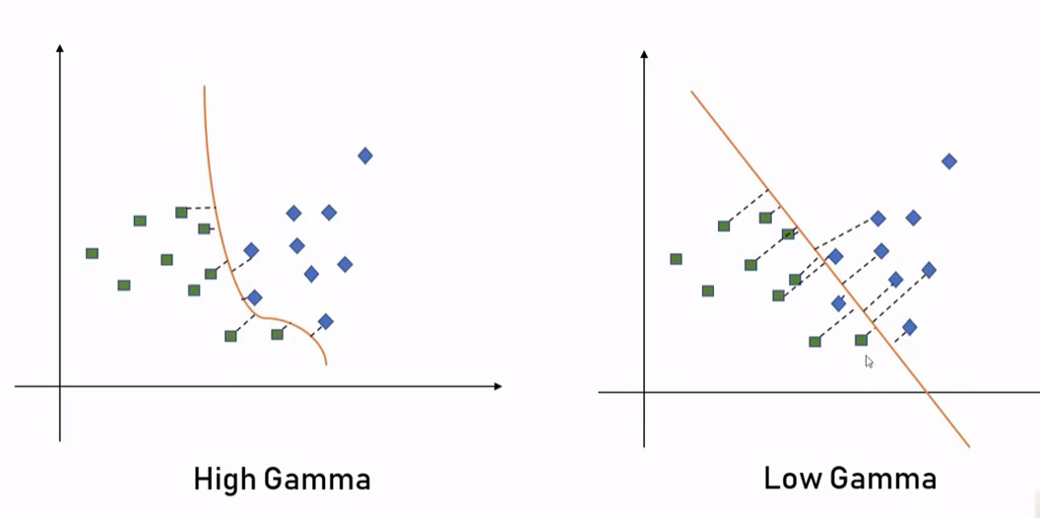

What is Gamma?
Gamma controls how far the influence of a single training point reaches.
Used mainly with:
- RBF (Gaussian) kernel
- Polynomial kernel

Effect of Gamma
🔹 Small Gamma
- Each point has wide influence
- Decision boundary is smooth
- Model considers faraway points
📌 Risk: Underfitting
🔹 Large Gamma
- Each point has narrow influence
- Decision boundary becomes very complex
- Model focuses only on nearby points
📌 Risk: Overfitting
Intuitive Analogy 🎯
- Small gamma → wide flashlight
- Large gamma → laser pointer

