Clustering
Unsupervised Learning
Means Cluster the points having common attributes/ features

Clustering is an unsupervised machine learning technique that groups similar data points into clusters based on their characteristics, without needing pre-labeled data.

The goal is to ensure that data points within the same cluster are more similar to each other than to those in other clusters, allowing the discovery of natural patterns in complex datasets. This is achieved by finding natural groupings in data

- Unsupervised learning: Clustering algorithms work on unlabeled data, meaning they find patterns without being told what to look for beforehand.
- Similarity and distance: Algorithms group data points based on similarity, often measured by distance metrics like Euclidean distance or cosine similarity.
- Grouping: The process assigns each data point to a cluster, creating groups where points within a group are more alike than points in other groups.
- Identifying patterns: By analyzing the resulting clusters, you can understand the underlying structure of the data.

Applications
- Customer segmentation: Grouping customers into segments based on their purchasing habits to tailor marketing strategies.
- Healthcare: Grouping patients with similar symptoms for better diagnosis or treatment plans.
- Anomaly detection: Identifying outliers or unusual data points that don't fit into any cluster, which could indicate errors or fraudulent activity.
- Recommendation systems: Grouping users with similar tastes to recommend content they might like.
- Document analysis: Grouping similar documents together to organize large collections of text.
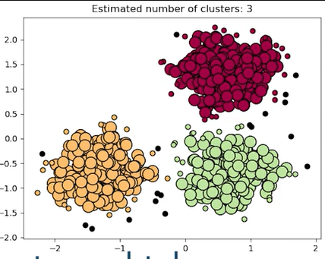

1. What is the main goal of clustering?
A. Predict a target variable
B. Group similar data points together
C. Reduce dimensionality
D. Improve model accuracy

2. Clustering is an example of:
A. Supervised learning
B. Reinforcement learning
C. Unsupervised learning
D. Semi-supervised learning

3. Clustering groups data points based on:
A. Labels
B. Similarity or distance
C. Time sequence
D. Random assignment

5. In clustering, the absence of labels means that:
A. The algorithm cannot train
B. The model predicts numeric output
C. Similarity must be discovered automatically
D. Data cannot be visualized

6. A cluster can best be described as:
A. A group of identical points
B. A group of unrelated points
C. A group of points that are more similar to each other than to others
D. A random subset of the dataset

10. Which type of data can clustering be applied to?
A. Only numeric data
B. Only text data
C. Only labeled datasets
D. Any data where similarity can be defined

