K-Means Clustering
It’s a clustering algorithm and unsupervised learning technique
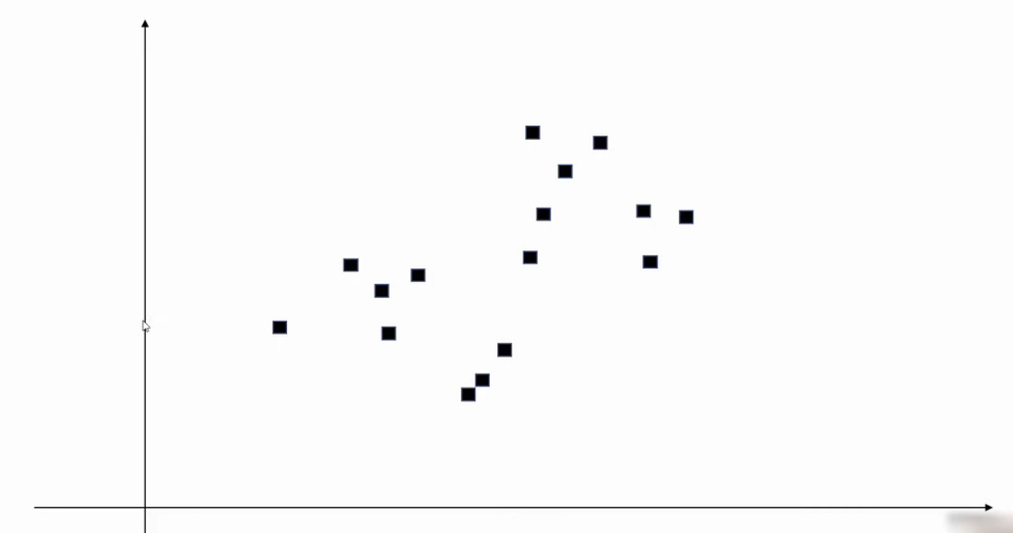

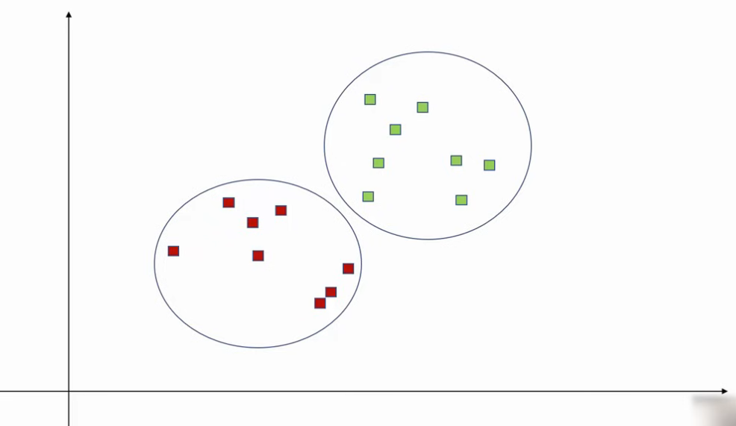

K Means tries to find these clusters
Let’s say k = 2, we take 2 datapoints (centroids)

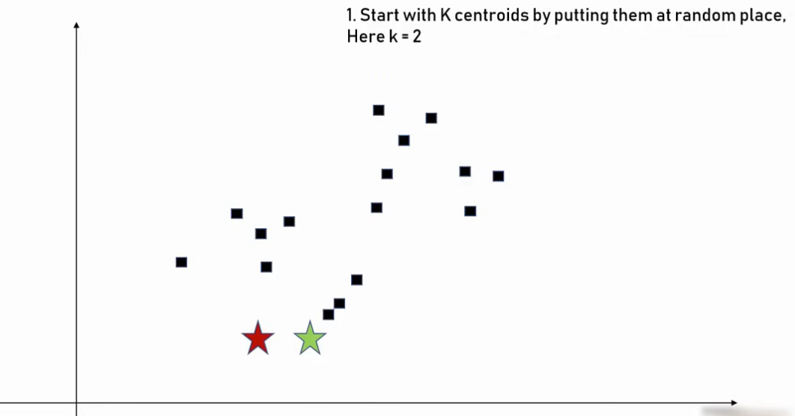

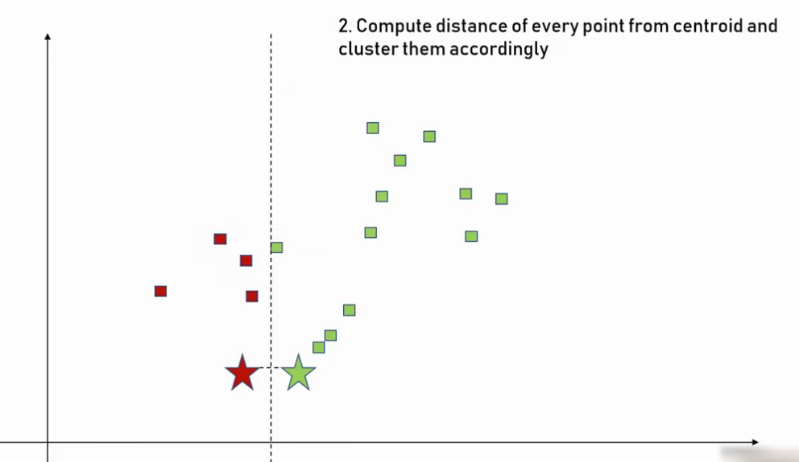

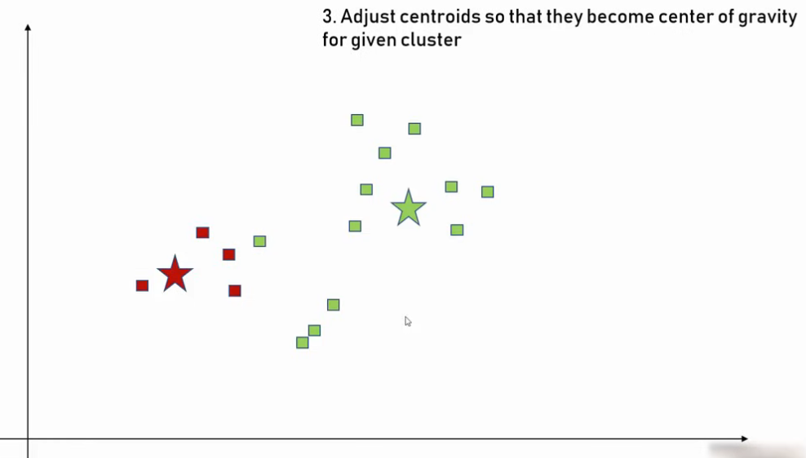

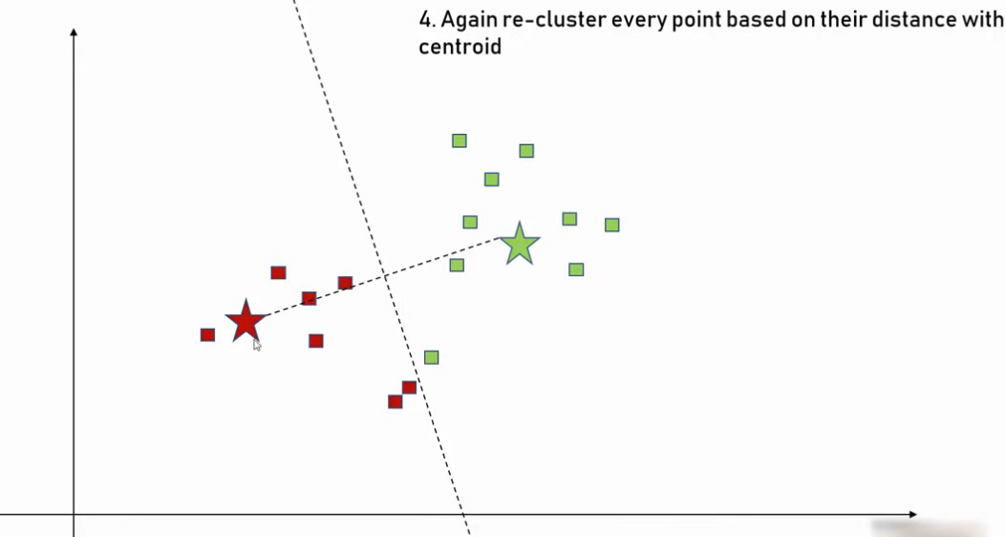

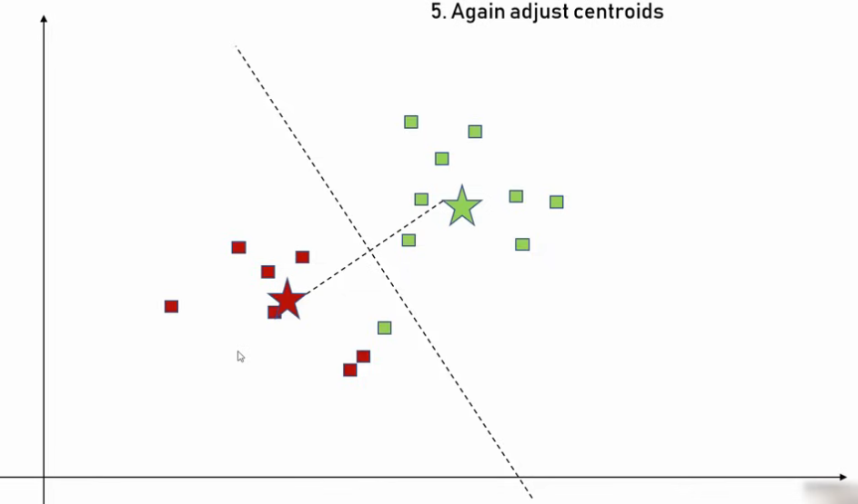

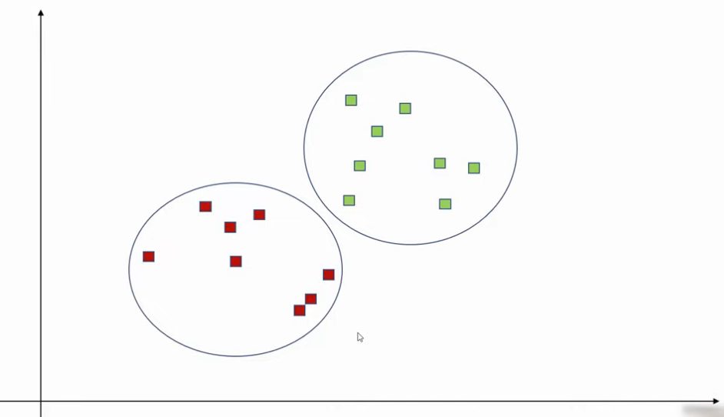

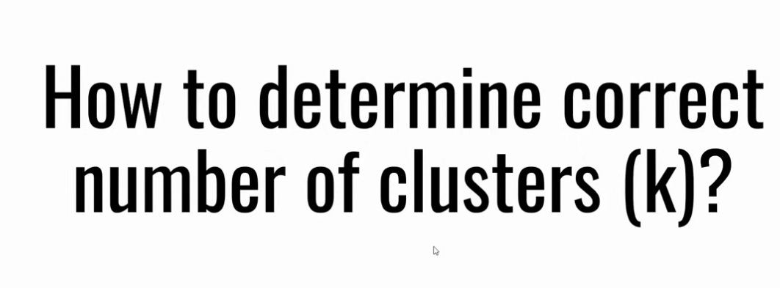

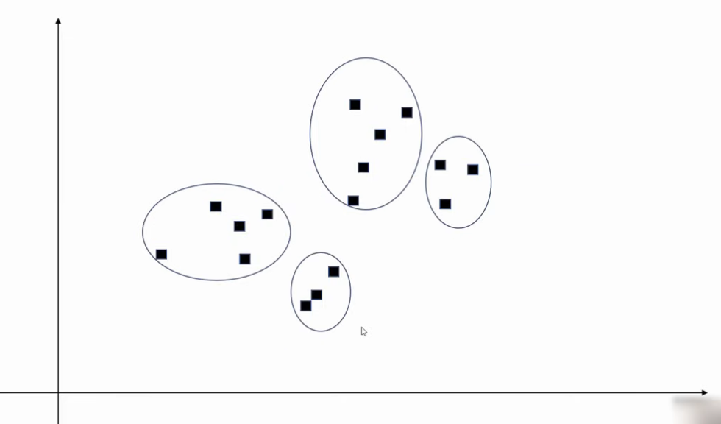
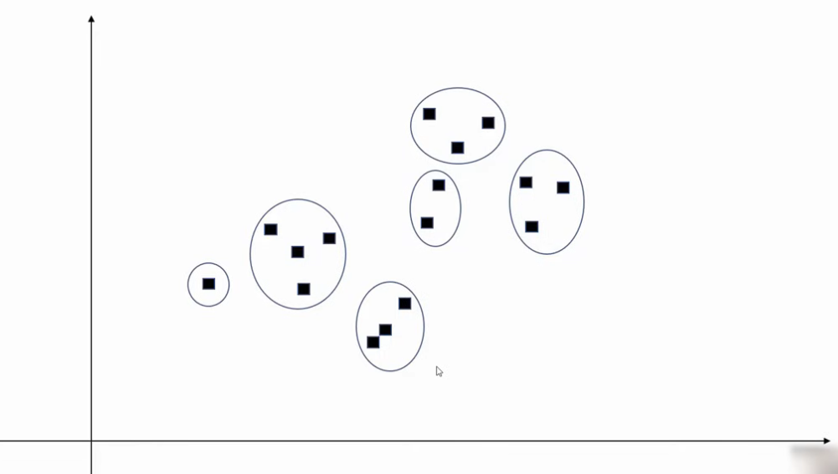

Elbow Method/ Elbow Technique

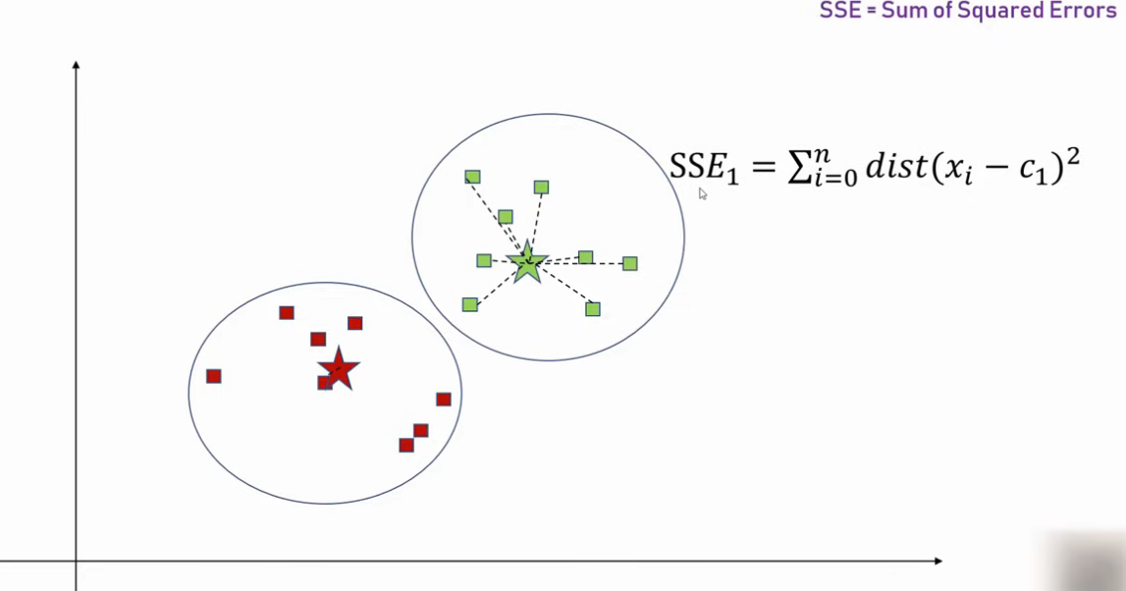

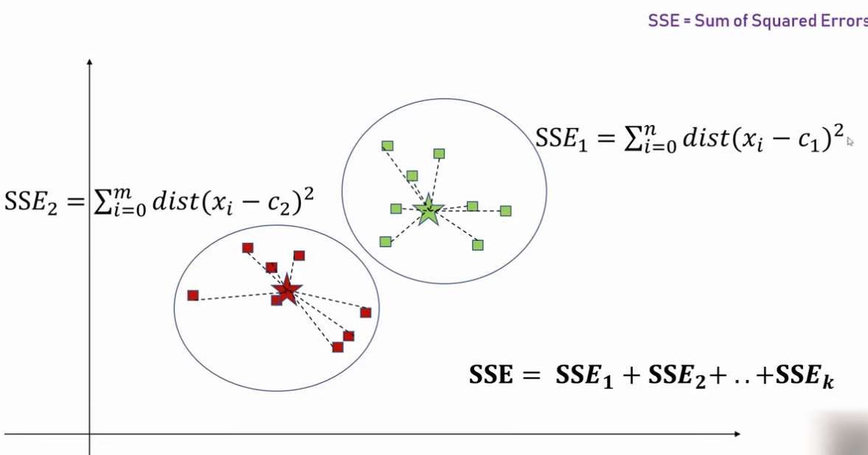

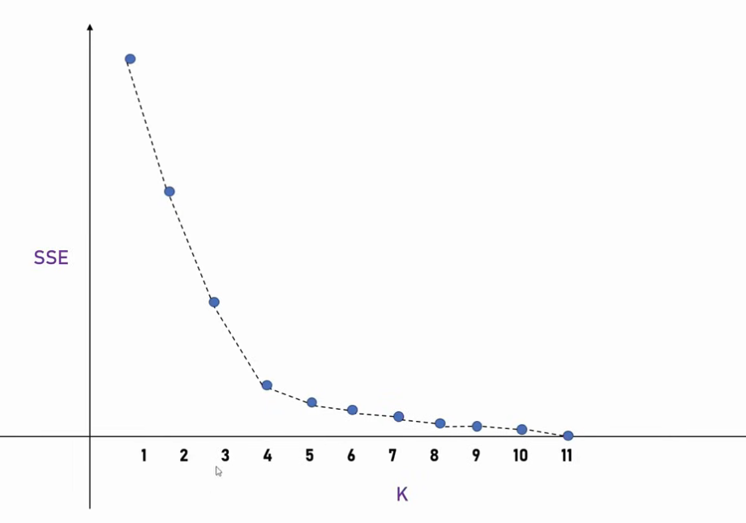

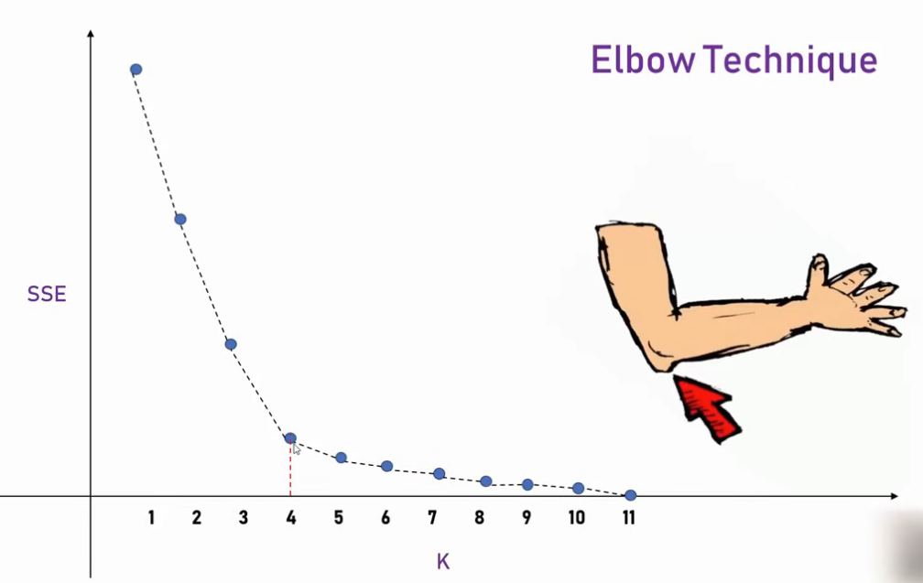

Quiz Questions
1. What is the main goal of the K-Means algorithm?
A. Maximize inter-cluster variance
B. Minimize within-cluster sum of squares
C. Maximize number of clusters
D. Minimize Euclidean distance between all points

3. Which distance metric is most commonly used in K-Means?
A. Manhattan distance
B. Cosine similarity
C. Jaccard distance
D. Euclidean distance

4. K-Means works best when clusters are:
A. Non-linear and irregular
B. Overlapping and elongated
C. Spherical and well separated
D. High-dimensional and categorical

6. The “K” in K-Means refers to:
A. Number of iterations
B. Number of clusters
C. Kernel used
D. Number of features

7. Which method is commonly used to find the optimal number of clusters K?
A. Confusion matrix
B. ROC curve
C. Elbow method
D. PCA

9. When does the K-Means algorithm stop iterating?
A. When accuracy reaches 100%
B. When centroids stop changing significantly
C. After exactly 10 iterations
D. Only when new data is added

