Random Forest
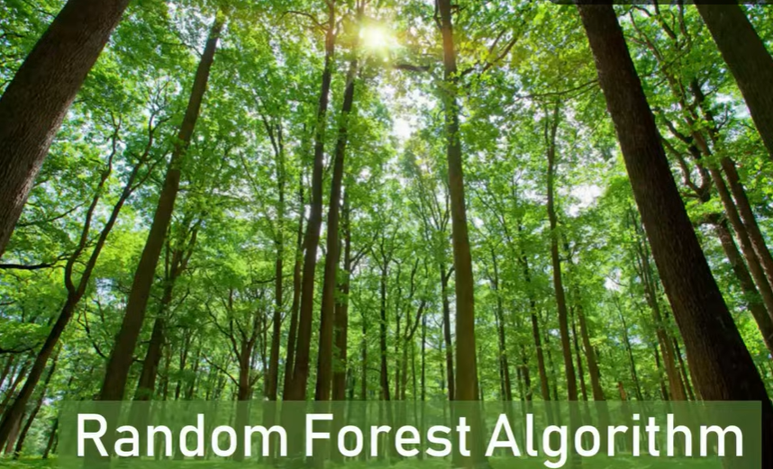
Random Forest is an ensemble learning method that builds multiple decision trees and combines their predictions to improve accuracy and robustness.

In simple terms: “Many trees vote together to make a better decision than a single tree.”

Why Random Forest?
- Decision trees are easy to interpret but prone to overfitting
- Random Forest reduces overfitting by averaging multiple trees
- Provides better generalization on unseen data

Ensemble Learning Technique – Ensemble means group (therefore called forest)

How It Works (Step-by-Step)
Step 1: Create Multiple Decision Trees
- Randomly select subsets of the dataset (Bootstrap sampling) → called bagging
- Randomly select subsets of features at each split
- Train a decision tree on each subset

Step 2: Make Predictions
- For classification, each tree predicts a class
- Random Forest uses majority voting to decide final class
Example:
Tree1 → Yes
Tree2 → No
Tree3 → Yes
Final Prediction → Yes (majority vote)

Step 3: Combine Results
- This averaging reduces variance compared to a single decision tree
- Makes model more stable and robust

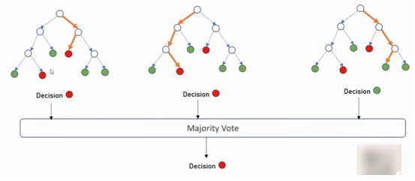

Bagging – Bootstrapped Aggregation
- Bagging (Bootstrap Aggregating): This is an ensemble method that creates multiple independent models (e.g., decision trees) by training each on a different random sample of the original data, selected with replacement. The final prediction is an average of all the individual model predictions.

Idea: Train multiple models independently on different random subsets of the data and average their predictions (for regression) or majority vote (for classification).

Let’s say we get 5 questions
5

1,4,5
2,3,4,1
1, 2,5

Parallel processing of questions

How Bagging Works
- Randomly sample with replacement from the training set → creates bootstrap datasets
- Train a separate model on each bootstrap sample (commonly decision trees)
- Combine predictions:
  - Classification → majority vote
  - Regression → average prediction

Boosting
Sequential Training:
Unlike other ensemble methods like bagging (e.g., Random Forests) where models are trained in parallel, boosting trains models one after another.
It train models sequentially, where each new model tries to correct errors made by previous models.

How Boosting Works
- Train first weak learner on the full dataset
- Identify misclassified samples
- Increase the weight/importance of misclassified samples
- Train next learner focusing on errors
- Repeat for N models
- Combine predictions weighted by each model’s performance

5
Let’s say we get 5 questions
Done
4,5
4,5
3
3,4,5
3,4,5
1,2
5

1, 2 answered correctly

3 answered correctly

Questions

1. What criterion is commonly used to split nodes in a classification decision tree?
A. Mean Squared Error
B. Gini Impurity
C. R-squared
D. Log-likelihood

2. A decision tree will continue splitting until:
A. All features are used
B. All samples belong to the same class or stopping criteria is met
C. Entropy is 0
D. All of the above

5. In Random Forest, each tree is trained on:
A. The whole dataset
B. A bootstrap sample of the dataset
C. Only outliers
D. Only categorical features

6. In Random Forest, feature selection at each split is done by:
A. Using all features
B. Using a random subset of features
C. Choosing features with least correlation
D. Using only categorical features

7. What happens to overfitting when adding more trees in a Random Forest?
A. It increases
B. It decreases
C. It stays the same
D. It becomes unpredictable

9. The final prediction of a Random Forest classifier is based on:
A. Weighted average of tree predictions
B. Majority vote
C. Maximum depth
D. Best-performing tree

B. True or False
2. Random Forest reduces overfitting compared to a single decision tree.
3. Increasing the number of trees in a Random Forest always increases test accuracy.
4. Gini and Entropy always select the same splits.
5. Random Forest uses bagging.
6. A deeper decision tree is more likely to overfit.
7. Random Forest can be used for regression.

