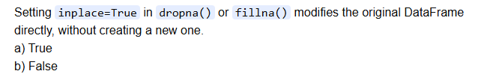

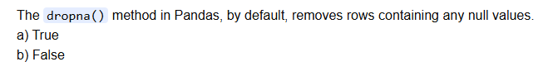

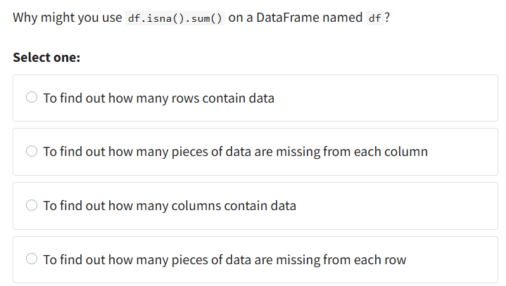

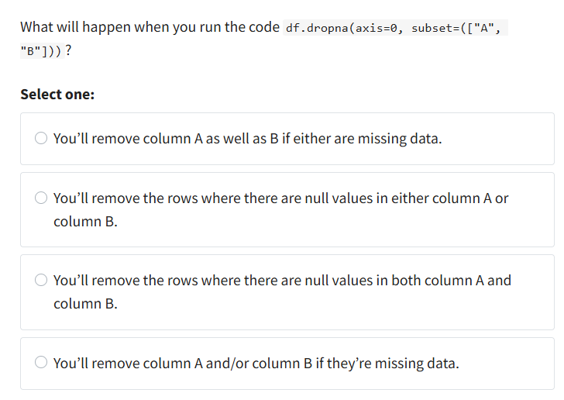

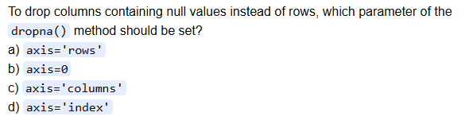

Question 1: Basic Concepts
Which encoding method should you use for converting country names (USA, Canada, India) to numerical values?
A) Label Encoder
B) Ordinal Encoder
C) One-Hot Encoder
D) Both A and C are correct

Question 2: Ordinal vs Label Encoding
You have education levels: ['High School', 'Bachelor', 'Master', 'PhD']. What's the main difference between Label Encoder and Ordinal Encoder for this data?
A) Label Encoder is faster
B) Ordinal Encoder preserves the natural order/hierarchy
C) Label Encoder uses less memory
D) No difference - both work the same

Question 3: One-Hot Encoding
If you have 5 categories (A, B, C, D, E) and use One-Hot Encoding with drop='first', how many columns will be created?
A) 5 columns
B) 4 columns
C) 6 columns
D) 3 columns

Question 4: Multicollinearity
Why do we use drop='first' in One-Hot Encoding?
A) To save memory
B) To avoid multicollinearity
C) To make processing faster
D) To reduce the number of features

Question 5: Code Analysis
What does ohe.categories_[0][1:] return when categories are ['Blue', 'Green', 'Red']?
A) ['Blue', 'Green', 'Red']
B) ['Green', 'Red']
C) ['Blue']
D) ['Red']

Question 6: Practical Application
You're encoding a 'Size' column with values ['Small', 'Medium', 'Large', 'Extra Large']. Which encoder preserves the meaningful order?
A) LabelEncoder()
B) OneHotEncoder()
C) OrdinalEncoder(categories=[['Small', 'Medium', 'Large', 'Extra Large']])
D) get_dummies()

Question 8: Error Analysis
This code gives an warning. What's wrong?
- df['color'].fillna(method='ffill', inplace=True)

A) Should use drop=True
B) Method parameter is deprecated, use .ffill() instead
C) Missing axis=1
D) Should use sparse_output=False

Question 9: Real-world Scenario
You have a dataset with columns: 'Gender' (Male/Female), 'Color' (Red/Blue/Green), 'Rating' (1-5). Which encoding strategy is most appropriate?
A) Label encode everything
B) One-hot encode Gender and Color, ordinal encode Rating
C) One-hot encode everything
D) Ordinal encode everything

