K-Nearest Neighbour Classification Algorithm (KNN)
KNN classification is a supervised, instance-based learning algorithm that classifies a new data point based on the majority class of its K closest neighbors in the training data.

A data point is likely to belong to the same class as the points closest to it.

Algorithm Steps (Classification)
Step 1: Choose K
- K = number of neighbors used to classify a new point
- Common values: 3, 5, 7
- Odd K avoids tie situations

Step 2: Compute Distance
Calculate distance between the test point and each training point.
Euclidean distance (most common):
$$d=\sqrt{\sum_{i=1}^{n}{(}x_{i}-y_{i})^{2}}$$
Other distance metrics:
- Manhattan
- Minkowski

Step 3: Identify K Nearest Neighbors
- Sort distances
- Select K points with the smallest distances

Step 4: Majority Voting
- Count class labels among neighbors
- The class with maximum votes is assigned
$$\hat{y}=\text{mode}(y_{1},y_{2},...,y_{k})$$

Example
Training data (2 classes):
Class A: ● ● ●
Class B: ▲ ▲
New data point lies closer to:
● ● ▲
For K = 3 → Prediction = Class A

Let try to apply KNN classification on Iris flower to classify it into its different species
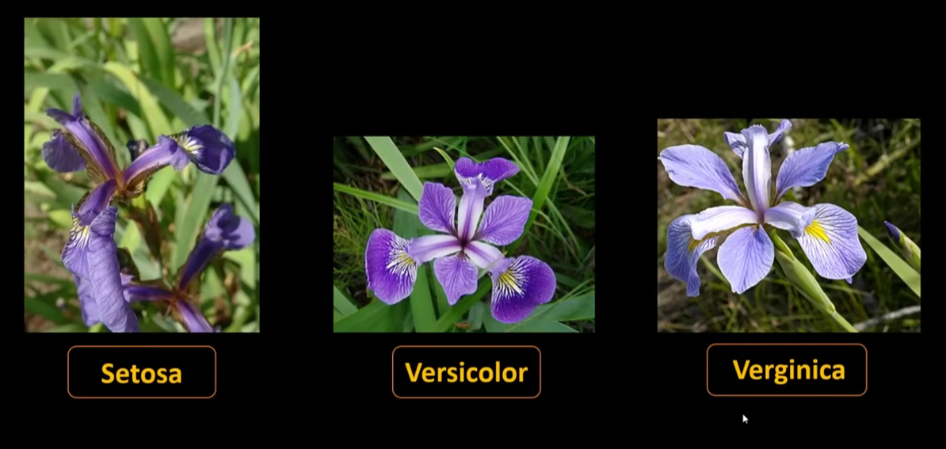
There are 3 known species of iris flower
Here is how they can be represented in the graph
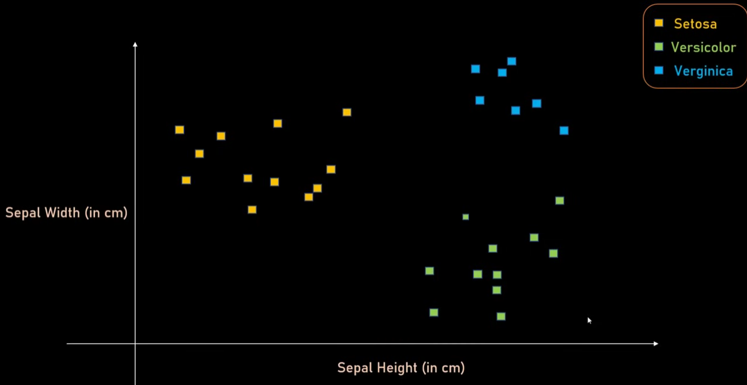

Let consider a new data point (yellow dot) and find its class/ category using KNN

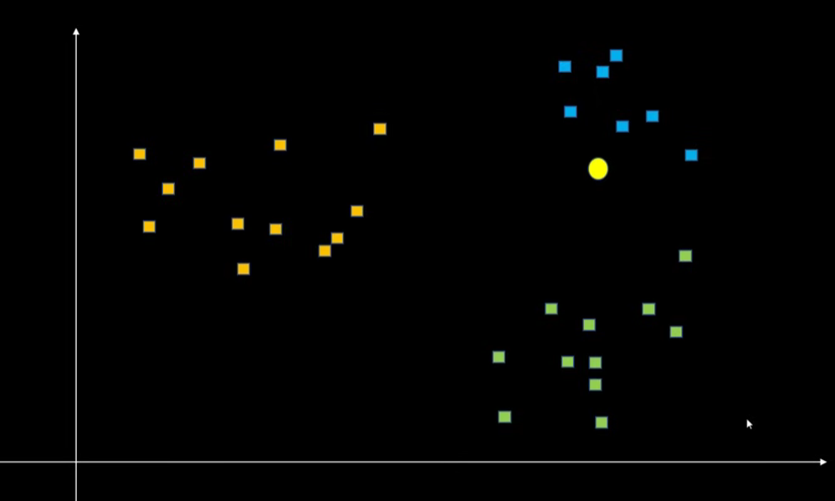
Step – 1 Choose a value for k. let say k=3
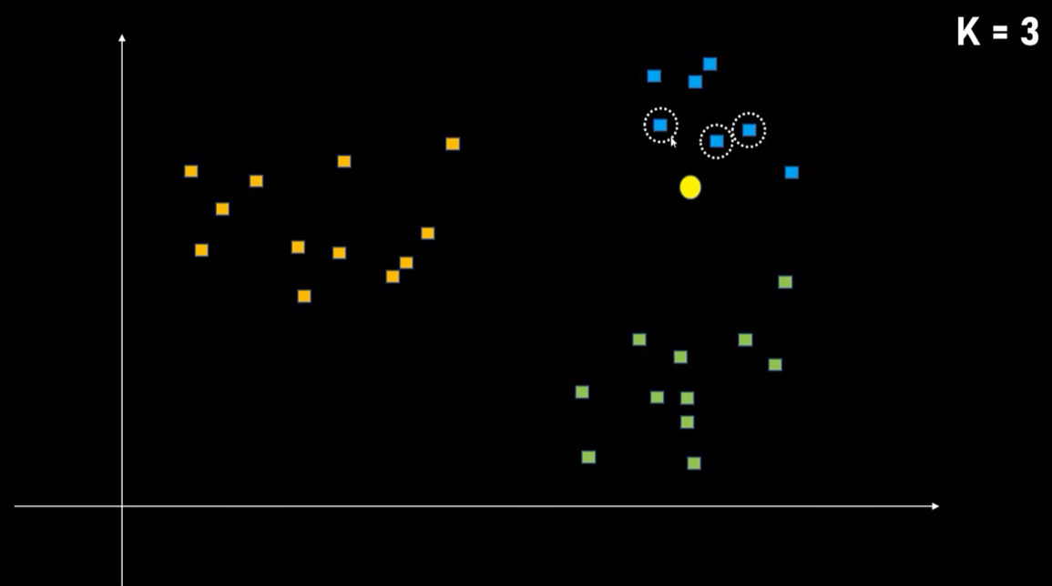
Step -2 find the distance of data point from the new data point using Euclidean distance
Step – 3 Sort the distances in ascending order
Step – 4 Pick the 3 closest data points or distances (because value of k = 3)
Step – 5 Find the class of the points, the new point will likely have the same class or the class of the majority data points

K values needs to be determined correctly. Otherwise it can give incorrect results as explained in the example below
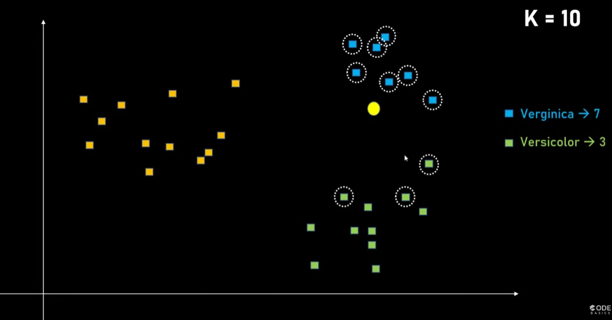
K= 10, new point belongs to Verginica Class
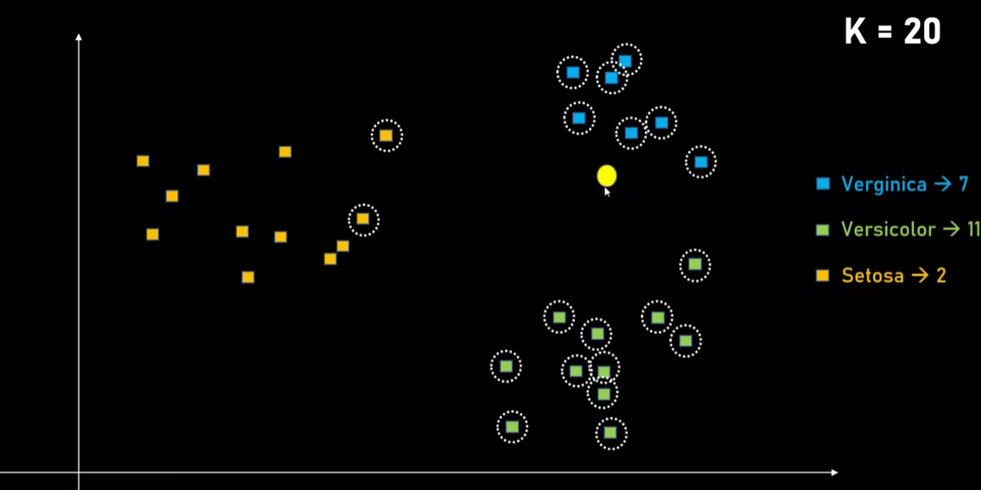
K = 20, since number of samples in verginica was less, majority is taken by c=versicolor and hence gives wrong prediction

How to find the best value of K?

Cross-Validation (Best & Most Used Method)
Step-by-step:
- Choose a range of K values (e.g., 1 to 25)
- Perform k-fold cross-validation
- Measure accuracy (or F1, precision, recall)
- Select K with best validation performance
✔️ This is the most reliable method

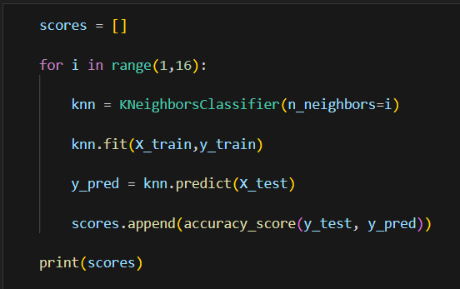

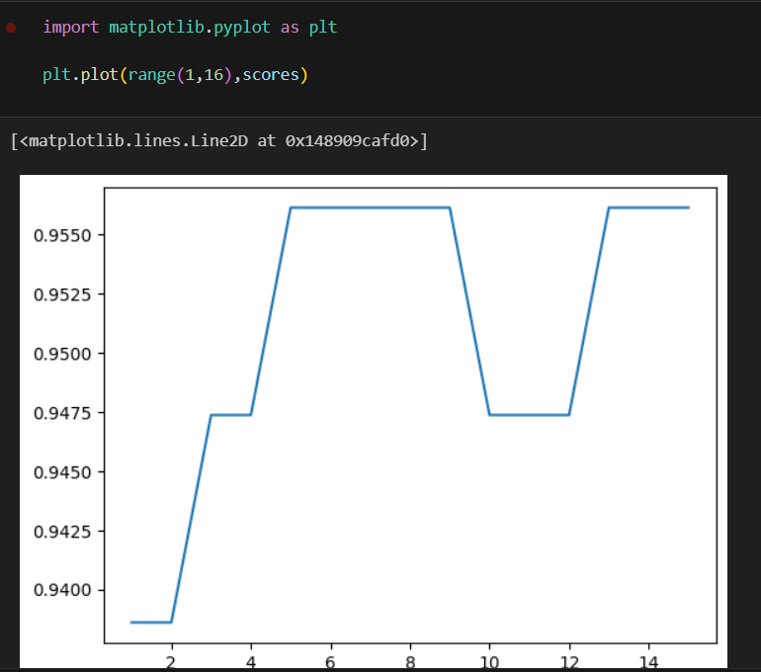

Looking the example, the best value for k can be 5, 6, 7, 8,9

Advantages ✅
- Simple and intuitive
- No assumptions about data distribution
- Effective for non-linear class boundaries
- Works for multi-class classification

Disadvantages ❌
- Computationally expensive
- Sensitive to:
  - Feature scale
  - Noise
  - Irrelevant features
- Requires storing entire dataset

Why Feature Scaling is important in KNN?
Because distance matters:
- StandardScaler
- MinMaxScaler
Without scaling → wrong neighbors chosen ❌

