Classification Metric

Confusion Metric
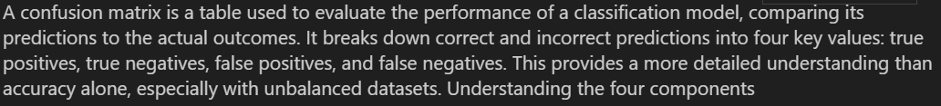

UNDERSTANDING THE FOUR COMPONENTS
=============================================
📧 SPAM EMAIL EXAMPLE:
=========================

Let's say we have 100 emails and our spam detector makes predictions:

ACTUAL SITUATION:
• 60 emails are actually HAM (not spam)
• 40 emails are actually SPAM

MODEL PREDICTIONS:
• Model predicts 55 as HAM
• Model predicts 45 as SPAM

CONFUSION MATRIX BREAKDOWN:

PREDICTED
Ham Spam
┌─────────────────┐
ACTUAL Ham │ 50 10 │
Spam │ 5 35 │
└─────────────────┘

🔍 DETAILED BREAKDOWN:
TN (True Negative) = 50: Ham emails correctly identified as Ham ✅
FP (False Positive) = 10: Ham emails wrongly labeled as Spam ❌
FN (False Negative) = 5: Spam emails missed (labeled as Ham) ❌
TP (True Positive) = 35: Spam emails correctly identified as Spam ✅

📊 WHAT THIS TELLS US:
• Model correctly identified 85 out of 100 emails
• Model made 15 errors
• 10 innocent emails marked as spam (annoying for users)
• 5 spam emails got through (security risk)

Accuracy Score

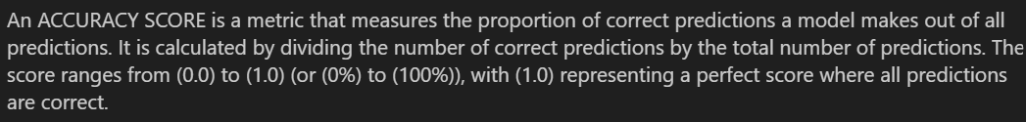

WHAT IS ACCURACY SCORE?
==============================

🎯 ACCURACY = Proportion of correct predictions out of all predictions

📊 Definition:
• Measures overall correctness of a classification model
• Simple and intuitive metric
• Most commonly used evaluation metric

📐 Formula:
Accuracy = (Correct Predictions) / (Total Predictions)
Accuracy = (TP + TN) / (TP + TN + FP + FN)

📈 Range:
• Minimum: 0.0 (0%) - All predictions wrong
• Maximum: 1.0 (100%) - All predictions correct
• Higher values = Better performance

🔢 SIMPLE EXAMPLE:
====================
Actual: [1, 0, 1, 1, 0, 1, 0, 0, 1, 0]
Predicted: [1, 0, 1, 0, 0, 1, 0, 1, 1, 0]
Matches: [1, 1, 1, 0, 1, 1, 1, 0, 1, 1]

Calculation:
Correct predictions: 8
Total predictions: 10
Accuracy: 8/10 = 0.80 = 80.0%

Precision
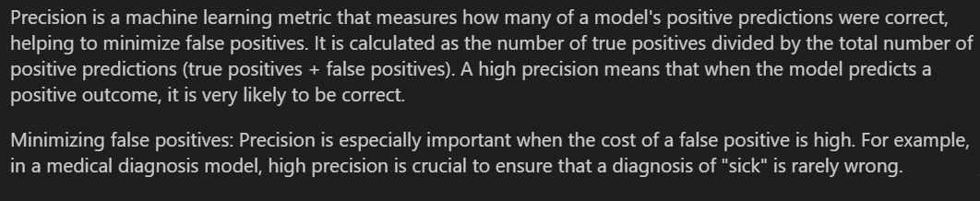

1. WHAT IS PRECISION?
=========================

🎯 PRECISION = How many positive predictions were actually correct

📊 Definition:
• Measures accuracy of positive predictions
• Focuses on minimizing false positives
• Answers: "Of all positive predictions, how many were right?"

📐 Formula:
Precision = True Positives / (True Positives + False Positives)
Precision = TP / (TP + FP)

📈 Range:
• Minimum: 0.0 (0%) - All positive predictions wrong
• Maximum: 1.0 (100%) - All positive predictions correct
• Higher values = Better performance

🎯 Key Question:
"When the model says YES, how often is it actually YES?"

🔍 PRECISION vs ACCURACY:
📊 Accuracy: Overall correctness (all predictions)
🎯 Precision: Correctness of positive predictions only
📈 Accuracy: Considers all four confusion matrix values
🔍 Precision: Only considers TP and FP
⚖️ Accuracy: Good for balanced datasets
🎯 Precision: Critical when false positives are costly

Recall

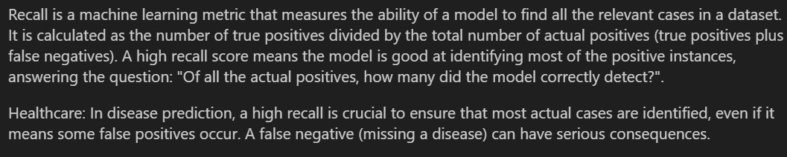

1. WHAT IS RECALL?
====================

🔍 RECALL = Ability of a model to find all the relevant cases

📊 Definition:
• Measures how well we capture all positive instances
• Focuses on minimizing false negatives
• Answers: "Of all actual positives, how many did we find?"

📐 Formula:
Recall = True Positives / (True Positives + False Negatives)
Recall = TP / (TP + FN)

📈 Range:
• Minimum: 0.0 (0%) - Found no positive cases
• Maximum: 1.0 (100%) - Found all positive cases
• Higher values = Better performance

🎯 Key Question:
"Of all the actual positives, how many did we correctly detect?"

🔄 Other Names:
• Sensitivity
• True Positive Rate (TPR)
• Hit Rate

🔍 RECALL vs PRECISION:
🔍 Recall: Of actual positives, how many did we catch?
🎯 Precision: Of predicted positives, how many were correct?
📈 Recall: Focuses on minimizing false negatives (missed cases)
🎯 Precision: Focuses on minimizing false positives (false alarms)
⚖️ Recall: Critical when missing positives is costly
⚖️ Precision: Critical when false alarms are costly

