Simple Recommendation System

Also known as popularity- based recommendation system
A. Popularity-Based Recommendation (Simplest)
Idea: Recommend items that are popular among everyone.
📌 Example
- Netflix shows “Top 10 Movies Today”
- Amazon shows “Best Sellers”
📌 How it works
- Count views, likes, purchases, or ratings
- Recommend items with the highest counts
📌 Pros
✔ Very easy
✔ Works without user data
📌 Cons
✘ Same recommendations for everyone
✘ No personalization

One simple way to implement a popularity-based recommender system is to use maximum counts of ratings or purchases and always recommend the items with the highest count.

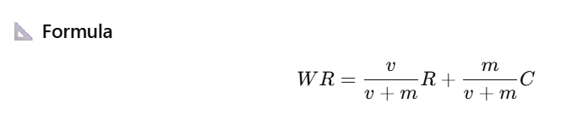

Symbol Meaning
R Movie’s average rating
v Number of ratings
m Minimum votes threshold = 200
C Global average rating = 2.9
1 = 5.0

1️⃣ What is a popularity-based recommendation system?
A. Recommends items based on user demographics
B. Recommends items based on user-item similarity
C. Recommends items based on overall item popularity
D. Recommends items randomly

2️⃣ Which of the following is NOT a popularity metric?
A. Number of views
B. Number of purchases
C. User age
D. Rating count

3️⃣ Popularity-based recommendation systems are best described as:
A. Highly personalized
B. User-specific
C. Same recommendations for all users
D. Based on item content

4️⃣ Which real-world feature is an example of popularity-based recommendation?
A. Netflix “Recommended for You”
B. Amazon “Best Sellers”
C. Spotify “Daily Mix”
D. LinkedIn “Jobs for You”

5️⃣ What is the main drawback of popularity-based recommenders?
A. High computational cost
B. Cold-start for new users
C. Lack of personalization
D. Complex implementation

6️⃣ Why is average rating alone not reliable for ranking items?
A. Ratings are too complex
B. It ignores user preferences
C. It causes small-sample bias
D. It is hard to compute

8️⃣ In the IMDb weighted rating formula, what does v represent?
A. Average rating
B. Global mean rating
C. Number of votes
D. Minimum votes required

9️⃣ What happens to an item’s IMDb score when it has very few ratings?
A. It increases sharply
B. It equals the maximum rating
C. It moves closer to the global average
D. It becomes zero

