Activation Function

1️⃣ Step Function (Threshold Function)
What it does:
- Outputs 1 if input > = 0, otherwise 0.
Formula (simplified):
f(x) = 1 if x >= 0
f(x) = 0 if x < 0
Use case:
- Early perceptrons for binary classification
Advantages:
- Simple and intuitive

2️⃣ Sigmoid Function
What it does:
- Maps input to a value between 0 and 1
- S-shaped curve
Formula (simplified):
f(x) = 1 / (1 + e^(-x))
Use case:
- Binary classification outputs
Advantages:
- Good for probability outputs

3️⃣ Tanh Function (Hyperbolic Tangent)
What it does:
- Maps input to -1 to +1
Formula:
f(x) = (e^x - e^-x) / (e^x + e^-x)
Use case:
- Hidden layers of neural networks
Advantages:
- Smooth, differentiable
Disadvantages:
Not widely used in deep hidden layers now: ReLU often outperforms it in deep networks.

4️⃣ ReLU (Rectified Linear Unit)
What it does:
- Outputs input directly if positive, else outputs 0
- f(x) = max(0, x)
Use case:
- Most common for hidden layers in deep networks
Advantages:
- Computationally fast

5️⃣ Softmax Function
What it does:
- Converts a vector of values into probabilities that sum to 1
- Each output = probability of belonging to a class
Formula (simplified):
f(x_i) = e^(x_i) / sum(e^(x_j)) for all j
Use case:
- Output layer for multi-class classification
- Example: MNIST digits (0–9)
Advantages:
- Produces interpretable probabilities

Summary Table
Activation | Range | Used in
Step | 0 or 1 | Early perceptron
Sigmoid | 0–1 | Output for binary classification
Tanh | -1–1 | Hidden layers
ReLU | 0–∞ | Hidden layers in deep nets
Softmax | 0–1 (sum=1) | Output layer for multi-class

✅ Rule of Thumb:
- Hidden layers: ReLU
- Binary output: Sigmoid
- Multi-class output: Softmax
- Old-school/simple perceptrons: Step / Tanh

Forward Propogation
Forward Propagation (How ANN Makes Predictions)
- Input flows from left to right
- Each neuron computes weighted sum
- Activation function introduces non-linearity
- Output layer gives prediction
📌 Without activation functions → ANN becomes a linear model

Initialize weights
↓
Forward propagation
↓
Compute loss
↓
Backpropagation
↓
Update weights
↓
Repeat (epochs)

Churn Modelling Example

Layer 1: 11 * 3 (Weights) + 3 (Bias)= 33 + 3 = 36
Layer 2: 3 * 1 + 1 = 3 + 1= 4

What does model.compile() do?
compile() configures the neural network for training.
It tells the model:
- How to learn → optimizer
- What mistake to minimize → loss function
- How to evaluate performance → metrics
Without compile(), the model cannot be trained.

1️⃣ Optimizer = 'adam'
What is an optimizer?
An optimizer updates the weights and biases of the network to minimize the loss.
Why Adam?
Adam (Adaptive Moment Estimation) is one of the most popular optimizers.
What Adam does internally:
- Automatically adjusts learning rates for each weight
📉 Training Loop Overview:
- Initialize weights randomly
- Forward pass → get output
- Compute loss
- Backprop → compute gradients
- Optimizer updates weights
- Repeat until convergence

2️⃣ Loss = 'binary_crossentropy'
What is a loss function?
The loss function measures how wrong the model’s prediction is.
Why binary cross-entropy?
Used when:
- Binary classification problem
- Output layer uses sigmoid activation
- Labels are 0 or 1
What it does conceptually:
- Encourages predicted probability to match true label
Example:
- True label = 1
- Prediction = 0.01 → very high loss
- Prediction = 0.9 → low loss

📌 Quick Selection Guide (Very Useful)
Task | Loss Function
Binary classification | Binary Cross-Entropy
Multi-class (one-hot) | Categorical Cross-Entropy
Multi-class (integer labels) | Sparse Categorical Cross-Entropy
Standard regression | MSE
Regression with outliers | MAE

3️⃣ Metrics = ['accuracy']
What are metrics?
Metrics are used only for evaluation, not for training.
Accuracy means:
$$\text{Accuracy}=\frac{\text{Correct Predictions}}{\text{Total Predictions}}$$

How Everything Works Together
- Model makes a prediction
- Binary cross-entropy calculates error
- Adam optimizer updates weights to reduce error
- Accuracy reports performance after each epoch

What is an Epoch in Machine Learning / ANN?
An epoch means one complete pass of the entire training dataset through the neural network.
📌 In simple words:
Epoch = one full round of learning from all training data

Why Epochs Are Needed
A neural network does not learn everything in one pass.
- After 1 epoch → model learns a little
- After many epochs → model gradually improves
- Too many epochs → model may overfit
So we train the model multiple epochs.

How Epoch Works Step-by-Step
- Model sees all training data once
- Makes predictions
- Calculates loss
- Updates weights using optimizer
- One epoch completes
Then the process repeats.

11 * 11 + 11 = 132 – Layer 1
11 * 11 + 11 = 132
11 * 1 + 1 = 12
132 + 132 + 12= 276

Notebook Link: https://www.kaggle.com/code/harmeet17/notebook8e3074c0b6/edit

Gradient Descent

Gradient Descent is one of the most fundamental optimization algorithms in machine learning and neural networks. It is nothing but an optimizer

🚨 Short Definition (Interview Style)
Gradient Descent is an optimization algorithm that updates model parameters in the direction that minimizes the loss function by moving opposite to the gradient of the loss.

🧠 Purpose
The goal of training is to minimize a loss function (error).
Gradient descent helps answer:
“How should we change the weights to reduce the error?

⚙️ Training Loop Context
Gradient descent works inside backpropagation:
- Forward pass → compute output
- Compute loss
- Backprop → compute gradients
- Gradient descent → update weights
- Repeat until convergence

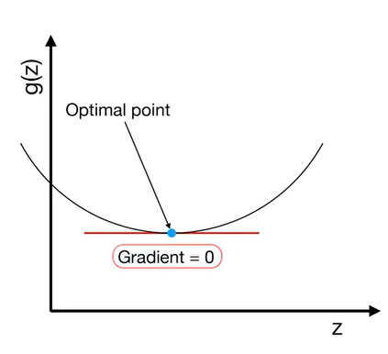

1️⃣ Batch Gradient Descent
Uses the entire dataset to compute the gradient:
$$∇_{θ}L=\frac{1}{N}\sum_{i=1}^{N}{∇_{θ}}L_{i}$$
Cons:
✘ Very slow for big datasets
✘ Requires large memory
Used where: dataset is small and fits in memory.

2️⃣ Stochastic Gradient Descent (SGD)
Uses one sample per update:
$$∇_{θ}L=∇_{θ}L_{i}$$
Pros:
✔ Good for large datasets
3️⃣ Mini-Batch Gradient Descent (most widely used)
Uses batches of size $B$(e.g., 32, 64, 128):
$$∇_{θ}L=\frac{1}{B}\sum_{i=1}^{B}{∇_{θ}}L_{i}$$
Pros:
✔ More stable than SGD

Adam is an extension of gradient descent that uses adaptive learning rates and momentum to update parameters more efficiently.
In other words:
- It still uses gradients from backpropagation
- It still aims to minimize loss
- It still updates weights by moving opposite to the gradient
So it is part of the gradient descent family, but it's a smarter, more advanced variant.

Backward Propagation

Backward propagation (or backpropagation) is the algorithm used to compute the gradients of the loss function with respect to each weight in the neural network, and then use those gradients to update the weights.
In short:
Backprop tells the network how to adjust its weights to reduce the error.

- Inputs X, arrive through the preconnected path.
- Input is modeled using real weights W. The weights are usually randomly selected.
- Calculate the output for every neuron from the input layer, to the hidden layers, to the output layer.
- Calculate the error in the outputs
- ErrorB= Actual Output – Desired Output
- Travel back from the output layer to the hidden layer to adjust the weights such that the error is decreased.
Keep repeating the process until the desired output is achieved.

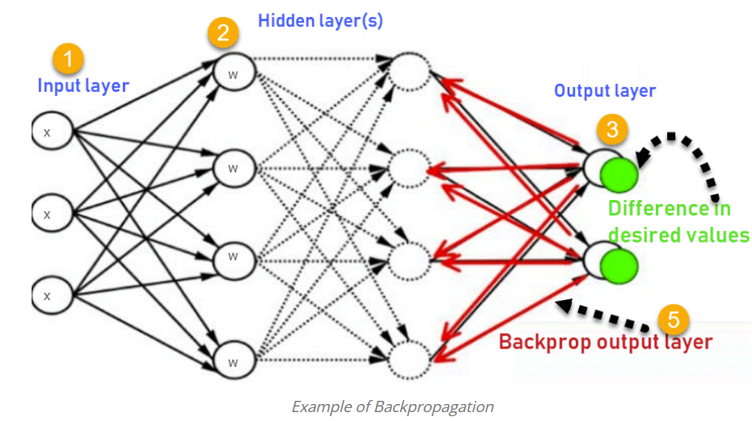

🔹 Bias
Bias is error due to wrong assumptions in the learning algorithm — usually because the model is too simple.
High bias means the model is underfitting.
Symptoms of high bias:
✔ high training error
✔ high testing error

🔹 Variance
Variance is error due to a model being too sensitive to training data.
High variance means overfitting.
Symptoms of high variance:
✔ low training error
✘ high testing error

How a “Just Right” Model Looks Like?
So, this how a “just right” model looks like, it does well on both testing, and training data.
The training error and test error are low and the difference between both errors is low, which implies low bias and low variance.

Regularization
Regularization techniques such as L1, L2 work by penalizing large weights in the neural network. But why does reducing weights help generalization?

🎯 1. Large Weights Make the Model Too Sensitive
If the network has very large weights, then small changes in input can produce very large changes in the output. This leads to:
- High variance
- Overfitting to noise in the training data
- Poor performance on unseen data
👇 Imagine a model trying to perfectly fit noisy training data:
Large Weights → Highly Complex Decision Boundary → Overfits Noise

🎯 2. Smaller Weights → Smoother Decision Boundaries
When regularization shrinks weights, the model becomes less complex and smoother.
Example:
Smaller Weights → Smoother Function → Better Generalization

Original Loss
Loss = Loss_data
With Regularization
Loss = Loss_data + λ * Regularization_term (Penalty term)
Where λ controls how strong regularization is.

.

🧠 6. Mathematical View (L2 as Example)
L2 regularization adds:
λ * Σ w²
This encourages weights toward zero but not exactly zero.

🤔 What About L1?
L1 adds:
λ * Σ |w|
This makes weights exactly zero.

Early Stopping
Early stopping is a technique used in training neural networks (including ANN, CNN, RNN, etc.) to prevent overfitting.

While training, the model's training loss keeps decreasing, but eventually the validation loss starts to increase — meaning the model has started to memorize instead of generalizing.
Early stopping stops training at the point where validation performance is best.

🧠 How it Works
Training loop:
- Train each epoch
- Monitor metric (usually validation loss or validation accuracy)
- Keep the best model weights
- If performance doesn’t improve for patience epochs → stop

Dropout
A Dropout layer is a technique used in neural networks (including ANN, CNN, RNN) to reduce overfitting by making the network less dependent on specific neurons.

During training, dropout randomly “drops” (disables) a percentage of neurons in a layer at each forward pass.
The disabled neurons do not participate in:
- forward pass
- backward pass (gradients)
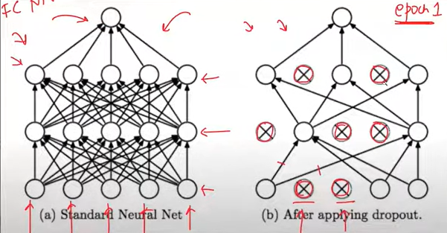

🎯 2. Acts Like Training Many Sub-Networks at Once
Imagine a network with dropout 0.5:
- Each training step uses a different subset of neurons
- This creates many “thinned” networks
- At test time, their combined output behaves like an ensemble model
Ensembles generalize better → lower validation/test error.

from tensorflow.keras.layers import Dropout, Dense

model.add(Dense(128, activation='relu'))
model.add(Dropout(0.3)) # drop 30% neurons
model.add(Dense(64, activation='relu'))
model.add(Dropout(0.2))

Regression Problem
https://www.kaggle.com/code/harmeet17/notebookd901552b8e/edit

