* **Select at least three classes and prepare a detailed state diagram for each class.**

1. State diagram for class Order

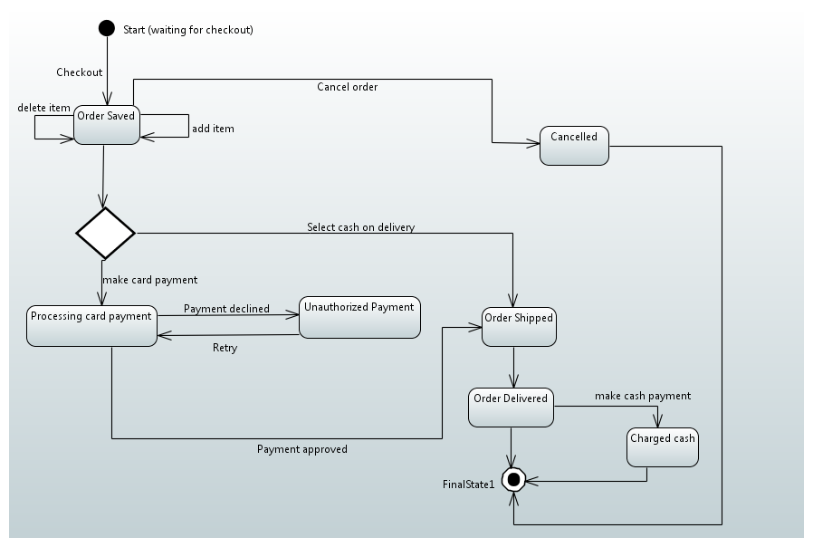

1. State Diagram for class ShoppingCart

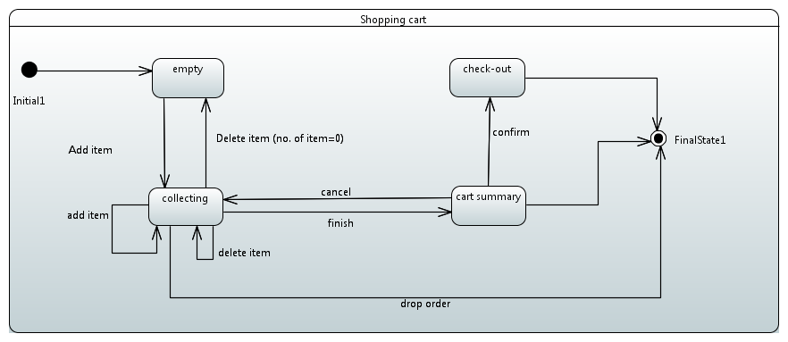

1. State diagram for class Item

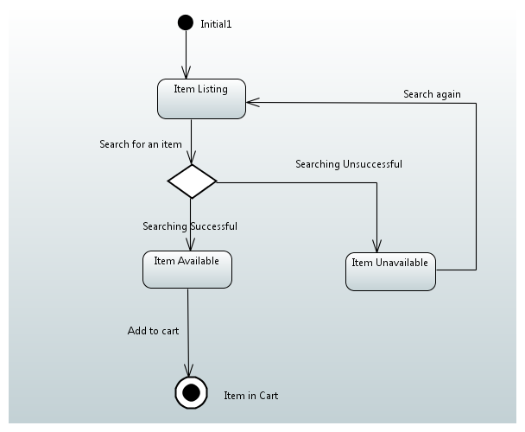

* **Select at least three operations and prepare an action specification for each.**

1. Class **ShoppingCart**; Operation **addItem**

Class Shoppingcart {

Private quantity : Integer;

Private itemPricePerUnit : Money;

Public getQuantity() : int {

return self.quantity;

}

Public getitemPricePerUnit () : Money {

return self.itempricePerunit;

Public getTotalItemprice() : Money {

return self.getQuantity * self.getItemPricePerunit;

}

}

activity addItem()

{

ShoppingCart= new ShoppingCart();

ShoppingCart.getTotalItemPrice(item=>this);

}

1. Class: **Order**; Operation: **MakeCardPayment**

activity MakeCardPayment()

{

cardPayment= new cardpayment();

cardpayment.Makenewpayment (

customerName =>this.customername,

cardNumber =>this.cardNumber,

cardExpirydate =>this.cardExpirydate,

cardCVVNumber =>this.cardCCVNumber,

billingAddress => this.billingAddress,

paymentAmount=>this.paymentAmount,

);

}

1. Class **Order**; Operation **shipOrder**

**activity shipOrder**() {

If(this.cardPayment=True) {

ShipOrder = new ShipOrder();

ShipOrder.CreateNewShipment(order=>this);

}

Else {

displayPaymentUnsuccessfullNotification();

}

**References:**

1. www.omg.org
2. Action Language for Foundational UML (Alf), Concrete Syntax for a UML Action Language, Version 1.0.1
3. http://morse.inf.unideb.hu/valseg/gybitt/07/ch03s04.html[2]
4. http://www.slideshare.net/alirezasafian1/5state-diagrams