**ACKNOWLEDGEMENT**

It was a highly eventful session at the Sutex Bank College of Computer Application & Science, SURAT working with highly devoted computer teachers’ community, and will probably remain the most memorable experience of my life. Hence this acknowledgement is a humble an attempt to earnestly thank are all those who were directly and indirectly involved in my project work and where of immense help to us.

We would like to express our gratitude towards our parents & member of family for their kind co-operation and encouragement which help us in completion of this project.

We owe debt of gratitude to **Mr. Ketan Patel owner of IT DOT FORCE** for bestowing that faith in us and giving us the privilege of working in such an esteemed organization, which will be building steps for my bright future.

We take this opportunity to acknowledge our gratitude to the staff of **It Dot Force** for their support & encouragement, which was very vital during our training session.

We would like to express our special gratitude and thanks to our internal project guide **Ms. Krupali patel** for giving us such attention, time, motivation and other such various valuable inputs and ideas for our project.

Finally, we are thankful to all the individuals whose names are not included here. All of these have made our project a success.

Thanks to All…

**Santosh Devganiya..**

**1.INTRODUCTION**

* **Project Profile:-**
* **Company Profile:-**

**1.1 Project Profile**

|  |  |
| --- | --- |
| Project title | Online Global Policy Market |
| Project Defination |  |
| Organization | **It Dot Force** |
| Front End | **Microsoft Visual Studion 2010** |
| Back End | **Sql Server 2008** |
| Lanquage | **Asp.net with C#** |
| Tools & Technology | **Asp.net,**  **Java Script,**  **Ajax Toolkit,**  **J query..** |
| Operating System | **Microsoft windows xp,**  **Windows 7,**  **Windows 8, ans so on..** |
| External Guade | **Mr. Ketan Patel** |
| Internal Guade | **Mr. Krupali patel** |
| Project Duration |  |
| Submited By | **Devganiya Santosh** |

**1.2 Company Profile**

**IT DOT FORCE**

The name of company is “ **I.T DOT FORCE** ” . It is running under the guidance of **Mr. Ketan Patel** , The Director of Company.

IT DOT FORCE is a Surat, INDIA based Software and Website Development Company, with good experience in customizes website development. We provide full-cycle services in the areas of Software Development,Website Designing, Domain Registration, Web Hosting,E-Mail Hosting, Search Engine Optimization, Internet Marketing etc.

We specialize in development and maintenance of web-based applications using a variety of technologies. Like ASP.NET, PHP, AJAX, JQuery, HTML.

|  |  |
| --- | --- |
| Organization | I.T DOT FORCE |
| Address | 64/Jalaram Society,  Juni Sadak,  Adajan,  Surat-395 009 |
| Phone No | 8866590208 |
| Email Id | [itdotforce@gmail.com](mailto:itdotforce@gmail.com) |

Our goal is to help our clients to optimize their business performance. Our mission is to attain leadership in our chosen field through our commitment to quality, innovation, value for money and creativity

**2.ENVIRONMENT**

**DESCRIPTION**

* **Hardware & Software Requirement:-**
* **Software Specification:-**

**2.1 Hardware & Software**

**Requirement**

* **Hardware Requirement:-**

|  |  |
| --- | --- |
| Processor | Intel Processor or faster |
| RAM | **2GB Or Higher** |
| Hard Disk | **35 GB** |
| I/O Devices | **Standard I/O devices** |

* **Software Requirement:-**

|  |  |
| --- | --- |
| Operating  System | Microsoft Wnidows xp,  Windows 7,  Windows 8, and So On.. |
| Web Browser | **Mozilla Firefox,Google Chrome**  **Microsoft Internet Explorer,** |
| Software | **ASP.NET 2010,SQL Server 2008** |

**2.2 Technology &**

**Literature Review**

1. **ASP.NET With C# (Front End)**
2. **SQL Server 2008 (Back End)**

**2.2.1 Front End: ASP.NET (MS Visiual Studio 2010)**

About Microsoft Visual Studio 2010:-



**Microsoft Visual Studio 2010 is an** [**integrated development environment**](http://en.wikipedia.org/wiki/Integrated_development_environment)**. It is used to develop** [**console**](http://en.wikipedia.org/wiki/Console_application) **and** [**graphical user interface**](http://en.wikipedia.org/wiki/Graphical_user_interface)[**applications**](http://en.wikipedia.org/wiki/Application_software) **along with** [**Windows Forms**](http://en.wikipedia.org/wiki/Windows_Forms) **applications,** [**web sites**](http://en.wikipedia.org/wiki/Web_site)**,** [**web applications**](http://en.wikipedia.org/wiki/Web_application)**, and** [**web services**](http://en.wikipedia.org/wiki/Web_service) **in both** [**native code**](http://en.wikipedia.org/wiki/Native_code) **together with** [**managed code**](http://en.wikipedia.org/wiki/Managed_code) **for all platforms supported by** [**Microsoft Windows**](http://en.wikipedia.org/wiki/Microsoft_Windows)**,** [**Windows Mobile**](http://en.wikipedia.org/wiki/Windows_Mobile)**,** [**Windows CE**](http://en.wikipedia.org/wiki/Windows_CE)**,** [**.NET Framework**](http://en.wikipedia.org/wiki/.NET_Framework)**,** [**.NET Compact Framework**](http://en.wikipedia.org/wiki/.NET_Compact_Framework) **and** [**Microsoft Silverlight**](http://en.wikipedia.org/wiki/Microsoft_Silverlight) **it can also develop windows presentation foundation(WPF) application.**

**Visual Studio supports different** [**programming languages**](http://en.wikipedia.org/wiki/Programming_language) **by means of language services, which allow the code editor and debugger to support (to varying degrees) nearly any programming language, provided a language-specific service exists. Built-in languages include** [**C**](http://en.wikipedia.org/wiki/C_%28programming_language%29)**/**[**C++**](http://en.wikipedia.org/wiki/C%2B%2B)[**[5]**](http://en.wikipedia.org/wiki/Microsoft_Visual_Studio#cite_note-5) **(via** [**Visual C++**](http://en.wikipedia.org/wiki/Visual_C%2B%2B)**),** [**VB.NET**](http://en.wikipedia.org/wiki/VB.NET) **(via** [**Visual Basic .NET**](http://en.wikipedia.org/wiki/Visual_Basic_.NET)**),** [**C#**](http://en.wikipedia.org/wiki/C_Sharp_%28programming_language%29) **(via** [**Visual C#**](http://en.wikipedia.org/wiki/Visual_C_Sharp)**), and** [**F#**](http://en.wikipedia.org/wiki/F_Sharp_%28programming_language%29) **(as of Visual Studio 2010**[**[6]**](http://en.wikipedia.org/wiki/Microsoft_Visual_Studio#cite_note-6)**). Support for other languages such as** [**M**](http://en.wikipedia.org/wiki/M_%28programming_language%29)**,** [**Python**](http://en.wikipedia.org/wiki/IronPython)**, and** [**Ruby**](http://en.wikipedia.org/wiki/IronRuby) **among others is available via language services installed separately. It also supports** [**XML**](http://en.wikipedia.org/wiki/XML)**/**[**XSLT**](http://en.wikipedia.org/wiki/XSLT)**,** [**HTML**](http://en.wikipedia.org/wiki/HTML)**/**[**XHTML**](http://en.wikipedia.org/wiki/XHTML)**,** [**JavaScript**](http://en.wikipedia.org/wiki/JavaScript) **and** [**CSS**](http://en.wikipedia.org/wiki/Cascading_Style_Sheets)**. Individual language-specific versions of Visual Studio also exist which provide more limited language services to the user: Microsoft Visual Basic, Visual J#, Visual C#, and Visual C++.**

**2.2.2 SQL Server 2008(Back End)**

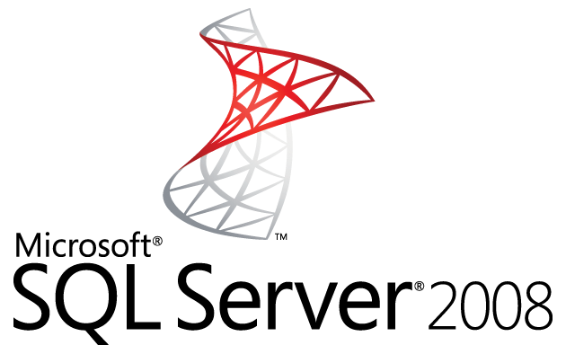

Microsoft SQL Server 2008 is comprehensive, integrated data management and analysis software that enables organizations to reliably manage mission-critical information and confidently run today’s increasingly complex business applications. SQL Server 2008 allows companies to gain greater insight from their business information and achieve faster results for a competitive advantage.

At the foundation of MSSQL Network is the SQL Database Server, the world’s most popular open source database. Its architecture makes it extremely fast and easy to customize. The latest certified production-ready release includes numerous enhancements that improve performance, internationalization and the ability to embed SQL-Server with other hardware and Software Solutions. Major enhancements include.

|  |  |
| --- | --- |
| **Feature of Microsoft SQL Server 2008:-** | |
| * Web-enabled enterprise database. |
| * Introduction of built in support for the extensible markup Language, XML. |
| * Improved distributed query capabilities. |
| * Replication and administration enhancements. |
| * High speeds in application development and transaction Processing. |
| * High speeds in application development and transaction Processing. |
| * English Query tools and full text search features. |
| * Improved security tools. |
| * Support for file and network encryption. |
| * Enhances Analysis services including data mining support. |
| * Data Transformation services. |
| * User defined function and administration tools like Enterprise Manager and Query Analyzer. |
| * Indexed views and support for distributed partition views |
| * Benchmark records for scalability and reliability. |

|  |
| --- |
|  |
|  |
|  |
|  |
|  |
|  |

Overview of .NET Framework release History:-

|  |  |  |  |  |  |
| --- | --- | --- | --- | --- | --- |
| Generation | Version No | Release Date | Notes | Development Tools | Distributed with |
| 1.0 | **1.0.3705.0** | **23/02/02** | **Original Version** | [**Visual Studio .NET**](http://en.wikipedia.org/wiki/Visual_Studio_.NET) | **N/A** |
| 1.1 | **1.1.4322.57** | **24/04/03** | **First Update** | **VS.NET 2003** | [**Windows Server 2003**](http://en.wikipedia.org/wiki/Windows_Server_2003) |
| 2.0 | **2.0.50727.42** | **07/11/05** | **Rewrite Of Framework** | **VS.NET 2005** | [**Windows Server 2003**](http://en.wikipedia.org/wiki/Windows_Server_2003) |
| 3.0 | **3.0.4506.30** | **06/11/06** | **WCF,WPF,WF** | [**Expression Blend**](http://en.wikipedia.org/wiki/Microsoft_Expression_Blend) | [**Windows Vista**](http://en.wikipedia.org/wiki/Windows_Vista)**,** [**Windows Server 2008**](http://en.wikipedia.org/wiki/Windows_Server_2008) |
| 3.5 | **3.5.21022.8** | **11/19/07** | **LINQ** | **VS.NET 2008** | [**Windows 7**](http://en.wikipedia.org/wiki/Windows_7)**,** [**Windows Server 2008 R2**](http://en.wikipedia.org/wiki/Windows_Server_2008_R2) |
| 4.0 | **4.0.30319.1** | **12/04/10** | **Parallel Extensions** | **VS.NET 2010** | **N/A** |
| 4.5 | **4.5.505709.17** | **15/08/12** | **Asynchronous Programming Model** | **VS.NET 2012** | [**Windows 8**](http://en.wikipedia.org/wiki/Windows_8)**,** [**Windows Server 2012**](http://en.wikipedia.org/wiki/Windows_Server_2012) |

**Technology Used**

We are not having any past work system. We are designing this project for the first time. So we are free to use any technology that we want. Online Recruitment is a web application developed using ASP.Net 4.0 Using C# used as front end with SQL server-2008 used as back end.

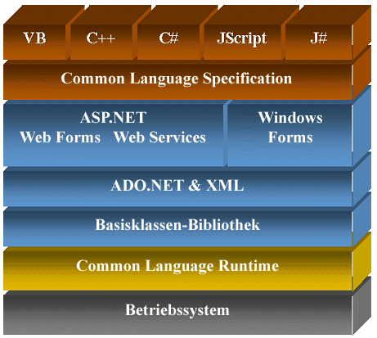

**.NET Framework 4.0 Architecture**

**Key Points:-**

The .NET Framework 4 provides a comprehensive development platform that offers a fast and efficient way to build applications and services. Using Visual Studio 2010, developers can utilize the .NET Framework 4 to create a wide range of solutions that operate across a broad range of computing devices. The .NET Framework 4 provides three principal elements: the CLR, the .NET Framework class library, and a collection of development frameworks.

**The Common Language Runtime:-**

The .NET Framework 4 provides an environment called the CLR. The CLR manages the execution of code and simplifies the development process by providing a robust and secure execution environment that provides common services such as memory management, transactions, interprocess communications, multithreading, and many other features.

**The .NET Framework Class Library:-**

The .NET Framework 4 provides a library of reusable classes that developers can use to build applications. The classes provide a foundation of common functionality and constructs that help simplify application development and remove the requirement for developers to constantly reinvent logic. For example, the **System.IO.File** class contains functionality that enables developers to manipulate files on the Windows file system. In addition to using the classes in the .NET Framework class library, you can extend these classes by creating your own libraries of classes**.**

**Development Frameworks:-**

The .NET Framework 4 provides several development frameworks that you can use to build common types of applications. These frameworks provide the necessary components and infrastructure to get you started.

**2.3 Architeucure**

**Used/Followed**

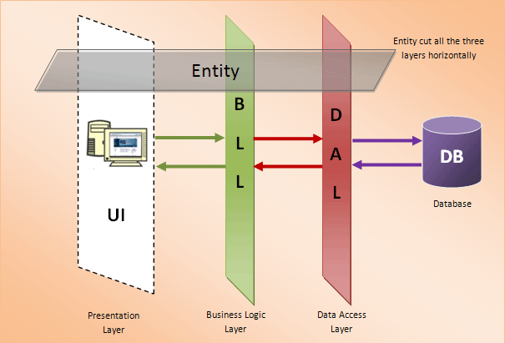 3-Tier Architecture

3-Tier architecture generally contains UI or Presentation Layer, Business Access Layer (BAL) or Business Logic Layer and Data Access Layer (DAL)

* **Presentation layer(UI)**
* **Business Access layer(BAL)**
* **Data Access Layer(DAL)**

**Presentation Layer (UI):-**

* Presentation layer contains pages like .aspx or windows form where data is presented to the user or input is taken from the user.
* This layer mainly used for design purpose and get or set the data back and forth.

**Business Access Layer (BAL) or Business Logic Layer (BLL):-**

* This layer contains our business logic, calculations related with the data like insert data, retrieve data and validating the data. This acts as a interface between Application layer and Data Access Layer
* Other line of business Applications a company build can use the business logic layer if needed, maximizing the code reuse.

**Data Access Layer (DAL):-**

* DAL contains methods that helps business layer to connect the data and perform required action, might be returning data or manipulating data (insert, update, delete etc) from database based on our input data.
* Project Flow Lines and Artificial Lift use a Microsoft SQL Server Express Edition database.

**3.EXISTING SYSTEM**

* **About Existing System:-**
* **Limitation of Existing**

**System:-**

**3.1 About Existing System**

The previous version of Global Policy Market mean the existing system of client of It Dot Force Technologies can be used insurance management Web Application.

This system can be help to manage sale various Company policy details and different company policy compare and online buy to this policy, Agent detail and just it commission or general report.

It have no more GUI(graphical user interface) to interact customer help to his/her maintain and retrieve fastest data .

**3.2 Limitation of**

**Existing System**

Insurance management system is existing system which is used by client of It Dot Force technologies for maintain data of policy saled and customer.They are maintaining software from beginning but they have found it very tedious and time consuming because there is no graphical interface and more searching facility so they have decide to develop another software system that will do all these things automatically.

* In existing system there are many problems one of those they are losing data because there have no facility available to take backup or restore backup.
* One main problem is that in existing system they only create and data of own policy and agent , they can’t maintain detail level of other company users (Agent) and policy of other company.
* Another problem is with the lazy working speed, the current system is so lazy and that’s why it takes more time in processing so they can’t get any information speeding.
* Main problem of existing system is graphics of application. It has no graphical user interface so it is boring for them moreover existing system they have no facility to display photograph of Agent or company. So without photograph of Agent or Buyer existing information system is become useless.

**4.SYSTEM PLANNING**

* **Feasibility Study :-**
* **RequirementGathering:**
* **Requirement Analysis:-**

**4.1 Feasibility Study**

**Introduction:-**

A feasibility study is an evaluation and analysis of the potential of the proposed project which is based on extensive investigation and research to give full comfort to the decisions makers.

An [analysis](http://www.investorguide.com/definition/analysis.html) and [evaluation](http://www.investorguide.com/definition/evaluation.html) of a proposed [project](http://www.investorguide.com/definition/project.html) to [determine](http://www.investorwords.com/9440/determine.html) if it (1) is technically [feasible](http://www.investorwords.com/1891/feasible.html) (2) is feasible within the [estimated cost](http://www.investorguide.com/definition/estimated-cost.html), and (3) will be [profitable](http://www.investorguide.com/definition/profitable.html). [Feasibility studies](http://www.investorguide.com/definition/feasibility-study.html) are almost always conducted where large [sums](http://www.businessdictionary.com/definition/sum.html) are at [stake](http://www.investorguide.com/definition/stake.html). Also called [feasibility analysis](http://www.businessdictionary.com/definition/feasibility-analysis.html).

1. **Economical Feasibility**
2. **Technical Feasibility**
3. **Behavioral and Operational Feasibility**

* **Economical Feasibility:-**
* In economical way the proposed system had no problems because the entire necessary infrastructure required for the proposed system was readily available and no new investment as such was required.
* Developed System is user friendly and Interactive so that user doesn’t require any training to use this system.
* **Technical Feasibility:-**
* The technical requirements for the proposed system are of necessary computer hardware and software.
* “The company” was having computer facilities, which satisfy the hardware requirements and software requirements were also met by it.
* **Behavioral Feasibility:-**
* The change in the existing system was desired by management and hence staff has to accept it, but it was necessary to feel the pulse of the staff that was actually going to use proposed system.
* The staff was properly explained as to why the change was needed and how it would benefit them in their daily routine.
* They were made to realize that the proposed system would be more convenient to them. This changed their thoughts towards the proposed system.

**4.2 Requirement Gathering**

* **Several Meetings Conducted** :
  + We conducted several meetings amongst ourselves and discussed on various aspects of the system and collected Information about the proposed system to be developed by us. By analyzing the workflow, we got a proper understanding of the ‘requirements’.
  + Meetings were conducted as and when necessary to gather requirements. We followed the basic approach for requirements gathering.
* **Information Exchange :**
  + Communicating within ourselves exposed us to the basic functionality to be executed by the system, so we got aware of our target to be met within the predefined deadline.
* **Understanding The Concept :**
  + Direct communication through meetings introduced us to the current scenario and provided us with the basic guidelines on which our system would be developed.
  + Free flow of ideas made us understand the benefits of our system.
* **Document Prototype :**
* All this discussions were documented for the future access. During the meetings itself, we note important things discussed on paper. After understanding the reason why we are developing the application and how our application would tackle problems, we prepared a document prototype. The document gave us an idea about the workflow of our application.

**4.3 Requirement Analysis**

Requirement analysis involves studying the workflow of the proposed system.

The process of requirement analysis is carried out in three steps

1. Requirement anticipation
2. Requirement investigation
3. Requirement specification
4. **Requirement Anticipation:-**

* Requirement anticipation is very important part of system designing. It is to predict the future requirements based on the previous experience.
* We have anticipated the requirements by careful analysis.
* We have played an active role in the analysis of the website. Thus, -most of the requirements were judged well in advance.
* A proper assessment was done regarding the possible futures of this site.

1. **Requirement Investigation:-**

* Requirement investigation is the actual study of the system. It involves an accurate study of what all aspects your software would cover. In our case as we were developing Global Policy Market web site, it covered answers to questions like:

1. What is the basic functionality of Online Insurance Management System Website?
2. How automated do you want the application to be?
3. What kind of functionalities is to be developed to make system easy to use on admin, member and visitor side?
4. How can we build attractive site so that more and more users can use this web site?
5. **Requirement Specification:-**

* The information gathered during the system study was analyzed to determine the requirement specifications. Based on the issues governing the system, requirements in non-technical terms formulated.
* We need to develop rough prototype to check the basic functionality of the software.
* If the major modules are not working properly then the software might not satisfy the user.

Interaction between the operator and system must be fast and reliable.

**4.4 Risk Management**

After gathering basic requirement, feasibility study and studying functionality of proposed system, we assessed collected project data for possible risks and found possible risks and found following possible risks for

**:- Risk analysis done during Analysis Phase -:-**

|  |  |  |  |  |  |
| --- | --- | --- | --- | --- | --- |
| Risks | Category | Probability | Impact | Consequences | Remedy |
| Project size  Is large | Project  Risk | 20% | 2 | The system may not  be completed in  time | The analysis of the  system was started  early so that no further confusions occur |
| Time  Constraint | Schedule  Risk | 30% | 2 | the quality of the  system will be affected & the client  is left unsatisfied | As this is a quite  larger system for  group of two,  the schedule will  be followed as  planned  as far as possible |
| Frequent  Changes may  Occur | Project  Risk | 50% | 3 | The requirements  of the customer are  not stable and requires continuous  change | The remedy is to  be clear with concepts & requirement as  much as possible and  of course the agile  process model  is used |

**-:- Risk Analysis done before Coding -:-**

|  |  |  |  |  |  |
| --- | --- | --- | --- | --- | --- |
| Risks | Category | Probability | Impact | Consequences | Remedy |
| Cancle,  Procedures,  Cursors,  Jobs,  Etc.. | technical  Risk | 30% | 4 | May lead to  Problems  In the process of  development | Search and  Study from  Internet or  Other  sources |
| Understand  Business  Processes | Technical  Risk | 30% | 2 | May not possess  Enough  Knowledge  About the  System and  organization | getting  The  Feedback  From clint use  This website |

**-:- Risk Analysis done before starting development -:-**

|  |  |  |  |  |  |
| --- | --- | --- | --- | --- | --- |
| Risks | Category | Probability | Impact | Consequences | Remedy |
| Will the  system be  able to meet all  its objectives? | Project  Risk | 50% | 2 | May not lead  to the  acceptance of  the system | Proper definition of project scope |
| Will the  system be  able to meet its  Requirements? | Performance  risk | 15% | 3 | The development may go in  a haphazard  way as opposed  to requirements | Proper requirement gathering  process |
| What if  Implementation fails? | Technical  Risk | 20% | 3 | Whole system  is not feasible | Potential  system design |
| Large  number of user  than estimated | Project  Risk | 50% | 4 | The system may  be bombarded  with lots of  requests in  unit time | Efficient  session and Database management |
| Insufficient knowledge  of environment  and  Business. | Project  risk | 60% | 3 | The system may  not be properly understood | Learn how  work  processes  are  followed  in the  business |

**5.PROPOSED SYSTEM**

* **Scope :-**
* **Objectives:-**
* **Constraints:-**
* **Expected Advantages:-**

**5.1 Scope**

* **GPM [Global Policy Market System]**, emerging in line with the new generation of web Insurance management systems, will assist you in managing your company's and other company policy sale online and agent management with own company and other company. GPM [Global Policy market System], which is applicable to diverse insurance company, is a perfect platform for re-engineering your policy sale processes and redefining the workflow operations of maintain database.
* It provide platform to all policy buyer view policy online for all companies and compare with each other, and decided which policy buy between them.
* It also provide facility to all agent of company and agent of other company to handle own customer separately then the company and make interaction with his/her.
* Admin can block the company, company Policy and also User approve the users and can view the active , blocked and inactive user lists..
* It is provide to facility to online policy purchase and online payment in this system and also get to agent details, how many company agent...

**5.2 Objectives**

* Online Global Policy Market is web application developed provides facilities to Online Policy Management, Company Management, Agent Management, Company Sale Management , Agent Sale Management, Buyer Management, The **GPM** is complete Insurance Management site which can reduce the difficulty of buyer for and help improve sale of Insurance company.
* **Features**
* Policy Management
* Company Management
* Agent Management
* Report Generation
* Buyer Management
* Sale Management

**Global Policy Market web application is based on modular architecture and consists of the following modules:**

* **Admin Module**

The part of the system where the appointed personnel perform all system administration tasks. These include create the company, create the policy, create the agent, manage buyer, handle loan demand and issue loan and other task that serves as the backbone for the rest of the system. Security issues are taken care of through this module as well by defining user rights. In short it perform all other task like super admin expect add new other user.

* **Company Module**

This core module maintains all relevant company related information, including different types of company information, Company policy, work company agent ,company customer, company contact information etc. . Information captured in this module is utilized by all othersale modules, thus eliminating data redundancy.

* **Agent Module**

This core module maintains all relevant agent related information, including different types of agent information, agent profile, agent company ,history of his/her policy business, own customer, agent contact information etc. . Information captured in this module is utilized by calculating agent status, thus eliminating data redundancy.

* **Company sale Module**

This module must be maintains all detail information of saled policy by company without helping of agent, it also contain the information of buyer who is purchase it . Information captured in this module is utilized by calculating company sale.

* **Agent sale Module**

This module must be maintains all detail information of saled policy by agent, it also contain the information of buyer who is purchase it . Information captured in this module is utilized by calculating agent sale.

* **Policy Module**

This core module maintains all relevant policy related information.

It contain information about various policy which generated by the different company. It contain policy type, it premium, befit etc.

Information captured in this module is utilized by all convince customer.

* **Registration Module**

This core module maintains all relevant information about all the registered buyer , who is allready visited our site however purchase or not policy. Like name of buyer , contact information, working information or all detail of all other running policy, Information captured in this module is utilized by admin or agent to advertisement of new generated policy.

* **Buyer Module**

This module maintains all relevant information about buyer of the particular policy , like which policy purchased by which customer, type of the policy, premium of policy, instalment etc. Information captured in this module is utilized by admin or agent or company to maintain account info.

* **Email Module**

This module can be used to to send mail to the particular user of the system

their email id by

**5.3 Constraints**

The constraint associated in the development of any system includes those that are common to all system. The common constraints may include frequent change in requirements of the managements etc. We have also experience similar types of constraints listed above and others.

Some of the constraints are listed below with which we have developed this sites is requires.

* User can enter incorrect data because there is no restriction from admin to user.
* User required special type of knowledge for operate the system.
* Parents Interaction is not as much with the system.
* No fee receipt mechanism implemented in this system.

**5.4 Expected Advantages**

This system is specially designed for the client of IT DOT FORCE Technology, keeping in mind that it will work for only GPM Pvt. Ltd. This program handles Online Insurance Market like Policy sale and Agent management, Loan management etc.

* This system does not require the user learn a highly extensive computer courses but user must be familiar with the computer and put in practice for few hours. He has to manage each every Policy Information, Agent Information ,company policy information to online and how many company policy and different policy online compare.
* This system gives you total control over every single aspect of the program and therefore can be configure to work identical or better than to your existing system. Help is provided in animated demonstration and in very simple language for the user to understand all the features and options. It can run help and system simultaneously so user can learn very easily about the system

**6.DETAIL PLANNING**

* **Details SRS :-**
* **UML:-**
* **Use case:-**
* **Activity:-**
* **Class:-**
* **Sequence:-**

**6.1 Use Case Diagram**

















**6.2 Activity Diagram**

















**6.2 Class Diagram**

Admin:

|  |
| --- |
| Classname:Tbl_admin_dal |
| Int_admin_id int,  Str_admin_name string(30),  Str_password(string),  Str_email(string) |

|  |
| --- |
| Tbl_admin_bal |
| Insert_data(tbl_admin_dal objdal)  Update_data(tbl_admin_dal objdal)  Delete_data(tbl_admin_dal objdal)  Select_data(tbl_admin_dal objdal) |

|  |
| --- |
| Classname:Tbl_company_dal |
| Int_com_id int,  Str_cname string,  Str_address strin,  Str_email string,  Int_contact int,  Str_country string,  Str_state string,  Str_city string,  Str_logo string,  Int_total_policy int,  Int_total_cust int, |

Company:-

|  |
| --- |
| Tbl_company_bal |
| Insert_data(tbl_company_dal objdal)  Update_data(tbl_company_dal objdal)  Delete_data(tbl_company_dal objdal)  Select_data(tbl_company_dal objdal) |

Agent:

|  |
| --- |
| Tbl_agent_bal |
| Insert_data(tbl_agent_dal objdal)  Update_data(tbl_agent_dal objdal)  Delete_data(tbl_agent_dal objdal)  Select_data(tbl_agent_dal objdal) |

|  |
| --- |
| class name:Tbl_agnet_dal |
| Int_agent_id int,  Str_fname string,  Str_mname string,  Str_lname string,  St_address string,  Int_contact int,  Str_email stirng,  int_country _id,  int_state _id,  int_city _idS,  Str_images string,  Int_policy_sale int,  Int_total_cust int, |

Company policy:

|  |
| --- |
| Tbl_company_policy_bal |
| Insert_data(tbl_agent_dal objdal)  Update_data(tbl_agent_dal objdal)  Delete_data(tbl_agent_dal objdal)  Select_data(tbl_agent_dal objdal) |

|  |
| --- |
| class name:Tbl_com_policy_dal |
| Int_com_policy_id int,  Str_com_policy_type string,  Str_desc string,  Int_related_age int,  Int_total_benifit int,  Int_total_premium int,  Int_time_diration int,  int_company_id int,  int_policy_id int,  int_total_buyer int,  bit_status boolean, |

Registration:-

|  |
| --- |
| Tbl_registration_bal |
| Insert_data(tbl_reg_dal objdal)  Update_data(tbl_reg_dal objdal)  Delete_data(tbl_reg_dal objdal)  Select_data(tbl_reg_dal objdal) |

|  |
| --- |
| class name:Tbl_reg_dal |
| Int_reg_id int,  Str_fname int,  Str_mname int,  Str_lname int,  Str_add string,  Int_contact int,  Int_dob date,  Str_Email string,  Int_country_id int,  Int_state_id int,  int_city_id int, |

**6.4 Sequence Diagram**



**7.SYSTEM DESIGN**

* **Database Design :-**
* **Interface Design:-**

**7.1 Database Design**

**Registration Details(tbl_reg):-**

|  |  |  |  |
| --- | --- | --- | --- |
| Filed Name | Type | Description | Null |
| Reg_id | Int | Primary key | No |
| Str_lname | Varchar(10) | First Name | No |
| Str_mname | Varchar(10) | Middle Name | No |
| Str_lname | Varchar(10) | Last Name | No |
| Str_Address | Varchar(150) | Address | No |
| Str_Password | Varchar(10) | Password | No |
| Int_Dob | Date | Date of birth | No |
| Int_Country_id | Varchar(10) | Foreign key | No |
| Int_State_id | Varchar(10) | Foreign key | No |
| int_City_id | Varchar(10) | Foreignkey | No |
| Int_Mobile | Bigint | Mobile | No |
| Str_Email | Varchar(30) | Email | No |

**Admin login Details(tbl_admin):-**

|  |  |  |  |
| --- | --- | --- | --- |
| Filed Name | Type | Description | Null |
| Int_Admin_id | Int | Primary key | No |
| Str_Aname | Varchar(15) | Admin Name | No |
| Str_Password | Varchar(15) | Password | No |
| Str_Email | Varchar(20) | Email | No |

**Company Details(tbl_company):-**

|  |  |  |  |
| --- | --- | --- | --- |
| Filed Name | Type | Description | Null |
| Int_Company_id | Int | Primary key | No |
| Str_company_name | Varchar(15) | Company name | No |
| Str_Address | Varchar(100) | Com_ Address | No |
| Int_Contact No | Bigint | Contact no | No |
| Str_Email | Varchar(30) | Company email | No |
| Int_Country_id | Varhcar(15) | Foreign Key | No |
| Int_State_id | Varchar(15) | Foreign Key | No |
| int_City_id | Varchar(15) | Foreign Key | No |
| Int_Total_customer | Int | Total customer | No |
| Int_Total_agent | Int | Total Agent | No |
| Int_total_policy | Int | Total Com Policy | No |

**Agent Details(tbl_agent):-**

|  |  |  |  |
| --- | --- | --- | --- |
| Filed Name | Type | Description | Null |
| Int_Agent_id | Int | Primary key | No |
| Str_Fname | Varchar(30) | First name | No |
| Str_Mname | Varchar(30) | Middle name | No |
| Str_Lname | Varchar(30) | Last name | No |
| Str_Address | Varchar(100) | Address | No |
| Int_Dob | Date | Date of birth | No |
| Int_Mobile no | Bigint | Contact no | No |
| Str_Email | Varchar(30) | Email | No |
| Int_Country_id | Varchar(30) | Foreign Key | No |
| Int_State_id | Varchar(30) | Foreign Key | No |
| Int_City_id | Varchar(30) | Foreign Key | No |
| Int_Company_id | Int | Foreign Key | No |
| Int_total_cust | Int | Total Customer | No |
| Int_policy_sale | Int | Total Policy Sale | No |

**Policy Type Details(tbl_Policy_type):-**

|  |  |  |  |
| --- | --- | --- | --- |
| Filed Name | Type | Description | Null |
| Policy_id | Int | Primary key | No |
| Policy_name | Varchar(25) | Policy name | No |
| str_policy_img | Varchar(30) | Policy image | No |

**County Details(tbl_country):-**

|  |  |  |  |
| --- | --- | --- | --- |
| Filed Name | Type | Description | Null |
| Int_country_id | Int | Country id | No |
| Str_cname | Varchar(25) | Country name | No |

**State Details(tbl_state):-**

|  |  |  |  |
| --- | --- | --- | --- |
| Filed Name | Type | Description | Null |
| Int_state_id | Int | State id | No |
| Str_sname | Varchar(25) | State name | No |
| Int_country_id | Int | Foreign Key | No |

**City Detaisl(tbl_city):-**

|  |  |  |  |
| --- | --- | --- | --- |
| Filed Name | Type | Description | Null |
| Int_city_id | Int | City id | No |
| Str_cname | Varchar(25) | City name | No |
| Int_state_id | Int | Foreign Key | No |

**Company Policy Plan(tbl_com_policy):-**

|  |  |  |  |
| --- | --- | --- | --- |
| Filed Name | Type | Description | Null |
| Int_com_policy_id | Int | Primary key | No |
| Str_com_policy_type | Varchar(20) | Policy name | No |
| Str_desc | Varchar(100) | Policy desc | No |
| Int_related_age | Int | Ralteted age | No |
| Int_total_benifit | Int | Total benefit | No |
| Int_total_premium | Int | Total primium | No |
| Int_time_duration | Int | Time duration | No |
| Int_policytype_id | Int | Foreign key | No |
| Int_company_id | Int | Foreign key | No |
| Int_total_buyer | Int | Total buyer | No |
| Str_img | Varchar(30) | Policy imags | No |
| Bit_status | Boolean | Policy status | No |

**7.2 Interface Design**

**Admin Panel**

**-:Login Page:-**

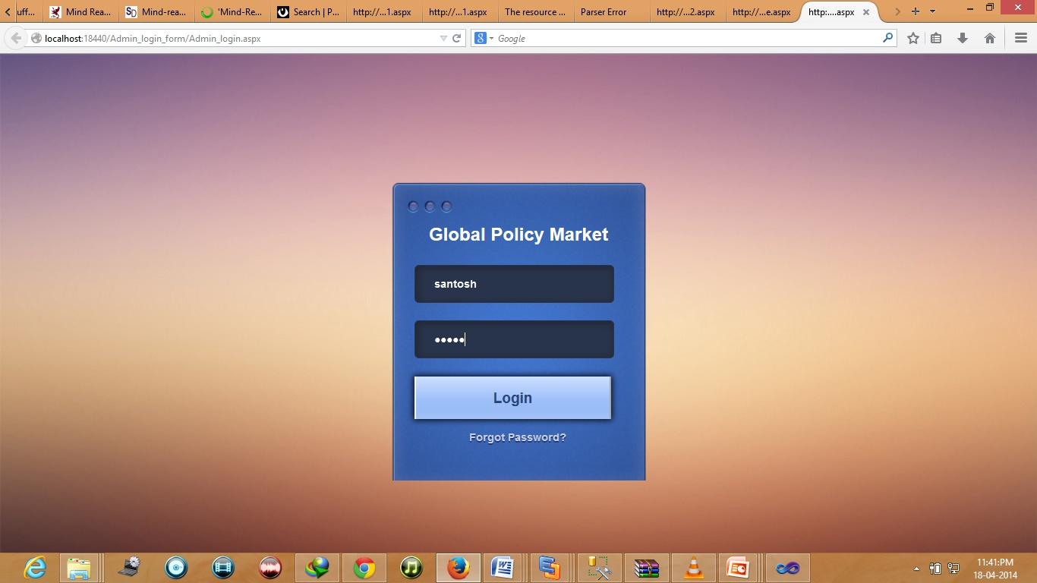

**Company Details Page**

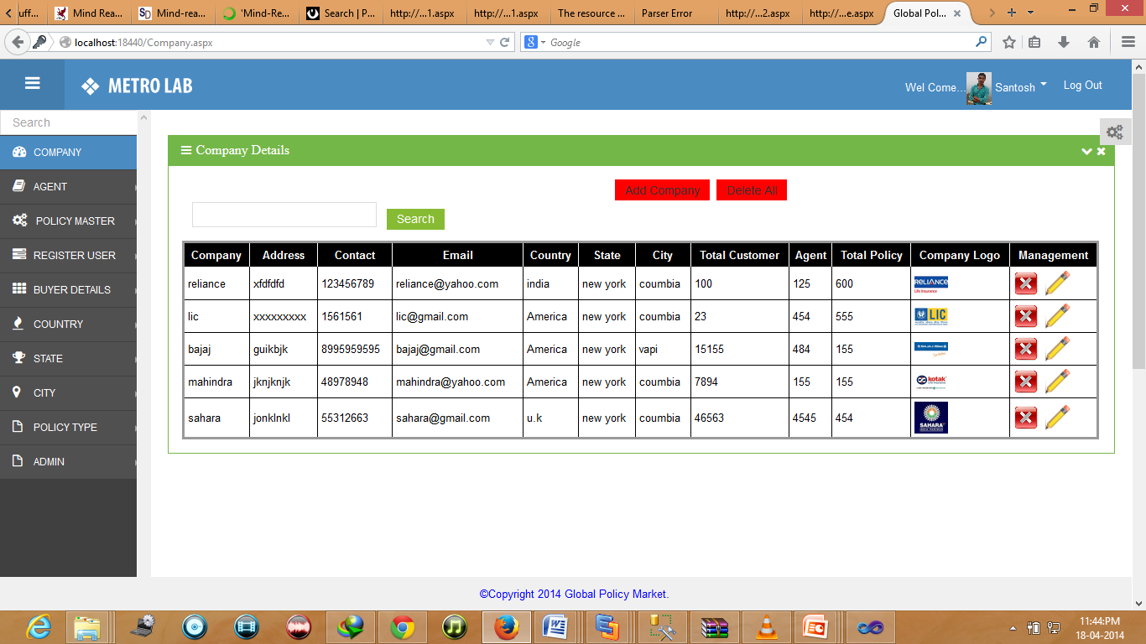

**Add New Company Details Page**

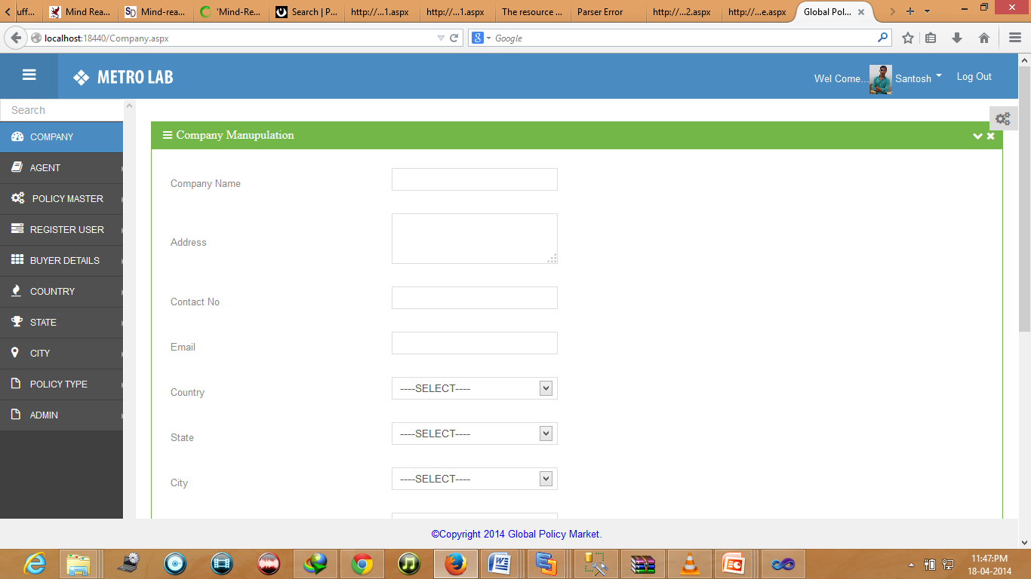

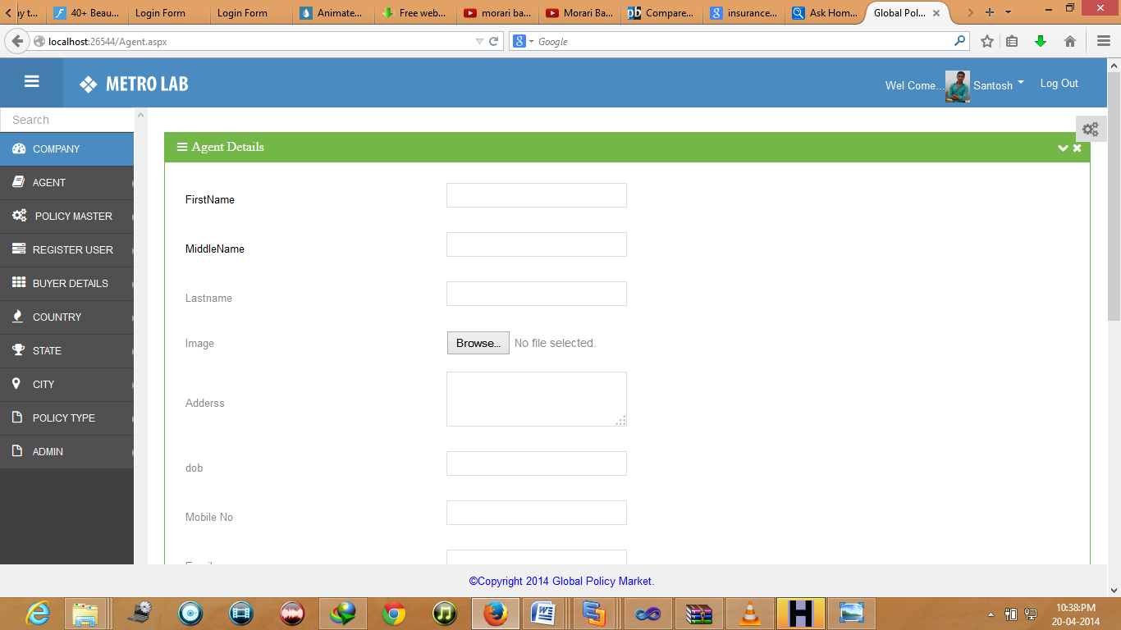

**8.SYSTEM TESTING**

* **Validate Performance.**
* **Detects Errors.**
* **Identify Inconsistencies.**

|  |
| --- |
| Test Objective |

There is strong evidence that effective requirement management leads to overall project cost savings. The three primary reasons for this are:

* Errors in requirement typically cost over 10 times more to repair than other errors.
* Requirement errors typically comprise over 40% of all errors in a software project.

The testing procedure should care for all of these, as well as, in order to attain a flawless, error-free and efficient functioning system; too, software testing is an important phase of any software development life cycle. The system presented here is a **Online Color Lab** based. Various reports and data used for the same are the core of the system. The testing, therefore, becomes important in order to maintain the cost as well as improve performance and consistency.

|  |
| --- |
| Testing Principles |

* All tests should be traceable to customer requirements.
* Tests should be planned long before testing begins.
* The Pareto principle applies to software testing.
* Testing should begin “in the small” and progress toward testing “in the large.”
* Exhaustive testing is not possible.



* **Unit Testing:**

Unit testing focuses verification effort on the smallest unit of software design – the software component or module. Using the component-level design description as a guide, important control paths are tested to uncover errors within the boundary of the module. The unit test focuses on the internal processing logic and data structures within the boundaries of a component. This type of testing can be conducted in parallel for multiple components.

* **Integration Testing:**

Integration testing is a systematic technique for constructing the software architecture while at the same time conducting tests to uncover errors associated with interfacing. The objective is to take unit tested components and build a program structure that has been dictated by design.

* **Top-down integration**

It is an incremental approach to construction of the software architecture. Modules are integrated by moving downward through the control hierarchy, beginning with the main control module.

* **Bottom-up integration**

It begins construction and testing with atomic modules. Because components are integrated from the bottom up, processing required for components subordinate to a given level is always available and the need for stubs is eliminated.

* **Validation Testing:**

In Validation testing, requirement established as part of software requirements analysis are validated against the software that has been constructed. All validation criteria are tested. Validation testing provides the final assurance that software meets all functional, behavioral and performance requirements.

The **Alpha Test** is conducted at the developer’s site by end-users. The software is used in a natural setting with the developer “looking over the shoulder” of typical users and recording errors and usage problems. It conducted in a controlled environment.

The **Beta Test** is conducted at end-user sites. Unlike alpha testing, the developer is generally not present. Therefore, the beta test is a “live” application of the software in an environment that cannot be controlled by the developer. The end-user records all problems that are encountered during beta testing and reports these to the developer at regular intervals.

* **System Testing:**

System testing is actually a series of different tests whose primary purpose is to fully exercise the computer-based system.

* **Recovery Testing**

It is a system test that forces the software to fail in a variety of ways and verifies that recovery is properly performed. If recovery is automatic, re-initialization, check pointing mechanisms, data recovery, and restart are evaluated for correctness. If recovery requires human intervention, the mean-time-to-repair is evaluated to determine whether it is within acceptable limit

* **Security Testing**

Security testing verifies that protection mechanisms built into a system will, in fact, protect it from improper penetration. During security testing, the tester plays the role(s) of the individual who desires to penetrate the system. /The role of the system designer is to make penetration cost more than the value of the information that will be obtained.

* **Stress Testing**

Stress testing executes a system in a manner that demands resources in abnormal quantity, frequency, or volume.

* **Sanity Testing:**

Sanity testing is a very basic check to see if all software components compile with each other without a problem. This is just to make sure that developers have not defined conflicting or multiple functions or global variable definitions.

* **Testing for Edit Master Tables**

|  |  |
| --- | --- |
| Test Case No | 01 |
| Description | To check whether the Editing with the master tables is done properly or not |
| Pre-Condition | Select table for editing |
| Test-actions | -Click on Edit button  -Change the value from the field  -Click on the Update button |
| Expected Result | Updated value should be displayed in the list as well in the database |
| Post-Condition | Correct record should be stored in table so that it can be retrieved afterwards |

* **Testing for Delete Master Tables**

|  |  |
| --- | --- |
| Test Case No | 02 |
| Description | To check whether the Deleting with the master tables is done properly or not |
| Pre-Condition | Select table for deleting |
| Test-actions | Click on Delete button |
| Expected Result | Selected Row will be deleted from the list as well in the database |
| Post-Condition | Selected Record must be deleted |

* **Testing for Add Master Tables**

|  |  |
| --- | --- |
| Test Case No | 03 |
| Description | To check whether the Adding data in the master tables is done properly or not |
| Pre-Condition | Select table for Adding the data |
| Test-actions | - Click on Add New button  -Specify data in the textbox  -Click on Save button |
| Expected Result | It generates new Id for the table  New ID should be added in the list as well in the database |
| Post-Condition | Correct record should be stored in table so that it can be retrieved afterwards |

* **Testing for Search in Master Tables**

|  |  |
| --- | --- |
| Test Case No | 07 |
| Description | To check whether the Searching with table is done properly or not. |
| Pre-Condition | Enter data in Search textbox |
| Test-actions | -Click on Search button |
| Expected Result | The record matching your criteria will be displayed and Highlight Search Word. |
| Post-Condition | Correct record should be stored in table so that it can be retrieved afterwards |

**9.LIMITATION &**

**ENHANCEMENT**

* This system is working when the system connected with the internet. Without internet connection it is unusable
* I you are stay working on the system and in between them occur power failure and you have no any power saving devices then your unsaved data is lost, can’t be recover it.
* Global Policy Market (GPM) System is part of functionality of various insurance management that’s why it bears too much important in organization.
* At present system client to online different company policy show and compare and online policy buy and how many company agent to show them.
* For future to add to facility company online show how many company agent ,buyer and also agent show own customers..
* For future enhancement we are thinking to extends our system which can help CEO of insurance management company in supporting their decision and also suggest decision to made new policy based on live market, And other sections and management decision are made on paper and manually We thinks these must be done computerized.
* At present out system includes insurance management module, which is only display of current submitted policy of each company. We are also thinking in the direction to improve it so that it can also generate various policy it self with combination of policy plane for different firm and sponsor,and automatically advertisement it with suitable destination. Because Insurance management has many activities to deal it is not possible that only few users in system can handle all the functions. The entire various departmentin management is spread across organization and different functions are required to be accessed by different users. So as part of future enhancement we are thinking to support our system to company by make management it self.
* In current system we are not use the more graphical report, we are use only listing report but in future we are also thinking for the graphical report which can show you chart for the report.
* We will also add to separate policy generator module which will generate policy for separate buyer based their past record and requirement without help of system administrator and market it.
* In this system also lack of functionality to protect state of power failure, so we will build our system fully protected from power failure or other cause to damage the current system data.

**10.REFERENCE**

**WEBSITE REFERENCES:-**

**www.w3Schools.com**

[**www.sureshdonnet.com**](http://www.sureshdonnet.com)

**www.free-css.com**

**www.asp.net.com**

**BOOKS REFERENCES:-**

**Asp.net Bille**

**Vb.net Black Book**