<!DOCTYPE html>

<html lang="en">

<head>

<meta charset="UTF-8">

<meta name="viewport" content="width=device-width, initial-scale=1.0">

<title>Sample Table</title>

</head>

<body>

<table border="1" cellspacing="0" cellpadding="5">

<tr align="center">

<th>FullName</th>

<th>Email</th>

<th>Mobile Number</th>

<th>City</th>

</tr>

<tr align="center">

<td>Yash Patel</td>

<td>yash_patel@gmail.com</td>

<td>8787989811</td>

<td>Rajkot</td>

</tr>

<tr align="center">

<td>Keyur Tanna</td>

<td>keyur1441@rediffmail.com</td>

<td>8874123210</td>

<td>Ahmedabad</td>

</tr>

<tr align="center">

<td>Harsh Panchal</td>

<td>harsh_panchal@yahoo.com</td>

<td>9855621232</td>

<td>Surat</td>

</tr>

<tr align="center">

<td>Jigar Makadiya</td>

<td>jmakadiya@gmail.com</td>

<td>7874636211</td>

<td>Baroda</td>

</tr>

</table>

</body>

</html>

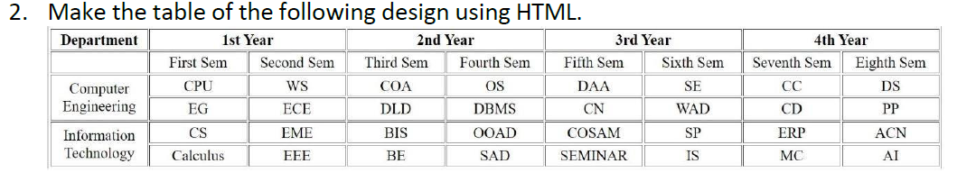

<!DOCTYPE html>

<html lang="en">

<head>

<meta charset="UTF-8">

<meta name="viewport" content="width=device-width, initial-scale=1.0">

<title>Department Table</title>

<style>

table {

width: 100%;

border-collapse: collapse;

}

th, td {

text-align: center;

}

</style>

</head>

<body>

<table border="1" cellspacing="0" cellpadding="5">

<tr>

<th rowspan="2">Department</th>

<th colspan="2">1st Year</th>

<th colspan="2">2nd Year</th>

<th colspan="2">3rd Year</th>

<th colspan="2">4th Year</th>

</tr>

<tr>

<th>First Sem</th>

<th>Second Sem</th>

<th>Third Sem</th>

<th>Fourth Sem</th>

<th>Fifth Sem</th>

<th>Sixth Sem</th>

<th>Seventh Sem</th>

<th>Eighth Sem</th>

</tr>

<tr>

<td rowspan="2">Computer Engineering</td>

<td>CPU</td>

<td>WS</td>

<td>COA</td>

<td>OS</td>

<td>DAA</td>

<td>SE</td>

<td>CC</td>

<td>DS</td>

</tr>

<tr>

<td>EG</td>

<td>ECE</td>

<td>DLD</td>

<td>DBMS</td>

<td>CN</td>

<td>WAD</td>

<td>CD</td>

<td>PP</td>

</tr>

<tr>

<td rowspan="2">Information Technology</td>

<td>CS</td>

<td>EME</td>

<td>BIS</td>

<td>OOAD</td>

<td>COSAM</td>

<td>SP</td>

<td>ERP</td>

<td>ACN</td>

</tr>

<tr>

<td>Calculus</td>

<td>EEE</td>

<td>BE</td>

<td>SAD</td>

<td>SEMINAR</td>

<td>IS</td>

<td>MC</td>

<td>AI</td>

</tr>

</table>

</body>

</html>

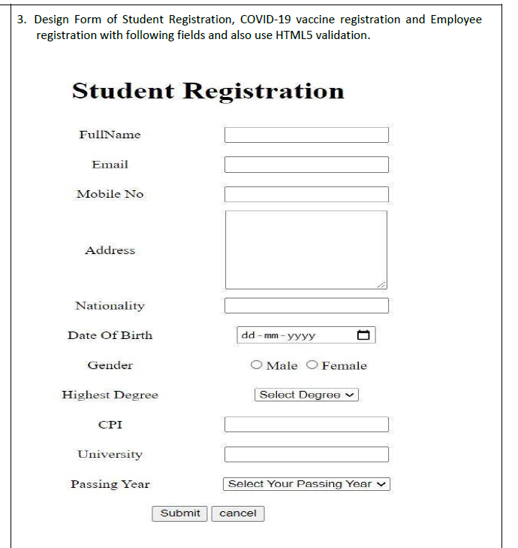

<!DOCTYPE html>

<html lang="en">

<head>

<meta charset="UTF-8">

<meta name="viewport" content="width=device-width, initial-scale=1.0">

<title>Student Registration</title>

</head>

<body>

<h1 style="text-align: center;">Student Registration</h1>

<form action="#" method="post">

<table align="center" cellpadding="5">

<tr>

<td><label for="fullname">FullName</label></td>

<td><input type="text" id="fullname" name="fullname" placeholder="Enter your full name" required></td>

</tr>

<tr>

<td><label for="email">Email</label></td>

<td><input type="email" id="email" name="email" placeholder="Enter your email" required></td>

</tr>

<tr>

<td><label for="mobile">Mobile No</label></td>

<td><input type="number" id="mobile" name="mobile" placeholder="Enter your mobile number" required></td>

</tr>

<tr>

<td><label for="address">Address</label></td>

<td><textarea id="address" name="address" rows="3" placeholder="Enter your address" required></textarea></td>

</tr>

<tr>

<td><label for="nationality">Nationality</label></td>

<td><input type="text" id="nationality" name="nationality" placeholder="Enter your nationality" required></td>

</tr>

<tr>

<td><label for="dob">Date Of Birth</label></td>

<td><input type="date" id="dob" name="dob" required></td>

</tr>

<tr>

<td>Gender</td>

<td>

<input type="radio" id="male" name="gender" value="male" required>

<label for="male">Male</label>

<input type="radio" id="female" name="gender" value="female">

<label for="female">Female</label>

</td>

</tr>

<tr>

<td><label for="degree">Highest Degree</label></td>

<td>

<select id="degree" name="degree" required>

<option value="">Select Degree</option>

<option value="bachelor">Bachelor's</option>

<option value="master">Master's</option>

<option value="phd">PhD</option>

</select>

</td>

</tr>

<tr>

<td><label for="cpi">CPI</label></td>

<td><input type="number" id="cpi" name="cpi" placeholder="Enter your CPI" step="0.01" min="0" max="10" required></td>

</tr>

<tr>

<td><label for="university">University</label></td>

<td><input type="text" id="university" name="university" placeholder="Enter your university name" required></td>

</tr>

<tr>

<td><label for="passing-year">Passing Year</label></td>

<td>

<select id="passing-year" name="passing-year" required>

<option value="">Select Your Passing Year</option>

<option value="2024">2024</option>

<option value="2023">2023</option>

<option value="2022">2022</option>

<option value="2021">2021</option>

</select>

</td>

</tr>

<tr>

<td colspan="2" align="center">

<button type="submit">Submit</button>

<button type="reset">Cancel</button>

</td>

</tr>

</table>

</form>

</body>

</html>

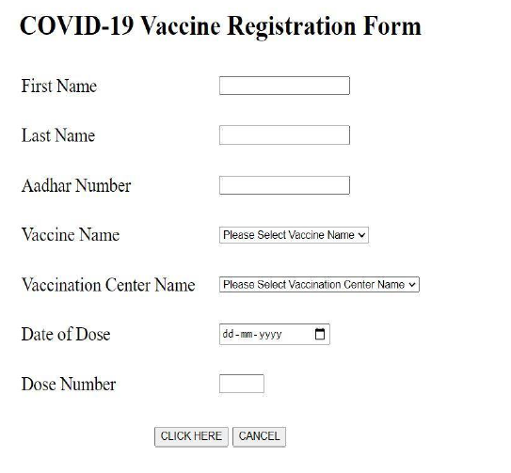

<!DOCTYPE html>

<html lang="en">

<head>

<meta charset="UTF-8">

<meta name="viewport" content="width=device-width, initial-scale=1.0">

<title>COVID-19 Vaccine Registration Form</title>

</head>

<body>

<h1>COVID-19 Vaccine Registration Form</h1>

<form action="#" method="post">

<label for="firstName">First Name:</label>

<input type="text" id="firstName" name="firstName"><br><br>

<label for="lastName">Last Name:</label>

<input type="text" id="lastName" name="lastName"><br><br>

<label for="aadhaar">Aadhar Number:</label>

<input type="text" id="aadhaar" name="aadhaar"><br><br>

<label for="vaccineName">Vaccine Name:</label>

<select id="vaccineName" name="vaccineName">

<option value="">Please Select Vaccine Name</option>

<option value="covaxin">Covaxin</option>

<option value="covishield">Covishield</option>

<option value="sputnik">Sputnik</option>

</select><br><br>

<label for="centerName">Vaccination Center:</label>

<select id="centerName" name="centerName">

<option value="">Please Select Vaccination Center Name</option>

<option value="center1">Center 1</option>

<option value="center2">Center 2</option>

<option value="center3">Center 3</option>

</select><br><br>

<label for="dateDose">Date of Dose:</label>

<input type="date" id="dateDose" name="dateDose"><br><br>

<label for="doseNumber">Dose Number:</label>

<input type="number" id="doseNumber" name="doseNumber"><br><br>

<button type="submit">CLICK HERE</button>

<button type="reset">CANCEL</button>

</form>

</body>

</html>

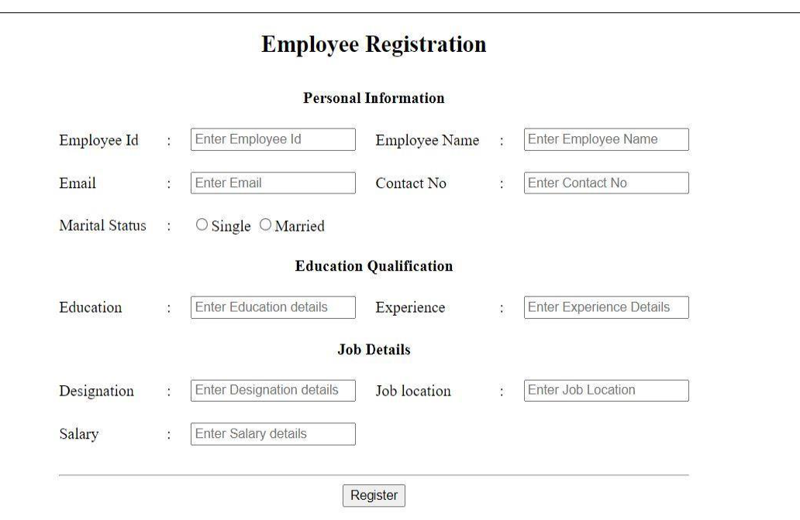

<!DOCTYPE html>

<html lang="en">

<head>

<meta charset="UTF-8">

<meta name="viewport" content="width=device-width, initial-scale=1.0">

<title>Employee Registration</title>

</head>

<body>

<h1 style="text-align: center;">Employee Registration</h1>

<form action="#" method="post">

<table cellspacing="10" align="center">

<tr><td colspan="4" align="center">

<h3>Personal Information</h3></td>

</tr>

<tr>

<td><label for="employeeId">Employee Id:</label></td>

<td><input type="text" id="employeeId" name="employeeId" placeholder="Enter Employee Id"></td>

<td><label for="employeeName">Employee Name:</label></td>

<td><input type="text" id="employeeName" name="employeeName" placeholder="Enter Employee Name"></td>

</tr>

<tr>

<td><label for="email">Email:</label></td>

<td><input type="email" id="email" name="email" placeholder="Enter Email"></td>

<td><label for="contactNo">Contact No:</label></td>

<td><input type="text" id="contactNo" name="contactNo" placeholder="Enter Contact No"></td>

</tr>

<tr>

<td><label>Marital Status:</label></td>

<td colspan="3">

<input type="radio" id="single" name="maritalStatus" value="Single">

<label for="single">Single</label>

<input type="radio" id="married" name="maritalStatus" value="Married">

<label for="married">Married</label>

</td>

</tr>

</table>

<!-- Education Qualification Section -->

<table cellspacing="10" align="center">

<tr>

<td colspan="4" align="center"><h3>Education Qualification</h3></td>

</tr>

<tr>

<td><label for="education">Education:</label></td>

<td><input type="text" id="education" name="education" placeholder="Enter Education Details"></td>

<td><label for="experience">Experience:</label></td>

<td><input type="text" id="experience" name="experience" placeholder="Enter Experience Details"></td>

</tr>

</table>

<!-- Job Details Section -->

<table cellspacing="10" align="center">

<tr>

<td colspan="4" align="center"><h3>Job Details</h3></td>

</tr>

<tr>

<td><label for="designation">Designation:</label></td>

<td><input type="text" id="designation" name="designation" placeholder="Enter Designation Details"></td>

<td><label for="jobLocation">Job Location:</label></td>

<td><input type="text" id="jobLocation" name="jobLocation" placeholder="Enter Job Location"></td>

</tr>

<tr>

<td><label for="salary">Salary:</label></td>

<td><input type="text" id="salary" name="salary" placeholder="Enter Salary Details"></td>

<td></td>

<td></td>

</tr>

</table>

<!-- Submit Button -->

<div style="text-align: center; margin-top: 20px;">

<button type="submit">Register</button>

</div>

</form>

</body>

</html>