**1.** **Design and develop the given pages using Bootstrap**

<!DOCTYPE html>

<html lang="en">

<head>

    <meta charset="utf-8" />

    <meta name="viewport" content="width=device-width, initial-scale=1" />

    <title>Lab-11 Layout Part A</title>

    <link href="https://cdn.jsdelivr.net/npm/bootstrap@5.3.3/dist/css/bootstrap.min.css" rel="stylesheet"

        integrity="sha384-QWTKZyjpPEjISv5WaRU9OFeRpok6YctnYmDr5pNlyT2bRjXh0JMhjY6hW+ALEwIH" crossorigin="anonymous" />

</head>

<body class="p-5">

    <div class="d-flex bg-dark flex-wrap justify-content-between p-1">

        <div class="h3 text-light">LOGO</div>

        <div>

            <ul class="nav nav-pills px-3 pt-2">

                <li class="nav-item"><a href="#" class="nav-link disables text-light">Home</a></li>

                <li class="nav-item"><a href="#" class="nav-link disables text-secondary">Contact</a></li>

                <li class="nav-item"><a href="#" class="nav-link disables text-secondary">About Us</a></li>

                <li class="nav-item"><a href="#" class="nav-link disables text-secondary">Massages <span

                            class="badge text-bg-success">12</span></a></li>

            </ul>

        </div>

    </div>

    <p class="fs-1 fw-bolder">Dashboard:</p>

    <table class="table table-striped">

        <thead>

            <tr>

                <th scope="col">Name</th>

                <th scope="col">Team</th>

                <th scope="col">All Star</th>

                <th scope="col">Remove</th>

            </tr>

        </thead>

        <tbody>

            <tr>

                <td>Steph</th>

                <td>Warriors</td>

                <td>Yes</td>

                <td><svg xmlns="http://www.w3.org/2000/svg" width="25" height="25" fill="red"

                        class="bi bi-x-square-fill" viewBox="0 0 16 16">

                        <path

                            d="M2 0a2 2 0 0 0-2 2v12a2 2 0 0 0 2 2h12a2 2 0 0 0 2-2V2a2 2 0 0 0-2-2zm3.354 4.646L8 7.293l2.646-2.647a.5.5 0 0 1 .708.708L8.707 8l2.647 2.646a.5.5 0 0 1-.708.708L8 8.707l-2.646 2.647a.5.5 0 0 1-.708-.708L7.293 8 4.646 5.354a.5.5 0 1 1 .708-.708" />

                    </svg></td>

            </tr>

            <tr>

                <td>Lebron</th>

                <td>Cavaliers</td>

                <td>Yes</td>

                <td><svg xmlns="http://www.w3.org/2000/svg" width="25" height="25" fill="red"

                        class="bi bi-x-square-fill" viewBox="0 0 16 16">

                        <path

                            d="M2 0a2 2 0 0 0-2 2v12a2 2 0 0 0 2 2h12a2 2 0 0 0 2-2V2a2 2 0 0 0-2-2zm3.354 4.646L8 7.293l2.646-2.647a.5.5 0 0 1 .708.708L8.707 8l2.647 2.646a.5.5 0 0 1-.708.708L8 8.707l-2.646 2.647a.5.5 0 0 1-.708-.708L7.293 8 4.646 5.354a.5.5 0 1 1 .708-.708" />

                    </svg></td>

            </tr>

            <tr>

                <td>Dwayne</th>

                <td>Heat</td>

                <td>Yes</td>

                <td><svg xmlns="http://www.w3.org/2000/svg" width="25" height="25" fill="red"

                        class="bi bi-x-square-fill" viewBox="0 0 16 16">

                        <path

                            d="M2 0a2 2 0 0 0-2 2v12a2 2 0 0 0 2 2h12a2 2 0 0 0 2-2V2a2 2 0 0 0-2-2zm3.354 4.646L8 7.293l2.646-2.647a.5.5 0 0 1 .708.708L8.707 8l2.647 2.646a.5.5 0 0 1-.708.708L8 8.707l-2.646 2.647a.5.5 0 0 1-.708-.708L7.293 8 4.646 5.354a.5.5 0 1 1 .708-.708" />

                    </svg></td>

            </tr>

            <tr>

                <td>Kobe</th>

                <td>Lakers</td>

                <td>Yes <span class="badge text-bg-warning">last</span></td>

                <td><svg xmlns="http://www.w3.org/2000/svg" width="25" height="25" fill="red"

                        class="bi bi-x-square-fill" viewBox="0 0 16 16">

                        <path

                            d="M2 0a2 2 0 0 0-2 2v12a2 2 0 0 0 2 2h12a2 2 0 0 0 2-2V2a2 2 0 0 0-2-2zm3.354 4.646L8 7.293l2.646-2.647a.5.5 0 0 1 .708.708L8.707 8l2.647 2.646a.5.5 0 0 1-.708.708L8 8.707l-2.646 2.647a.5.5 0 0 1-.708-.708L7.293 8 4.646 5.354a.5.5 0 1 1 .708-.708" />

                    </svg></td>

            </tr>

            <tr>

                <td>Isaiah</th>

                <td>Celtics</td>

                <td>Yes <span class="badge text-bg-success text-light">First</span></td>

                <td><svg xmlns="http://www.w3.org/2000/svg" width="25" height="25" fill="red"

                        class="bi bi-x-square-fill" viewBox="0 0 16 16">

                        <path

                            d="M2 0a2 2 0 0 0-2 2v12a2 2 0 0 0 2 2h12a2 2 0 0 0 2-2V2a2 2 0 0 0-2-2zm3.354 4.646L8 7.293l2.646-2.647a.5.5 0 0 1 .708.708L8.707 8l2.647 2.646a.5.5 0 0 1-.708.708L8 8.707l-2.646 2.647a.5.5 0 0 1-.708-.708L7.293 8 4.646 5.354a.5.5 0 1 1 .708-.708" />

                    </svg></td>

            </tr>

        </tbody>

    </table>

    <p class="fs-2 fw-bolder">Todos:</p>

    <ul class="list-group">

        <li class="list-group-item list-group-item-success">Feel good about Bootstrap</li>

        <li class="list-group-item list-group-item-info">Feel informed about Bootstrap</li>

        <li class="list-group-item list-group-item-warning">Feel warned about Bootstrap</li>

        <li class="list-group-item list-group-item-warning">Maybe I should read the docs...</li>

        <li class="list-group-item list-group-item-danger">Danger Zone</li>

        <li class="list-group-item list-group-item-danger">I really should read the docs...</li>

    </ul>

    <script src="https://cdn.jsdelivr.net/npm/bootstrap@5.3.3/dist/js/bootstrap.bundle.min.js"

        integrity="sha384-YvpcrYf0tY3lHB60NNkmXc5s9fDVZLESaAA55NDzOxhy9GkcIdslK1eN7N6jIeHz"

        crossorigin="anonymous"></script>

</body>

</html>

**OUTPUT**

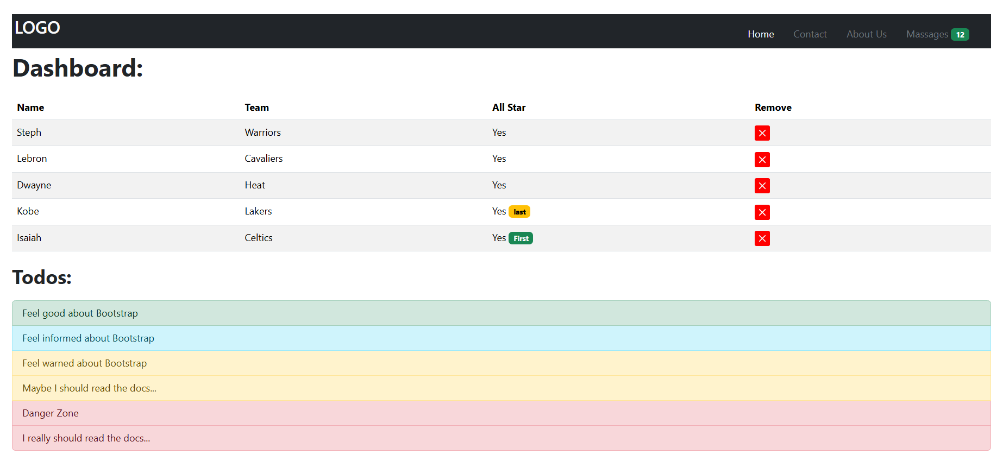

**2.** **Design and develop the given pages using Bootstrap**

<!DOCTYPE html>

<html lang="en">

<head>

    <meta charset="utf-8">

    <meta name="viewport" content="width=device-width, initial-scale=1">

    <title>Lab-11 Layout Part B</title>

    <link href="https://cdn.jsdelivr.net/npm/bootstrap@5.3.3/dist/css/bootstrap.min.css" rel="stylesheet">

</head>

<body>

    <nav class="navbar bg-dark">

        <div class="container-fluid ">

            <a class="navbar-brand  text-secondary text-start mx-3">Project Name</a>

            <form class="d-flex gap-3">

                <input class="form-control w-50 h-100" type="email" placeholder="Email" aria-label="email">

                <input class="form-control w-50 h-100" type="password" placeholder="Password" aria-label="password">

                <button class="btn btn-success btn-sm  px-4" type="submit">Signin</button>

            </form>

        </div>

    </nav>

    <!-- Jumbotron -->

    <div class="container-fluid">

        <div class="p-5 mb-4 bg-light rounded">

            <h1 class="display-4">Hello, world!</h1>

            <p class="lead">

                This is a template for a simple marketing or informational website. It includes a large callout

                called a jumbotron and three supporting pieces of content. Use it as a starting point to create something more unique.

            </p>

            <button class="btn btn-primary">Learn more &raquo;</button>

        </div>

    </div>

    <!-- Three Columns Section -->

    <div class="container-fluid p-5">

        <div class="row">

            <div class="col-md-4">

                <h2>Heading</h2>

                <p>Donec id elit non mi porta gravida at eget metus. Fusce dapibus, tellus ac cursus commodo.</p>

                <button class="btn btn-outline-secondary">View details &raquo;</button>

            </div>

            <div class="col-md-4">

                <h2>Heading</h2>

                <p>Donec id elit non mi porta gravida at eget metus. Fusce dapibus, tellus ac cursus commodo.</p>

                <button class="btn btn-outline-secondary">View details &raquo;</button>

            </div>

            <div class="col-md-4">

                <h2>Heading</h2>

                <p>Donec sed odio dui. Cras justo odio, dapibus ac facilisis in, egestas eget quam.</p>

                <button class="btn btn-outline-secondary">View details &raquo;</button>

            </div>

        </div>

    </div>

    <!-- Footer -->

    <footer class="mx-5 mt-5 mb-3 text-muted">

        &copy; Company 2014

    </footer>

</body>

</html>

**OUTPUT**

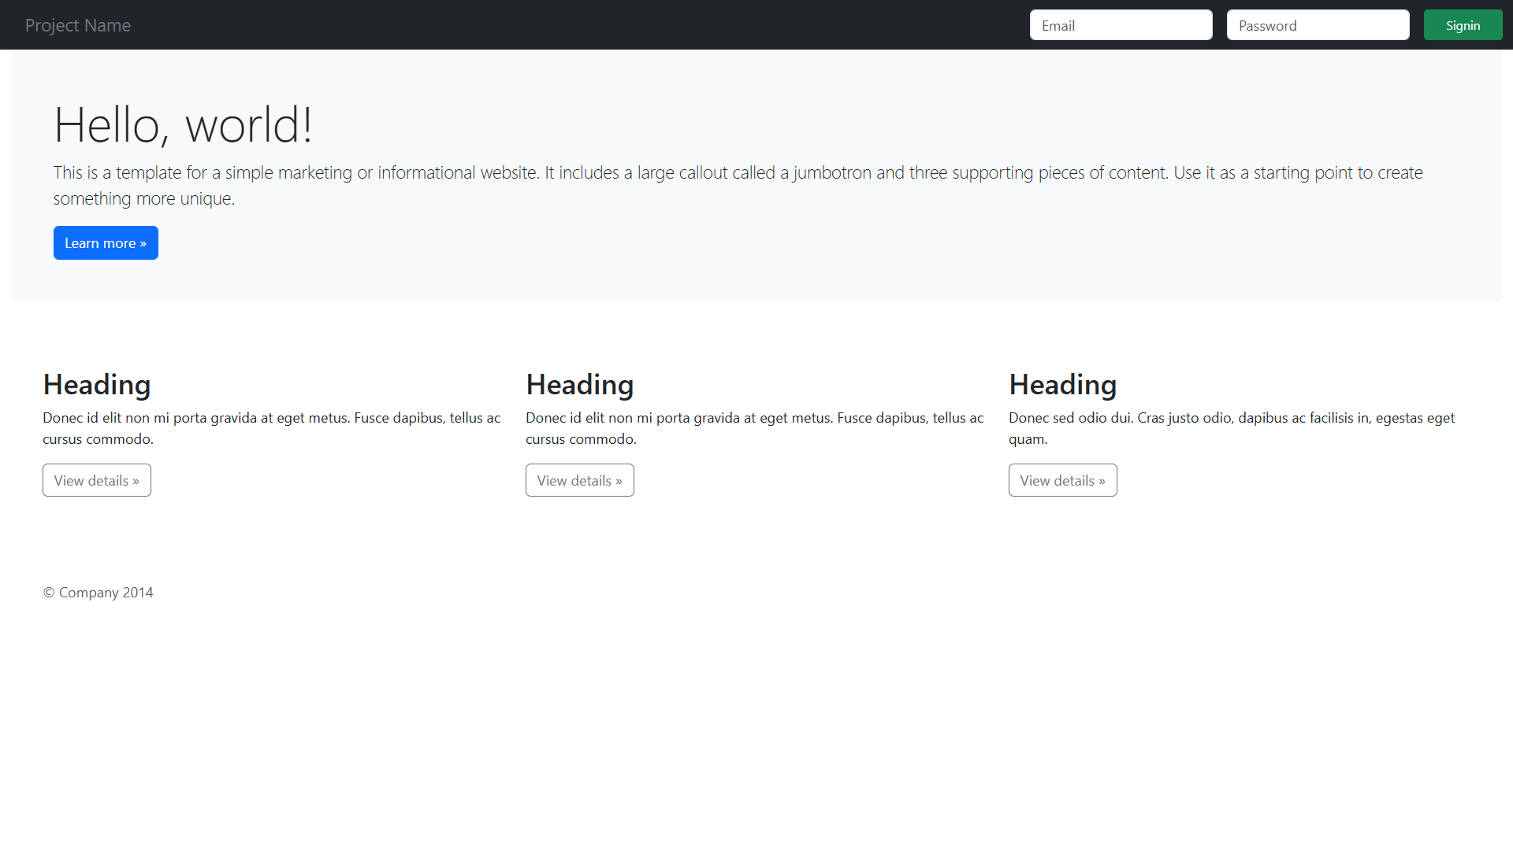

**3. Design and develop the given pages using Bootstrap**

<!DOCTYPE html>

<html lang="en">

<head>

    <meta charset="UTF-8">

    <meta name="viewport" content="width=device-width, initial-scale=1">

    <title>Bootstrap Pricing Table</title>

    <link href="https://cdn.jsdelivr.net/npm/bootstrap@5.3.0/dist/css/bootstrap.min.css" rel="stylesheet">

</head>

<body>

<!-- Navigation Bar -->

<nav class="navbar navbar-light bg-light px-3">

    <a class="navbar-brand">Company name</a>

    <div>

        <a href="#" class="me-3 text-dark text-decoration-none">Enterprise</a>

        <a href="#" class="me-3 text-dark text-decoration-none">Features</a>

        <a href="#" class="me-3 text-dark text-decoration-none">Support</a>

        <a href="#" class="me-3 text-dark text-decoration-none">Pricing</a>

        <a href="#" class="btn btn-outline-primary">Sign up</a>

    </div>

</nav>

<!-- Pricing Section -->

<div class="container text-center my-5">

    <h2 class="fw-bold">Pricing</h2>

    <p class="text-muted">Quickly build an effective pricing table for your potential customers with this Bootstrap example.</p>

    <div class="row row-cols-1 row-cols-md-3 g-4 mt-4">

        <!-- Free Plan -->

        <div class="col">

            <div class="card shadow-sm">

                <div class="card-header text-center">

                    <h4 class="fw-normal">Free</h4>

                </div>

                <div class="card-body">

                    <h2 class="card-title">$0 <small class="text-muted">/ mo</small></h2>

                    <ul class="list-unstyled mt-3 mb-4">

                        <li>10 users included</li>

                        <li>2 GB of storage</li>

                        <li>Email support</li>

                        <li>Help center access</li>

                    </ul>

                    <a href="#" class="btn btn-outline-primary w-100">Sign up for free</a>

                </div>

            </div>

        </div>

        <!-- Pro Plan -->

        <div class="col">

            <div class="card shadow-sm">

                <div class="card-header text-center">

                    <h4 class="fw-normal">Pro</h4>

                </div>

                <div class="card-body">

                    <h2 class="card-title">$15 <small class="text-muted">/ mo</small></h2>

                    <ul class="list-unstyled mt-3 mb-4">

                        <li>20 users included</li>

                        <li>10 GB of storage</li>

                        <li>Priority email support</li>

                        <li>Help center access</li>

                    </ul>

                    <a href="#" class="btn btn-primary w-100">Get started</a>

                </div>

            </div>

        </div>

        <!-- Enterprise Plan -->

        <div class="col">

            <div class="card shadow-sm">

                <div class="card-header text-center">

                    <h4 class="fw-normal">Enterprise</h4>

                </div>

                <div class="card-body">

                    <h2 class="card-title">$29 <small class="text-muted">/ mo</small></h2>

                    <ul class="list-unstyled mt-3 mb-4">

                        <li>30 users included</li>

                        <li>15 GB of storage</li>

                        <li>Phone and email support</li>

                        <li>Help center access</li>

                    </ul>

                    <a href="#" class="btn btn-primary w-100">Contact us</a>

                </div>

            </div>

        </div>

    </div>

</div>

<script src="https://cdn.jsdelivr.net/npm/bootstrap@5.3.0/dist/js/bootstrap.bundle.min.js"></script>

</body>

</html>

**OUTPUT**

