**1. Demonstrate gradient in CSS.**

<!DOCTYPE html>

<html lang="en">

<head>

    <meta charset="UTF-8">

    <meta name="viewport" content="width=device-width, initial-scale=1.0">

    <title>Gradient</title>

    <style>

        .container{

            display: flex;

        }

        .first{

            border: 1px solid black;

            height: 500px;

            width: 500px;

            margin: auto;

            background-image: linear-gradient(to bottom right,red ,yellow );

        }

        .second{

            border: 1px solid black;

            height: 500px;

            width: 500px;

            margin: auto;

            background-image: radial-gradient(ellipse,red,green,yellow);

        }

    </style>

</head>

<body>

    <div class="container">

        <div class="first"></div>

        <div class="second"></div>

    </div>

</body>

</html>

**OUTPUT**

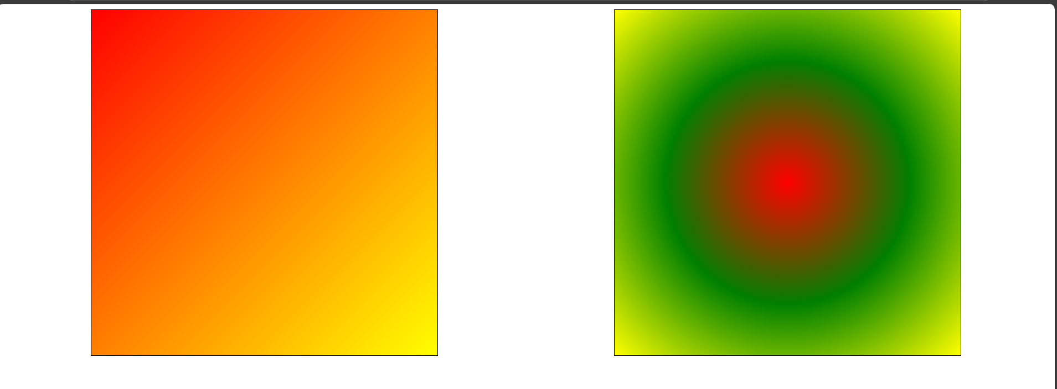

**2. Write an HTML snippet with CSS for following effects:**

* **Link after visited red color before visited orange color.**
* **Add special style(change color, font size etc) to first line of paragraph.**

<!DOCTYPE html>

<html lang="en">

<head>

<meta charset="UTF-8">

<meta name="viewport" content="width=device-width, initial-scale=1.0">

<title>Styled Links & Paragrap h</title>

<style>

a:link { /* pseudo class */

color: orange;

}

a:visited { /* pseudo class */

color: blue;

}

p::first-line { /* pseudo element */

color: blue;

font-size: 1.5em;

font-weight: bold;

}

</style>

</head>

<body>

<a href="https://darshan.ac.in/">DU</a>

<p>Lorem ipsum dolor sit amet consectetur adipisicing elit. Blanditiis deserunt facilis corrupti accusantium,

veritatis voluptate harum? Ad delectus iste vero, libero impedit, expedita corrupti, non soluta eos repudiandae

consequuntur numquam.</p>

</body>

</html>

**OUTPUT**

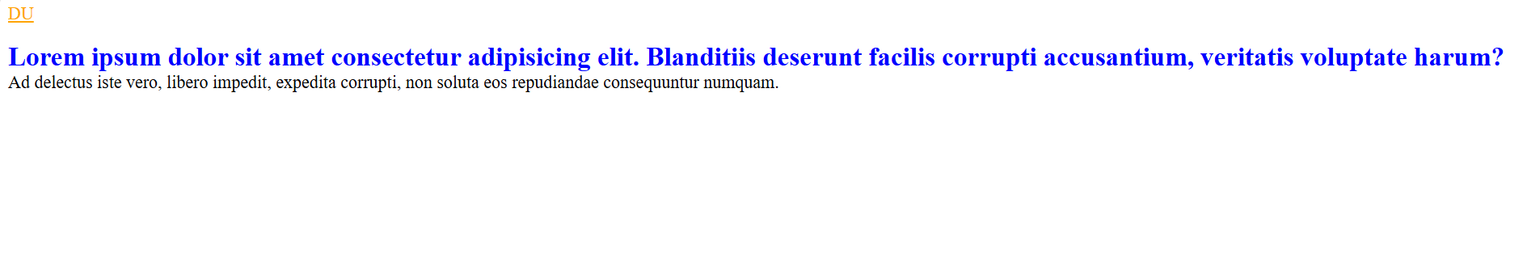

**3. Write an HTML snippet with CSS for following effects:**

* **Add special style (change color,font size etc) to first letter of paragraph**
* **Change background color to yellow when user select particular text**
* **Add special style to an element when user mouse over it.**

<!DOCTYPE html>

<html lang="en">

<head>

<meta charset="UTF-8">

<meta name="viewport" content="width=device-width, initial-scale=1.0">

<title>Document</title>

<style>

p::first-letter{ /* pseudo element */

font-size: large;

color: red;

font-weight: bold;

}

p::selection{ /* pseudo element */

background-color: yellow;

}

h5:hover{ /* pseudo class */

background-color:aliceblue;

color:gray;

}

</style>

</head>

<body>

<p>Lorem ipsum dolor sit amet consectetur adipisicing elit. Non cumque eum repellat quas voluptatem adipisci, itaque

delectus maxime ipsam est. Eveniet, numquam! Porro corporis necessitatibus minima doloremque itaque nemo neque!

</p>

<h5>This sentence change style when u over the mouse</h5>

</body>

</html>

**OUTPUT**

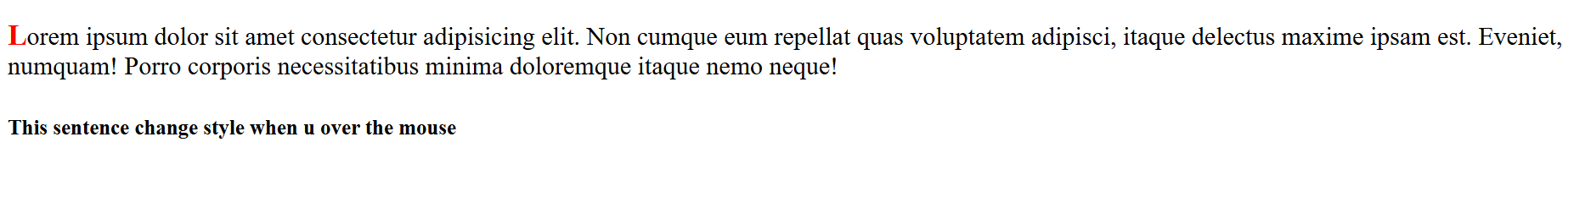

psuedo class : https://www.w3schools.com/cssref/css_ref_pseudo_classes.php

psuedo element : https://www.w3schools.com/cssref/css_ref_pseudo_elements.php