**Lab Practical #01:**

Study of basic networking commands and IP configuration.

**Practical Assignment #01:**

1. Perform and explain various networking commands listed below:
   1. ipconfig
   2. ping
   3. getmac
   4. systeminfo
   5. traceroute / tracert
   6. netstat
   7. nslookup
   8. hostname
   9. pathping
   10. arp

## ipconfig

### Description:

Ipconfig displays all current TCP/IP network configuration values. It shows IP address, subnet mask, and default gateway for all adapters.

|  |  |  |
| --- | --- | --- |
| No. | Option | Description |
| 1 | /all | Display full configuration information. |
| 2 | /release | Release the IPV4 address for specific for the specific adapter. |
| 3 | /renew | Renew the IPv4 address for the specified adapter. |
| 4 | /flushhdns | Purges the DNS Resolver cache. |
| 5 | /displaydns | Display the contents of the DNS Resolver Cache. |

### Implementation:

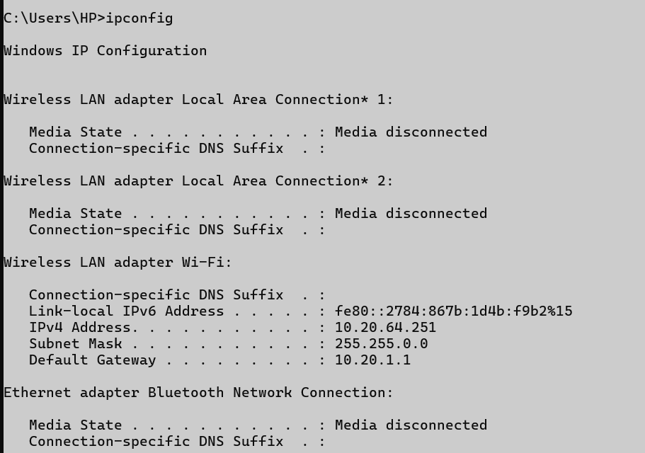

## ping

### Description:

Ping checks the connection between the source host and a destination IP or domain

|  |  |  |
| --- | --- | --- |
| No. | Option | Description |
| 1 | -t | Ping the specified host until stopped. |
| 2 | -a | Resolve addresses to hostnames. |
| 3 | -n count | Number of echo requests to send. |
| 4 | -l size | Send buffer size. |
| 5 | -i TTL | Time To Live. |

### Implementation:

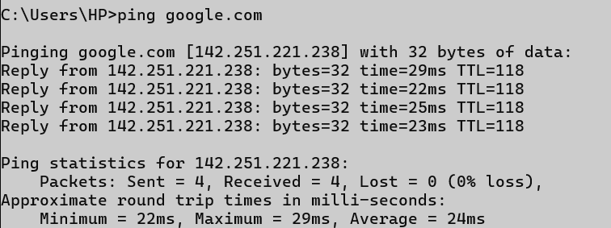

## getmac

### Description:

Getmac displays the MAC addresses for all network adapter on the system

|  |  |  |
| --- | --- | --- |
| No. | Option | Description |
| 1 | /S system | Specifies the remote system to connect to. |
| 2 | /U [domain\]user | Specifies the user context under which the command should execute. |
| 3 | /P [password] | Specifies the password for the given context. Prompts for input if omitted. |
| 4 | /FO format | Specifies the format in which the output is to be displayed. |
| 5 | /V | Specifies that verbose output is displayed. |

### Implementation:

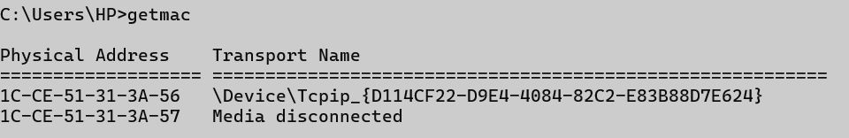

## systeminfo

### Description:

Systeminfo provides detailed configuration information about the computer and its OS.

|  |  |  |
| --- | --- | --- |
| No. | Option | Description |
| 1 | /S system | Specifies the remote system to connect to. |
| 2 | /U [domain\]user | Specifies the user context under which the command should execute. |
| 3 | /P [password] | Specifies the password for the given context. Prompts for input if omitted. |
| 4 | /FO format | Specifies the format in which the output is to be displayed. |
| 5 | /NH | Specifies that the "Column Header" should not be displayed in the output. |

### Implementation:

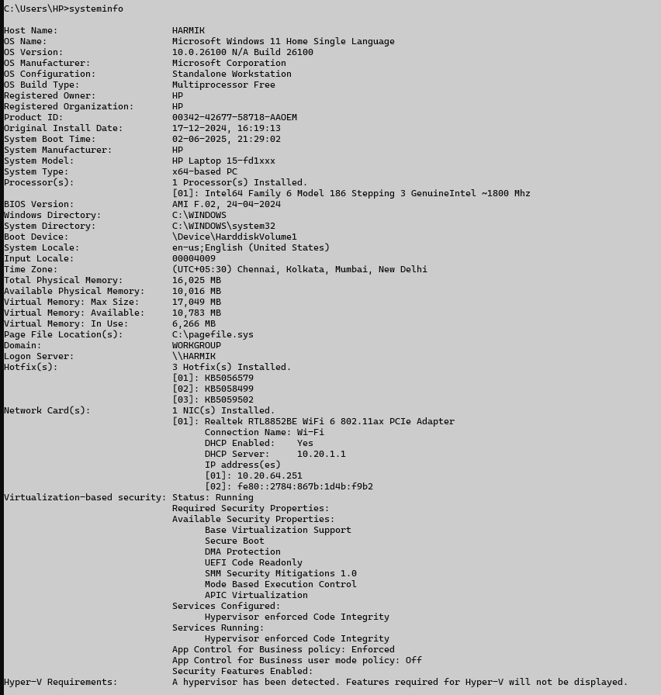

## traceroute / tracert

### Description:

Shows the path the packets take to a destination.

|  |  |  |
| --- | --- | --- |
| No. | Option | Description |
| 1 | -d | Do not resolve addresses to hostnames. |
| 2 | -h maximum_hops | Maximum number of hops to search for target. |
| 3 | -j host-list | Loose source route along host-list (IPv4-only). |
| 4 | -4 | Force using IPv4. |
| 5 | -6 | Force using IPv6. |

### Implementation:

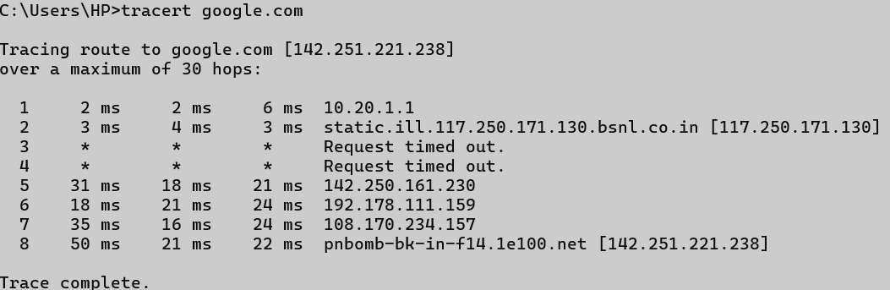

## netstat

### Description:

Display network connections, routing tables, interface stats, etc.

|  |  |  |
| --- | --- | --- |
| No. | Option | Description |
| 1 | -a | Displays all connections and listening ports. |
| 2 | -b | Displays the executable involved in creating each connection or listening port. In some cases well-known executables host multiple independent components, and in these cases the sequence of components involved in creating the connection or listening port is displayed. In this case the executable name is in [] at the bottom, on top is the component it called, and so forth until TCP/IP was reached. Note that this option can be time-consuming and will fail unless you have sufficient permissions. |
| 3 | -c | Displays a list of processes sorted by the number of TCP or UDP ports currently consumed. |
| 4 | -d | Displays DSCP value assocated with each connection. |
| 5 | -e | Displays Ethernet statistics. This may be combined with the -s option. |

### Implementation:

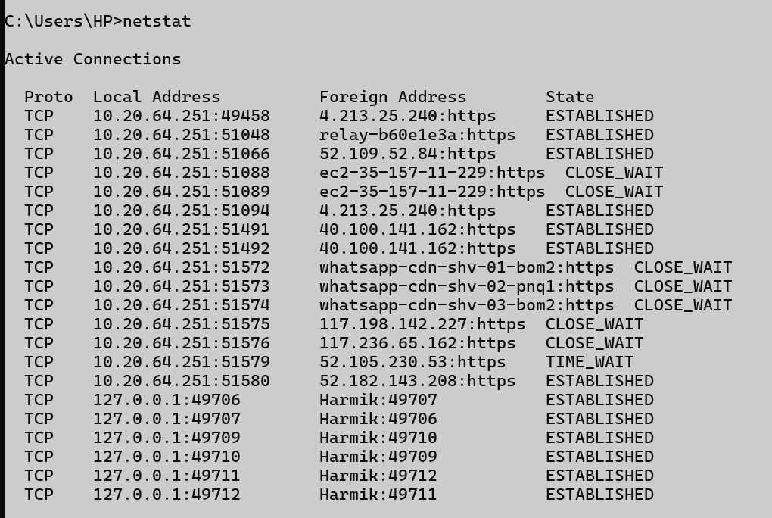

## nslookup

### Description:

Query internet name servers to get domain name or IP address mapping.

|  |  |  |
| --- | --- | --- |
| No. | Option | Description |
| 1 | -g host-list | Loose source route along host-list. |
| 2 | -h maximum_hops | Maximum number of hops to search for target. |
| 3 | -i address | Use the specified source address. |
| 4 | -n | Do not resolve addresses to hostnames. |
| 5 | -p period | Wait period milliseconds between pings. |

### Implementation:

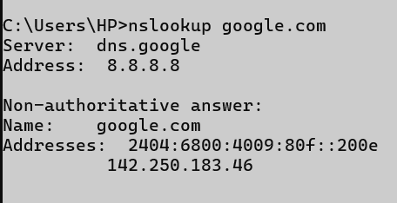

## hostname

### Description:

Display the name of the current system.

### Implementation:



## pathping

### Description:

Combines the features of ping and tracert to identify network problems.

|  |  |  |
| --- | --- | --- |
| No. | Option | Description |
| 1 | -g host-list | Loose source route along host-list. |
| 2 | -h maximum_hops | Maximum number of hops to search for target. |
| 3 | -i address | Use the specified source address. |
| 4 | -n | Do not resolve addresses to hostnames. |
| 5 | -p period | Wait period milliseconds between pings. |

### Implementation:

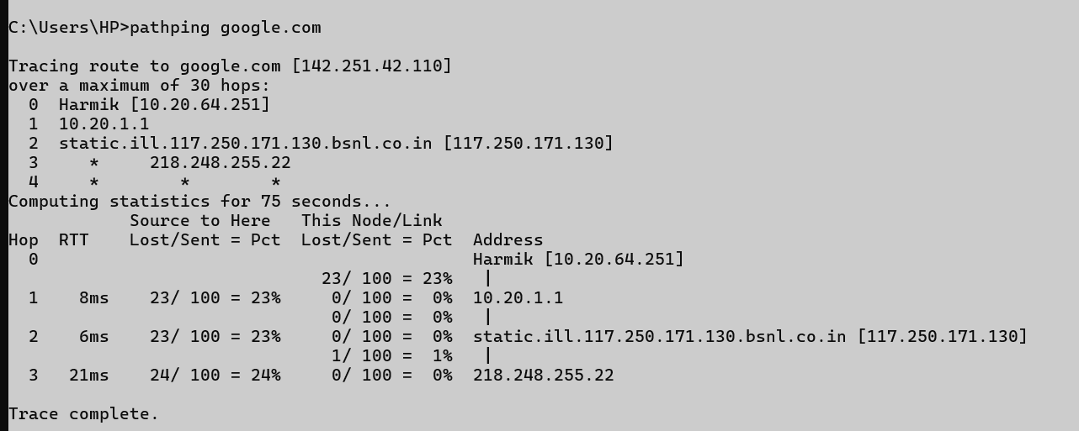

## arp

### Description:

Displays and modifies the IP-to-Physical address translation table.

|  |  |  |
| --- | --- | --- |
| No. | Option | Description |
| 1 | -a | Displays current ARP entries by interrogating the current protocol data. If inet_addr is specified, the IP and Physical addresses for only the specified computer are displayed. If more than one network interface uses ARP, entries for each ARP table are displayed. |
| 2 | -g | Displays current ARP entries by interrogating the current protocol data. If inet_addr is specified, the IP and Physical addresses for only the specified computer are displayed. If more than one network interface uses ARP, entries for each ARP table are displayed. |
| 3 | -v | Displays current ARP entries in verbose mode. All invalid entries and entries on the loop-back interface will be shown. |
| 4 | -d | Deletes the host specified by inet_addr. inet_addr may be wildcarded with * to delete all hosts. |
| 5 | -s | Adds the host and associates the Internet address inet_addr with the Physical address eth_addr. The Physical address is given as 6 hexadecimal bytes separated by hyphens. The entry is permanent. |

### Implementation:

