**Lab Practical #03:**

Study of different types of network cables & connectors and crimping a LAN.

**Practical Assignment #03:**

1. List various networks cable. Also, write short description.
2. Difference between guided and unguided media.
3. Give cross-wired cable and straight through cable diagram (Color Code wise).

## List various networks cable and connectors. Also, write short description.

* **Cabels:**

1. **Twisted Pair:** 
   * **Description**:

* It is physical media made up of a pair of cables twisted with each other.
* It is cheap as compared to other transmission media.
* Installation of the cable is easy, and it is a lightweight cable.
* The frequency range for cable is from 0 to 3.5KHz.
* It consists of two insulated copper wires arrange in a regular spiral pattern.
* The degree of reduction in noise interference is determined by the number of turns per foot.
* Increasing the number of turns per foot decreases noise interference.
* Separately insulated.
* It is widely used in different kinds of data and voice infrastructure.
* The use of two wires twisted together helps to reduce crosstalk and electromagnetic induction.
* Two types of twisted pair cable:
* Unshielded Twisted Pair Cable : It consists of pairs of copper wires twisted together without any shielding.
* Shielded Twisted Pair Cabel : Similar to UTP but with an additional shielding layer (metallic foil or braid) around the pairs.
  + **Diagram**:

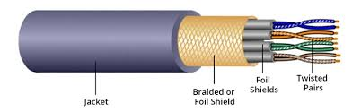

1. **Coaxial Cabel:**
   * **Description**:

* Outer conductor is braided shield.
* Inner conductor is solid metal.
* Separated by insulating material, and whole cover by plastic cover.
* The middle core is responsible for the data transferring whereas the copper mesh prevents from the EMI (Electromagnetic interference).
* Used in television, long distance telephone transmission.
* It has excellent noise immunity.
* It has a higher frequency as compared to Twisted pair cable.
* Two types of coaxial cable:
* Baseband transmission: It is defined as the process of transmitting a single single at high speed.
* Broadband transmission: It is defined as the process of transmitting multiple signals simultaneously.
  + **Diagram**:

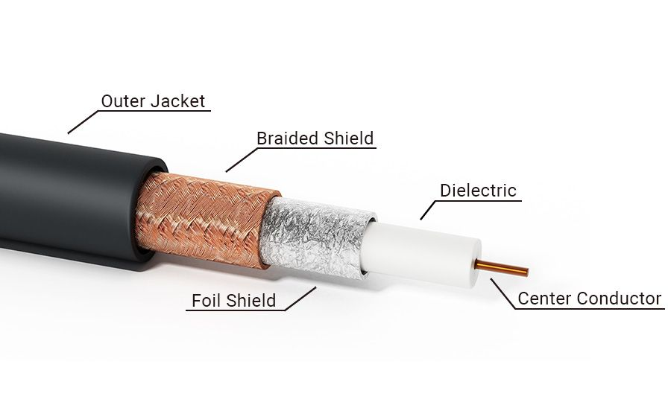

1. **Fiber Optic Cable**
   * **Description**:

* A fiber-optic cable is made of glass or plastic and transmits signals in form of light.
* A glass or plastic core is surrounded by a cladding of less dense glass or plastic.
* The difference in density of the two materials must be such that a beam of light moving through a core is reflected off the cladding instead of being refracted into it.
* Optical fibers use reflection to guide light through a channel.
* Core: The optical fiber consists of a narrow stand of glass or plastic known as a core.
* Cladding: The concentric layer of glass is known as cladding.
* Jaket: The protective coating consisting of plastic is known as a jacket.
* Light travels in a straight line as long as it is moving through a single uniform substance.
  + **Diagram**:

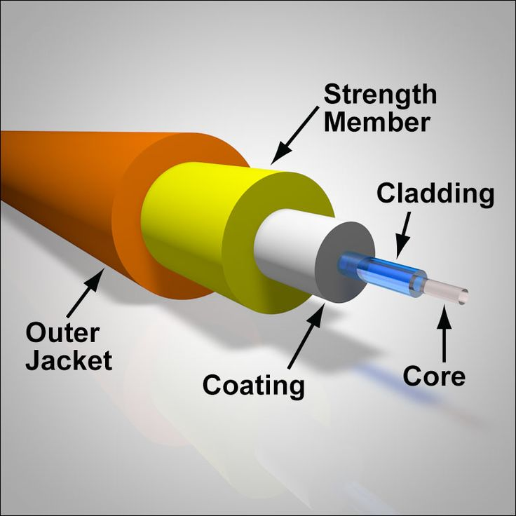

* **Connectors:**

1. **RJ-45 Connector**
   * **Description**:

* Most common connector for UTP/STP cables in Ethernet networks.
* Used to connect computers, routers, switches, etc.
* Has 8 pins for data transmission.
  + **Diagram**:

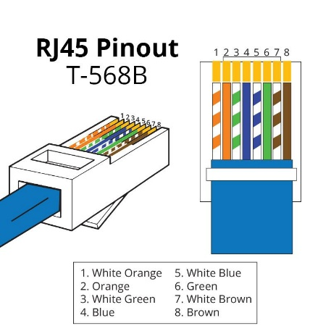

1. **BNC Connector**
   * **Description**:

* Used with coaxial cables.
* Commonly used in CCTV, radio, and older Ethernet networks.
* Provides a secure and quick connection.
  + **Diagram**:

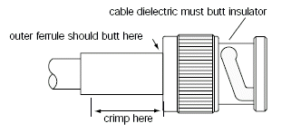

1. **F-Type Connector**
   * **Description**:

* Used with coaxial cables for cable TV and satellite connections.
* Provides a screw-type connection for stability.
  + **Diagram**:

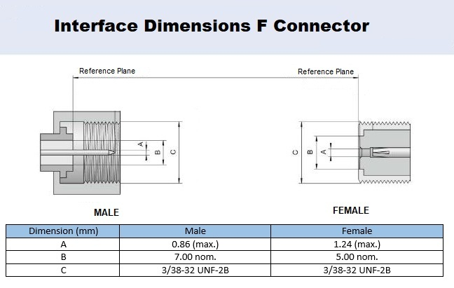

1. **LC, SC, ST Connectors (Fiber Optic)**
   * **Description**:

* Used to connect fiber optic cables.
* Provide high-speed, stable connections for internet and backbone networks.
* LC is compact, SC is square-shaped, and ST has a bayonet-style twist lock.
  + **Diagram**:

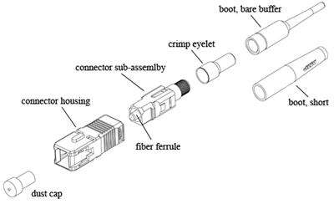

1. **Difference between guided and unguided media.**

|  |  |  |
| --- | --- | --- |
| **No.** | **Guided Media** | **Unguided Media** |
| **1** | The guided media is also called wired communication or bounded transmission media. | The unguided media is also called wireless communication or unbounded transmission media |
| **2** | The signal energy propagates through wires in guided media. | The signal energy propagates through the air in unguided media. |
| **3** | Used to perform point-to-point communication. | Unguided media is generally suited for radio broadcasting in all direction. |
| **4** | It is affordable. | It is costly. |
| **5** | Discrete network topologies are formed by the guided media. | Signals are in the form of electromagnetic waves in unguided media. |
| **6** | For a shorter distance, this is the best option. | For longer distance, this method is used. |
| **7** | It is unable to pass through walls. | It can pass through walls. |

## Give cross-wired cable and straight through cable diagram (Color Code wise).

1. Cross-wired Cable Diagram (Color Code)

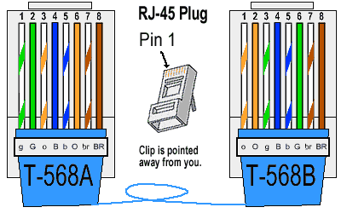

1. Straight Through Cable Diagram (Color Code)

